|  |  |
| --- | --- |
|  | |
|  | Social Science ProgramNational Park Service **U.S. Department of the Interior**  **Visitor Services Project** |

# Martin Van Buren

# National Historic Site

### Visitor Study

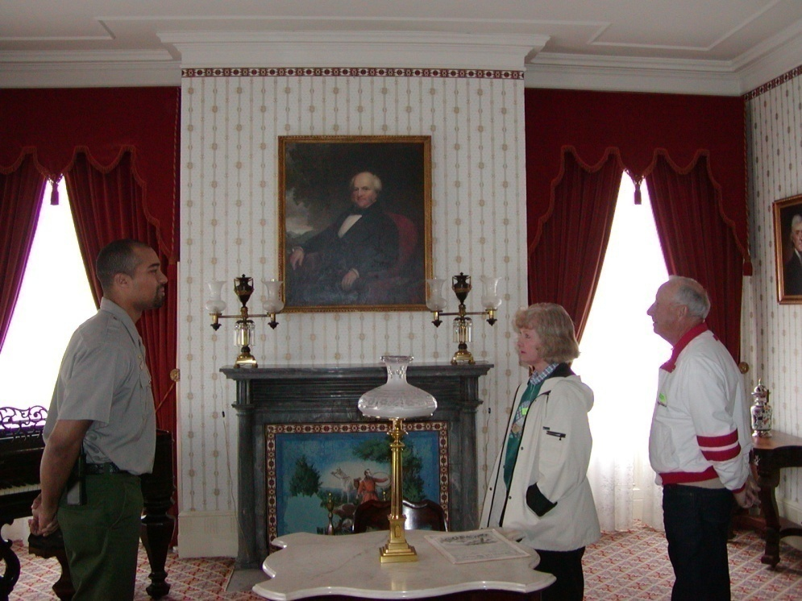

OMB Approval 1024-XXX (NPS# 09-XXX)

Expiration date: XXX-2009

|  |  |  |
| --- | --- | --- |
| IN REPLY REFER TO: | **United States Department of the Interior**  NATIONAL PARK SERVICE  Martin Van Buren National Historic Site  1013 Old Post Road  Kinderhook, NY 12106-3605 |  |
| August 2009  Dear Visitor:  Thank you for participating in this important study. Our goal is to learn about the expectations, opinions, and interests of visitors to Martin Van Buren National Historic Site. This information will assist us in our efforts to better manage this park and to serve you, our visitor.  This questionnaire is only being given to a select number of visitors, so your participation is very important! It should only take about 20 minutes after your visit to complete.  When your visit is over, please complete this questionnaire. Seal it with the stickers provided on the last page and drop it in any U.S. mailbox.  If you have any questions, please contact Margaret Littlejohn, NPS VSP Coordinator, Park Studies Unit, College of Natural Resources, P.O. Box 441139, University of Idaho, Moscow, Idaho 83844-1139, phone: 208-885-7863, email: littlej@uidaho.edu.  We appreciate your help.  Sincerely,  Daniel J. Dattilio  Superintendent | | |

**DIRECTIONS**

At the end of your visit:

1) Please have the selected individual complete this questionnaire.

2) Answer the questions carefully since each question is different.

3) For questions that use circles (O), please mark your answer by

filling in the circle with black or blue ink, or a #2 pencil~~.~~



4) Seal it with the stickers provided.

5) Drop it in a U.S. mailbox.

Thank you!

**PRIVACY ACT and PAPERWORK REDUCTION ACT statement**:

16 U.S.C. 1a-7 authorizes collection of this information. This information will be used by park managers to better serve the public. Response to this request is voluntary. No action may be taken against you for refusing to supply the information requested. Your name is requested for follow-up mailing purposes only. When analysis of the questionnaire is completed, all name and address files will be destroyed. Thus the permanent data will be anonymous. Please do not put your name or that of any member of your personal group on the questionnaire. An agency may not conduct or sponsor, and a person is not required to respond to, a collection of information unless it displays a currently valid OMB control number.   
 **Burden estimate statement**: Public reporting burden for this form is estimated to average 20 minutes per response. Direct comments regarding the burden estimate or any other aspect of this form to Margaret Littlejohn, NPS Visitor Services Project, College of Natural Resources, University of Idaho, P.O. Box 441139, Moscow, ID, 83844-1139; email: littlej@uidaho.edu.

**Your Visit To Martin Van Buren National Historic Site**

NOTE: In this questionnaire, your **personal group** is defined as anyone that you are visiting the park with, such as spouse, family, friends, etc. This does not include the larger group that you might be traveling with, such as school, church, scouts, or tour group.

1. a) Prior to your visit, how did you and your personal group obtain information about Martin Van Buren National Historic Site (NHS)? Please mark (•) **all** that apply in column (a).

b) If you were to visit Martin Van Buren NHS in the future, how would you and your personal group prefer to obtain information about the park? Please mark (•) **all** that apply in column (b).

a) **Prior to this visit** b) **Prior to future visits**

O Did not obtain information prior to visit 🡺**Go to part b of this question**

O Previous visits O

O Friends/relatives/word of mouth O

O Travel guides/tour books (such as AAA, etc.) O

O Maps/brochures O

O Newspaper/magazine articles O

O E-mail/telephone/written inquiry to park O

O Television/radio programs/videos O

O Martin Van Buren NHS website: www.nps.gov/mava O

O Other websites O

O School class/program O

O Local businesses (hotels, motels, restaurants, etc.) O

O Chamber of Commerce/visitor’s bureau/state welcome center O

O Other (Please specify below) O

This visit Future visit

c) From the sources you used prior to this visit, did you and your personal group receive the type of information about the park that you needed?

O No O Yes 🡺 **Go to Question 2**

d) If NO, what type of park information did you and your personal group need that was not available? Please be specific.

2.  **Prior to this visit**, were you and your personal group aware that Martin Van Buren NHS is a unit of National Park System?

O Yes O No

3. a) Prior to your visit, had you and your personal group ever heard of the Friends of Lindenwald group? This group supports the park through advocacy of future plans, fundraising, etc. Please mark (•) **one.**

O Yes O No

b) Are you or members of your group interested in learning more about the Friends of Lindenwald?

O Yes O No

c) Would you and/or any member of your group have any interest in joining the Friends of Lindenwald?

O Yes O No O Already a member

4. On this trip, what was the **primary** reason that you and your personal group came to the **Kinderhook area**? Please mark (•) **one**.

O Resident of the area (within 50 miles of the park) 🡺 **Go to Question 5**

O Visit Martin Van Buren NHS

O Visit other attractions in the area

O Interested in U.S. History

O Saw sign on highway

O Visit friends/relatives in the area

O Business

O Other (Please specify)

5. a) In what town/city did you and your personal group stay on the **night before your arrival** at Martin Van Buren NHS? If you stayed at home, please write the name of the city/town and state where you live.

Nearest city/town State

b) In what town/city did you and your personal group stay on the **night after your departure** from Martin Van Buren NHS? If you stayed at home, please write the name of the city/town and state where you live.

Nearest city/town State

6. a) On this trip, did you and your personal group stay overnight **away from your permanent residence** in the surrounding area (within 50 miles of Martin Van Buren NHS)?

O Yes O No 🡺 **Go to Question 7**

b) If YES, please list the number of nights you and your personal group stayed within 50 miles Martin Van Buren NHS.

Number of nights in the **surrounding area** outside the park

c) In what type of lodging did you and your personal group spend the night(s) in the area within 50 miles of Martin Van Buren NHS? Please mark (•) **all** that apply.

O Lodges, hotels, vacation rentals, B&B, etc.

O RV/trailer camping

O Tent camping in developed campground

O Seasonal residence

O Residence of friends or relatives

O Other (Please specify)

7. On this visit, were the signs directing you and your personal group to and around Martin Van Buren NHS adequate? Please mark (•) **one** answer for each of the following.

a) Interstate signs O Yes O No O Did not use

b) State highway signs O Yes O No O Did not use

c) Signs in local communities O Yes O No O Did not use

d) If you answered NO for any of the above, please explain.

Interstate:

State highway:

In local communities:

8. a) Compared to what you had planned, how much time did you and your personal group spend visiting Martin Van Buren NHS? Please mark (•) **one**.

O Did not have a planned amount of time to visit 🡺 **Go to Question 9**

O About the same as planned

O Longer than planned visit

🡻

b) Why was visit longer?

O Shorter than planned visit

🡻

c) Why was visit shorter?

9. On this visit, how much time did you and your personal group spend at Martin Van Buren NHS?

Number of hours (Please list partial hours as 1/4, 1/2, 3/4)

10. a) On this visit, did you and your personal group take a tour of the Martin Van Buren Home?

O Yes O No

🡻 🡻

|  |  |
| --- | --- |
| b) If YES, what were your reasons for taking it? Please mark (•) **all** that apply.  O To learn about Martin Van Buren  O To learn U.S. history  O To view the home where Martin  Van Buren lived  O Other (Please specify)    🡻  **Go to Question 11** | c) If NO, why not? Please mark (•) **all** that apply.  O Tour time not convenient O Have visited on past visits  O Not interested  O Have taken it in the past  O Other (Please specify)    🡻  **Go to Question 12** |

11. Please mark (•) **one** response for each of the following aspects of the tour.

a) Historic appearance of rooms in the home (very good… very poor)

a) Tour length: O Too short O About right O Too long

b) Taking tour at desired time: O Able to take tour O NOT able to take

at desired time tour at desired time

c) Ability to view interior of

rooms because of tour size: O Could see O Difficult to see

d) Topics discussed on tour: O Of interest O NOT of interest

e) On the tour, did you learn something about Martin Van Buren that is relevant or meaningful to your life today?

O Yes O No O Not sure

12. a) On this visit, did you and your personal group walk from the visitor center parking lot to the Martin Van Buren home?

O Yes O No

b) If YES, did any member of your group have difficulty walking this distance?

O Yes O No

13. a) On this visit, what activities did you and your personal group participate in at Martin Van Buren NHS? Please mark (•) **al**l that apply.

O Attended ranger-led talks/programs

O Creative arts (photography/drawing/painting/writing)

O Enjoyed solitude/quiet

O Learned about U.S. history/president

O Picnicked

O Visited the Martin Van Buren home

O Visited the visitor center

O Viewed outdoor exhibits (wayside loop trail)

O Walked/hiked

O Watched visitor center film/video

O Other (Please specify)

b) Which **one** of the above activities was the primary reason you and your personal group visited Martin Van Buren NHS on this visit? Please list only one.

14. a) Please mark (•) **all** of the visitor services and facilities that you or your personal group **used** at Martin Van Buren NHS during this visit.

b) Next, for only those services and facilities that you or your personal group **used**, please rate their importance to your visit from 1-5.

c) Finally, for only those services and facilities that you or your personal group **used**, please rate their quality from 1-5.

|  |  |  |
| --- | --- | --- |
| **a) Visitor services/facilities used?**  Mark (•) | **b) If used,**  **how important?**  1=Not important  2=Somewhat important  3=Moderately important  4=Very important  5=Extremely important | **c) If used,**  **what quality?**  1=Very poor  2=Poor  3=Average  4=Good  5=Very good |

O Access for people with disabilities

O Assistance from park staff

O Bookstore sales items

(selection, price, etc.)

O Directional signs

O Junior Ranger program

O Outdoor exhibits (wayside loop trail)

O Park brochure/map

O Park website: [www.nps.gov/mava](http://www.nps.gov/mava)

used before or during visit

O Picnic tables

O Restrooms

O Ranger-led house tour

O Video/film in visitor center

O Visitor center (other than restrooms or

video/film)

15. On this trip to Martin Van Buren NHS, what other historic sites did you and your personal group visit within or near Columbia County? Please mark (•) **all** that apply.

O LuykasVan Alen House O Columbia County Museum

O James Vanderpoel House O Olana State Historic Site

O Thomas Cole National Historic Site O Clermont State Historic Site

O Shaker Museum & Library

O Other (Please specify)

16. a) In recent years, the area surrounding the Martin Van Buren’s home has been maintained as a modern, mowed lawn. However, research reveals that during President Van Buren’s residence, the area was more typical of a farm field with grasses of different heights with a rustic appearance. In your opinion, which of the following options should be used to maintain the lawn. Please mark (•) **one**.

O Modern, mowed lawn

O Maintained by NPS personnel to replicate historic appearance, which means the grass height varies and has a rustic appearance

O Maintained by sheep, which means the grass height varies and has a rustic appearance and which has additional costs associated. Access to the lawn would also be restricted while animals are grazing.

O Other (Please specify)

b) In the future, Martin Van Buren NHS Visitor Center may move to the Village of Kinderhook, NY, approximately 2 miles from the Martin Van Buren home. The Visitor Center would have space for exhibits and presentations as well as meeting space for use by park staff and the community. If you visit again in the future, would you and your personal group be likely to visit both the Visitor Center and the Martin Van Buren home? Please mark (•) **one**.

O Would likely visit both 🡺 **Go to Question 17**

O Would likely only visit the Martin Van Buren home

O Would likely only visit the Visitor Center

O Unlikely to visit the park again

17. a) Did you and your personal group notice any differences between Lindenwald farm and other historic sites in the Hudson River Valley?

O Yes O No

b) If YES, what differences did you notice?

18. If you were to visit Martin Van Buren NHS in the future, how would you and your personal group prefer to learn about cultural and natural history/features of Martin Van Buren NHS? Please mark (•) **all** that apply.

O Not interested in learning about the park 🡺 **Go to Question 19**

O Indoor exhibits O Outdoor exhibits

O Park website: www.nps.gov/mava O Self-guided tours

O Volunteer opportunities O Special events

O Ranger-led interpretive programs O Evening events

O Electronic media/devices for visitors (downloadable digital files,

podcasts, interactive computer programs/tours, etc.)

O Audiovisual programs (DVD, video, or audio)

O Printed materials (brochures, books, maps, etc.)

O Other (Please specify)

19. a) Prior to your visit, were you and your personal group aware Martin Van Buren NHS was part of the Hudson River Valley National Heritage Area, which includes sites such as the Kendall Sculpture Garden, Kykuit-Rockefeller Estate, Vanderbilt Mansion, Saratoga National Battlefield and other significant sites?

O Yes O No

b) Do you and your personal group have any interest in learning more about the Hudson River Valley National Heritage Area?

O Yes O No

c) On a future visit, would you and your personal group be interested in riding a shuttle bus between sites in Columbia County, such as Olana State Historic Site, Clermont State Historic Site, James Vanderpoel’s mansion and Shaker Museum & Library?

O Yes, likely O No, unlikely

d) The shuttle bus would likely require a fee of $7 per person, which would be in addition to admission charges at the various sites. Would you be willing to pay this amount to ride the shuttle bus?

O Yes, likely O No, unlikely O Not sure

20. a) On a future visit to Martin Van Buren NHS, would you and your personal group be interested in using walking trails to visit more of the Lindenwald farm?

O Yes, likely O No, unlikely

b) If YES, what lengths of trails would you and your personal group be willing to hike?

O ½ mile O ½ to 1 mile O More than 1 mile

21. a) Martin Van Buren NHS occasionally holds special events, such as Harvest Day in September and Lindenwald Winter Celebration in December, and is considering holding additional ones. Have you and your personal group ever attended any of these events, or would you like to attend in the future?

O Not interested in special events 🡺 **Go to Question 22**

O Have attended in past O Would like to attend in future

b) Whether you have attended these special events or not, please rate their importance to you and your personal group. Please mark (•) **one** for each.

|  |  |  |  |  |  |
| --- | --- | --- | --- | --- | --- |
| Special event | Not important | Somewhat important | Moderately important | Very important | Extremely important |
| Monthly evening home tours in period costume | O | O | O | O | O |
| Lectures on different topics from U.S. history | O | O | O | O | O |
| Demonstrations of historic crafts and skills | O | O | O | O | O |
| Natural history programs such as bird walks | O | O | O | O | O |

22. a) During this visit to Martin Van Buren NHS, did you and your personal group have any personal interaction with a park ranger other than on the Home tour?

O Yes O No 🡺 **Go to Question 23**

1. If YES, on a scale from 1 to 5, please rate the quality of your interaction with the park ranger. Please mark (•) one response for each item.

|  |  |  |  |  |  |
| --- | --- | --- | --- | --- | --- |
| Park ranger (other than home tour) | Very poor | Poor | Average | Good | Very good |
| Helpfulness | O | O | O | O | O |
| Courteousness | O | O | O | O | O |
| Quality of information provided | O | O | O | O | O |

23. a) The Martin Van Buren NHS Visitor Center currently operates in a small, temporary space that provides limited services such as the park orientation video and bookstore sales items. On a future visit to Martin Van Buren NHS, would you and your personal group like to see any changes to the visitor center, such as different services or resources available there?

O Yes, likely O No, unlikely

b) If YES, what changes would you and your personal group like to see? Please be specific.

24. Currently, tours of the Martin Van Buren NHS home are provided daily from 9 a.m. to 4 p.m. from mid-May through October each year. In your opinion, should tours be offered into the evening hours?

O Yes O No

25. If you were to visit Martin Van Buren NHS in the future, what topics would you and your personal group like to learn about in interpretive programs? Please mark (**•**) **all** that apply.

|  |  |  |  |
| --- | --- | --- | --- |
| O | Not interested in interpretive programs 🡺 **Go to Question 26** | | |
| O | Modern political activity | O | In-depth programs about Martin Van Buren’s political organizing and party politics | |
| O | Daily life and activities at the Lindenwald home and farm | O | Other antebellum politicians and topics | |
| O | Other (Please specify) | | |

26. What would encourage you and your personal group to come back to visit Martin Van Buren NHS again in the future?

27. On this visit, were you and your personal group part of one of the following types of organized groups?

a) Commercial guided tour group O Yes O No

b) School/educational group O Yes O No

c) Other (scouts, work, church) O Yes O No

d) If you were with one of these organized groups, how many people, including yourself, were in this group?

Number of people in organized group

28. a) On this visit, with what kind of personal group (not guided tour/school/other organized group) were you?

O Alone O Friends

O Family O Family and friends

O Other (Please specify)

b) On this visit, how many people were in your personal group, including yourself?

Number of people

c) On this visit, how many vehicles did you and your personal group use to arrive at the park?

Number of vehicles

29. a) Does anyone in your personal group have a physical condition that made it difficult to access or participate in park activities or services?

O Yes O No 🡺**Go on to Question 30**

b) If YES, what services or activities were difficult to access/participate in?

30. For you and your personal group on this visit, please provide the following. (If you do not know the answer, leave blank).

|  |  |  |  |  |  |
| --- | --- | --- | --- | --- | --- |
|  | **a) Current age** | **b) U.S. ZIP code or name of country other than U.S.** | | **c) Number of visits to Martin Van Buren NHS**  (including this visit) | |
| Yourself |  | |  |  |  |
| Member #2 |  | |  |  |  |
| Member #3 |  | |  |  |  |
| Member #4 |  | |  |  |  |
| Member #5 |  | |  |  |  |
| Member #6 |  | |  |  |  |
| Member #7 |  | |  |  |  |

31. For you only, what is the highest level of education you have completed? Please mark (•) **one.**

O Some high school O Bachelor’s Degree

O High School Diploma/GED O Graduate Degree

O Some college

32. If you were a manager planning for the future of Martin Van Buren NHS, what would you and your personal group consider important issues to consider?

33. Is there anything else you and your personal group would like to tell us about your visit to Martin Van Buren NHS?

34. Overall, how would you rate the quality of the facilities, services, and recreational opportunities provided to you and your personal group at Martin Van Buren NHS during this visit? Please mark (•) **one**.

Very poor Poor Average Good Very good

O O O O O

35. a) Which category best represents your annual **household** income? Please mark (**•**) **only one**.

|  |  |  |  |  |  |
| --- | --- | --- | --- | --- | --- |
| O | Less than $24,999 | O | $50,000-$74,999 | O | $150,000-$199,999 |
| O | $25,000-$34,999 | O | $75,000-$99,999 | O | $200,000 or more |
| O | $35,000-$49,999 | O | $100,000-$149,999 | O | Do not wish to answer |

b) How many people are in your household? Number of people

Thank you for your help! Please seal the questionnaire with the stickers provided and drop it in any U.S. mailbox.

Printed on recycled paper



**OFFICIAL BUSINESS**

**Visitor Services Project**

**Park Studies Unit**

**College of Natural Resources**

**University of Idaho**

**P.O. Box 441139**

**Moscow, Idaho 83844-1139**