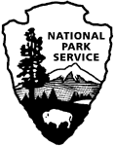 | Social Science Program  National Park Service  U.S. Department of the Interior  Visitor Services Project

Yosemite National Park

Visitor Study

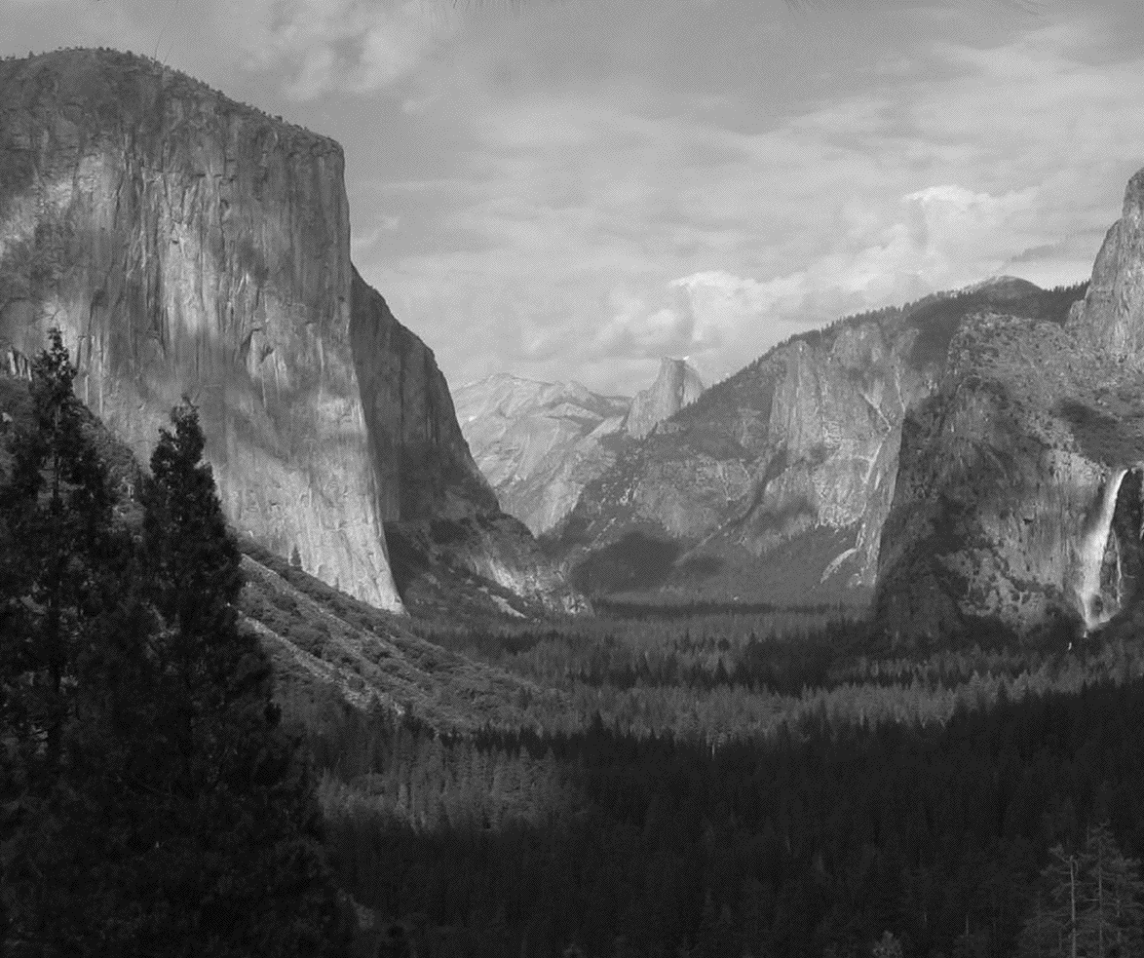

OMB Approval 1024-0224 (NPS# 08-006)
Expiration date: 02/29/2008

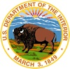  IN REPLY REFER TO: | United States Department of the Interior  NATIONAL PARK SERVICE  Yosemite National Park  P.O. Box 700  El Portal, CA 95318
July 2009

Dear Visitor:

Thank you for participating in this important study. We want to learn about the expectations, opinions, and interests of visitors to Yosemite National Park. This information will help us improve our management of this park and better serve you, our visitor.

This questionnaire will be given to only a select number of visitors, so your participation is very important! It should only take about 20 minutes after your visit to complete.

When your visit is over, please complete the questionnaire. Seal it with the stickers provided on the last page and drop it in any U.S. mailbox.

If you have any questions, please contact Margaret Littlejohn, NPS VSP Director, Park Studies Unit, College of Natural Resources, P.O. Box 441139, University of Idaho, Moscow, Idaho 83844-1139,
phone: 208-885-7863, email: littlej@uidaho.edu.

We appreciate your help.

Sincerely,

Dave Uberuaga
Acting Superintendent

DIRECTIONS

At the end of your visit:

1) Please have the selected individual complete this questionnaire.
2) Answer the questions carefully since each question is different.
3) For questions that use circles (O), please mark your answer by
filling in the circle with black or blue ink, or a pencil with dark
(e.g. #2) lead.

4) Seal it with the stickers provided.
5) Drop it in a U.S. mailbox.

Thank you!

PRIVACY ACT and PAPERWORK REDUCTION ACT statement:

16 U.S.C. 1a-7 authorizes collection of this information. This information will be used by park managers to better serve the public. Response to this request is voluntary. No action may be taken against you for refusing to supply the information requested. Your name is requested for follow-up mailing purposes only. When analysis of the questionnaire is completed, all name and address files will be destroyed. Thus the permanent data will be anonymous. Please do not put your name or that of any member of your group on the questionnaire. An agency may not conduct or sponsor, and a person is not required to respond to, a collection of information unless it displays a currently valid OMB control number.

Burden estimate statement: Public reporting burden for this form is estimated to average 20 minutes per response. Direct comments regarding the burden estimate or any other aspect of this form to Margaret Littlejohn, NPS Visitor Services Project, College of Natural Resources, University of Idaho, P.O. Box 441139, Moscow, ID, 83844-1139; email: littlej@uidaho.edu.

Please go to the next page ➔

Your Visit To Yosemite National Park

NOTE: In this questionnaire, personal group is defined as anyone that you are visiting the park with, such as spouse, family, friends, etc. This does not include the larger group that you might be traveling with, such as school, church, scouts, or tour group.

1. a) Prior to this visit, how did you and your personal group obtain information to plan your visit to Yosemite National Park? Please mark (•) all that apply in the left column.

b) If you were to visit Yosemite National Park in the future, how would you and your personal group prefer to obtain information about Yosemite National Park? Please mark (•) all that apply in the right column.

a) Prior to this visit b) On future visits
O Obtained no information prior to visit ➔
Go to part b of this question
O Previous visits O
O Friends/relatives/word of mouth O
O Travel guides/tour books (such as AAA, etc.) O
O Maps/brochures O
O Newspaper/magazine articles O
O E-mail/telephone/written inquiry to park O
O Television/radio programs/videos O
O Yosemite National Park website: www.nps.gov/yose/ O
O DNC Parks and Resorts website: www.yosemitepark.com O
O Yosemite Association website: www.yosemite.org O
O Yosemite Institute website: www.yni.org O
O Other websites O
O Other National Park Service areas O
O Other (Please specify below) O
This visit Future visit

c) From the sources you used prior to this visit, did you and your personal group receive the type of information about the park that you needed?
O No O Yes ➔ Go to Question 2

d) If NO, what type of park information did you and your personal group need that was not available? Please be specific.

3. a) Prior to your visit, were you and members of your personal group informed about proper food storage regulations in bear country at Yosemite NP?

O Yes O No

b) During your visit, did you and your group learn about proper food storage regulations in bear country from talking with rangers, brochures, exhibits, or by other means?

O Yes O No

4. a) In some national park units, the National Park Service policy involves setting fires under prescribed weather and burning conditions to meet specific resource management objectives, such as reduction of non-native plants, restoration of native vegetation, and removal of unnatural levels of woody or grassy materials which could help reduce a potential catastrophic fire. Prior to this visit to Yosemite NP, were you aware of this prescribed fire policy?

O Yes O No

b) If you and your personal group were to visit Yosemite NP in the future, would you be willing to tolerate short periods of occasional smoke or reduced visibility caused by prescribed burns?

O Yes, likely O No, unlikely O Not sure

c) If you and your personal group were to visit Yosemite NP in the future, would you be willing to tolerate temporarily charred fields or trees resulting from prescribed burns?

O Yes, likely O No, unlikely O Not sure

5. a) On this visit to Yosemite National Park, how long did you and your personal group spend visiting the park? List partial hours or days as 1/4, 1/2, 3/4.
Number of hours if less than 24 hours
Number of days if 24 hours or more

b) On this visit to Yosemite National Park, how long did you and your personal group stay in the area (within 50 miles of any entrance point)? List partial hours or days as 1/4, 1/2, 3/4.
Number of hours if less than 24 hours
Number of days if 24 hours or more

6. When did you and your group make the decision to visit Yosemite National Park? Please mark (•) one.
O On the day of the visit O 2-7 days before the visit
O 8-30 days before the visit O 1-6 months before the visit
O More than 6 months but less than a year before the visit
O A year or more before the visit

7. On this visit, at what time did you and your group first enter Yosemite National Park? Please mark (•) only one.
O 2:01 am to 6 am O 6:01 am to 10 am O 10:01 am to 2 pm
O 2:01 pm to 6 pm O 6:01 pm to 10 pm O 10:01 pm to 2 am

8. a) On this visit, which entrance point did you and your group use to first enter Yosemite National Park? Please mark (•) only one.
b) On this visit, which exit point did you and your group use to last exit Yosemite National Park? Please mark (•) only one.
a) First entry |  | b) Last exit
O | South Entrance (Highway 41 Corridor through Fresno, Oakhurst) | O
O | Arch Rock Entrance (Highway 140 Corridor through Merced, El Portal) | O
O | Tioga Pass Entrance (Highway 120 through Lee Vining, Mammoth Lakes) | O
O | Big Oak Flat Entrance (Highway 120 Corridor through Modesto, Stockton) | O
O | Hetch Hetchy Entrance Station | O
c) During your stay in the area (within 50 miles of any entrance point), how many times did you and your personal group enter Yosemite National Park?
Number of entries

9. a) On this trip, did you and your personal group stay overnight away from your permanent residence in Yosemite National Park or in the area within 50 miles of any entrance point?
O Yes O No ➔ Go to Question 10

b) If YES, please list the number of nights you and your personal group stayed.

Number of nights inside Yosemite National Park
Number of nights outside park within 50 miles of any entrance point

c) and d) In what type of lodging did you and your personal group spend the night(s)? Please mark (•) all that apply.

c) Inside park d) Outside park within 50 miles

O Lodge, motel, cabin, rented condo/home, or bed & breakfast O
O RV/trailer camping O
O Tent camping in developed campground O
O Backcountry campsite O
O Backcountry cabin O
n/a Personal seasonal residence O
O Residence of friends or relatives O
O Other (Please specify below) O
Inside Outside

10. For this trip, what was the primary reason that you and your personal group visited the Yosemite National Park area (within 50 miles of any entrance point)? Please mark (•) one.
O Resident of area (within 50 miles of any entrance point)
O Visit Yosemite National Park O Visit other attractions in area
O Visit friends/relatives in area O Business
O Travel through to other destination
O Other (Please specify)

11. a) On this visit, which one of the following entrance fees applied to you and your group? Please mark (•) one.
O $20 per car (valid for 7 days)
O $10 per person arriving on foot or bicycle or a bus in a non-commercial group (free for those who are 15 years old and younger)
O As a part of a commercial tour package or school/educational permit
O Annual passes (Yosemite Annual Pass, Interagency Pass)
O Other passes (e.g. Interagency Access Pass, Interagency Senior Pass)

b) On this visit, how would you and your personal group rate the value you received for the entrance fee paid or pass you used to enter Yosemite National Park? Please mark (•) one.
Very poor Poor Average Good Very good
O O O O O
12. a) On this visit, what forms of transportation did you and your group use to travel between your overnight accommodations or home and Yosemite National Park? Please mark (•) all that apply.
O Private vehicle (car, SUV, pickup, RV, motorcycle, etc.)
O Rental vehicle (any type) O Bicycle
O Commercial tour/school bus O On foot
O Bus service (Please specify)
O Other (Please specify)

b) On this visit, how many vehicles did you and your personal group use to arrive at the park?
Number of vehicles (not including park shuttle)

13. a) On this visit, what activities did you and your personal group participate in while visiting Yosemite National Park? Please mark (•) all that apply.
O View scenery (from outside the vehicle)
O Take scenic drive O Visit visitor center
O Shop in visitor center bookstore O Rock climb
O Eat in park restaurant O Bicycling
O Take photographs/paint/draw O Day hike
O Wildlife viewing/birdwatching O Nature study
O Stay in park lodging O Picnic
O Attend ranger-led programs O Visit museum
O Overnight backpacking
O Camping in developed campground
O Shopping inside park (other than at visitor center bookstore)
O Other (Please specify)

b) Which one of the above activities was the primary activity in which you and your personal group participated while visiting Yosemite National Park? Please list only one.

14. a) On this trip, where did you and your personal group stay on the night prior to visiting Yosemite National Park? If you stayed at home, please write the name of the town/city and state where you live.

Town/city State

b) On this trip, where did you and your personal group stay on the night after leaving Yosemite National Park? If you stayed at home, please write the name of the town/city and state where you live.

Town/city State

15. On this visit, which of the following sites in Yosemite National Park did you and your personal group visit? Please mark (•) all that apply on the map below.
O Other (Please specify)

16. a) Please mark (•) all visitor services and facilities that you or your personal group used during this visit to Yosemite National Park.

b) Next, for only those services and facilities that you or your personal group used, please rate their importance to your visit from 1-5.

c) Finally, for only those services and facilities that you or your personal group used, please rate their quality from 1-5.
a) Visitor services and facilities used  Mark (•) | b) If used,  how important?  1=Not important  2=Somewhat important  3=Moderately important  4=Very important  5=Extremely important | c) If used,  what quality?  1=Very poor  2=Poor  3=Average  4=Good  5=Very good

O Directional signs (in park)
O Directional signs (outside park)
O Roads
O Trails
O Restrooms
O Campgrounds
O Picnic areas O Trash collection
O Recycling
O Parking
O In-park lodging
O In-park restaurants
O Items purchased in gift shops
(other than visitor center bookstore)
O Access for disabled persons

17. a) Does anyone in your personal group have a physical condition that made it difficult to access or participate in park activities or services?
O Yes O No ➔ Go to Question 18

b) If YES, what services or activities were difficult to access/participate in?

18. a) Please mark (•) all information services and facilities that you or your personal group used during this visit to Yosemite National Park.

b) Next, for only those services and facilities that you or your personal group used, please rate their importance to your visit from 1-5.

c) Finally, for only those services and facilities that you or your personal group used, please rate their quality from 1-5.
a) Information services and facilities used  Mark (•) | b) If used,  how important?  1=Not important  2=Somewhat important  3=Moderately important  4=Very important  5=Extremely important | c) If used,  what quality?  1=Very poor  2=Poor  3=Average  4=Good  5=Very good
O Park brochure/map
O Yosemite Guide (booklet distributed
at park entrance)
O Trail guides
O Items purchased in visitor center bookstore
(selection, quality, price, etc.)
O Assistance from park staff
O Ranger-led walks/talks
O Ranger-led campground program
O Junior Ranger program
O Indoor exhibits
O Outdoor exhibits (outside visitor centers, museums
or in campgrounds, parking lots, etc.)
O Trailside exhibits (along walking/hiking trails)
O Yosemite Valley loop shuttle bus service
O Yosemite National Park website:
www.nps.gov/yose/ (used before or during visit)

19. a) Is there any service/facility that you and your personal group needed inside Yosemite National Park that was not available?
O Yes O No ➔ Go to Question 20

b) If YES, what is it? Please be specific.

20. On this visit, were you and your personal group part of the following types of groups? Please mark (•) one for each.

a) Commercial guided tour group O Yes O No
b) School/educational group O Yes O No
c) Wedding/reunion O Yes O No
d) Other organized group (such as O Yes O No
business group, scout group, etc.)

e) If you were with one of these organized groups, how many people, including yourself, were in this group?
Number of people in organized group

21. a) On this visit, what kind of personal group (not guided tour/school/other organized group) were you with? Please mark (•) one.
O Alone O Family
O Friends O Family and friends
O Other (Please specify)

b) On this visit, how many people were in your personal group, including yourself?
Number of people in your personal group

22. For you and your personal group on this visit, please provide the following. If you do not know the answer, please leave it blank.
 | a) Current age | b) U.S. ZIP code or name of country other than U.S. | c & d) Number of visits to Yosemite NP  (including this visit)
 | a) Current age | b) U.S. ZIP code or name of country other than U.S. | past 12 months | lifetime
Yourself
Member #2
Member #3
Member #4
Member #5
Member #6
Member #7

23. a) Are you or members of your group Hispanic or Latino? Please mark (•) one for each group member.
 | Yourself | Member #2 | Member #3 | Member #4 | Member #5 | Member #6 | Member #7
Hispanic or Latino | O | O | O | O | O | O | O
Not Hispanic or Latino | O | O | O | O | O | O | O

b) What is your race? What is the race of each member of your personal group? Please mark (•) one or more for you and each group member.
 | Yourself | Member #2 | Member #3 | Member #4 | Member #5 | Member #6 | Member #7
American Indian or Alaska Native | O | O | O | O | O | O | O
Asian | O | O | O | O | O | O | O
Black or African American | O | O | O | O | O | O | O
Native Hawaiian or other Pacific Islander | O | O | O | O | O | O | O
White | O | O | O | O | O | O | O

c) Are you or members of your group of Middle Eastern/Arab ancestry/descent? Please mark (•) one for each group member.
 | Yourself | Member #2 | Member #3 | Member #4 | Member #5 | Member #6 | Member #7
Middle Eastern/ Arab | O | O | O | O | O | O | O
Not Middle Eastern/Arab | O | O | O | O | O | O | O
24. If you or your personal group members are of Asian race, which of these best describe your race? Please mark (•) one or more for your group.
O No group members of Asian race ➔ Go to Question 25
O Asian Indian O Cambodian O Chinese
O Filipino O Hmong O Japanese
O Korean O Laotian O Pakistani
O Thai O Vietnamese O Other Asian
25. When visiting an area such as Yosemite NP, what one language do you and most members of your personal group prefer to use for the following?
a) Speaking : O English O Other (Specify)
b) Reading : O English O Other (Specify)

c) What services in the park need to be provided in languages other than English? Please specify a service(s) or write “None.”

26. Overall, how would you and your group rate the quality of the visitor facilities, services, and recreational opportunities provided to you and your personal group at Yosemite National Park during this visit? Please mark (•) one.
Very poor Poor Average Good Very good
O O O O O
27. For you and your group, please report all expenditures for the items listed below for this visit to Yosemite National Park and the surrounding area (within 50 miles of any entrance point). Please write "0" if no money was spent in a particular category.

a) Please list your group's total expenditures inside Yosemite National Park.

b) Please list your group's total expenditures outside the park (within 50 miles).

NOTE: Surrounding area residents should only include expenditures that were just for this visit to Yosemite National Park
EXPENDITURES
a) Inside park b) Outside park
Hotels, motels, cabins, B&B, etc. $ $
Camping fees and charges $ $
Guide fees and charges $ $
Restaurants and bars $ $
Groceries and takeout food $ $
Gas and oil (auto, RV, boat, etc.) $ $
Other transportation expenses $ $
(rental cars, taxis, auto repairs, but
NOT airfare)
Admission fees $ $
Recreation, entertainment fees
(including equipment rental) $ $
All other purchases (souvenirs, film, books, $ $
sporting goods, clothing, etc.)
Donations $ $

c) How many people do the above expenses cover?

Adults (18 years or over) Children (under 18 years)

28. If you were to visit Yosemite National Park in the future, how would you and your personal group prefer to learn about Yosemite NP? Please mark (•) all that apply.

O Not interested in learning about the park ➔ Go to Question 29
O Indoor exhibits O Outdoor exhibits
O Park website: www.nps.gov/yose O Trailside exhibits
O Volunteer opportunities O Self-guided tours
O Interactive computer programs tours O Special events
O Living history/costumed interpretive programs
O Electronic media/devices available to visitors (downloadable podcasts, MP3/MP4, Windows Media™, etc.)
O Audiovisual programs (DVD, video, or movie)
O Printed materials (brochures, books, maps, etc.)
O Other (Please specify)

29. If you were a manager planning for the future of Yosemite National Park, what would you propose? Please be specific.

30. Is there anything else you and your personal group would like to tell us about your visit to Yosemite National Park?

Thank you for your help! Please seal the questionnaire with the stickers provided and drop it in any U.S. mailbox.
 | Printed on recycled paper

OFFICIAL BUSINESS

Visitor Services Project
Park Studies Unit
College of Natural Resources
University of Idaho
P.O. Box 441139
Moscow, Idaho 83844-1139

