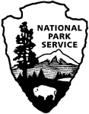 | Social Science Program  National Park Service  U.S. Department of the Interior  Visitor Services Project

Acadia National Park

Visitor Study

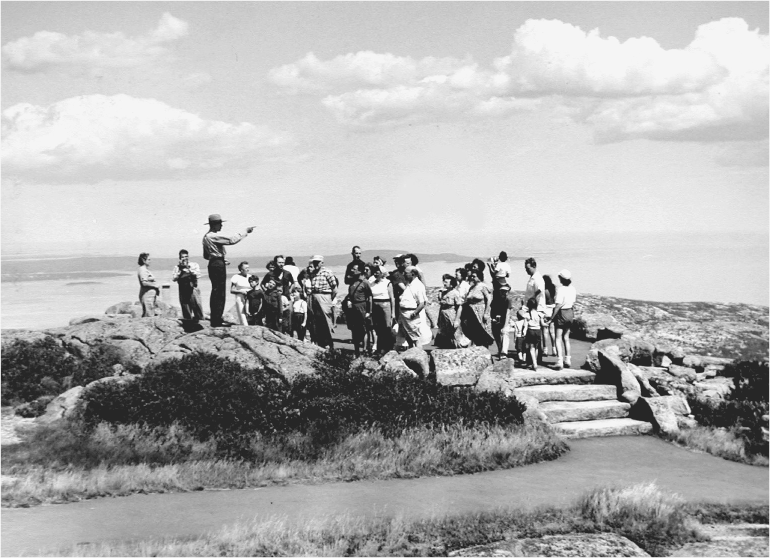

OMB Approval 1024-XXX (NPS# 08-XXX)
Expiration date: XXX-2009
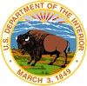  IN REPLY REFER TO: | United States Department of the Interior  NATIONAL PARK SERVICE  Acadia National Park  P.O. Box 177  Bar Harbor, ME 04609-0177

August 2009

Dear Visitor:

Thank you for participating in this important study. Our goal is to learn about the expectations, opinions, and interests of visitors to Acadia National Park. This information will assist us in our efforts to better manage this park and to serve you, our visitor.

This questionnaire is only being given to a select number of visitors, so your participation is very important! It should only take about 20 minutes after your visit to complete.

When your visit is over, please complete this questionnaire. Seal it with the stickers provided on the last page and drop it in any U.S. mailbox.

If you have any questions, please contact Margaret Littlejohn, NPS VSP Director, Park Studies Unit, College of Natural Resources, P.O. Box 441139, University of Idaho, Moscow, Idaho 83844-1139, phone: 208-885-7863, email: littlej@uidaho.edu.

We appreciate your help.

Sincerely,

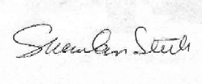
Sheridan Steele
Superintendent

DIRECTIONS
At the end of your visit:
1) Please have the selected individual complete this questionnaire.
2) Answer the questions carefully since each question is different.
3) For questions that use circles (O), please mark your answer by
filling in the circle with black or blue ink, or a pencil with dark
(e.g. #2) lead.

4) Seal it with the stickers provided.
5) Drop it in a U.S. mailbox.

Thank you!

PRIVACY ACT and PAPERWORK REDUCTION ACT statement:
16 U.S.C. 1a-7 authorizes collection of this information. This information will be used by park managers to better serve the public. Response to this request is voluntary. No action may be taken against you for refusing to supply the information requested. Your name is requested for follow-up mailing purposes only. When analysis of the questionnaire is completed, all name and address files will be destroyed. Thus the permanent data will be anonymous. Please do not put your name or that of any member of your personal group on the questionnaire. An agency may not conduct or sponsor, and a person is not required to respond to, a collection of information unless it displays a currently valid OMB control number.
Burden estimate statement: Public reporting burden for this form is estimated to average 20 minutes per response. Direct comments regarding the burden estimate or any other aspect of this form to Margaret Littlejohn, NPS Visitor Services Project, College of Natural Resources, University of Idaho, P.O. Box 441139, Moscow, ID, 83844-1139; email: littlej@uidaho.edu.

Your Visit To Acadia National Park
NOTE: In this questionnaire, your personal group is defined as anyone that you are visiting the park with, such as spouse, family, friends, etc. This does not include the larger group that you might be traveling with, such as school, church, scouts, or tour group.

1. a) Prior to your visit, how did you and your personal group obtain information about Acadia National Park? Please mark (•) all that apply in column (a).

b) Please rate the importance of the sources of information that you and your personal group used in column (b).

a) Sought Acadia National Park information prior to this visit  Mark (•) |  | b) If used,  how important?  1=Not important  2=Somewhat important  3=Moderately important  4=Very important  5=Extremely important
O | Did not obtain information prior to visit Go to Question 2
O | Previous visits
O | Friends/relatives/word of mouth
O | Travel guides/tour books (such as AAA, etc.)
O | Maps/brochures
O | Newspaper/magazine articles
O | E-mail/telephone/written inquiry to park
O | Television/radio programs/videos/DVDs
O | Maine State Tourism Center along Interstate 95
O | Acadia National Park website: www.nps.gov/acad
O | Other websites
O | School class/program
O | Chamber of Commerce/visitors bureau
O | Other (Please specify)

c) From the sources marked above, did you and your personal group receive the type of information about the park that you needed?
O No O Yes Go to Question 2

d) If NO, what type of park information did you and your personal group need that was not available? Please be specific.

2. a) On this trip, what forms of transportation did you and your personal group use to visit Acadia National Park? Please mark (•) all that apply.
O Car/pickup/SUV/van O Car/pickup/SUV/van with trailer/camper
O Motorhome/RV O Motorhome/RV with towed car/boat/trailer
O Bicycle O Tour bus
O Island Explorer Bus O Ferry boat/Mail boat
- O Private boat O Motorcycle
O Taxi O Other (Specify)

b) On this visit, how many motor vehicles did you and your personal group use to arrive at the park?
Number of vehicles

3. a) During this trip to Acadia National Park, did you and your personal group stay overnight on Mount Desert Island?
O Yes O No Go to Question 4

b) If YES, what type of overnight accommodations did you and your personal group use during this visit? Please mark (•) all that apply.
O Year-round residence O Motel or hotel
O Summer residence O Bed and Breakfast
- O Campground in Acadia NP O Private campground
O Short-term house rental (less than one month stay)
O Other (Please specify)

4. On this trip, how many total hours or days did you and your personal group spend visiting the following places? Please list hours or days as ¼ hr, 1½ days, 5¾ hrs, etc.

a) Mount Desert Island |  | Number of hours, if less than 24 hours
 |  | Number of days, if 24 hours or more
b) Acadia National Park |  | Number of hours, if less than 24 hours
 |  | Number of days, if 24 hours or more

5. On the list below, please mark (•) all of the activities that you and your personal group participated in at Acadia National Park during this trip.
O Boating/canoeing/kayaking on lakes/ponds O Hiking on trails
O Walking on carriage roads O Birdwatching
O Biking on carriage roads O Picnicking
O Biking on park motor roads O Sea kayaking
O Horse and carriage ride O Rock climbing
O Sightseeing/driving for pleasure O Shopping in park
O Participating in ranger-led programs/cruises O Earthcaching
O Dining at Jordan Pond House Restaurant
O Camping at Seawall, Blackwoods, Isle au Haut, or Wildwoods Stables
Campgrounds
O Other (Please specify)

6. Many businesses offer guided tours, instruction, or activities to help visitors enjoy Acadia National Park. On this trip, which of these commercial activities did you and your personal group pay a fee for while visiting Acadia National Park? Do not include businesses where you only rented equipment. Please mark (•) all that apply.
O Bicycling tour O Nature walks
O Hiking tour O Rock climbing
O Sea kayaking tour O Boat cruise (not ferry boat, mail boat,
or whale watch)
O Concession bus tour (National Park Tours or Oli’s Trolley)
O Other bus tour (Specify company)
O Other (Please specify)

7. a) During this visit, did aircraft affect your enjoyment of Acadia National Park?
O Yes O No Go to Question 8

b) If YES, how?

8. During this trip, which of these places in Acadia National Park did you and personal your group visit? Use the map below to help you locate the places. Please mark (•) all that apply.
O Sieur de Monts area (Wild Gardens, Nature Center, Abbe Museum)
O Sand Beach O Thunder Hole
O Jordan Pond House and area O Cadillac Mountain summit
O Bubble Rock O Bubble Pond
O Eagle Lake parking area O Sargent Drive
O Beech Mountain area O Echo Lake Beach
O Acadia Mountain (Ledges) parking area O Valley Cove area
O Bass Harbor Head Light Lighthouse O Western Mountain Road
O Pretty Marsh picnic area O Schoodic Peninsula
O Baker Island O Islesford Museum
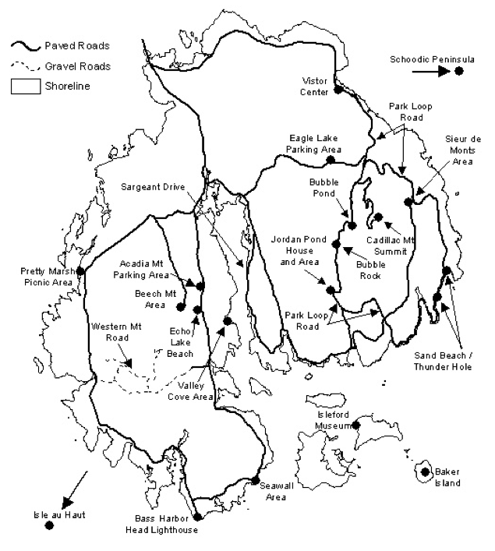O Isle au Haut O Seawall area

9. a) Prior to this visit, were you and your personal group aware of the following rules/ regulations at Acadia National Park? Please mark (•) one answer for each item in column (a).

b) On this visit, did you and your personal group learn (via publications, signs, talking to park staff, etc.) about these rules/regulations during this visit to Acadia National Park? Please mark (•) one answer for each item in column (b).

a) Aware? |  | Rules/regulations | b) Learned during visit?
Yes | No | Rules/regulations | Yes | No
O | O | Pets are allowed in the park on a leash six feet or less in length, but are prohibited from hiking trails with ladders. | O | O
O | O | Dead and down wood may be collected as fuel for campfires within the park, except within campgrounds. | O | O
O | O | Collecting natural and historic objects such as starfish, beach cobbles, or arrowheads is prohibited. | O | O
O | O | Collecting certain fruits, nuts, or berries or unoccupied seashells by hand for personal use or consumption is allowed. | O | O

10. a) Prior to this visit, were you and your personal group aware of the following guidelines for visiting Acadia National Park? Please mark (•) one answer for each item in column (a).

b) Did you and your personal group learn (via publications, signs, talking to park staff, etc.) about these guidelines during this visit to Acadia National Park? Please mark (•) one answer for each item in column (b).

a) Aware? |  | Guidelines | b) Learned during visit?
Yes | No | Guidelines | Yes | No
O | O | The Leave No Trace program and principles. | O | O
O | O | Adding to or building new cairns or other rock objects detracts from the natural landscape, causes soil erosion and plant loss, and misleads hikers.  (Stone cairns are used as trail markers where there are no trees). | O | O
O | O | Staying on trails or stepping on rock preserves fragile mountain soil and plants. | O | O

11. a) Please mark (•) all of the information services and facilities that you and your personal group used at Acadia National Park during this visit.

b) Next, for only those services and facilities that you and your personal group used, please rate their importance to your visit from 1-5.

c) Finally, for only those services and facilities that you and your personal group used, please rate their quality from 1-5.
a) Information services/facilities used?  Mark (•) | b) If used,  how important?  1=Not important  2=Somewhat important  3=Moderately important  4=Very important  5=Extremely important | c) If used,  what quality?  1=Very poor  2=Poor  3=Average  4=Good  5=Very good
O Assistance from park staff
O Park brochure/map
O Park newspaper Beaver Log
O Ranger-led walks/talks/programs/cruises
O Hulls Cove Visitor Center exhibits
O Jordan Pond House exhibits
O Bar Harbor Village Green Information Center
O Nature Center exhibits (Sieur de Monts)
O Cadillac Mountain Summit Center exhibits
O Thunder Hole Information Center exhibits
O Thompson Island Information Center exhibits
O Islesford Museum
O Roadside interpretive exhibits
O Trailside exhibits
O Information/bulletin boards
O Jordan Pond or Carroll Homestead
self-guiding trails

12. a) Overall, how would you rate the quality of information provided on the park website to plan your visit? Please mark (•) one.
O Did not use the park website Go to Question 13
Very poor Poor Average Good Very good
O O O O O
b) Did you find the information that you needed on the park website?
O No O Yes Go to part d of this question

c) If NO, what type of information did you and your personal group need that was not available on the park website? Please be specific.

d) If YES, what type of information was most valuable for you and your personal group?

13. a) On this trip, which of the following ranger-led programs did you and your personal group attend at Acadia National Park? Please mark (•) all that apply.

b) How appropriate was the depth of information in the programs you and your personal group attended?

O Did not attend any ranger-led programs Go on to Question 14
Attend ranger-led program? | Program depth of information?
Attend ranger-led program? | Too simple | About right | Too difficult
O Talk | O | O | O
O Walk/Hike | O | O | O
O Bike tour | O | O | O
O Children’s program | O | O | O
O Campground evening program | O | O | O
O Boat cruise | O | O | O
O O Drop in (Falcon Watch,  Hawk Watch, Otter Cove) | O | O | O
O Other (Please specify) | O | O | O

c) If you and your personal group were to visit Acadia National Park in the future, would you be willing to pay a modest fee (such as $10/person) to attend a 2-3 hour ranger-led program with a limited group size?
O Yes, would be willing to pay a modest fee to attend ranger-led programs
O No, would not be willing to pay a modest fee to attend ranger-led programs

14. If you did not attend any park ranger-led programs, what prevented you and your personal group from participating? Please mark (•) all that apply.
O Not interested in attending ranger-led programs Go to Question 15
O Did not have time for this activity O Weather
O Not aware of any ranger-led talks/ O Not enough programs
programs offered at park offered
O Other (Please specify)

                - 15. a) If you and your personal group visit again in the future, what topics would you like to learn about in interpretive/ranger-led programs at Acadia National Park? Please mark (•) all that apply.
- O | - Not interested in interpretive programs Go to Question 16
- O | - Birds | - O | - Animals other than birds
- O | - Plants | - O | - Tidal areas
- O | - Geology | - O | - Astronomy
- O | - Human history | - O | - Opportunities for volunteer stewardship
- O | - Other (Please specify)

b) What program length would be most suitable for you and your personal group? Please mark (•) one.

O Under 1/2 hour | O 1 - 2 hours
O 1/2 - 1 hour | O Other

c) What time of day would be most suitable for you and your personal group? Please mark (•) all that apply.

O 8 – 10 am | O Noon- 2 pm | O After 4 pm
O 10 am - Noon | O 2 pm – 4 pm | O Other (Specify) ____________________

16. a) Please mark (•) all of the visitor facilities that you or your personal group used at Acadia National Park during this visit.

b) Next, for only those facilities that you or your personal group used, please rate their importance to your visit from 1-5.

c) Finally, for only those facilities that you or your personal group used, please rate their quality from 1-5.
a) Park visitor facilities used?  Mark (•) | b) If used,  how important?  1=Not important  2=Somewhat important  3=Moderately important  4=Very important  5=Extremely important | c) If used,  what quality?  1=Very poor  2=Poor  3=Average  4=Good  5=Very good
O Park road directional signs--outside park
O Park road directional signs--in park
O Park Loop Road
O Carriage roads
O Parking lots
O Restrooms
O Hiking trails
O Beaches
O Campgrounds (Blackwoods, Seawall,
Isle au Haut, Wildwood Stables)
O Picnic areas
O Jordan Pond House Restaurant
O Jordan Pond House Gift Shop
O Cadillac Mountain Gift Shop
O Thunder Hole Gift Shop
O Wildwood Stables (excluding campground)

17. Overall, how would you rate the quality of the facilities, services, and recreational opportunities provided to you and your personal group at Acadia National Park during this visit? Please mark (•) one.
Very poor Poor Average Good Very good
O O O O O

18. It is the National Park Service’s responsibility to protect Acadia National Park’s natural, scenic, and cultural resources, while at the same time providing for public enjoyment. How important is protection of the following resources/attributes to you and your personal group? Please mark (•) one answer for each resource/attribute.
Acadia NP resource/attribute | Not important | Somewhat important | Moderately important | Very important | Extremely important
Clean air (visibility) | O | O | O | O | O
Clean water | O | O | O | O | O
Dark night sky | O | O | O | O | O
Educational opportunities | O | O | O | O | O
Historic features and buildings | O | O | O | O | O
Native plants | O | O | O | O | O
Native wildlife | O | O | O | O | O
Natural quiet/sounds of nature | O | O | O | O | O
Recreational opportunities | O | O | O | O | O
Scenic views | O | O | O | O | O
Solitude | O | O | O | O | O

19. a) On this visit to Acadia National Park, did you and your personal group bring any of the following electronic devices with you? Please mark (•) all that apply.

b) On this visit, did you and your personal group use any of the following electronic devices to obtain park information? Please mark (•) all that apply.
Brought on this visit (•) Used for park information (•)
O None Go to Question 20
O Laptop computer O
O Cell phone O
O MP3/MP4 Players (audio tour) O
O Other portable electronic device (iPhone, Blackberry, PDA, etc.) O
O Handheld Global Positioning System receiver (navigation) O

c) What park information did you obtain using these devices?

d) If you did not use these devices on this visit, would you like to use them to access information about Acadia National Park on a future visit?
O Yes O No O Not sure

20. A new facility, Acadia Gateway Center, is being designed to welcome visitors to Mount Desert Island and Acadia National Park. This center, on Route 3 in Trenton, Maine will provide parking, restrooms, and information for Acadia National Park and the Chamber of Commerce, and will serve as the hub for the free Island Explorer bus. Visitors will be able to park vehicles there and take the Island Explorer to Acadia National Park and Mount Desert Island.

a) Would you and your personal group be willing to stop at the Acadia Gateway Center on a future trip to Acadia National Park or Mount Desert Island? Please mark (•) one.
Very unlikely | Somewhat unlikely | Not sure | Somewhat likely | Very likely
O | O | O | O | O

b) Would you and your personal group be willing to park your car at the Acadia Gateway Center and ride the Island Explorer bus around Acadia National Park or Mount Desert Island on a future trip? Please mark (•) one.
Very unlikely | Somewhat unlikely | Not sure | Somewhat likely | Very likely
O | O | O | O | O

21. On this visit, were you and your personal group part of the following types of organized groups?
a) Commercial guided tour group O Yes O No
b) School/educational group O Yes O No
c) Other (scouts, work, church) O Yes O No
d) If you were with one of these organized groups, how many people, including yourself, were in this group?
Number of people in organized group

22. a) On this visit, with what kind of personal group (not guided tour/school/other organized group) were you? Please mark (•) one.
O Alone O Friends
O Family O Family and friends
O Other (Please specify)

b) On this visit, how many people were in your personal group, including yourself?
Number of people

23. a) & b) When visiting an area such as Acadia National Park, what one language do you and most members of your personal group prefer to use for the following?
a) Speaking: O English O Other (Specify)
b) Reading: O English O Other (Specify)

24. a) Does anyone in your personal group have a physical condition that made it difficult to access or participate in park activities or services?
O Yes O No Go on to Question 25

b) If YES, what services or activities were difficult to access/participate in?

c) Because of the physical condition, what specific problems did the person(s) have? Please mark (•) all that apply.
O Hearing (difficulty hearing ranger-led programs, bus drivers, audio-visual exhibits or programs, or information desk staff, even with hearing aid)
O Visual (difficulty seeing exhibits, directional signs, or visual aids that are part of programs, even with prescribed glasses or due to blindness)
O Mobility (difficulty accessing facilities, services, or programs, even with walking aid and/or wheelchair)
O Other (Please specify)

25. For you and your personal group on this visit, please provide the following. If you do not know the answer, leave blank.
 | a) Current age | b) U.S. ZIP code or name of country other than U.S. | Frequency of visits to Acadia National Park  (including this visit)  c) Lifetime d) Past 5 years
Yourself
Member #2
Member #3
Member #4
Member #5
Member #6
Member #7

26. Is there anything else you and your personal group would like to tell us about your visit to Acadia National Park?

Thank you for your help! Please seal the questionnaire with the stickers provided and drop it in any U.S. mailbox.
Printed on recycled paper

OFFICIAL BUSINESS

Visitor Services Project
Park Studies Unit
College of Natural Resources
University of Idaho
P.O. Box 441139
Moscow, Idaho 83844-1139

