July 29, 2026
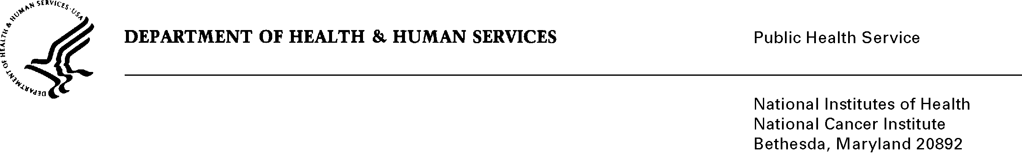

Name
Address
Address
City State Zip

Dear Dr. :

The National Cancer Institute (NCI) at the National Institutes of Health (NIH), along with the National Institute of Child Health and Human Development, the Office of Behavioral and Social Sciences Review, the National Institute of Diabetes and Digestive and Kidney Diseases, and the Centers for Disease Control and Prevention request your participation in a physician survey of their knowledge, attitudes, and practices regarding diet, physical activity, and weight management. We are sending this survey to a group of 2,000 randomly selected physicians, including you.

There is an increasing body of literature supporting the relationship between poor diet, low levels of physical activity, being overweight, and the risk of chronic disease. The goal of this survey is to understand physicians’ practices regarding the use of risk assessment, counseling and referral services for diet, physical activity and weight control. Data from the survey will be used to understand existing physician practice, understand barriers to counseling and referral, and to inform methods for improving the utilization of these services for adults and children. We need your views on these practices.

We will combine your responses with those of other surveyed physicians, and use these data to publish publicly-available reports and journal articles with the goal of informing health care policy and improving health care.

Completing the enclosed questionnaire should take no longer than 20 minutes, and space is left at the end for comments. The information you provide is confidential. Your participation is voluntary; there are no penalties for not responding to the information collection as a whole or to any particular questions. Your answers will be stored separately from your identity, and only aggregated findings will be reported. A $30 check is enclosed as a token of our appreciation for your participation.

Please complete this one-time survey and return it in the enclosed envelope. If you would prefer to complete your survey by telephone with a researcher, please call 800-937-8281 ext 1234, weekdays between 9 a.m. and 5 p.m. EDT, or e-mail ResearchAssistant@westat.com. If you have questions about the study, please call Dr. Caroline McLeod, Westat, (800-937-8281 ext. 2786 or carolinemcleod@westat.com) or Dr. Ashley Wilder-Smith at NCI (301) 451-1843 or smithas@mail.nih.gov).

Your participation is both critical and much appreciated. Thank you in advance for your valuable contribution to this important study.

Sincerely,

Rachel Ballard-Barbash, M.D.
Associate Director
Division of Cancer Control and Population Sciences
National Cancer Institute

