March 24, 2008

Supporting Statement for
Paperwork Reduction Act Submissions

OMB Control Number: 1660-0057
Expiration date: 04/30/2008

Title: Chemical Stockpile Emergency Preparedness Program (CSEPP)
Evaluation and Customer Satisfaction Survey

Form Number(s): None

General Instructions

A Supporting Statement, including the text of the notice to the public required by 5 CFR 1320.5(a)(i)(iv) and its actual or estimated date of publication in the Federal Register, must accompany each request for approval of a collection of information. The Supporting Statement must be prepared in the format described below, and must contain the information specified in Section A below. If an item is not applicable, provide a brief explanation. When Item 17 or the OMB Form 83-I is checked “Yes”, Section B of the Supporting Statement must be completed. OMB reserves the right to require the submission of additional information with respect to any request for approval.

Specific Instructions

A. Justification
- Explain the circumstances that make the collection of information necessary. Identify any legal or administrative requirements that necessitate the collection. Attach a copy of the appropriate section of each statute and regulation mandating or authorizing the collection of information. Provide a detailed description of the nature and source of the information to be collected.
The Chemical Stockpile Emergency Preparedness Program (CSEPP) is a branch of the multi-hazard readiness programs, dealing with the potential of chemical spills or releases into the communities surrounding the seven U.S. chemical stockpiles (known as CSEPP sites). The program’s goal is to improve preparedness to protect the people of these communities in the unlikely event of an accident involving this country’s stockpiles of obsolete chemical munitions. CSEPP, a cooperative effort between FEMA and the U.S. Army, provides funding (grants), training, guidance, and technical support and expertise to State, local, and tribal governments to improve their capabilities to prepare for and respond to this type of disaster. Application and reporting forms for CSEPP grants are covered under information collection number OMB 1660-0025.
In 2000, FEMA and the U.S. Army established the CSEPP Public Affairs Integrated Process Team (PA IPT) to develop an outreach strategy that could be shared with all CSEPP sites. The PA IPT members determine public outreach performance measures for all CSEPP sites and make recommendations to the PA IPT. This information collection constitutes the assessment tool that measures public knowledge of emergency preparedness and response actions in the event of a chemical emergency affecting any of the seven CSEPP sites and surrounding communities.
Authorities supporting this information collection and this program are as follows
1) Title 44 CFR § 2.42, the Preparedness, Training, and Exercises Directorate, supports the emergency preparedness, training, and exercises capabilities of Federal, State and local governments. A principal function of the Preparedness, Training, and Exercises Directorate is management of programs to establish, maintain, and enhance the capabilities of Federal, State, and local governments to prepare for, respond to, recover from a broad range of emergencies, including such programs as the Radiological Emergency Preparedness (REP) Program, Chemical Stockpile Emergency Preparedness Program (CSEPP), and the delegated responsibilities under the Federal Civil Defense Act of 1950, as amended (50 U.S.C. App. 2251–2303).
2) P.L. 99-145, Title 50 §1521 allows for carrying out the destruction of the United States’ stockpile of lethal chemical agents and munitions that exist.
3) The Government Performance Results Act of 1993 (GPRA)-Public Law 103-62, which mandates Federal agencies to provide valid and reliable quantification of achievement of strategic goals.
- Indicate how, by whom, and for what purpose the information is to be used. Except for a new collection, indicate the actual use the agency has made of the information received from the current collection. Provide a detailed description of: how the information will be shared, if applicable, and for what programmatic purpose.
Program managers will use data findings specifically to: 1) assess outreach programs’ effectiveness using five national performance indicators unique to CSEPP, 2) measure and monitor customer satisfaction with CSEPP products and services, and 3) identify weaknesses and strengths in individual sites and program components.
Results from this information collection will be shared with State, local, and other FEMA officials for subsequent action plans addressing program-wide and stockpile site-specific issues. Results will also be shared with other Federal agencies that lend their expertise in specific areas of the program.
The goal of the overall survey concept was to design and implement a public survey strategy to support the development of public outreach and education efforts that will improve the emergency preparedness of citizens living in the Immediate Response Zones (IRZ) and Protective Action Zones (PAZ) surrounding participating CSEPP sites.
As part of continuing efforts to better serve CSEPP sites, an assessment of the survey initiative was performed to assess the continuing need for the ongoing measurement of public outreach efforts. Changes in public awareness in participating CSEPP communities over the course of the survey work were analyzed to determine areas of notable improvement and areas that require additional efforts. Great improvements have been made in residents’ knowledge of shelter-in-place as well as overall confidence in their ability to protect themselves in the unlikely event of a chemical emergency. Because of the persistent efforts and targeted outreach, the levels of trust and control of the residents in CSEPP communities have increased over the past few years.
However, many CSEPP communities are still struggling with low levels of awareness when it comes to family and school emergency plans. A large proportion of parents indicate they are confident their child is safe at school, yet they are unaware of their child’s school emergency plan. Emergency plans are an important area for future outreach. Based on survey data, for example, it is suggested that Public Information Officers (PIOs) continue to focus on school preparedness and get parents involved. They should also encourage all residents in the community to develop an emergency plan. In the future, CSEPP sites should continue to strive to reach as many residents as possible with valuable emergency preparedness information.
Yearly surveys allow CSEPP sites to assess the effectiveness of ongoing outreach campaigns and note areas of improvement. The survey tool provides true measurement of public awareness and knowledge of appropriate protective actions citizens will take during an emergency.
- Describe whether, and to what extent, the collection of information involves the use of automated, electronic, mechanical, or other technological collection techniques or other forms of information technology, e.g., permitting electronic submission of responses, and the basis for the decision for adopting this means of collection. Also describe any consideration of using information technology to reduce burden.
This collection consists of telephone surveying that utilizes Computer Assisted Telephone Interview (CATI) technology to enter the survey responses. Although some CSEPP sites may consider using additional survey modes (e.g., the Internet) in the future, it is very unlikely at this point to implement technology-based applications to collect this information due to two reasons: (1) while conducting the surveys, one of the goals of sample selection is to reach respondents belonging to groups with varied demographic characteristics. However, the availability of the Internet and its usage in low-income families as well as among senior citizens is very limited, hence the survey will be biased towards respondents who have a greater likelihood of access to the internet. For emergency planning, it is crucial to reach all respondents in these demographic groups (including low income and senior citizens); therefore, telephone survey practices are advantageous. (2) There is a need to custom-tailor individual data collection instruments to accommodate the needs of CSEPP sites, each with its own individual characteristics and requirements.
However, the reports are made available electronically on the CSEPP portal. A snapshot of the portal displaying the report is displayed in Figure 1.
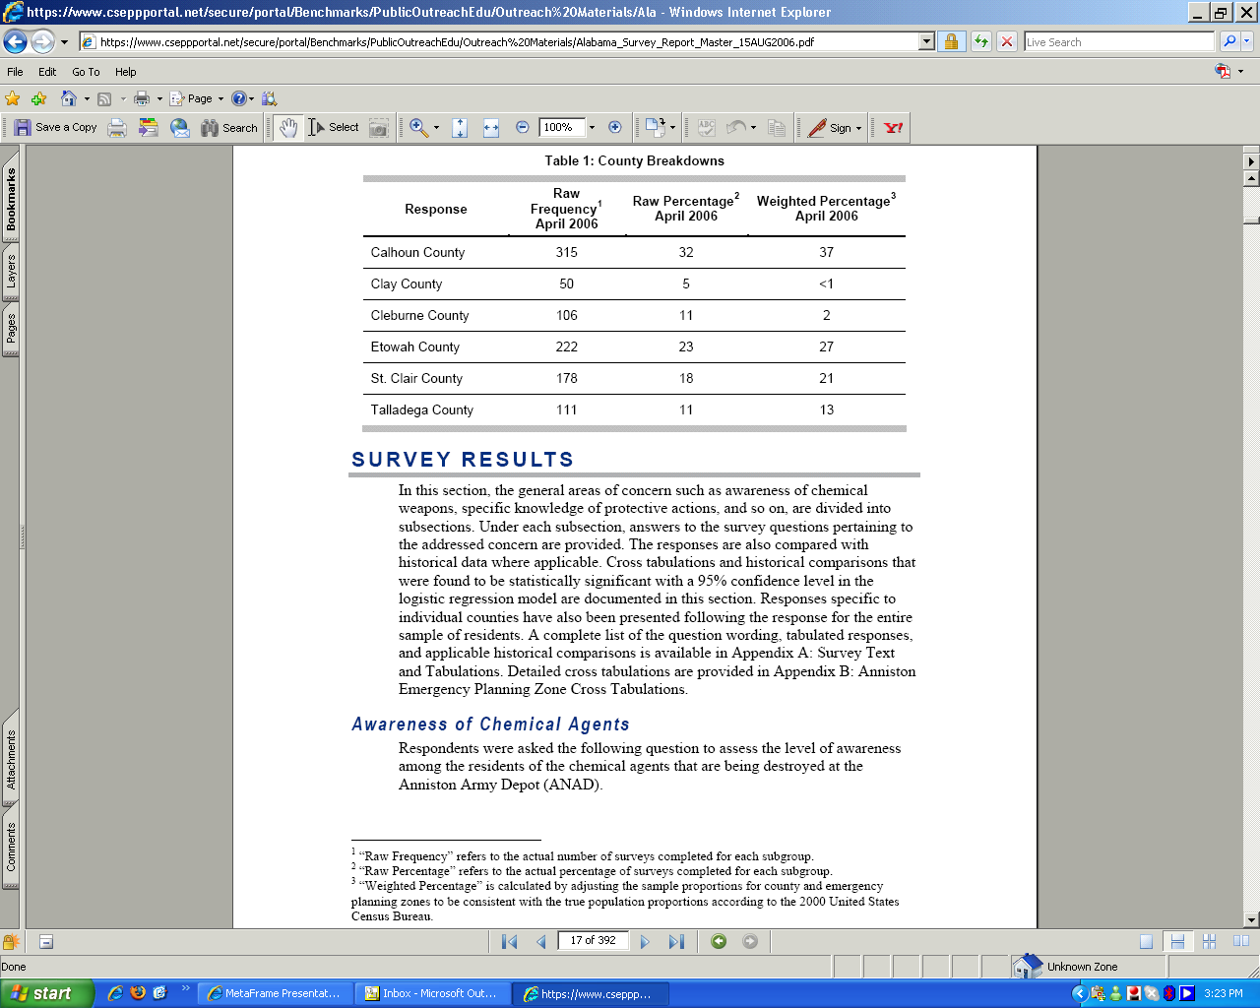
Figure 1: CSEPP Portal Displaying Survey Results
- Describe efforts to identify duplication. Show specifically why any similar information already available cannot be used or modified for use for the purposes described in Item 2 above.
There is no CSEPP-specific quantitative data available that is similar to data collected through these surveys. Knowledge gained through previous research efforts related to CSEPP has been integrated into this collection as a foundation in the design of these surveys. As described in Item 2, since this is a continuous data gathering activity, the information reflects program conditions for the timeframe in which it is collected (e.g., FY 2006). Therefore, there is no duplication since the newly collected data only reflects current site conditions. The information evolves as recently-collected data is integrated with existing information and measured against baseline data to generate current program and site information. This process allows the systematic monitoring of outreach performance within the context of strategic goals and objectives of the program and the Agency overall.
- If the collection of information impacts small businesses or other small entities (Item 5 of OMB Form 83-I), describe any methods used to minimize.
The impact of this information collection on small entities (i.e. county and local governments and small businesses) is none. There are no reporting or recordkeeping requirements that would result in time and cost burdens to these entities.
- Describe the consequence to Federal/FEMA program or policy activities if the collection of information is not conducted, or is conducted less frequently as well as any technical or legal obstacles to reducing burden.
Current national conditions of increased risk for man-made and/or accidental chemical disasters create great demand for the constant monitoring of preparedness-related activities. Since CSEPP is a cooperative effort among local, State, and Federal governments working closely with the public in communities surrounding fixed hazards, documenting performance at each of these levels is vital for program planning and management in each of the CSEPP sites. Furthermore, since no preparedness program can be successful without the public’s understanding and cooperation, input from the residents and businesses of immediate and/or surrounding areas is vital for program managers to design custom-tailored strategies to educate and communicate risks and action plans at the local level. Failure to collect this information will hamper the program’s ability to document strengths and weaknesses at each individual site, forcing managers to rely on intuitive rather than on factual decision-making, with no objective basis to quantify program performance, a requirement of GPRA.
- Explain any special circumstances that would cause an information collection to be conducted in a manner:
  - Requiring respondents to report information to the agency more often than quarterly.
There are no requirements for respondents to report information to the agency more often than quarterly.
  - Requiring respondents to prepare a written response to a collection of information in fewer than 30 days after receipt of it.
There are no requirements for respondents to prepare a written response to this collection of information in fewer than 30 days.
  - Requiring respondents to submit more than an original and two copies of any document.
There are no requirements for respondents to submit copies of any documents.
  - Requiring respondents to retain records, other than health, medical, government contract, grant-in-aid, or tax records for more than three years.
This collection does not require any record keeping by respondents.
  - In connection with a statistical survey, that is not designed to produce valid and reliable results that can be generalized to the universe of study.
Survey methodology used in this information collection conforms to standard and accepted statistical principles and practices designed to produce valid and reliable results that can be extrapolated to the population under study
  - Requiring the use of a statistical data classification that has not been reviewed and approved by OMB.
This collection is not intended as general statistical information, but rather as program-specific performance-based data. All statistical analysis and reporting comply with accepted principles and standards of data validity and reliability. There is no requirement for this collection not to be reviewed or approved by OMB.
  - That includes a pledge of confidentiality that is not supported by authority established in statute or regulation, that is not supported by disclosure and data security policies that are consistent with the pledge, or which unnecessarily impedes sharing of data with other agencies for compatible confidential use.
There is no pledge of confidentiality that is not supported by authority established in statue or regulation required to respondents.
  - Requiring respondents to submit proprietary trade secret, or other confidential information unless the agency can demonstrate that it has instituted procedures to protect the information’s confidentiality to the extent permitted by law.
There are no requirements for respondents to submit proprietary trade secrets or other confidential information.
- Federal Register Notice:
  - Provide a copy and identify the date and page number of publication in the Federal Register of the agency’s notice soliciting comments on the information collection prior to submission to OMB. Summarize public comments received in response to that notice and describe actions taken by the agency in response to these comments. Specifically address comments received on cost and hour burden.
A 60-day Federal Register Notice inviting public comments was published on November 21, 2007, Volume 72, Number 224, Page 65585. There were no comments received for this collection of information. Since publication of the 60 day Federal Register Notice, the number of burden hours have decreased from 1910 to 556 due to a drop in the number of sites surveyed and therefore number of respondents surveyed.
  - Describe efforts to consult with persons outside the agency to obtain their views on the availability of data, frequency of collection, the clarity of instructions and recordkeeping, disclosure, or reporting format (if any), and on the data elements to be recorded, disclosed, or reported.
Determination of data collection needs have been made in close consultation with Federal, State, and local governments and refined accordingly to support program objectives and changing realities at CSEPP sites. Since this is an existing information collection, basic data elements in the questionnaires have been validated for content over the last three years. Due to the continuous nature of this information collection effort and the uniqueness of individual CSEPP sites and surrounding communities, some questions in the survey instrument reflect data elements specific to each site. Accordingly, questions may be deleted or added to include those specific data elements. For instance, when a new warning system is implemented at a particular site, the questionnaire will reflect such implementation. Every effort to minimize response time is exerted. Based on the experience of the last three years, changes in the questionnaire for individual sites have been minor and did not affect the estimated 15-minute response time.
Issues related to survey design and methodologies are handled by Innovative Emergency Management, Inc., (IEM) an external contractor with extensive experience in the field. As technical advisor to the PA IPT, IEM assisted in developing the survey, and provided analysis of the survey results. For the telephone surveys, IEM has secured the services of CR Dynamics & Associates, Inc. (CR Dynamics) in Baltimore, Maryland, to conduct the telephone surveys and provide data to IEM for analysis. Genesys Sampling Systems (Genesys) in Ft. Washington, Pennsylvania, generates the database of telephone numbers (sampling frames) necessary for the completion of the surveys. The contractor and subcontractors abide by the appropriate code of standards and ethics governing survey research.
  - Describe consultations with representatives of those from whom information is to be obtained or those who must compile records. Consultation should occur at least once every three years, even if the collection of information activities is the same as in prior periods. There may be circumstances that may preclude consultation in a specific situation. These circumstances should be explained.
CSEPP staff maintains constant consultation with Federal, State, and local government officials with direct or indirect responsibilities over emergency management and specific knowledge of individual chemical stockpiles sites in the eight states where they are located. Representatives from emergency management, public health, environmental, fire and rescue, law enforcement, medical services agencies, subject-matter experts, and other staff involved in response activities provide input to this information collection, either formally or informally, through completion of the open-ended questionnaire or through routine contacts with CSEPP officials during day-to-day program operation.
- Explain any decision to provide any payment or gift to respondents, other than remuneration of contractors or grantees.
There are no payment or gifts to respondents for this collection of information.
- Describe any assurance of confidentiality provided to respondents. Present the basis for the assurance in statute, regulation, or agency policy.
Participation in this survey is strictly voluntary and a statement to this effect is printed in the first page of the questionnaire and read to respondents at the beginning of the telephone interview call. All survey data collected from the public is kept anonymous unless permission is granted by the survey responder to release such information. There is no Privacy Act information involved with this data collection.
- Provide additional justification for any question of a sensitive nature (such as sexual behavior and attitudes, religious beliefs and other matters that are commonly considered private). This justification should include the reasons why the agency considers the questions necessary, the specific uses to be made of the information, the explanation to be given to persons from whom the information is requested, and any steps to be taken to obtain their consent.
There are no questions of a sensitive nature involved in this collection of information.
- Provide estimates of the hour burden of the collection of information. The statement should:
  - Indicate the number of respondents, frequency of response, annual hour burden, and an explanation of how the burden was estimated. Unless directed to do so, agencies should not conduct special surveys to obtain information on which to base hour burden estimates. Consultation with a sample (fewer than 10) of potential respondents is desired. If the hour burden on respondents is expected to vary widely because of differences in activity, size, or complexity, show the range of estimated hour burden, and explain the reasons for the variance. Generally, estimates should not include burden hours for customary and usual business practices.
Due to the constant need for up-to-date performance data, this study, which was initiated five years ago, will continue as the assessment mechanism to document and quantify outreach program achievements through the implementation of the following estimated survey schedule at participating CSEPP sites surrounding communities:
Survey Instrument | Respondents
Open-ended Questionnaire | State and local officials (n=170)
Site Surveys (Structured-Phone) | Residents (n=2,054)
The total estimated annual burden is 556 hours based on 2,224 respondents (170 state/local officials and 2,054 residents) surveyed once annually with an estimated 15-minute (.25 hour) response time per respondent per survey.

Table 1: Annual Hour Burden
Data Collection Activity/Instrument | No. of Respondents | Frequency of Responses | Hour Burden Per Response | Annual Responses | Total Annual Burden Hours
Data Collection Activity/Instrument | (A) | (B) | (C) | (D) = (AxB) | (CxD)
Open-ended Questionnaire ⁽¹⁾ | 170 | 1 | 0.25 | 170 | 42.50
Site Survey Questionnaires ⁽²⁾
Anniston, AL | 961 | 1 | 0.25 | 961 | 240.25
Pine Bluff, AR | 1,093 | 1 | 0.25 | 1,093 | 273.25
*TOTAL | 2,224 |  |  | 2,224 | 556.00
Notes: (1) State and local officials. (2) Individual/residential respondents. *Since publication of the 60 day Federal Register Notice, Volume 72, Number 224, page 65585, the number of burden hours have decreased from 1910 to 556 due to a drop in the number of sites surveyed and therefore number of respondents surveyed.
  - If this request for approval covers more than one form, provide separate hour burden estimates for each form and aggregate the hour burdens in Item 13 of OMB Form 83-I.
There are no forms involved in this collection.
  - Provide an estimate of annualized cost to respondents for the hour burdens for collections of information, identifying and using appropriate wage rate categories. The cost to the respondents of contracting out or paying outside parties for information collection activities should not be included here. Instead this cost should be included in Item 13.
Table 2: Annual Cost to Respondents for Hour Burden
Respondent’s Occupational Category | Total Annual Burden Hours | Mean Hour Rate ($) | Average Cost per Respondent ($) | Total Annual Cost Burden  ($)
Emergency Management (Open-ended Questionnaire) ⁽¹⁾ | 42.50 | $22.79 | $5.70 | $968.58
State Level All Occupations (Site Survey Questionnaires) ⁽²⁾
Anniston, AL | 240.25 | $12.49 | $3.12 | $3,000.72
Pine Bluff, AR | 273.25 | $11.93 | $2.98 | $3,259.87
TOTAL | 556.00 |  |  | $7,229.17
Notes: (1) National median hourly rate for emergency management-related fields from May 2006 Bureau of Labor Statistics (BLS) data. (2) State-level median hourly rate for all occupations from May 2006 BLS data.
According to the U.S. Department of Labor, Bureau of Labor Statistics website (www.bls.gov) the wage rate category for emergency management-related fields is estimated to be $22.79 per hour, therefore, the estimated burden hour cost to respondents (Emergency Management personnel) is estimated to be $968.58 annually. Similarly, State- level median hourly rate for all occupations for the State of Alabama and Arkansas are $12.49 and $11.93 respectively. The estimated annual burden cost for all respondents is $7,229.17
- Provide an estimate of the total annual cost burden to respondents or recordkeepers resulting from the collection of information. The cost of purchasing or contracting out information collection services should be a part of this cost burden estimate. (Do not include the cost of any hour burden shown in Items 12 and 14.)
The cost estimates should be split into two components:
  - Operation and Maintenance and purchase of services component. These estimates should take into account cost associated with generating, maintaining, and disclosing or providing information. Include descriptions of methods used to estimate major cost factors including system and technology acquisition, expected useful life of capital equipment, the discount rate(s), and the time period over which costs will be incurred.
Operation and Maintenance Cost: There is no annual cost burden to respondents due to ‘Operations and Maintenance’ cost related to this collection.
  - Capital and Start-up-Cost should include, among other items, preparations for collecting information such as purchasing computers and software, monitoring sampling, drilling and testing equipment, and record storage facilities.
Capital and Start-up-Cost: There is no Capital and Start-up cost associated with this collection.
Table 3: Annual Cost Burden to Respondents or Recordkeepers
Data Collection Activity/Instrument | *Annual Capital Start-Up Cost  (investments in overhead, equipment and other one-time expenditures) | *Annual Operations and Maintenance Cost (such as recordkeeping, technical/professional services, etc.) | Annual Non-Labor Cost  (expenditures on training, travel and other resources) | Total Annual Cost to Respondents
 | --- | --- | --- | ---
Total | --- | --- | --- | ---
- Provide estimates of annualized cost to the federal government. Also, provide a description of the method used to estimate cost, which should include quantification of hours, operational expenses (such as equipment, overhead, printing and support staff), and any other expense that would have been incurred without this collection of information. You may also aggregate cost estimates for Items 12, 13, and 14 in a single table.
Annual Cost to the Federal Government
Item | Cost ($)
Contract Costs [Includes questionnaire development, survey field application, data analysis and final report] | $175,279.12
CSEPP Staff Salaries [2 GS- 12 and GS-13 employees spending approximately 25 percent of their time coordinating activities related to this collection.] | $33,000.00
Total | $208,279.12
- Explain the reasons for any program changes or adjustments reported in Items 13 or 14 of the OMB Form 83-I in a narrative form. Present the itemized changes in hour burden and cost burden according to program changes or adjustments in Table 5. Denote a program increase as a positive number, and a program decrease as a negative number.
A "Program increase" is an additional burden resulting from an federal government regulatory action or directive. (e.g., an increase in sample size or coverage, amount of information, reporting frequency, or expanded use of an existing form). This also includes previously in-use and unapproved information collections discovered during the ICB process, or during the fiscal year, which will be in use during the next fiscal year.
A "Program decrease", is a reduction in burden because of: (1) the discontinuation of an information collection; or (2) a change in an existing information collection by a Federal agency (e.g., the use of sampling (or smaller samples), a decrease in the amount of information requested (fewer questions), or a decrease in reporting frequency).
"Adjustment" denotes a change in burden hours due to factors over which the government has no control, such as population growth, or in factors which do not affect what information the government collects or changes in the methods used to estimate burden or correction of errors in burden estimates.
Table 4: Itemized Changes in Annual Burden Hours
Data collection Activity/Instrument | Program Change (hours currently on OMB Inventory) | Program Change (New) | Adjustment (hours currently on OMB Inventory) | Adjustment (New)
Open-ended Questionnarie | --- | -1354
Explanation: There is a net decrease of 1354 hours in the annual burden estimate for this submission due to program changes. Specifically, since publication of the 60 day Federal Register Notice, Volume 72, Number 224, page 65585, the number of burden hours have decreased from 1910 to 556 due to a drop in the number of sites surveyed and therefore number of respondents surveyed. Requested burden hours total 556 representing a decrease of 1354 hours over the approximated 1,910 hours approved in the last submission. Reasons for the program changes include the fact that as the demilitarization of chemical weapons progresses some CSEPP sites are nearing closeout and anticipate no need for future surveys.

Table 5: Itemized Change in Annual Cost Burden
Data Collection Activity/Instrument | Program Change  (Old Cost Burden) | Program Change (New) | Adjustment  Old Cost Burden | Adjustment (New)
Anninston Site Survey | --- | --- | --- | ---
Pine Bluff Site Survey
Total(s) | --- | --- | --- | ---
Explanation: There is no cost to respondents resulting from recordkeeping or reporting obligations involved in this information collection.
- For collections of information whose results will be published, outline plans for tabulation and publication. Address any complex analytical techniques that will be used. Provide the time schedule for the entire project, including beginning and ending dates of the collection of information, completion of report, publication dates, and other actions.
There are no outline plans for tabulation and publication of data for this information collection.
- If seeking approval not to display the expiration date for OMB approval of the information collection, explain reasons that display would be inappropriate.
This collection does not seek approval to not display the expiration date for OMB approval.
- Explain each exception to the certification statement identified in Item 19 “Certification for Paperwork Reduction Act Submissions,” of OMB Form 83-I.
This collection does not seek exception to “Certification for Paperwork Reduction Act Submissions.”

