Lender Self Reporting for  Noncompliances  On Title II Mortgagees | U.S. Department of Housing and Urban Development  Office of Housing / Federal Housing Commissioner | OMB Approval No. 2502-0005  (exp. 10/31/2006)

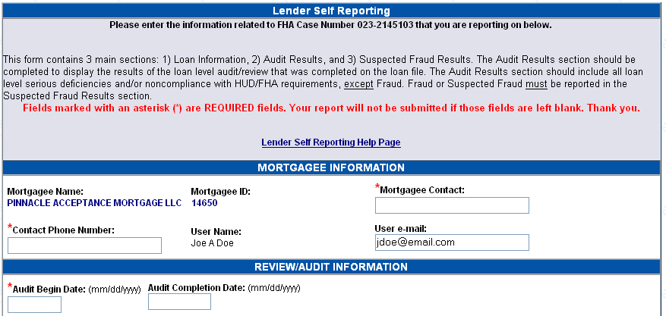
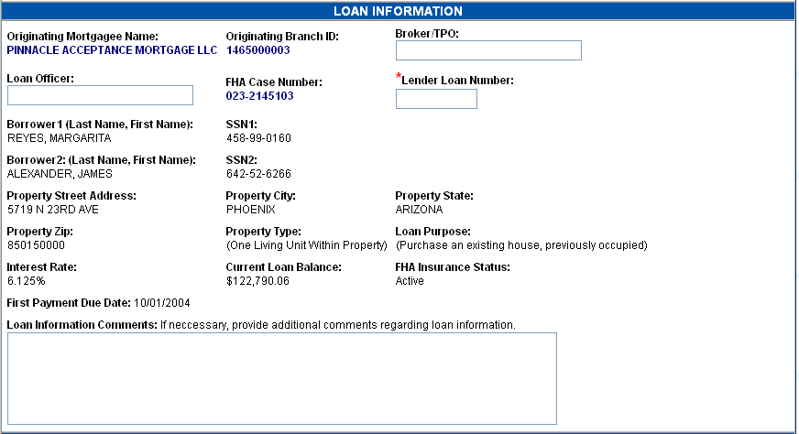
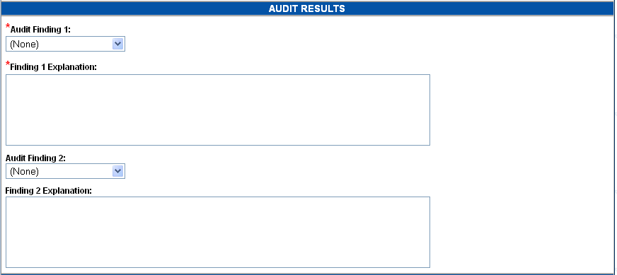
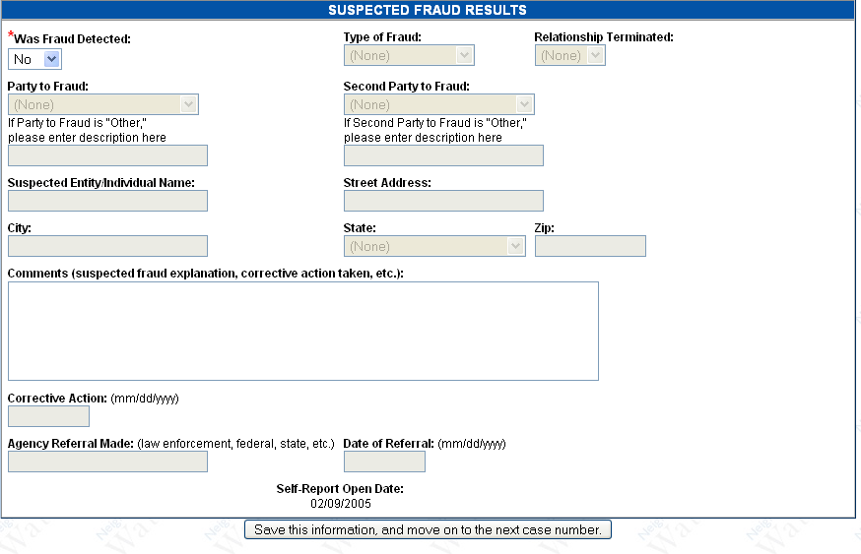

Public Reporting Burden for this collection of information is estimated to average 0.15 hour per response, including the time for reviewing instructions, searching existing data sources, gathering and maintaining the data needed, and completing and reviewing the collection of information. The information requested on this form is required by 24 CFR Part 202. The information collected assists FHA in determining which lenders should be approved to participate in the FHA single and multifamily insurance programs. It is used to help FHA minimize its risk in insuring single family and multifamily mortgages to minimize its risk. Applicants are not required to respond to this collection of information unless a currently valid approved OMB control number is displayed.

Privacy Act Statement. Names and Social Security Numbers are requested in order for the Department to obtain positive identification of the applicant’s officers, directors, stockholders and employees who have authority to obligate the applicant. The information requested will be used solely to determine the eligibility of the individuals to participate in the Department’s mortgage insurance programs. The Department is authorized to request this information by Executive Order 9397 and it will not be disclosed outside the Department without prior consent except as required or permitted by law. The Social Security Numbers are provided to HUD on a voluntary basis. Failure to provide this information could cause delay in processing of the applications.

