ATTACHMENT J – FOCUS GROUP DISCUSSION GUIDE FOR CHILD NUTRITION PROFESSIONALS
FOCUS GROUP OBJECTIVES
- OBTAIN INFORMATION ABOUT PARTICIPANTS’ INFORMATION SOURCES AND MEDIA HABITS
- ASSESS PARTICIPANTS’ OPINIONS OF SCHOOL LUNCHES
- OBTAIN FEEDBACK ABOUT CURRENT AND PROPOSED PROGRAM NAMES
- ASSESS AWARENESS OF AND ATTITUDES TOWARD USDA COMMODITIES
- ASSESS AWARENESS OF AND ATTITUDES TOWARD THE NATIONAL SCHOOL LUNCH PROGRAM
- OBTAIN REACTIONS TO MESSAGE PLATFORMS AND TAGLINES
- OBTAIN REACTIONS TO PROPOSED PROGRAM LOGOS
- OBTAIN REACTIONS TO INFORMATION VIDEO
- DETERMINE EFFECTIVE COMMUNICATION VEHICLES FOR DISSEMINATING INFORMATION ABOUT USDA COMMODITIES

NOTE: THIS IS THE FH/GMMB DISCUSSION LEADER’S GUIDE. IT WILL GUIDE THE LEADER THROUGH THE DISCUSSION, BUT WILL NOT BE READ VERBATIM TO PARTICIPANTS. PLEASE NOTE THAT THE LEADER WILL READ OUT LOUD ONLY THOSE WORDS OR SENTENCES THAT APPEAR IN regular type face.

- Introduction (10 minutes)
- Moderator Introduction

- Purpose: To share thoughts and opinions about a number of issues surrounding government nutrition assistance programs administered by the U.S. Department of Agriculture or USDA.

- Audio-record the discussion

- Group Rules
- Please speak one at a time; don’t interrupt.
- Speak up/speak loudly; please try to remain seated within view of the Web camera.
- We want to hear your opinions and experiences; we want your honest opinions. You don’t have to agree with others. There are no right or wrong answers, just different points of view.
- Your name will never be associated with what you say; it will be kept confidential.

NOTE: THE BELOW SECTIONS WILL BE SENT TO PARTICIPANTS PRIOR TO THE GROUP AND WILL BE READ OUT LOUD BY THE MODERATOR.

READ OMB BURDEN STATEMENT: According to the Paperwork Reduction Act of 1995, no persons are required to respond to a collection of information unless it displays a valid OMB control number. The valid OMB control number for this information collection is 0584-0524. The time required to complete this information collection is estimated to average 1 hour and 45 minutes per response, including the time for reviewing instructions, searching existing data sources, gathering and maintaining the data needed, and completing and reviewing the collection of information.

Send comments regarding this burden estimate or any other aspect of this collection of information, including suggestions for reducing this burden, to: U.S. Department of Agriculture, Food and Nutrition Service, Office of Research and Analysis, 3101 Park Center Drive, Room 1014, Alexandria, VA 22302 (0584-0524). Do not return the completed form to this address.

The research records that will be collected and used for this study may include an opinion survey, written notes, and an audiotape made during your participation in the focus group discussion. However, your comments and survey responses will be shared only in the aggregate with those from other participants. Aggregated information or results from this study may be presented in meetings or in internal reports to the USDA, Food and Nutrition Service (FNS). Your name and any information that can be traced back to you will not be included in any reports or meetings to the USDA.

- The discussion will end in 90 minutes.
- I need to make sure I have everyone’s consent to participate in this discussion and that you agree to and understand the terms of the consent form your received in the mail. Does everyone consent to participate in this discussion? If at any point you decide you do not want to participate, please know that you are free to leave the discussion at any point.

- Participant Introductions
- First name
- Where you live
- How long you’ve worked in the child nutrition field

- Media Habits/Health and Nutrition Information Sources (5 minutes)
- HANDOUT A (ATTACHED) – THIS QUESTIONNAIRE WILL APPEAR ON THE HOME SCREEN OF THE WEB SOFTWARE AND WILL BE FILLED OUT PRIOR TO THE START OF THE DISCUSSION.

- How do you get health, food service, and/or nutrition information for your current occupation? PROBE: Professional associations and/or journals – particularly the School Nutrition Association (SNA)? If child nutrition professionals are not members, where else do they get information? Internet – which sites? Blogs? Social networks? Magazines? Journals? TV? Radio?

- What type of information are you normally looking for? PROBE: Nutrition facts? Recipe or meal ideas? What else? What kind of information would you like to see more of?

- In your opinion, when it comes to health, food service, and nutrition information for your job as a child nutrition professional, who or what do you consider to be the most credible sources? PROBE: Professional associations? Journals? Blogs? Web sites – which ones? Government agencies? Co-workers/Colleagues? Traditional media (such as newspapers and magazines)? Doctors and other medical professionals? Nutritionists?

- Attitudes and Perceptions of School Lunches in General (10 minutes)
I want to talk briefly about your opinions/thoughts on the types of foods available in schools as a child nutrition professional.
- To start, can a few people tell me about the types of foods frequently provided to students through the school cafeteria at lunch? PROBE: How is food prepared?

- What words or adjectives would you use to describe the foods provided in cafeterias? Why?
- To what extent do you think students are provided nutritious foods in the cafeteria? Why do you think this?

- What opinions and/or attitudes exist among students, parents/guardians, or the public regarding the foods served at schools? PROBE: Are these opinions/attitudes accurate? Why do you think these opinions/attitudes exist? PROBE ANY SPECIFIC MISPERCEPTION AS APPROPRIATE.

- Based on what you see, tell me a little bit about the food choices students make while at school. PROBE: To what extent do you think students make smart, healthy choices?

- For what reasons do you think parents/guardians and/or students choose to buy their meals – breakfast or lunch – at school rather than bringing food from home? PROBE: Is it less expensive? Easier or more convenient? Healthier? Perceived as better quality? What other reasons?

- In your opinion, what should be done, if anything, to improve school lunches in your school or district? Or do you feel improvements aren’t needed? Why?

- I’m assuming everyone is at least aware of Food Service Management Companies. For those of you who work with or who are affiliated with these companies, can you tell me a little bit about how these relationships impact the types of foods provided in school cafeterias?

- Reactions to Proposed Program Names (10 to 15 minutes)
We are going to spend the rest of our time discussing the USDA Commodities Program. While most of you may be aware of this program let’s discuss the program and the possibility of renaming the program.

On your computer screen, you will see several potential program names along with the current name – USDA Commodities. Please take a moment and read each one and answer the questions on the screen. After everyone has answered the questions, we’ll discuss. SEE HANDOUT B (ATTACHED).

- Let’s start by discussing the current name – USDA Commodities. What, if anything, do you like about it? Why? What does this name convey or communicate to you? What comes to mind?

- What, if anything, do you dislike about it? Why?

- What do you think about the program changing its name? PROBE: Is this a good or bad idea? Why?

- Now let’s talk about all of the other names. Looking at your responses, it looks like most people preferred PROGRAM NAME. Let’s start with this one.

- What did you especially like about PROGRAM NAME? PROBE: Why does this appeal to you? Why did it catch your attention?

- What did you dislike, if anything, about PROGRAM NAME? Why?

- Based on this name, what expectations would you have of the program? Why do you think this is?

REPEAT QUESTIONS E, F, AND G FOR ALL NAMES.

- Are there any other names that you think would be better?

- Awareness Of and Attitudes Toward USDA Commodities (10 minutes)
- Tell me what you know about USDA Commodities -- and how you interact with the program. PROBE: What does the USDA Commodities program provide? Can you provide a few examples? Are you familiar with any other nutrition assistance programs that fall under the USDA Commodities program? If so, which ones?

IF NECESSARY, PROVIDE BRIEF, HIGH-LEVEL, DESCRIPTION OF THE PROGRAM.

- What do you perceive as benefits or strengths of USDA Commodities? How does your school benefit from its use of USDA Commodities? Why do you think this?

- And what do you perceive as weaknesses or drawbacks of USDA Commodities? Why do you think this?

- IF NOT ALREADY MENTIONED, PROBE ON OPINIONS OF THE FOODS PROVIDED: How would you describe the foods/commodities provided by USDA Commodities to schools? PROBE: Nutritious? Variety? Low salt? Low fat? Low-sugar?

- What are your general attitudes about the USDA Commodities program? Are these attitudes positive or negative? Do you think people think the program is good or bad? What do you think has created these attitudes? What about the food – what are the attitudes – both positive and negative – toward the food?

- What do you think about the link between USDA Commodities and U.S. agriculture? Is this positive or negative to connect the two?
- What type of contributions does USDA Commodities make to the National School Lunch Program? How do these two programs work together?

- What barriers exist, if any, that make it difficult for a school to use USDA Commodities? PROBE: What issues exist, if any, with your State’s Distributing Agencies? What types of things would prevent schools from using USDA Commodities? Why?

- How much does USDA Commodities help to supplement your food purchases? PROBE: A little? A lot?

- To what extent do you think the value of USDA Commodities is competitive to the foods you obtain commercially? PROBE: Which types of USDA Commodities are a good value for your meal program? Why? Cost? Convenience? Nutritious?

- What do you like about how your State Agency runs the USDA Commodity Program in your State? PROBE: What, if anything, do you dislike? If you could change how the program is run in your State, what would you do differently? What, if anything, would you keep the same? Why?

- Why do you have USDA Commodities diverted to manufacturers for processing, if at all? PROBE: What percentage of your USDA Commodities is diverted? To what extent are you satisfied with the processing choices your State Agency gives you? Why?

- How do you feel about schools having the choice to further process these foods? What impact, if any, does this have on the nutritional value of the foods? Why?

- Awareness Of and Attitudes Toward the National School Lunch Program (10 minutes)
- Before we continue, I want to get your reaction to the importance of some topics about the foods and meals provided by schools. Please rank the following topics in order of importance to you, where “1” equals the most important topic and “6” equals the least important topic when it comes to the foods provided by schools. HANDOUT C (ATTACHED). After everyone has ranked them, we’ll discuss.

- Ok, it looks like most of you ranked TOPIC as the most important. Why is this topic important?

- Other TOPICS that ranked high include: TOPIC and TOPIC. Why are these important?

- Tell me about the topics that you ranked as five or six. Why are these less important?

- Are there any topics missing from this list? What are they and why are they important?

- Next, I’d like to spend a few minutes talking about the National School Lunch Program. Can a few of you tell me about it? What’s the purpose of this program?

- In your opinion, what are the strengths of the National School Lunch Program?

- What are the weaknesses of the National School Lunch Program, if any? Why?

- Why do schools or school districts choose to participate in the National School Lunch Program? PROBE: What are the benefits?

- What barriers exist, if any, that keep schools from participating in the National School Lunch Program? PROBE: Do you know why any other districts do not participate?

- What alternatives are there to the National School Lunch Program? PROBE: What other options exist? Why would a school/school district choose another option? Why would a parent/guardian choose not to have their child participate in the program?

- What, if anything, have you heard from parents/guardians (particularly mothers) regarding the National School Lunch Program? Do they contact you about their opinions or provide you feedback? What do they say about the program? What role do they play in encouraging their child(ren) to participate?

- What barriers exist, if any, real or false, that keep students from participating in the National School Lunch Program? PROBE: Meal prices? Teachers’ influence? Peer pressure? Parents/guardians?

- What barriers keep parents/guardians from encouraging their child(ren) to participate in the National School Lunch Program?

- Reactions to Message Platforms and Taglines (15 to 20 minutes)
USDA Commodities is exploring new ways to communicate with its key audiences – including you – about the benefits of the program. Along with a potential new name, USDA Commodities is developing a number of new creative concepts, and we’d like your feedback. I’d like to start by sharing some potential taglines with you. On the screen you will see a number of potential taglines for USDA Commodities. Please rate how likely each tagline is to catch your attention. Once everyone has submitted their answers, a new question will appear and you will proceed to choose the tagline you like the most.

- HANDOUT D (ATTACHED).

- Now that everyone has had a chance to individually review each tagline, let’s talk about them. It looks like many of you prefer TAGLINE the most.

- What did people like about this TAGLINE? Why did it catch your attention? PROBE: What does it communicate to you?

- What, if anything, did people dislike about this TAGLINE? Why?
REPEAT QUESTIONS B AND C FOR EVERY TAGLINE.

- Next, I want to share some statements about USDA Commodities with you. These statements will appear on the screen. After I read each one, please rate the extent to which you like each one and the extent to which each one inspires you to promote the National School Lunch Program within your school and school district (HANDOUT E - ATTACHED).

READ EACH MESSAGE OUT LOUD.

- Before we discuss the messages/statements, please select the one that best describes the purpose of USDA Commodities.

- It looks like most people picked MESSAGE as the one that best describes the purpose of USDA Commodities. Why do you think this?

- What other messages/statements do a good job of communicating the purpose of the USDA Commodities program? Why?

- Are there any messages/statements that do a poor job? Why?

- In general, are there any key words or phrases that are especially meaningful to you or catch your attention?

- Now that you have heard some accurate statements about USDA Commodities, have your attitudes toward the taglines changed at all? Why? PROBE: Does anyone have a new preferred tagline? Why did you change your mind?

- Reactions to Logos (10 to 15 minutes)
- Next, I want to share some potential logos for USDA Commodities with you. In a moment you will see the logos on the screen. After you have seen each one, please rate how well it describes the purpose of the USDA Commodities. Once everyone has done this, I will ask you to select the logo that best describes the purpose of USDA Commodities. (HANDOUT F - ATTACHED)

- Now, let’s talk about each logo. It looks like many people chose LOGO as the one that best describes the program. Let’s talk about this one first.

- First, what is the logo communicating? PROBE: What messages is it communicating, if any?

- What do people like about this logo? PROBE: Colors? Words? Fonts/Text Size/Style? What else? Why?

- And what do people dislike about this logo? PROBE: Colors? Words? Fonts/Text Size/Style? What else? Why? Do you have suggestions for how to improve it?

REPEAT QUESTIONS C, D, AND E FOR EACH LOGO.

- Now that we’ve discussed the logos and taglines, let’s talk about the combination we like best. On the screen you will see a list of potential program taglines and potential logos. Please choose your favorite combination by selecting one tagline and one logo. Each tagline and logo can only be used once. (HANDOUT G - ATTACHED)

- It looks like everyone is finished and that the majority of people like the combination of TAGLINE and LOGO best. What did people like about this?

- Reactions to Informational Video (5 to 10 minutes)
USDA Commodities is considering using a video to provide child nutrition professionals, such as you, schools, and parents/guardians with information about the healthy benefits that USDA Commodities have and the nutritious contribution they make to the National School Lunch Program. I want to share this video with you. While we do not have time to watch the entire video, I would like your reactions to the messages and images used.

PLAY VIDEO

- What did people particularly like about this video? PROBE: What about it, if anything, was inspiring? What caught your attention? Why?

- Based on what you saw in the video, do you think it will help people understand USDA Commodities and how they contribute to the National School Lunch Program, as well as improve their opinions of these programs? Why or why not?

- What, if anything, did people dislike about this video? Why?

- Do you have any thoughts or suggestions on the best way to share and use this video? PROBE: Post on a Web site? Send DVDs to schools? Show at PTA meetings? Food service staff training? Any other ideas?

- Preferred Communication Vehicles (5 to 10 minutes)
- Thinking about everything we discussed this evening, what do you think is the most effective way of providing school officials with information about USDA Commodities? What are the most successful communication tools/resources? Why?

- What do you think is the best way to communicate with child nutrition professionals, like yourselves, about the benefits of USDA Commodities? PROBE: Newsletters? Videos? Email? Blogs? Recipes or cooking demonstrations? What else?

- In order to encourage parents/guardians to take advantage of USDA Commodities through the National School Lunch Program, what communication tools/methods do you think are the best way to reach parents/guardians (particularly mothers) Why?

- And finally, what tools or information would you need or want from USDA Commodities to help you communicate to others about the program? Why?

- Conclusion/Wrap-Up (2 minutes)
- What do you think are the most important findings from our discussion?

- Thank you for your time!

HANDOUT A – INFORMATION SOURCES

1. Which of the following information sources do you use on a regular basis to obtain news and information about health and nutrition for your professional career? Choose all that apply.

1 | Local radio news broadcasts
2 | National radio news broadcasts
3 | Local TV news broadcasts
4 | National TV news broadcasts
5 | Local newspapers
6 | National newspapers
7 | Magazines
8 | Internet search engines such as Google or Yahoo!
9 | Health and/or nutrition Web sites
10 | Government Web sites
11 | Internet news sites such as CNN.com
12 | Blogs and/or online discussion groups
13 | Professional journals
14 | Professional associations
15 | Colleagues, co-workers
16 | Friends, neighbors, family members

2. Using a five point scale, where 5 equals “extremely credible” and 1 equals “not at all credible,” please rate how credible you think each of the following information sources are in providing reliable health and/or nutrition information for your professional career.

 | Extremely Credible | Very Credible | Somewhat Credible | Not Very Credible | Not At All Credible
Local radio news broadcasts | 5 | 4 | 3 | 2 | 1
National radio news broadcasts | 5 | 4 | 3 | 2 | 1
Local TV news broadcasts | 5 | 4 | 3 | 2 | 1
National TV news broadcasts | 5 | 4 | 3 | 2 | 1
Local newspapers | 5 | 4 | 3 | 2 | 1
National newspapers | 5 | 4 | 3 | 2 | 1
Magazines | 5 | 4 | 3 | 2 | 1
Internet search engines such as Google or Yahoo! | 5 | 4 | 3 | 2 | 1
Health and/or nutrition Web sites | 5 | 4 | 3 | 2 | 1
Government Web sites | 5 | 4 | 3 | 2 | 1
Internet news sites such as CNN.com | 5 | 4 | 3 | 2 | 1
Blogs and/or online discussion groups | 5 | 4 | 3 | 2 | 1
Professional journals | 5 | 4 | 3 | 2 | 1
Professional associations | 5 | 4 | 3 | 2 | 1
Colleagues, co-workers | 5 | 4 | 3 | 2 | 1
Friends, neighbors, family members | 5 | 4 | 3 | 2 | 1

HANDOUT B – Proposed Program Names

1. On a five-point scale, please tell us how much you like each of the following names for USDA Commodities:
PROGRAM NAME | Like A Lot  “5” | Like  “4” | Neither Like Nor Dislike  “3” | Do Not Like  “2” | Do Not Like At All “1” | Not Sure
USDA Foods | 5 | 4 | 3 | 2 | 1 | 6
USDA Nutritious Choices | 5 | 4 | 3 | 2 | 1 | 6
USDA Healthy Choices | 5 | 4 | 3 | 2 | 1 | 6
USDA Wholesome Options | 5 | 4 | 3 | 2 | 1 | 6
USDA Nutritious Foods | 5 | 4 | 3 | 2 | 1 | 6
USDA Nutritious Options | 5 | 4 | 3 | 2 | 1 | 6

2. Which of the following names best describes a program that helps provide access to healthy foods? Select only one.

1 | USDA Foods
2 | USDA Nutritious Choices
3 | USDA Healthy Choices
4 | USDA Wholesome Options
5 | USDA Nutritious Foods
6 | USDA Nutritious Options

HANDOUT C – MESSAGE TOPICS
1. After reading through the list of topics below, please rank these topics in order of importance to you– where 1 equals the MOST important to you and 6 equals the LEAST important to you.

Rank | Topic
 | Food Safety and Standards
 | Nutrition Benefits
 | American Grown
 | Healthy Choices
 | Meals at a Good Value
 | Foods that Taste Good

HANDOUT D – TAGLINES

1. On a five-point scale, please tell us how much you like each of the following taglines for USDA Commodities. Please circle your response.:

TAGLINE | Like A Lot  “5” | Like  “4” | Neither Like Nor Dislike  “3” | Do Not Like  “2” | Do Not Like At All “1” | Not Sure
Healthy Choices. American Grown. | 5 | 4 | 3 | 2 | 1 | 6
Growing a Healthy America | 5 | 4 | 3 | 2 | 1 | 6
Growing America’s Future | 5 | 4 | 3 | 2 | 1 | 6
From Farms to Families | 5 | 4 | 3 | 2 | 1 | 6
Choices for a Healthy Life | 5 | 4 | 3 | 2 | 1 | 6

2. Please look at the 5 taglines that could be used for USDA Commodities. Please rank them from 1 to 5 -- where 1 represents the “highest or best” ranking and 5 represents the “lowest” ranking.
Healthy Choices. American Grown.
Growing a Healthy America
Growing America’s Future
From Farms to Families
Choices for a Healthy Life

HANDOUT E – STATEMENTS
1. On a five-point scale, please tell us how much you like each of the following messages for USDA Commodities. Please circle your response.:

STATEMENT | Like A Lot  “5” | Like  “4” | Neither Like Nor Dislike  “3” | Do Not Like  “2” | Do Not Like At All “1” | Not Sure
When more Americans are able to eat right, our nation thrives. That’s why USDA purchases high-quality, American-grown foods for a variety of [INSERT PROGRAM NAME] programs, including the National School Lunch Program. USDA provides a wide variety of nutritious foods that are lower in sugar, salt, and fat. And you can feel confident knowing these foods are safe and support the Dietary Guidelines for Americans and MyPyramid. USDA goes to great lengths to ensure America’s future is a healthy one. | 5 | 4 | 3 | 2 | 1 | 6
The world’s best foods are grown on American farms. We believe everyone should have access to these quality food choices because they are key to good health. That’s why USDA purchases a wide variety of nutritious foods that are lower in sugar, salt, and fat. And they meet USDA’s high food safety standards. Then we distribute these foods across the nation through [INSERT PROGRAM NAME] programs for adults, families, and children—including the National School Lunch Program. USDA helps connect people who grow good food and those who need it. | 5 | 4 | 3 | 2 | 1 | 6
Nutritious food choices are essential to a healthy life. That’s why USDA works with American farmers to purchase high-quality foods for the National School Lunch Program and other [INSERT PROGRAM NAME] programs. We offer a wide variety of nutritious foods that are low in salt, sugar, and fat, which support the Dietary Guidelines for Americans and MyPyramid. When we help people eat right, we help them get the most out of life. | 5 | 4 | 3 | 2 | 1 | 6

2. Using a five-point scale, where 5 equals “extremely inspiring” and 1 equals “not at all inspiring,” please rate how much each statement about USDA Commodities inspires you to not only learn more about the program, but to promote the program within your school and school district.
STATEMENT | Extremely Inspiring | Very Inspiring | Somewhat Inspiring | Not Very Inspiring | Not At All Inspiring | Not sure
When more Americans are able to eat right, our nation thrives. That’s why USDA purchases high-quality, American-grown foods for a variety of [INSERT PROGRAM NAME] programs, including the National School Lunch Program. USDA provides a wide variety of nutritious foods that are lower in sugar, salt, and fat. And you can feel confident knowing these foods are safe and support the Dietary Guidelines for Americans and MyPyramid. USDA goes to great lengths to ensure America’s future is a healthy one. | 5 | 4 | 3 | 2 | 1 | 6
The world’s best foods are grown on American farms. We believe everyone should have access to these quality food choices, because they are key to good health. That’s why USDA purchases a wide variety of nutritious foods that are lower in sugar, salt, and fat. And they meet USDA’s high food safety standards. Then we distribute these foods across the nation through [INSERT PROGRAM NAME] programs for adults, families, and children—including the National School Lunch Program. USDA helps connect people who grow good food and those who need it. | 5 | 4 | 3 | 2 | 1 | 6
Nutritious food choices are essential to a healthy life. That’s why USDA works with American farmers to purchase high-quality foods for the National School Lunch Program and other [INSERT PROGRAM NAME] programs. We offer a wide variety of nutritious foods that are low in salt, sugar, and fat, which support the Dietary Guidelines for Americans and MyPyramid. When we help people eat right, we help them get the most out of life. | 5 | 4 | 3 | 2 | 1 | 6

3. Which statement do you think does the best job of communicating the purpose of the USDA Commodities? Select only one.
1 | When more Americans are able to eat right, our nation thrives. That’s why USDA purchases high-quality, American-grown foods for a variety of [INSERT PROGRAM NAME] programs, including the National School Lunch Program. USDA provides a wide variety of nutritious foods that are lower in sugar, salt, and fat. And you can feel confident knowing these foods are safe and support the Dietary Guidelines for Americans and MyPyramid. USDA goes to great lengths to ensure America’s future is a healthy one.
2 | The world’s best foods are grown on American farms. We believe everyone should have access to these quality food choices, because they are key to good health. That’s why USDA purchases a wide variety of nutritious foods that are lower in sugar, salt, and fat. And they meet USDA’s high food safety standards. Then we distribute these foods across the nation through [INSERT PROGRAM NAME] programs for adults, families, and children—including the National School Lunch Program. USDA helps connect people who grow good food and those who need it.
3 | Nutritious food choices are essential to a healthy life. That’s why USDA works with American farmers to purchase high-quality foods for the National School Lunch Program and other [INSERT PROGRAM NAME] programs. We offer a wide variety of nutritious foods that are low in salt, sugar, and fat, which support the Dietary Guidelines for Americans and MyPyramid. When we help people eat right, we help them get the most out of life.

HANDOUT F – LOGOS
1. On a five-point scale, please tell us how much you like each of the following logos for USDA Commodities.
LOGO | Like a lot  “5” | Like  “4” | Neither like nor dislike  “3” | Do Not Like  “2” | Do not like at all “1” | Not sure
Logo 1  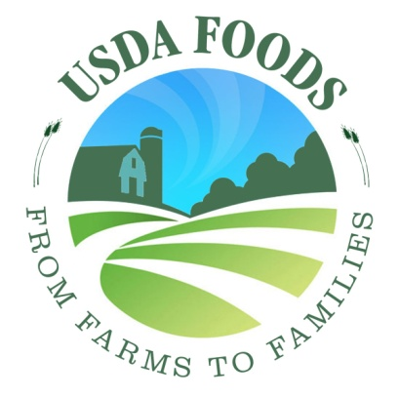 | 5 | 4 | 3 | 2 | 1 | 6
Logo 2  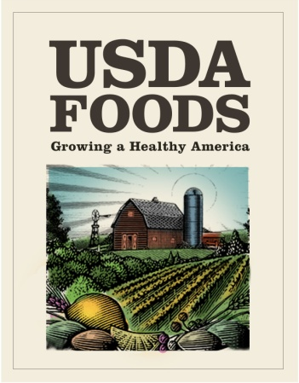 | 5 | 4 | 3 | 2 | 1 | 6
Logo 3  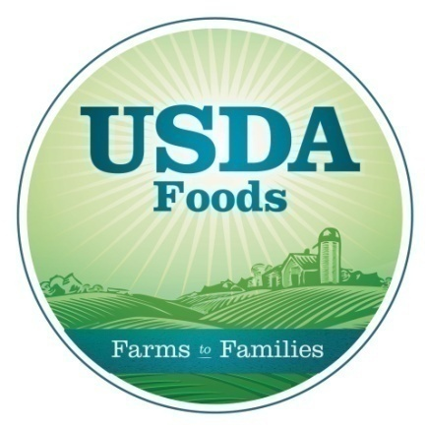 | 5 | 4 | 3 | 2 | 1 | 6
Logo 4  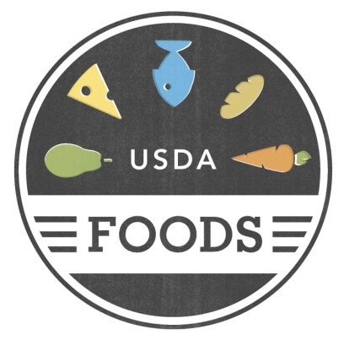 | 5 | 4 | 3 | 2 | 1 | 6
Logo 5  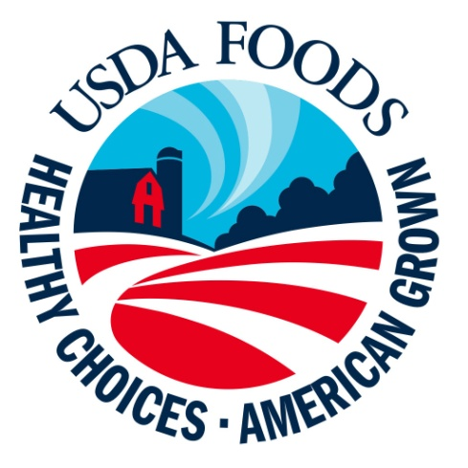 | 5 | 4 | 3 | 2 | 1 | 6

2. Please look at the five logos that could be used for USDA Commodities. Please select the logo that you think will do the best job of communicating the purpose of the program in the future.
Logo 1

Logo 2
Logo 3

Logo 4

Logo 5

HANDOUT G – Tagline & Logo Combination

- Select the tagline and logo combination that you like best by clicking on one tagline in the left-hand column and select the one logo that you think goes with it best in the right-hand column.
Column A | Column B
Healthy Choices. American Grown. | Logo 1
Growing a Healthy America | Logo 2
Growing America’s Future | Logo 3
From Farms to Families | Logo 4
Choices for a Healthy Life | Logo 5

