ATTACHMENT L – FOCUS GROUP DISCUSSION GUIDE FOR ADMINISTRATORS
FOCUS GROUP OBJECTIVES
- OBTAIN INFORMATION ABOUT PARTICIPANTS’ INFORMATION SOURCES AND MEDIA HABITS
- ASSESS PARTICIPANTS’ OPINIONS OF SCHOOL LUNCHES
- OBTAIN FEEDBACK ABOUT CURRENT AND PROPOSED PROGRAM NAMES
- ASSESS AWARENESS OF AND ATTITUDES TOWARD USDA COMMODITIES
- ASSESS AWARENESS OF AND ATTITUDES TOWARD THE NATIONAL SCHOOL LUNCH PROGRAM
- OBTAIN REACTIONS TO MESSAGE PLATFORMS AND TAGLINES
- OBTAIN REACTIONS TO PROPOSED PROGRAM LOGOS
- OBTAIN REACTIONS TO INFORMATION VIDEO CLIP
- DETERMINE EFFECTIVE COMMUNICATION TOOLS FOR DISSEMINATING INFORMATION ABOUT USDA COMMODITIES

NOTE: THIS IS THE FH/GMMB DISCUSSION LEADER’S GUIDE. IT WILL GUIDE THE LEADER THROUGH THE DISCUSSION, BUT WILL NOT BE READ VERBATIM TO PARTICIPANTS. PLEASE NOTE THAT THE LEADER WILL READ OUT LOUD ONLY THOSE WORDS OR SENTENCES THAT APPEAR IN regular type face.

- Introduction (10 minutes)
- Moderator Introduction

- Purpose: To share thoughts and opinions about a number of issues surrounding government nutrition assistance programs administered by the U.S. Department of Agriculture or USDA.

- Audio-record the discussion

- Group Rules
- Please speak one at a time; don’t interrupt. You don’t have to raise your hand.
- Speak up/speak loudly.
- We want to hear your opinions and experiences; we want your honest opinions. You don’t have to agree with others. There are no right or wrong answers, just different points of view.
- Turn off cell phones.
- Your name will never be associated with what you say; it will be kept confidential.

READ OMB BURDEN STATEMENT: According to the Paperwork Reduction Act of 1995, no persons are required to respond to a collection of information unless it displays a valid OMB control number. The valid OMB control number for this information collection is 0584-0524. The time required to complete this information collection is estimated to average 2 hours and 20 minutes per response, including the time for reviewing instructions, searching existing data sources, gathering and maintaining the data needed, and completing and reviewing the collection of information.
Send comments regarding this burden estimate or any other aspect of this collection of information, including suggestions for reducing this burden, to: U.S. Department of Agriculture, Food and Nutrition Service, Office of Research and Analysis, 3101 Park Center Drive, Room 1014, Alexandria, VA 22302 (0584-0524). Do not return the completed form to this address.

The research records that will be collected and used for this study may include an opinion survey, written notes, and an audiotape made during your participation in the focus group discussion. However, your comments and survey responses will be shared only in the aggregate with those from other participants. Aggregated information or results from this study may be presented in meetings or in internal reports to the USDA, Food and Nutrition Service (FNS). Your name and any information that can be traced back to you will not be included in any reports or meetings to the USDA.

- The discussion will end in 2 hours.
- I need to make sure I have everyone’s consent to participate in this discussion and that you agree to, and understand, the terms of the consent form you reviewed and signed in the lobby. Does everyone consent to participate in this discussion? If at any point you decide you do not want to participate, please know that you are free to leave the discussion at any point.

- Participant Introductions
- First Name
- Occupation/Job Title
- Number of years in the education field

- Media Habits/Health and Nutrition Information Sources (5 minutes)
- HANDOUT A (ATTACHED) – PARTICIPANTS WILL FILL OUT IN THE LOBBY PRIOR TO THE START OF THE GROUP. USE HANDOUT A TO GUIDE DISCUSSION.

- What information sources do you frequently watch, listen to, or read to get health and nutrition information, particularly as it relates to schools and children? PROBE: Professional associations or journals? Internet – which sites? Blogs? Social networks? Magazines? Journals? Radio?

- What type of health and nutrition information are you normally looking for? PROBE: Nutrition guidelines and/or facts? Best practices? What else?

- In your mind, when it comes to health and nutrition information, who or what do you consider to be the most credible sources? PROBE: Professional associations or journals? Blogs? Web sites – which ones? Government agencies? Colleagues? TV? Radio? Magazines or newspapers?

- Attitudes and Opinions of School Lunches in General (10 minutes)
I’d like to get your opinions, as a school administrator, on the types of foods available in schools.
- To start, can a few people tell me about the types of foods available to students and staff through the school cafeteria at lunch? PROBE: Are there full meals? If so, what makes up an actual meal? A la carte items? How is the food prepared?

- What words or adjectives would you use to describe the foods available in cafeterias? Why?

- To what extent do you think healthy and nutritious foods (e.g., salads, fruits, etc.) are available to students in the cafeteria? Why do you think this?

- To what extent do any opinions and/or attitudes exist about the foods served at schools? PROBE: What are these opinions/attitudes? Are they accurate? Are they positive or negative? Why do you think these opinions and/or attitudes exist? Are these opinions and/or attitudes specific to any particular group – students? Parents? PROBE ANY SPECIFIC MISPERCEPTION AS APPROPRIATE.

- Based on what you see, tell me a little bit about the food choices students make while at school. PROBE: To what extent do you think students make healthy choices? What role, if any, do schools play in influencing students’ food choices? What role do you think they should play? Why?

- As an Administrator, do you support the meal program in your school? If so, how? If not, why? PROBE: What type of activities do you plan to promote/encourage children to participate in the National School Lunch Program? Do you recognize food service workers? Are food service staff included in activities?

- For what reasons do you think parents choose to buy their child’s/children’s meals – breakfast or lunch – at school, rather than sending food from home? PROBE: Is it less expensive? Easier or more convenient? Healthier? Perceived as better quality? What other reasons?

- Why do you think students choose to buy their meals – breakfast or lunch – at school rather than bringing food from home? PROBE: Is it less expensive? Easier or more convenient? Healthier? Perceived as better quality? What other reasons?

- To what extent are you satisfied with the nutritional quality of the meals provided to students in your school? PROBE: What, if anything, can be done to improve school meals?

- Reactions to Proposed Program Names (10 to 15 minutes)
We are going to be spending the rest of our time discussing the USDA Commodities Program. This program is considering changing its name. Before I tell you more about the program, I want to first get your reaction to some potential new names.

On the following handout, you will see several potential program names, along with the current name – USDA Commodities. Please take a moment and read each one and answer the related questions. After everyone has answered the questions, we’ll discuss. HANDOUT B (ATTACHED).

- Let’s start by discussing the current name – USDA Commodities. What, if anything, do you like about this name? What does this name mean or communicate to you? What comes to mind? Why?

- Based on this name, what expectations would you have of the program? Why?

- What, if anything, do you dislike about this name? Why?

- What do you think about the USDA Commodities Program changing its name? PROBE: Is this a good or bad idea? Why?

- Now, let’s talk about all the other names. Looking at your responses, it looks like most people preferred PROGRAM NAME. Let’s start with this one.

- What did you especially like about PROGRAM NAME? PROBE: Why does this appeal to you? Why did it catch your attention?

- What did you dislike, if anything, about PROGRAM NAME? Why?

- Based on this name, what type of services would you expect this program to provide? Why do you think this?

REPEAT QUESTIONS F, G, AND H FOR ALL NAMES.

- Are there any other names that you think would be better?

- Awareness Of and Attitudes Toward USDA Commodities (10 minutes)
- Thinking again about the meals provided by your school, what role, if any, does the government play in providing foods to schools? PROBE: What types of foods do they provide? Is there a benefit to receiving government food? How did you know this?

- Before today, has anyone heard of the USDA Commodities Program? Please raise your hands. MODERATOR WILL TAKE A HAND COUNT AND RECORD IN WRITING.

- IF AWARE, ASK: What do you know about USDA Commodities and how it interacts with your school. PROBE: What types of services does this program provide? Are you familiar with any other nutrition assistance programs that fall under the USDA Commodities Program? If so, which ones?

- Since most of you are not aware of the USDA Commodities Program, I want to provide you with a little background about it and its role in providing nutritious foods to schools and families.
IF NECESSARY, PROVIDE BRIEF, HIGH-LEVEL, DESCRIPTION OF THE PROGRAM

- Based on the description I just read, what are your reactions now, to the USDA Commodities program potentially changing its name? Why?

- What do you think are benefits or strengths of this USDA Commodities? How does/would your school benefit from USDA Commodities? Why do you think this?

- And what do you think are weaknesses or drawbacks of USDA Commodities? Why do you think this?

- What are the general attitudes about the USDA Commodities Program – either based on your own personal knowledge or based on the description I just read? Are the attitudes positive or negative? What has created these attitudes? What about the food – what are the attitudes – both positive and negative – toward the food?

- What do you think about the connection between USDA Commodities and U.S. agriculture? Is this positive or negative to connect the two?

- Based on the description I shared with you and your own personal knowledge, what type of contributions do you think USDA Commodities make to the National School Lunch Program? How do you think these two programs work together? PROBE: Impact on cost? Impact on types of food?

- FOR THOSE AWARE OF THE PROGRAM: What role do you play, if any, in administering the National School Lunch Program or NSLP in your school?

- Once your school receives foods from USDA Commodities what does it do with them? How does your school prepare these foods? Is it different than how you initially received it? PROBE: How do you feel about schools having the ability to prepare/further process these foods? What impact, if any, does this have on the healthfulness of the food? Why?

- What do you think would be the best way to communicate with school administrators, like yourselves, about the benefits of USDA Commodities? PROBE: Newsletters? Videos? Blogs? Recipes or cooking demonstrations? What else?

- Awareness Of and Attitudes Toward the National School Lunch Program (10 minutes)
- Before we move on, I want to get your reaction to the importance of some topics about the food and meals provided by schools. Please rank the following topics in order of importance to you, where “1” equals the most important topic and “6” equals the least important topic, when it comes to the food provided by schools. HANDOUT C (ATTACHED). After everyone has ranked them, we’ll discuss.

- Ok, it looks like most of you ranked TOPIC as the most important. Why is this topic important?

- Other TOPICS that ranked high include: TOPIC and TOPIC. Why are these important?

- Tell me about the topics that you ranked as five or six. Why are these less important?

- Are there any topics missing from this list? What are they and why are they important?

- Let’s spend a few minutes talking about the National School Lunch Program. Can a few of you tell me about it? What’s the purpose of this program?

IF NECESSARY, PROVIDE BRIEF, HIGH-LEVEL, DESCRIPTION OF THE PROGRAM.

- To what extent were you aware of the National School Lunch Program before today?

- In your opinion, what are the strengths of the National School Lunch Program? PROBE: What are the benefits of participating in the National School Lunch Program?

- And what are the weaknesses of the National School Lunch Program, if any? Why?

- Why do you think schools or school districts choose to participate in the National School Lunch Program? PROBE: What are the benefits?

- What barriers exist, if any, that keep parents/guardians from encouraging their child(ren) to participate in the National School Lunch Program? PROBE: Other food options? Knowledge? Cost?

- What barriers exist, if any, that keep students from participating in the National School Lunch Program? PROBE: Other food options? Knowledge?

- What barriers exist, if any, that keep schools from participating in the National School Lunch Program? PROBE: For what reasons do you think other schools/school districts choose not to participate in the National School Lunch Program?

- Thinking about the items available in the school cafeteria, tell me about the types of food and/meals you see students purchasing. PROBE: Purchasing whole meals or a la carte items? Why do you think students do this?

- Based on your knowledge, how do students participate in the school lunch program? PROBE: Do they typically purchase an entire meal or a la carte items? Why?

- What type of controls, if any, do parents have over the types of food their child(ren) purchase? PROBE: Meal card controls? Have you heard anything about the program from mothers or other parents/guardians? If so, what have you heard?

- Reactions to Message Platforms and Taglines (15 to 20 minutes)
USDA Commodities is exploring new ways to communicate with its stakeholders – which includes you – about the benefits of the National School Lunch Program. Along with a potential new name, USDA Commodities is developing a number of new creative concepts and we’d like your feedback. I’d like to start by sharing some potential taglines with you. A tagline is a short phrase that describes the tone and purpose of a brand or program. The tagline will be used with the program name and logo. For example, Nike’s tagline is, “Just Do It.” McDonald’s is, “I’m Loving It”.

On this handout, you will see a number of potential taglines for USDA Commodities. Please rate how likely each tagline is to catch your attention and then choose the tagline you like best.

- HANDOUT D (ATTACHED)

- Now that everyone has had a chance to individually review each tagline, let’s talk about them. It looks like the majority of you prefer TAGLINE.

- What did people particularly like about this TAGLINE? Why did it catch your attention? PROBE: What does it communicate or mean to you?

- What, if anything, did people dislike about this TAGLINE? Why?

REPEAT QUESTIONS C AND D FOR EVERY TAGLINE.

- Next, I want to share some statements/messages about USDA Commodities. HANDOUT E (ATTACHED). After you read each one, please rate the extent to which each one inspires you to further promote the program within your school and school district, and then rank them according to how well they describe the purpose of USDA Commodities. As you read each statement, please underline or circle any words or phrases that are especially meaningful to you.

- It looks like most people picked MESSAGE as the one that best describes the purpose of USDA Commodities. Why do you think this is?

- And which one(s) is the most inspiring? Why?

- What other statements/messages do a good job of communicating the purpose of the program? Why?

- Any that do a poor job? Why?

- In general, are there any key words or phrases that are meaningful to you or that really catch your attention?

- Now that you have heard some accurate statements about USDA Commodities, have your attitudes/opinions toward the taglines changed at all? Why? PROBE: Does anyone have a new preferred tagline? Why did you change your mind?

- Reactions to Logos (10 to 15 minutes)
- Next, I want to share some potential logos for USDA Commodities. After you have looked at each logo, please rate how well it represents the purpose of the USDA Commodities and choose the logo that does the best job of communicating the purpose of USDA Commodities. HANDOUT F (ATTACHED).

- Let’s talk about each logo. It looks like many people chose LOGO as the one that best describes the program. Let’s talk about this one first.

- What is this logo communicating? PROBE: What messages are being communicated, if any

- What do people particularly like about this logo? PROBE: Colors? Fonts/Text Size/Style? Images? What else? Why?

- What do people dislike about this logo? PROBE: Colors? Fonts/Text Size/Style? Images? What else? Why? Do you have suggestions for how to improve it?

REPEAT QUESTIONS C, D, AND E FOR EACH LOGO.

- Now that we’ve discussed the logos and taglines, let’s talk about the combination we like best. Please select your favorite logo/tagline combination by drawing a line from one tagline to one logo. Only choose a tagline and logo once. HANDOUT G (ATTACHED).

- It looks like everyone is finished and that the majority of you like the combination of TAGLINE and LOGO. What did people like about this?

- Reactions to Informational Video (5 to 10 minutes)
USDA Commodities is considering using a video to provide schools and parents/guardians with information about the healthy benefits that USDA Commodities have and the nutritious contribution they make to the National School Lunch Program. I want to share a few minutes of this video with you. While we do not have time to watch the entire video, I would like your reactions to the messages and images used in this video.

PLAY VIDEO.

- What did people particularly like about this video? What caught your attention? Why?

- Based on what you saw, do you think this video will help people understand USDA Commodities and how they contribute to the National School Lunch Program as well as improve their opinions of these programs? Why or why not?

- What, if anything, did people particularly dislike about this video? Why?

- Any thoughts or suggestions on the best way to share and use this video? PROBE: Post on a Web site? Send DVDs to schools? Show at PTA meetings? Staff training? Any other ideas?

- Preferred Communications Vehicles (5 to 10 minutes)
- Thinking about everything we discussed this evening, what do you think is the most effective way of providing schools with information about USDA Commodities? What are the most successful channels? Why?

- In order to encourage parents and guardians to take advantage of the school lunch program, what do you think the best way to reach parents/guardians? Why?

- What do you think is the best way to reach school administrators like you, with information about the USDA Commodities Program? What form of communication are you most likely to respond to? Why? PROBE: To what extent are you willing to become an advocate of the National School Lunch Program? By advocate, I mean willing to share information about the program with others, and encourage parents/guardians and students, to participate. Why or why not?

- And finally, what tools or information would you need or want from USDA Commodities to help you communicate to others about the program? Why?

- Conclusion/Wrap-Up (2 minutes)
- What do you think are the most important findings from our discussion?

- Thank you for your time!

HANDOUT A – INFORMATION SOURCES

1. Which of the following information sources do you use on a regular basis to obtain news and information about health and nutrition? Choose all that apply.

1 | Local radio news broadcasts
2 | National radio news broadcasts
3 | Local TV news broadcasts
4 | National TV news broadcasts
5 | Local newspapers
6 | National newspapers
7 | Magazines
8 | Internet search engines such as Google or Yahoo!
9 | Health and/or nutrition Web sites
10 | Government Web sites
11 | Internet news sites such as CNN.com
12 | Blogs and/or online discussion groups
13 | Professional journals
14 | Professional associations
15 | Colleagues, co-workers
16 | Friends, neighbors, family members

2. Using a five point scale, where 5 equals “extremely credible” and 1 equals “not at all credible,” please rate how credible you think each of the following information sources are in providing reliable health and/or nutrition information.

 | Extremely Credible | Very Credible | Somewhat Credible | Not Very Credible | Not At All Credible
Local radio news broadcasts | 5 | 4 | 3 | 2 | 1
National radio news broadcasts | 5 | 4 | 3 | 2 | 1
Local TV news broadcasts | 5 | 4 | 3 | 2 | 1
National TV news broadcasts | 5 | 4 | 3 | 2 | 1
Local newspapers | 5 | 4 | 3 | 2 | 1
National newspapers | 5 | 4 | 3 | 2 | 1
Magazines | 5 | 4 | 3 | 2 | 1
Internet search engines such as Google or Yahoo! | 5 | 4 | 3 | 2 | 1
Health and/or nutrition Web sites | 5 | 4 | 3 | 2 | 1
Government Web sites | 5 | 4 | 3 | 2 | 1
Internet news sites such as CNN.com | 5 | 4 | 3 | 2 | 1
Blogs and/or online discussion groups | 5 | 4 | 3 | 2 | 1
Professional journals | 5 | 4 | 3 | 2 | 1
Professional associations | 5 | 4 | 3 | 2 | 1
Colleagues, co-workers | 5 | 4 | 3 | 2 | 1
Friends, neighbors, family members | 5 | 4 | 3 | 2 | 1

HANDOUT B – Proposed Program Names

1. On a five-point scale, please tell us how much you like each of the following names for USDA Commodities:
PROGRAM NAME | Like A Lot  “5” | Like  “4” | Neither Like Nor Dislike  “3” | Do Not Like  “2” | Do Not Like At All “1” | Not Sure
USDA Foods | 5 | 4 | 3 | 2 | 1 | 6
USDA Nutritious Choices | 5 | 4 | 3 | 2 | 1 | 6
USDA Healthy Choices | 5 | 4 | 3 | 2 | 1 | 6
USDA Wholesome Options | 5 | 4 | 3 | 2 | 1 | 6
USDA Nutritious Foods | 5 | 4 | 3 | 2 | 1 | 6
USDA Nutritious Options | 5 | 4 | 3 | 2 | 1 | 6

2. Which of the following names best reflects a program that helps provides access to healthy foods? Select only one.

1 | USDA Foods
2 | USDA Nutritious Choices
3 | USDA Healthy Choices
4 | USDA Wholesome Options
5 | USDA Nutritious Foods
6 | USDA Nutritious Options

HANDOUT C – MESSAGE TOPICS

1. After reading through the list of topics below, please rank these topics in order of importance to you– where 1 equals the MOST important to you and 6 equals the LEAST important to you.

Rank | Topic
 | Food Safety and Standards
 | Nutrition Benefits
 | American Grown
 | Healthy Choices
 | Meals at a Good Value
 | Foods that Taste Good

HANDOUT D – TAGLINES

1. On a five-point scale, please tell us how much you like each of the following taglines for USDA Commodities. Please circle your response:

TAGLINE | Like A Lot  “5” | Like  “4” | Neither Like Nor Dislike  “3” | Do Not Like  “2” | Do Not Like At All “1” | Not Sure
Healthy Choices. American Grown. | 5 | 4 | 3 | 2 | 1 | 6
Growing a Healthy America | 5 | 4 | 3 | 2 | 1 | 6
Growing America’s Future | 5 | 4 | 3 | 2 | 1 | 6
From Farms to Families | 5 | 4 | 3 | 2 | 1 | 6
Choices for a Healthy Life | 5 | 4 | 3 | 2 | 1 | 6

2. Please look at the five taglines that could be used for USDA Commodities. Please rank them from 1 to 5 -- where 1 represents the “highest or best” and 5 represents the “lowest”.
Healthy Choices. American Grown.
Growing a Healthy America
Growing America’s Future
From Farms to Families
Choices For A Healthy Life

HANDOUT E – STATEMENTS
1. On a five-point scale, please tell us how much you like each of the following messages for USDA Commodities. Please circle your response:

STATEMENT | Like A Lot  “5” | Like  “4” | Neither Like Nor  Dislike  “3” | Do Not Like  “2” | Do Not Like At All “1” | Not Sure
When more Americans are able to eat right, our nation thrives. That’s why USDA purchases high-quality, American-grown foods for a variety of [INSERT PROGRAM NAME] programs, including the National School Lunch Program. USDA provides a wide variety of nutritious foods that are lower in sugar, salt, and fat. And you can feel confident knowing these foods are safe and support the Dietary Guidelines for Americans and MyPyramid. USDA goes to great lengths to ensure America’s future is a healthy one. | 5 | 4 | 3 | 2 | 1 | 6
The world’s best foods are grown on American farms. We believe everyone should have access to these quality food choices, because they are key to good health. That’s why USDA purchases a wide variety of nutritious foods that are lower in sugar, salt, and fat. And they meet USDA’s high food safety standards. Then we distribute these foods across the nation through [INSERT PROGRAM NAME] programs for adults, families, and children—including the National School Lunch Program. USDA helps connect people who grow good food and those who need it. | 5 | 4 | 3 | 2 | 1 | 6
Nutritious food choices are essential to a healthy life. That’s why USDA works with American farmers to purchase high-quality foods for the National School Lunch Program and other [INSERT PROGRAM NAME] programs. We offer a wide variety of nutritious foods that are low in salt, sugar, and fat which support the Dietary Guidelines for Americans and MyPyramid. When we help people eat right, we help them get the most out of life. | 5 | 4 | 3 | 2 | 1 | 6

2. Using a five-point scale, where 5 equals “extremely inspiring” and 1 equals “not at all inspiring,” please rate how much each statement about USDA Commodities motivates you to not only learn more about the program, but to promote the program within your school and school district.
STATEMENT | Extremely Inspiring | Very Inspiring | Somewhat Inspiring | Not Very Inspiring | Not At All Inspiring | Not Sure
When more Americans are able to eat right, our nation thrives. That’s why USDA purchases high-quality, American-grown foods for a variety of [INSERT PROGRAM NAME] programs, including the National School Lunch Program. USDA provides a wide variety of nutritious foods that are lower in sugar, salt, and fat. And you can feel confident knowing these foods are safe and support the Dietary Guidelines for Americans and MyPyramid. USDA goes to great lengths to ensure America’s future is a healthy one. | 5 | 4 | 3 | 2 | 1 | 6
The world’s best foods are grown on American farms. We believe everyone should have access to these quality food choices, because they are key to good health. That’s why USDA purchases a wide variety of nutritious foods that are lower in sugar, salt, and fat. And they meet USDA’s high food safety standards. Then we distribute these foods across the nation through [INSERT PROGRAM NAME] programs for adults, families, and children—including the National School Lunch Program. USDA helps connect people who grow good food and those who need it. | 5 | 4 | 3 | 2 | 1 | 6
Nutritious food choices are essential to a healthy life. That’s why USDA works with American farmers to purchase high-quality foods for the National School Lunch Program and other [INSERT PROGRAM NAME] programs. We offer a wide variety of nutritious foods that are low in salt, sugar, and fat which support the Dietary Guidelines for Americans and MyPyramid. When we help people eat right, we help them get the most out of life. | 5 | 4 | 3 | 2 | 1 | 6

3. Which statement do you think does the best job of communicating the purpose of the USDA Commodities? Select only one.
1 | When more Americans are able to eat right, our nation thrives. That’s why USDA purchases high-quality, American-grown foods for a variety of [INSERT PROGRAM NAME] programs, including the National School Lunch Program. USDA provides a wide variety of nutritious foods that are lower in sugar, salt, and fat. And you can feel confident knowing these foods are safe and support the Dietary Guidelines for Americans and MyPyramid. USDA goes to great lengths to ensure America’s future is a healthy one.
2 | The world’s best foods are grown on American farms. We believe everyone should have access to these quality food choices because they are key to good health. That’s why USDA purchases a wide variety of nutritious foods that are lower in sugar, salt, and fat. And they meet USDA’s high food safety standards. Then we distribute these foods across the nation through [INSERT PROGRAM NAME] programs for adults, families, and children—including the National School Lunch Program. USDA helps connect people who grow good food and those who need it.
3 | Nutritious food choices are essential to a healthy life. That’s why USDA works with American farmers to purchase high-quality foods for the National School Lunch Program and other [INSERT PROGRAM NAME] programs. We offer a wide variety of nutritious foods that are low in salt, sugar, and fat which support the Dietary Guidelines for Americans and MyPyramid. When we help people eat right, we help them get the most out of life.

HANDOUT F – LOGOS

1. On a five-point scale, please tell us how much you like each of the following logos for USDA Commodities.
LOGO | Like A Lot  “5” | Like  “4” | Neither Like Nor Dislike  “3” | Do Not Like  “2” | Do Not Like At All “1” | Not Sure
Logo 1  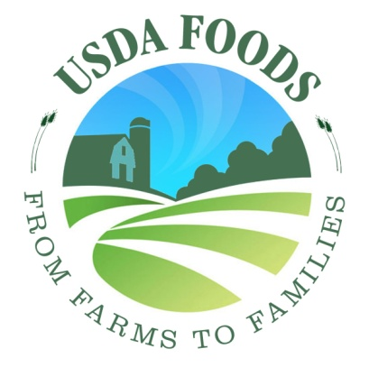 | 5 | 4 | 3 | 2 | 1 | 6
Logo 2  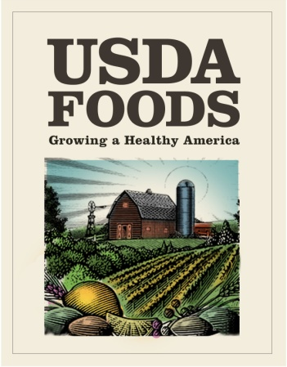 | 5 | 4 | 3 | 2 | 1 | 6
Logo 3  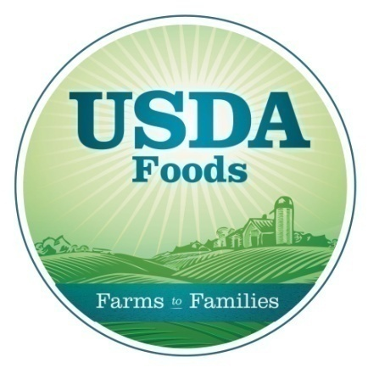 | 5 | 4 | 3 | 2 | 1 | 6
Logo 4  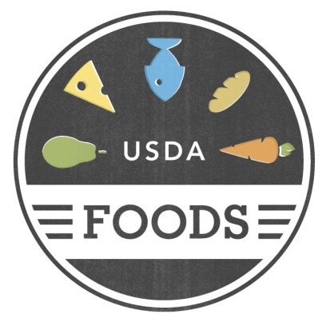 | 5 | 4 | 3 | 2 | 1 | 6
Logo 5  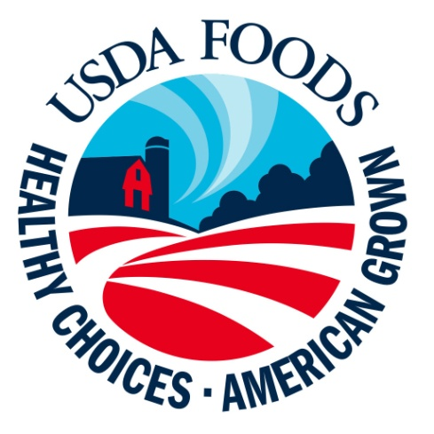 | 5 | 4 | 3 | 2 | 1 | 6

2. Please look at the five logos that could be used for USDA Commodities. Please select the logo that you think will do the best job of communicating the purpose of the program.
Logo 1

Logo 2
Logo 3

Logo 4

Logo 5

HANDOUT G – Tagline and Logo Combination

- Select the tagline and logo combination that you like best by drawing a line from one tagline in the left-hand column to one logo that you think goes with it best in the right-hand column. Please only use each tagline and each logo once.
Column A | Column B
Healthy Choices. American Grown. | Logo 1
Growing a Healthy America | Logo 2
Growing America’s Future | Logo 3
From Farms to Families | Logo 4
Choices for a Healthy Life | Logo 5

