ATTACHMENT Ja – SCREEN SHOTS AND URL FOR FOCUS GROUP DISCUSSION WITH CHILD NUTRITION PROFESSIONALS

As described in Attachment A (Study Design), child nutrition professionals will be invited to participate in a Web-based focus group to discuss the USDA Commodities Program. This technology allows participants to see and speak to one other and also view visual images.
Participants will click on the following link to access the focus group room and will log-in as guests:
http://qualmeeting.acrobat.com/fleishman/
Sample screen shots of the focus group room and how participants will interact with each other and the visual images are included on the following pages.
Please note that all questions outlined in Attachment J (Focus Group Discussion Guide for Child Nutrition Professionals) will be asked during the Web-based focus groups and handouts will appear as polls on the screens. The OMB Control Number and expiration date will always be visible to participants.

Screen Shot 1: Lobby Area
When participants first enter the focus group room, they will be in the Lobby Area until everyone has logged in and the moderator is ready to start the group. During this time, participants will answer the poll questions (Handout A of Discussion Guide).
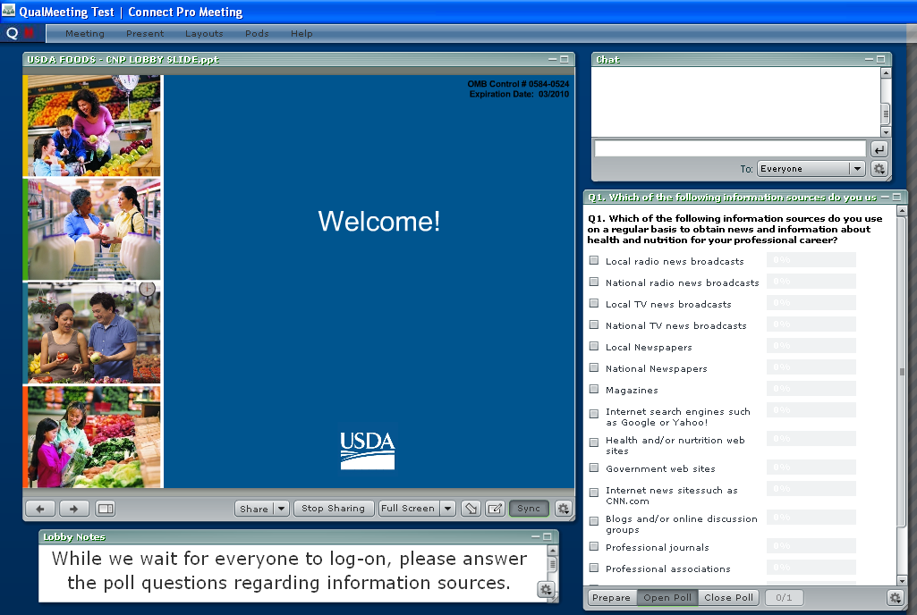

Screen Shot 2: OMB Burden Statement and Confidentiality
Before starting the discussion, the moderator will read the OMB Burden Statement and make sure everyone consents to participate in the discussion.
At this point, participants will be able to see one another via web cameras.
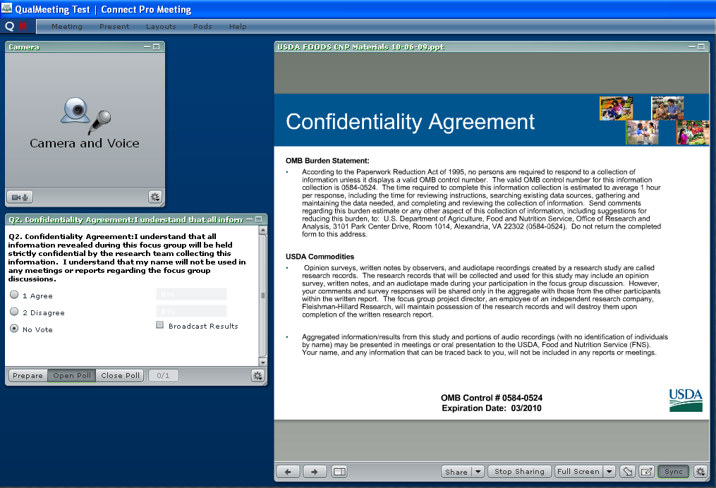

Screen Shot 3: Web Cameras
When not viewing creative elements, participants will be able to see each other in this room. The OMB Control Number and expiration date will also be visible.
(NOTE: When participants are logged into the room, there will be multiple camera/voice pods on this screen)
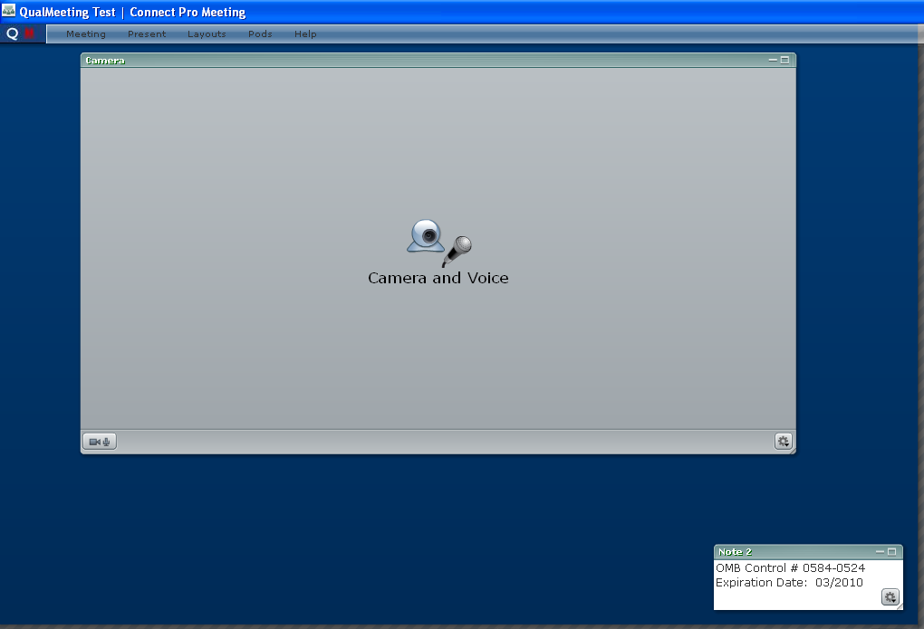

Screen Shot 4: Creative Concepts and Polls
When participants are providing feedback to any creative concepts (e.g., names, taglines, messages or logos), these concepts will appear on the screen. Participants will complete a number of polls (identical to Handouts B, C, D, E and F in the discussion guide).
