ATTACHMENT Oa – SCREEN SHOTS AND URL FOR BENCHMARK AND TRACKING SURVEYS WITH TEACHERS

As described in Attachment A (Study Design), K through 12 teachers will be invited to participate in a Web-based benchmark and tracking survey about USDA Commodities.
Participants will click on the following link to survey:
Sample screen shots of programmed Web survey are included on the following pages.
http://mrd.saynation.com/MRDSAYNATION/QSurvey/?UID=panelist&SID=S195377173683131&TEST=1
Please note that all questions outlined in Attachment O (Benchmark and Tracking Survey Questionnaire for Teachers) are identical to those asked in the programmed survey. The OMB Control Number and expiration date will always be visible to participants.

Screen Shot 1: Introduction and OMB Burden Statement
After clicking the above link, participants will read the introduction and OMB Burden Statement associated with this collection of information.
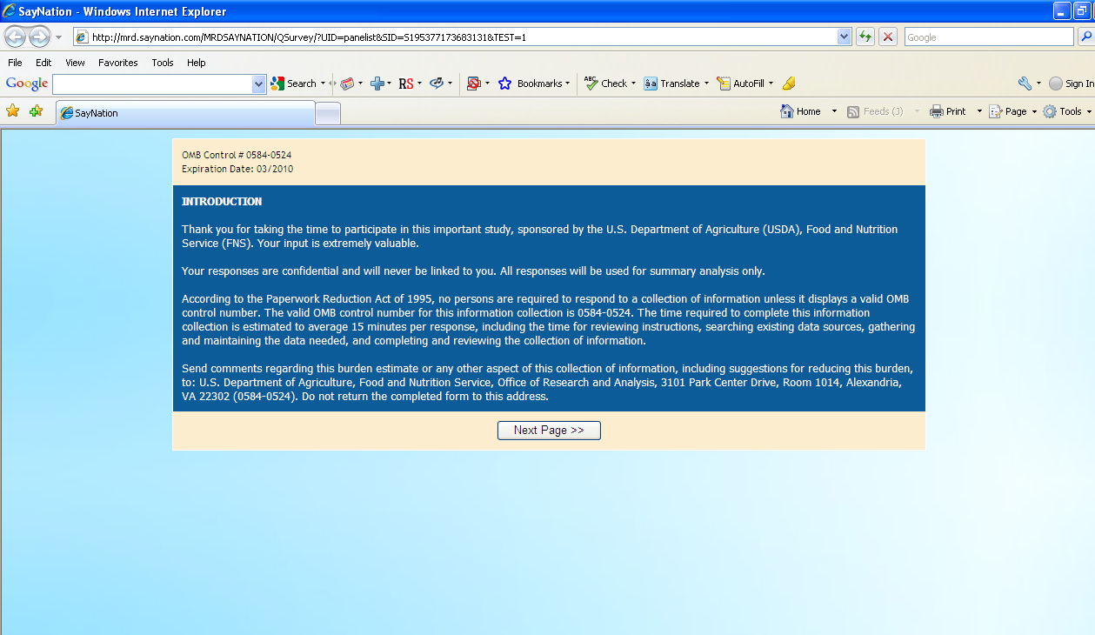

Screen Shot 2, 3, 4, 5 and 6: Sample Survey Questions
The following sample screen shots illustrate how the questions will appear to participants. Again, all questions are identical to those in Attachment O.
