ATTACHMENT 1

Form Approved

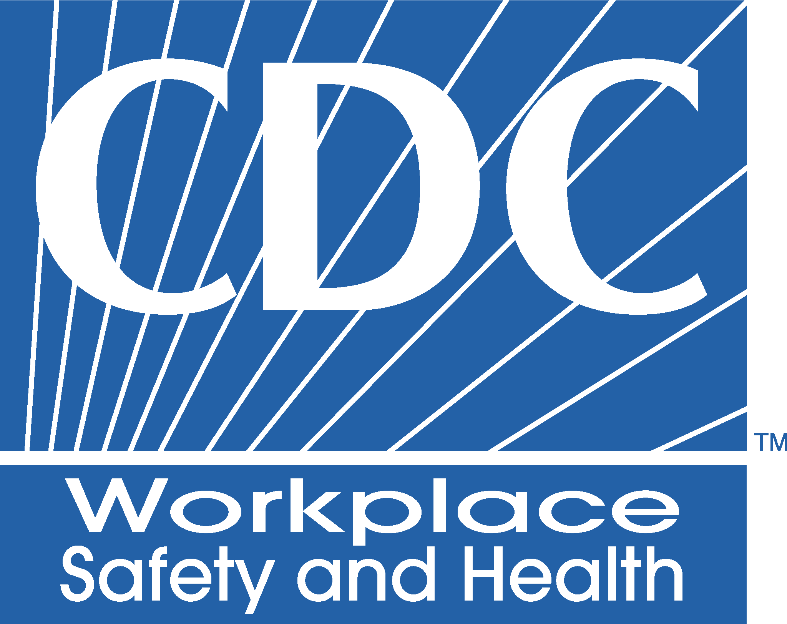
OMB NO. 0920-0566

Exp. Date mm/dd/yyyy

WORKER NOTIFICATION READER RESPONSE FORM:

Please read the enclosed Notification materials. After reading the materials, please take a few moments to give us some feedback about what you read. Fill in the circle showing your level of agreement with each statement. Please use a black or dark blue pen or black pencil.

Strongly Somewhat Neither Agree Somewhat Strongly Agree Agree or Disagree Disagree Disagree

1. The information was easy to understand O O O O O O O O O O

2. There was too much information. O O O O O O O O O O O O

3. There was not enough information. O O O O O O O O O O

4. You explained what I wanted to know. O O O O O O O O O O

5. I plan to use the health suggestions O O O O O O O O O O

6. The materials were appealing to look at. O O O O O

7. I plan to share this information with my doctor. O O O O O

8. I plan to share this information with others. O O O O O
9. I use the Internet to look up information. O O O O O O O O O O

10. I plan to use the CDC/NIOSH website. O O O O O O O O O O

Comments: We appreciate any other comments or suggestions you may have. Please write your comments below.

Public reporting burden of this collection of information is estimated to average 10 minutes per response, including the time for reviewing instructions, searching existing data sources, gathering and maintaining the data needed, and completing and reviewing the collection of information. An agency may not conduct or sponsor, and a person is not required to respond to a collection of information unless it displays a currently valid OMB control number. Send comments regarding this burden estimate or any other aspect of this collection of information, including suggestions for reducing this burden to CDC/ATSDR Reports Clearance Officer; 1600 Clifton Road NE, MS D-74, Atlanta, Georgia 30333; ATTN: PRA (0920-0566).

