Attachment 7B

Refusal Letter
[DATE]

[SUBJECT]
[ADDRESS]
[CITY, STATE, ZIP CODE]

Dear [SUBJECT],

In 2004 or 2005, you took part in a study of fatiguing illness in Georgia. The Centers for Disease Control and Prevention (CDC) is conducting a follow-up research study. We very much appreciate your participation. We would like to invite you to take part in the follow-up study.

When our interviewer last called, you said that you did not want to continue to take part in this study. I am writing to ask you to reconsider. The interview will take about 20 minutes. It contains most of the questions asked during your last interview. We are interviewing both fatigued and non-fatigued people for this study.

An interviewer from Abt Associates will call you in the next few days. Abt Associates Inc. is the research firm CDC has hired to collect information for this study. If you want to call us at a more convenient time, our toll-free number is 1-800-786-4816.

I hope that you will continue to help with this important study. Thousands of people must limit the time they can spend at work or with family because of fatigue. The economic, social, and emotional costs of this illness are quite high. Because little is known about fatiguing illness, this study is very important. We need your help.

If you have any questions about your rights in this study, you may call the CDC Deputy Director for Science toll-free at 1-800-584-8814. Please leave a message, and your call will be returned. If you have any other questions about this research study, call Dr. Jim Jones at the CDC. Dr. Jones’ number is: 1-404-639-3748. Please note that this call may be a toll call.

Thank you in advance for your help.

Very truly yours,
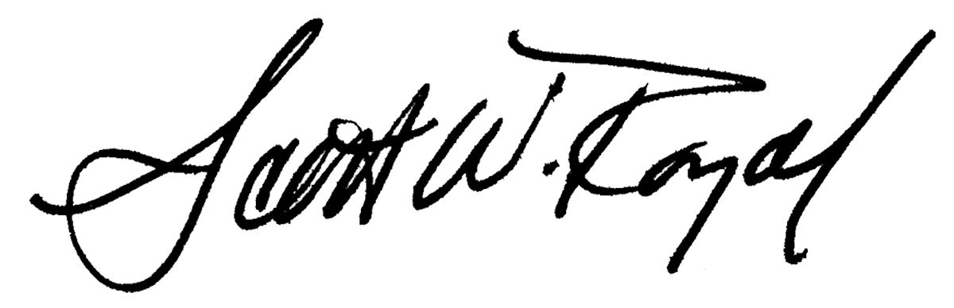
Scott Royal
Project Director

