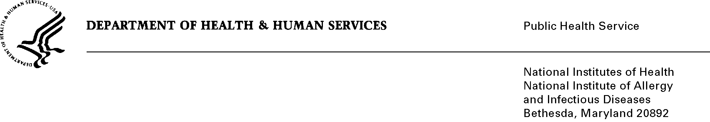

DATE: July 31, 2026

TO: Reports Clearance Officer, DHHS
Through: Project Clearance Officer, NIH
Project Clearance Officer, NIAID

FROM: Katharine Kripke PhD
Project Officer
National Institute of Allergy and Infectious Diseases (NIAID)

SUBJ: Pretesting of NIAID’s HIV Vaccine Research Education Initiative Communication Messages and Programs Activities

This is a request for OMB to approve the attached new generic clearance request for “Prestesting of NIAID’S HIV Vaccine Research Education Initiative Communications Messages and Program Activities.”
HIV vaccines represent the best hope of ending the HIV pandemic. Developing safe and effective HIV vaccines is one of NIAID’s highest priorities; however, given the daunting complexity of the HIV virus, doing so ultimately will require tens of thousands of HIV-negative volunteer clinical trials participants. Minority participation in HIV vaccine clinical trials is essential; nearly two-thirds of people diagnosed with HIV in the United States are African American or Latino. Historically, recruitment of racial/ethnic minorities has been a critical challenge for medical researchers; initiatives to increase recruitment of these groups into cancer and chronic disease trials have been only partially successful.

To address the need for clinical trials volunteers and therefore allow NIAID to fulfill its Congressional mandate, NIAID created the National HIV Vaccine Research Education Initiative (NHVREI). The goal of NHVREI is to create support for current and future HIV vaccine trials among populations most affected and infected by HIV/AIDS, specifically Blacks/African Americans, Hispanics/Latinos, men who have sex with men (MSM) of all racial/ethnic groups, and among key influencers of these populations.

The NHVREI will use a variety of communication messages, materials and programmatic activities to increase support of current and future HIV vaccine clinical trials among highly affected populations. Testing these strategies assesses their potential effectiveness in reaching and communicating with their intended audience while they are still in the developmental stage and can be revised. The pretesting process thus contributes to maximizing NIAID’s limited dollar resources for information dissemination and education.

Approval is requested for up to 18 pretests annually using such methods as individual in-depth interviews, focus groups, intercept interviews, self-administered questionnaires, gatekeeper reviews, and telephone surveys. The content, timing, and number of respondents to be included in each pretest will vary, depending on the nature of the strategy being tested, the methodology selected, and the intended audiences. Total annual respondent burden is calculated at 1,230 hours.

Please feel free to call me if there are any questions about this submission. Thank you in advance for your consideration.

