Attachment I: Webinar IRS.gov Advertisement – Example from FY10
Internal Revenue Service Webinar

Hiring Incentives to Restore Employment (HIRE) Act Webinar
Date: July 8, 2010

This FREE Webinar is for:

- Tax professionals
- Attorneys
- Payroll professionals
- Industry partners
- Small businesses

Learn about:

- The HIRE Act payroll tax exemption and retention income tax credit for employers who hire previously unemployed workers.
- Who qualifies as an eligible individual for each benefit.
- What businesses may claim each benefit.
- How business can claim those HIRE benefits.

Earn Continuing Professional Education credit:
- Enrolled agents receive one CPE credit for participating for a minimum of 50 minutes from the start of the Webinar. Other tax professionals may receive credit if the Webinar meets your organization’s or state’s CPE requirements.
- To receive credit, you must attend the event offered on July 8, 2010. You must also register for the Webinar using your e-mail address, and use the same e-mail address to log in to attend. This will confirm your attendance and generate your Certificate of Completion. Groups will not receive individual certificates as attendance can not be verified.
- *Only July 8, 2010 participants will receive certificates. If you do not need a certificate to obtain CPE credit, you may choose to view the archived version of the Webinar after
July 8, 2010.
- Look for your Certificate of Completion by e-mail approximately one week after the Webinar. If you have met all requirements, you will receive your certificate automatically.

Register on-line at:
http://www.visualwebcaster.com/IRS/69705/reg.asp?id=69705
REGISTER & ATTEND  (Click on the link to register and attend the session) | EASTERN | CENTRAL | MOUNTAIN | PACIFIC
 | 2 p.m. | 1 p.m. | Noon | 11 a.m.
Note: Time zones shown are standard time.

General information:

- Visit www.irs.gov and search Webinars for information on other programs available.
- If you experience difficulty viewing the event, please use the e-mail option on the event page or call 866-956-4770.
- The event will be archived for later viewing, approximately two weeks after the date of the event, on the new IRS Video Portal.

Sponsored by: IRS Small Business/Self Employed; Communications, Liaison and Disclosure
Attachment II: Webinar Enrollment Confirmation Notice Examples from FY10

You are now pre-registered for the Internal Revenue Service Webinar, " Requirements for Federal Tax Return Preparers - Learn the Who, What, When and How". This Webinar event is scheduled to start at Wednesday, June 09, 2010 at 2:00:00 PM Eastern.
View Event
Download Outlook Calendar Reminder

Attachment III: Event Evaluation – Sample (for Example Purposes)
OMB# 1545-1432
Attachment IV: Event – Example TE/GE Feedback Form

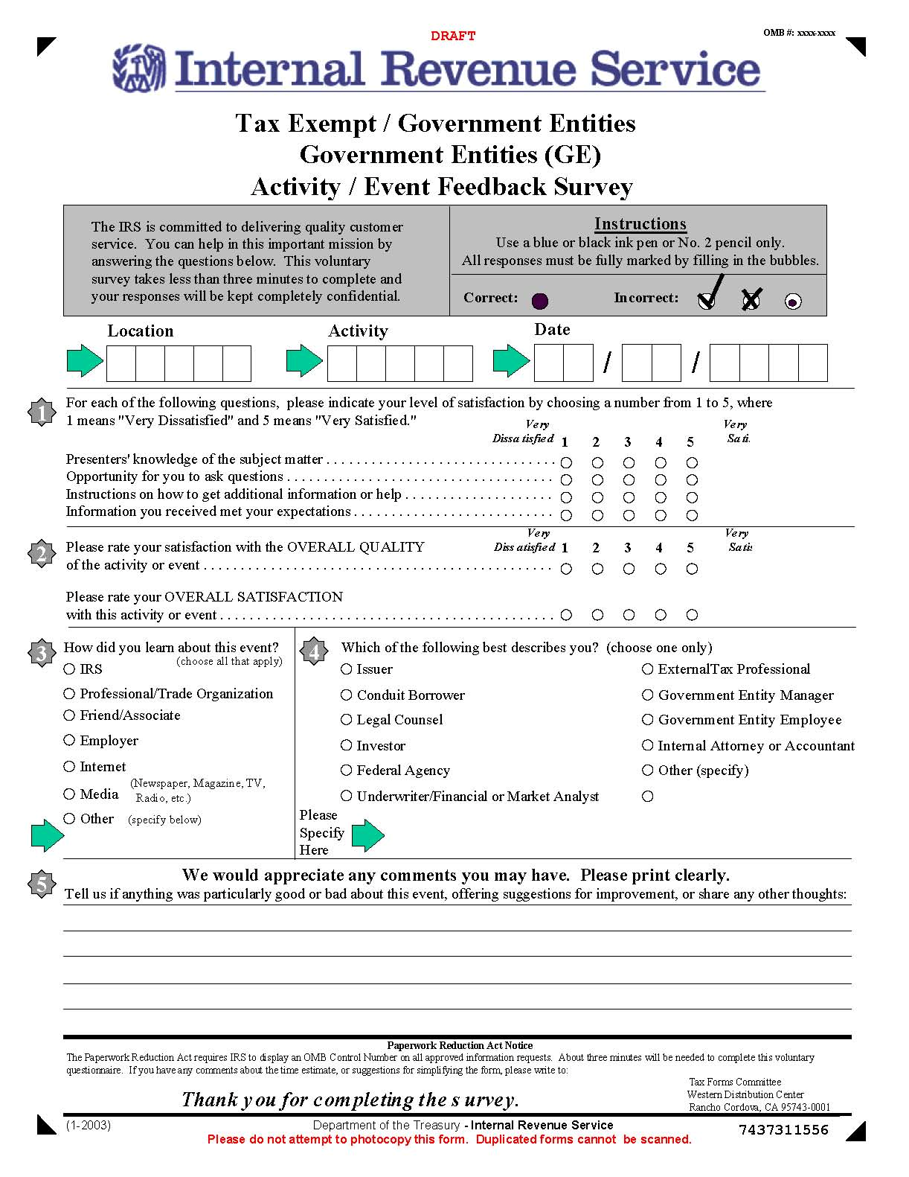

Attachment V: Printable Phone Forum/Webinar Event Evaluation Example

OMB# 1545-1432
Attachment VI: Event Evaluation Email Example

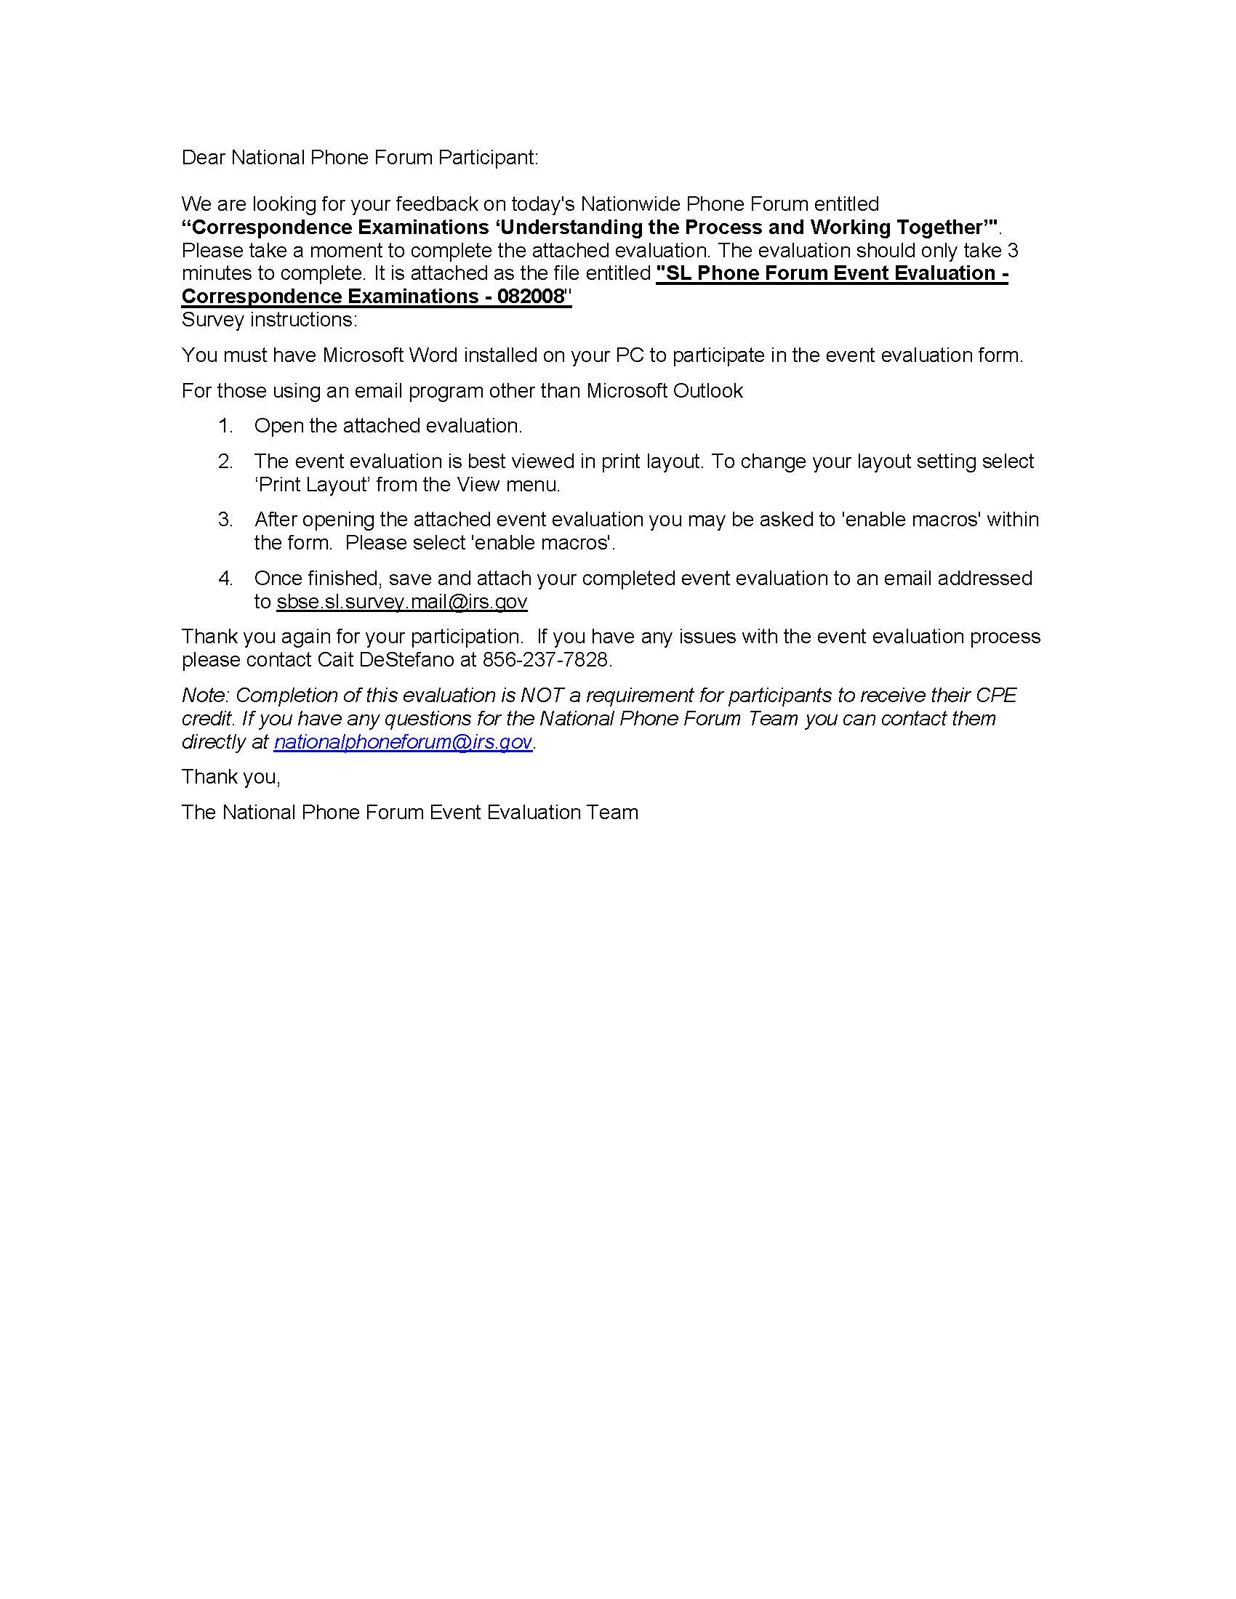

This advertisement message is intended as an example and will be updated with the actual date and title of the presentation.

