VERIFICATION OF DISABILITY WHEN ELIGIBILITY FOR ADMISSION OR QUALIFICATION FOR CERTAIN INCOME DEDUCTIONS IS BASED ON DISABILITY
FOR USE WITH ALL PROGRAMS EXCEPT SECTION 202/8, SECTION 202 PAC,
SECTION 202 PRAC, AND SECTION 811 PRAC
DATE:
TO: (Name and address of third party FROM: (Name of individual
who is being requested to verify requesting the information,
this information) title, name of the housing project,
address)

RETURN THIS VERIFICATION TO THE PERSON LISTED ABOVE (or other instructions to the third party to ensure that the verification is returned to the right person. This is important because owners have a responsibility to treat this information confidentially.)

SUBJECT: Verification of Disability

NAME___________________________________________________________
ADDRESS________________________________________________________
This person has applied for housing assistance under a program of the U.S. Department of Housing and Urban Development (HUD). HUD requires the housing owner to verify all information that is used in determining this person’s eligibility or level of benefits.
We ask your cooperation in providing the following information and returning it to the person listed at the top of the page. Your prompt return of this information will help to ensure timely processing of the application for assistance. Enclosed is a self-addressed, stamped envelope for this purpose. The applicant/tenant has consented to this release of information as shown above.
===================================================================
INFORMATION BEING REQUESTED
For each numbered item below, mark an “X” in the applicable box that accurately describes the person listed above.

1. ___YES ___NO Has a disability, as defined in 42 U.S.C. 423, which means;
- Inability to engage in any substantial gainful activity by reason of any medically determinable physical or mental impairment that can be expected to result in death or that has lasted or can be expected to last for a continuous period of not less than 12 months; or
- In the case of an individual who has attained the age of 55 and is blind, inability by reason of such blindness to engage in substantial gainful activity requiring skills or abilities comparable to those of any gainful activity in which he/she has previously engaged with some regularity and over a substantial period of time.
For the purposes of this definition, the term blindness, as defined in section 416(i)(1) of this title, means central vision acuity of 20/200 or less in the better eye with use of a correcting lens. An eye which is accompanied by a limitation in the fields of vision such that the widest diameter of the visual field subtends an angle no greater than 20 degrees shall be considered for the purposes of this paragraph as having a central visual acuity of 20/200 or less.
2. ___YES ___NO Has a physical, mental, or emotional impairment that:
a. Is expected to be of long-continued and indefinite duration;
b. Substantially impedes his or her ability to live independently; and
c. Is of such a nature that the ability to live independently could be improved by more suitable housing conditions.

3. ___YES ___NO Has a developmental disability as defined in Section 102(7) of the Developmental Disabilities Assistance and Bill of Rights Act 42 U.S.C. 6001(8)), i.e., a person with a severe chronic disability that:
a. Is attributable to a mental or physical impairment or combination of mental and physical impairments;
b. Is manifested before the person attains age 22;
c. Is likely to continue indefinitely;
d. Results in substantial functional limitation in three or more of the following areas of major life activity:
- Self-care,
- Receptive and expressive language,
- Learning,
- Mobility,
- Self-direction,
- Capacity for independent living, and
- Economic self-sufficiency; and
e. Reflects the person's need for a combination and sequence of special, interdisciplinary, or generic care, treatment, or other services that are of lifelong or extended duration and are individually planned and coordinated.
4. ___YES ___NO Is the above a person **whose** disability is based solely on any drug or alcohol dependence **(the person has no other disability which meets the above definition)**.

____________________________ _______________________________
NAME AND TITLE OF PERSON FIRM/ORGANIZATION
SUPPLYING THE INFORMATION

____________________________ ________________________________
SIGNATURE DATE
============================================================================

Public reporting burden for this collection is estimated to average 12 minutes per response, including the time for reviewing instructions, searching existing data sources, gathering and maintaining the data needed, and completing and reviewing the collection of information. This information is required to obtain benefits and is voluntary. HUD may not collect this information, and you are not required to complete this form, unless it displays a currently valid OMB control number. Owners/management agents must obtain third party verification that a disabled individual meets the definition for persons with disabilities for the program governing the housing where the individual is applying to live. The definitions for persons with disabilities for programs covered under the United States Housing Act of 1937 are in 24 CFR 403 and for the Section 202 and Section 811 Supportive Housing for the Elderly and Persons with Disabilities in 24 CFR 891.305 and 891.505.

Privacy Act Statement. The Department of Housing and Urban Development (HUD) is authorized to collect this information by the U.S. Housing Act of 1937, as amended (42 U.S.C. 1437 et. seq.); the Housing and Urban-Rural Recovery Act of 1983 (P.L. 98-181); the Housing and Community Development Technical Amendments of 1984 (P.L. 98-479); and by the Housing and Community Development Act of 1987 (42 U.S.C. 3543).

========================================================================
RELEASE: I hereby authorize the release of the requested information. Information obtained under this consent is limited to information that is no older than 12 months. There are circumstances that would require the owner to verify information that is up to 5 years old, which would be authorized by me on a separate consent attached to a copy of this consent.

Signature Date
Note to Applicant/Tenant: You do not have to sign this form if either the requesting organization or the organization supplying the information is left blank.
========================================================================
PENALTIES FOR MISUSING THIS CONSENT:
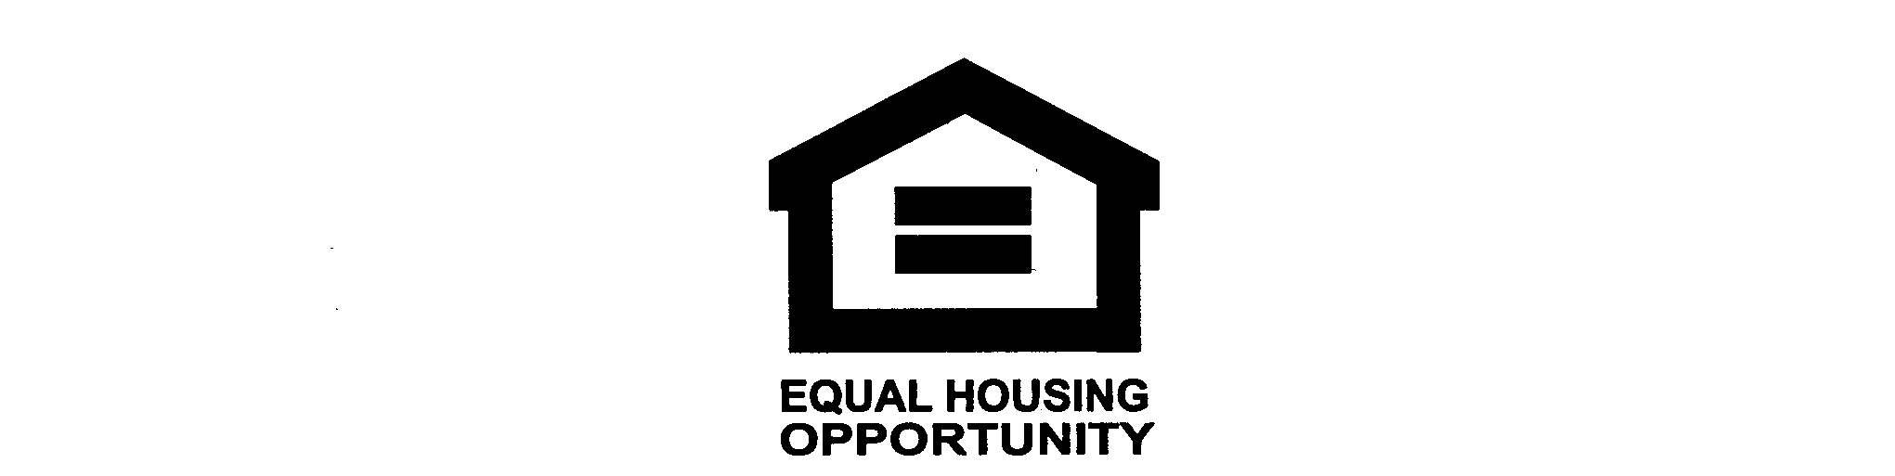
Title 18, Section 1001 of the U.S. Code states that a person is guilty of a felony for knowingly and willingly making false or fraudulent statements to any department of the United States Government. HUD and any owner (or any employee of HUD or the owner) may be subject to penalties for unauthorized disclosures or improper uses of information collected based on the consent form. Use of the information collected based on this verification form is restricted to the purposes cited above. Any person who knowingly or willingly
requests, obtains, or discloses any information under false pretenses concerning an applicant or participant may be subject to a misdemeanor and fined not more than $5,000. Any applicant or participant affected by negligent disclosure of information may bring civil action for damages and seek other relief, as may be appropriate, against the officer or employee of HUD or the owner responsible for the unauthorized disclosure or improper use. Penalty provisions for misusing the social security number are contained in the Social Security Act at **208 (a) (6), (7) and (8).** Violations of these provisions are cited as violations of 42 USC **408 (a), (6), (7) and (8).**

