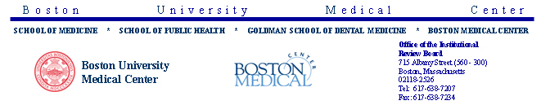
 | Title of Study: | THE FRAMINGHAM HEART STUDY N01-HC-25195 1910G
 | Protocol Number: | H-22762
 | RE: | Contining Review
 | Review Type: | Full Board
 | Action: | Approved
 | Date of Action: | 5/16/2007
 | Date of Expiration: | 5/15/2008

Dear PHILIP WOLF, MD:
The Institutional Review Board (IRB) has reviewed the above referenced protocol and has determined that it meets the requirements set forth by the IRB and is hereby approved. This protocol is valid through the date indicated above.
The IRB acknowledges that this summer you are (1) planning to make overall changes to all of the FHS consent forms; (2) that the new consent forms will be reviewed in depth by several FHS committees and monitoring boards; and (3) that the new consent forms will be submitted to the BUMC IRB for approval prior to [their use with subjects in] the upcoming exam cycles.
The study may not continue after the approval period without additional IRB review and approval for continuation. You will receive an email renewal reminder notice prior to study expiration; however, it is your responsibility to assure that this study is not conducted beyond the expiration date.
Please be aware that only IRB-approved informed consent forms may be used when informed consent is required.
Any changes to the protocol or informed consent must be reviewed and approved prior to implementation unless the change is necessary for the safety of subjects. In addition, you must inform the IRB of serious adverse events encountered during the course of the study or of any new and significant information that might impact a research participant's safety or willingness to continue in your study.
Investigators are required to ensure that all HIPAA requirements have been met prior to initiating this study. Once approved, validated HIPAA forms may be found within INSPIR as External Attachments.
Please note that the IRB is no longer stamping attachments, subject letters, recruitment materials, etc. These documents are each associated with this approved version of the protocol. They can be found by going to Letters/Protocol History in INSPIR and clicking on the highlighted (linked) word "Approved" and then clicking on the paperclip icon in the upper left corner.
Sincerely yours,
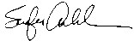
SANFORD AUERBACH
IRB Chair

