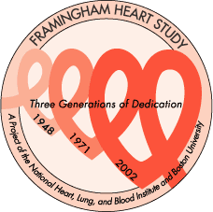
The Framingham Heart Study
LABORATORY

CELL LINE VENIPUNCTURE FORM

PARTICIPANT INFORMATION

ID: ____ - _________
Cohort | Offspring | Gen3 | Omni Gen2 | NOS

Exam: ____________

Name: _________________________________________________________________

Date: ____ / ____ / ____

Type of Appointment: _______
0 = clinic | 4 = remote
1 = home visit | 5 = osteo
2 = nursing home | 6 = blood only
3 = hospital | 7 = other

Comments: _____________________________________________________________

_____________________________________________________________

_____________________________________________________________

_____________________________________________________________

_____________________________________________________________

PHLEBOTOMIST USE ONLY

Phlebotomist Name: ______________________________________________________

Date of Blood Draw: ____ / ____ / ____

Samples Obtained: Yes No Number of tubes: ____________________

If blood draw only; Consent received: Yes No

Comments: _____________________________________________________________

_____________________________________________________________

_____________________________________________________________

Numbers for Participants who are alive and do not have a successful cell line through October 31, 2007.

Cumulative Cumulative
IDTYPE Frequency Percent Frequency Percent
-------------------------------------------------------------------------------------------------------
Original 93 11.80 93 11.80
Offspring 642 81.47 735 93.27
Gen 3 53 6.73 788 100.00

