DRAFT
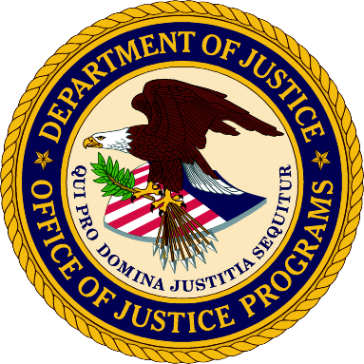
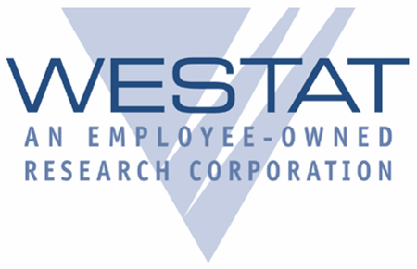
National Survey of Youth in Custody (NSYC)
State Roles and Responsibilities
U.S. Department of Justice
Bureau of Justice Statistics
State Director/Commissioner

1. Designate a State Liaison: The State Director/Commissioner will select a state staff person who will serve as a liaison to the study. This liaison will work with the residential juvenile facilities and Westat to prepare for and coordinate the survey team visit.

2. Provide State Clearance: The State Director/Commissioner will provide authorization, via the State Liaison, for Westat to contact the selected facilities in your state to arrange for participation in this survey.

State Liaison

1. Inform Facility Superintendent/Administrator and Identify a Facility Coordinator:
The State Liaison will contact the superintendents/administrators of the selected facilities in the state to inform them of the NSYC study and identify a staff person in the facility who will serve as the point-of-contact for scheduling and arranging for the survey team visit.

2. Communicate Requirements to Obtain Informed Consent for Minors: The State Liaison will identify whether the state/facility will provide consent for adjudicated minors to participate in the survey on behalf of the parents (i.e., in loco parentis). If this is not an option for your state, the Liaison will work with the facility and Westat to define the procedures for obtaining written or verbal consent from the minors’ parents/guardians.

3. Confirm State Mandatory Reporting Procedures: The State Liaison will confirm how incidents should be reported to child welfare authorities if a youth informs the survey team of abuse or neglect. Prior to the survey visit, the team will need to understand the state mandatory reporting procedures and will need the telephone number and paperwork requirements (if applicable) for submitting a report.

4. Assist in Obtaining Youth Rosters: The State Liaison will support NSYC to ensure each facility provides complete and accurate rosters of all adjudicated youth in a timely manner.

5. Specify Security Clearances Requirements for Westat Survey Staff: The State Liaison will specify any special requirements required for the survey team to gain access to the facilities. This may include special identification requirements or background checks.

6. Identify External Counseling Resources: The State Liaison will confirm that both internal and external counseling will be available to youth who participate in the survey. The Westat Institutional Review Board (IRB) requires that youth receive counseling if they become upset after the survey or if they ask to speak to a counselor. If the youth requests to speak to someone who is not a facility counselor, arrangements must be in place for the youth to speak privately with an outside counselor.

