Office of Management and Budget
Clearance Package

IRS Office of Governmental Liaison & Disclosure (GLD) Customer Satisfaction Evaluation for:
Primary Agency Liaison
&
Users of IRS GLD Services and Products
2008

Internal Revenue Service
Small Business/Self Employed (SB/SE)

October 21, 2008
Introduction

Background

To emphasize the Communications, Liaison and Disclosure (CLD) mission statement above, CLD develops and delivers integrated strategic communications and educational products to SB/SE employees and taxpayers. CLD also partners with key stakeholders in tax administration including: federal, state and local governmental agencies, practitioners, and industry groups.

CLD is responsible for developing as well as executing strategies designed to enhance voluntary compliance and ensuring that federal tax information is protected by those agencies that receive federal tax data. CLD is also responsible for a wide range of programs and activities in support of both SB/SE and the IRS Strategic Plan. This includes the administration of IRS Disclosure Programs (IRC §6103), overseeing the Freedom of Information Act and Privacy Act and administration of the IRS Disaster Assistance Program.

CLD is comprised of six functions that provide critical support toward the accomplishment of SB/SE and IRS missions and objectives:

- Governmental Liaison and Disclosure
- Stakeholder Liaison Headquarters
- Stakeholder Liaison Field
- Communications
- Policy and Strategic Planning
- Safeguards
Stakeholder Liaison Headquarters (SL HQ) – focuses on national engagement of the payroll and practitioner community and stakeholder organizations to provide information about IRS policies, practices and procedures to ensure compliance with the tax laws, both by voluntary means and through enforcement programs. In addition, SL oversees IRS involvement in disaster assistance and emergency relief activities.
The key engagement vehicle for GLD and their customers is the use of the data exchange program (GLDEP). This is a program in which the IRS shares tax data from about 20 data bases, primarily with state agencies. Beginning in 2007, states reciprocated with the State Revenue File Matching Initiative, a program which may prove beneficial to IRS non-filer and underreporter operations.
GLD conducts an annual satisfaction survey of its customers. For several years, the purpose of the survey was to gauge the satisfaction of state taxing agencies (GLD’s primary customer) with the data exchange program. In 2007 GLD asked Research to upgrade their annual survey. They wanted to better measure the effectiveness of their programs in order to make strategic adjustments to improve the service-wide GLD programs. Surveys distributed prior to 2007 indicated that customers are extremely satisfied with the exchange program (high satisfaction from nearly 100 percent of their customers). However, GLD was concerned that the data they received did not provide useful information. In addition, GLD wished to expand the scope of the survey to include the customers’ opinions regarding the liaison and disclosure functions.

Objectives of Data Collection

GLD wishes to measure customer satisfaction with its bulk data exchange program as well as its liaison and disclosure programs. The evaluations will be used to enhance future GLD products and to develop new strategies if needed. Furthermore, the evaluation will be used to identify key issues with their products and services.

Methodology

Sample Design

These evaluations will be administered in mid-September 2008. GLD intends to survey the total population of their state tax agency customers.
The Primary Agency Liaison 2008 Evaluation requests feedback about the participant’s satisfaction with their IRS GLD primary contact and the program implementation, as well as on Safeguards/Security and the performance of the Secure Data Transfer (SDT).
The IRS GLD Services and Products 2008 Evaluation asks for feedback on Disclosure, Safeguards/ Security, Compliance, the GL Data Exchange Program, and SDT.
Both evaluations will be used to measure the quality of the products and services provided by the IRS GLD primary contact.
Primary agency liaison participants will be notified via e-mail of the two evaluations (see Attachment I). They will be asked to complete and return the first evaluation titled ‘GLD Survey for Primary Agency Liaison 2008’ evaluation (see Attachment II). They will also be notified that a second evaluation will be sent to them and will be asked to forward this email to anyone within their agency who used GLD products or services. The second evaluation titled ‘GLD Survey for Users of IRS GLD Services and Products 2008’ (see Attachment III) will be sent with a separate cover letter (see Attachment IV).

Data Collection Date

The 2008 customer satisfaction evaluation is sent out annually each fall. The customers are given 3 weeks to complete the evaluation. Seven days after the first evaluation is sent a follow-up/reminder email (see Attachment V) will be sent to those agencies who have not returned either evaluation. No evaluation will be collected after 21 days.
Potential dates contacts will be sent:
Primary Agency Liaison Evaluation October 22, 2008
Users of IRS GLD Products and Services Evaluation October 22, 2008
Follow-up / Reminder email October 29, 2008
Closing of Evaluation process November 5, 2008

Data to be Collected

Attachment II, ‘GLD Survey for Primary Agency Liaison 2008’ and Attachment III ‘GLD Survey for Users of IRS GLD Services and Products 2008’ outlines the type of information that will be collected from participants.

Primarily, GLD seeks to obtain customer feedback on the overall quality of and satisfaction with the GLD services.

How Data will be Used

GLD primary agency liaisons will be notified of the evaluations via e-mail.

The evaluations will be reviewed and their answers will be profiled by SB/SE Research in Philadelphia. Using descriptive statistics, the findings will be presented to GLD in table format. Findings will be reviewed and considered by GLD to determine if they are meeting their customer’s needs, as well as to enhance the GLD program.

How Data will be Analyzed

The analysis will consist of a profile of the GLD Customer Satisfaction evaluation results.

Who is Conducting the Research

The IRS Office of Governmental Liaison and Disclosure (GLD) requests this research. The evaluations were developed by the SB/SE Research staff in Philadelphia, PA. The evaluations will be administered and analyzed by the same research site. The preliminary results will be provided to GLD within 31 days after the closing of the evaluation process.

Location and Facility

GLD customers are located nationwide. The email accounts the customers used when registering for GLD services will be used to administer the evaluations. See Attachment VI for a copy of the GLD Agency Enrollment form.

Stipend

A monetary stipend will not be offered to participants.

Recruitment Efforts

All state tax agency customers will be asked to participate in the evaluation.
Based on interest in IRS GLD Products and Services, GLD expects that customers who have an ongoing relationship with their GLD contact and need for the GLD products will complete the evaluations.

Methods to Maximize Response Rate

All GLD customers will be issued an evaluation notice via email. Seven days after the initial contact, customers will be sent a reminder email requesting that they take the evaluations if they have not done so already.

Expected Response Rate

Given the prior evaluation response rate, GLD expects to have a response rate of 65% for the Primary Liaisons.

Test Structure/Design

Prior to distributing the evaluations, Philadelphia Research and GLD will conduct a pilot test using at least 10 participants. The purpose is to ensure that all questions and statements are interpreted similarly by all participants. Once the responses from the pilot participants are received, SBSE Research will confer with GLD to finalize the evaluation instrument.

Efforts to not Duplicate Research

In 2007 Research administered a similar customer satisfaction evaluation for GLD. GLD asked Research to conduct a 2008 customer satisfaction evaluation that includes questions related to their Secure Data Transfer (SDT) program as well as the topics covered in the previous year’s evaluation (Disclosure, Safeguards/ Security, Compliance, and the GL Data Exchange Program). This type of evaluation is unique to CLD – GLD. No other GLD evaluation has been or will be issued to GLD customers. The evaluation may be used in subsequent years with OMB approval.

Cost of Study

The estimated cost to administer and analyze the evaluation results is $57,881. This amount includes the salary of the Lead Analyst and any procured survey software.

Participant Criteria

Participants for this evaluation must be customers with GLD and participate in one of the GLD programs.

Privacy/Disclosure/Anonymity/Security Issues

SBSE Research will ensure compliance with the Taxpayer Bill of Rights II. All participants will be treated fairly and appropriately. The security of the data used in this project and the privacy of taxpayers/participants will be carefully safeguarded at all times. Anonymity will be safeguarded. Respondents to the survey will not be identified to Research or to GLD.

For the subject project,
- The use of taxpayer data will be restricted to authorized personnel for approved research projects;
- Taxpayer/participant privacy will be safeguarded;
- The data used in a research project will be validated;
- Any known or potential limitations in the data used in a research project will be properly disclosed;
- Any data used in a research project will be obtained, utilized, stored, disseminated, and transported in accordance with the Internal Revenue Manual;
- Related documentation (data dictionary, record layout, sampling plan, data validation documentation, syntax and other computer code) will be made available to any research site requesting data;
- All data used in a research project and under the control of Research, whether stored on computer or archived on magnetic media, will be destroyed in a timely manner in accordance with the Internal Revenue Manual.

This document covers all data used in any research activity from internal or external sources.

The Paperwork Reduction Act Statement & OMB Control Number will be provided on the evaluation.

Burden Hours

GLD plans to issue these evaluations one time.
The Primary Liaison evaluation will take 10 minutes to complete. There is a potential evaluation population of 157 people. Given this population the total estimated public burden is 26 hours. However, with an expected response rate of 65% the public burden would be 17 hours.
For persons participating in the evaluation, the burden time is estimated at 10 minutes.
Participants will not experience travel time for this study. The following table details the total burden calculation.

The Product and Services evaluation will take 10 minutes to complete. Based on the FY2007 survey there is a potential evaluation population of 96 people. Given this population the total estimated public burden is 16 hours. Using the Primary Liaison evaluation response rate of 65% the public burden would be 10.4 hours.
For persons participating in the evaluation, the burden time is estimated at 10 minutes.
Participants will not experience travel time for this study. The following table details the total burden calculation.

Study Contact

For questions regarding the Evaluation, contact:
Reuben Robinson
Chief SB/SE Research – Philadelphia
600 Arch Street (RM 7204)
Philadelphia, PA 19106
(215) 861-1268
Cait DeStefano
Operations Research Analyst –Lead Analyst for the Evaluation
SBSE Research - Philadelphia
600 Arch Street (RM 7204)
Philadelphia, PA 19106
(215) 861-3890

Attachments
Attachment I: Primary Agency Liaison Cover letter
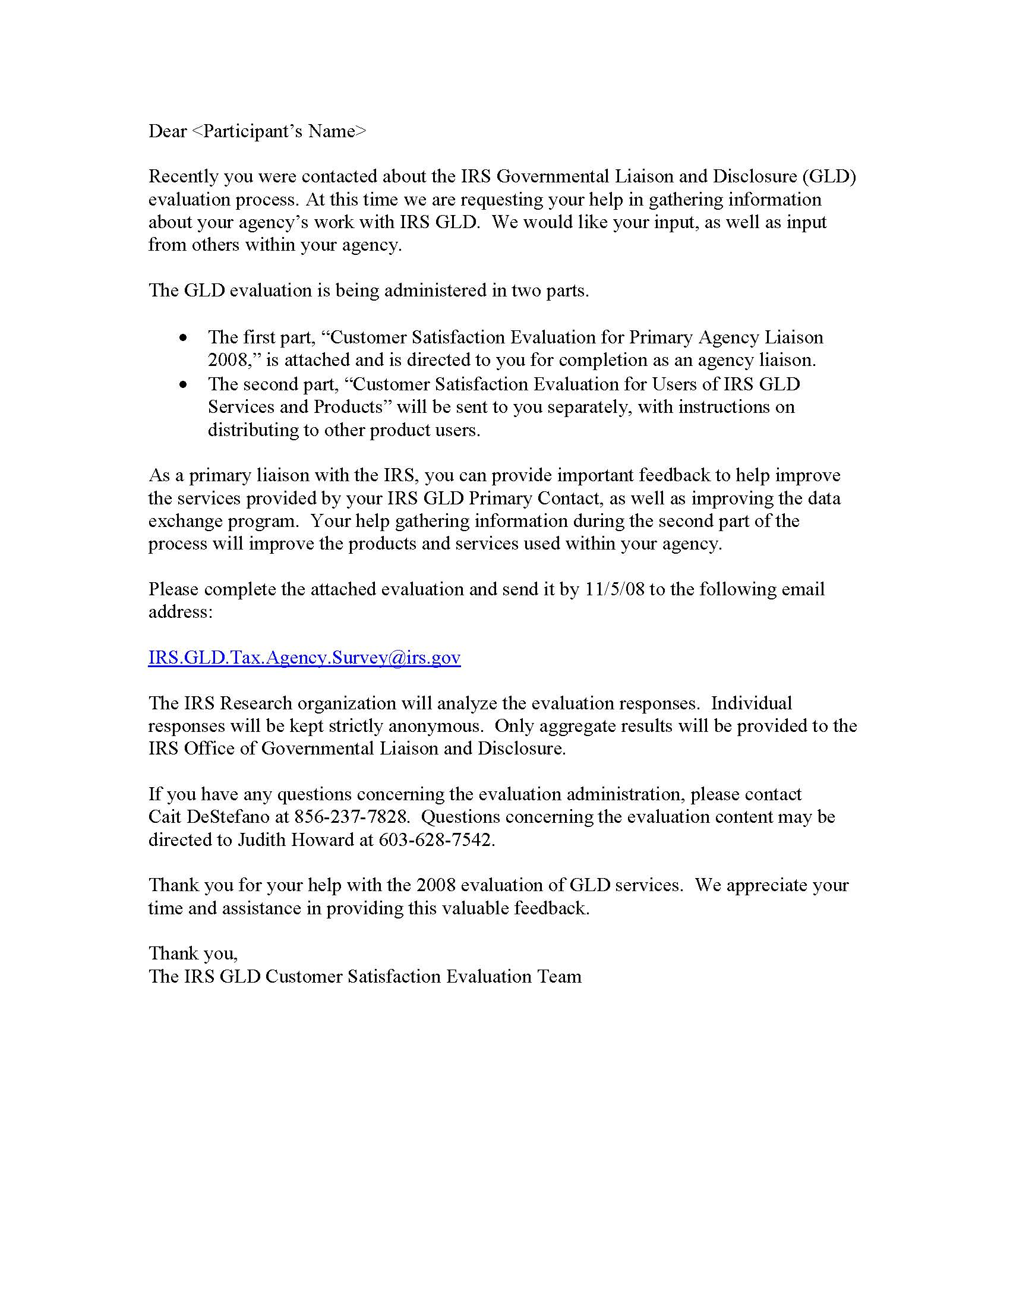

Attachment II: Primary Agency Liaison Evaluation

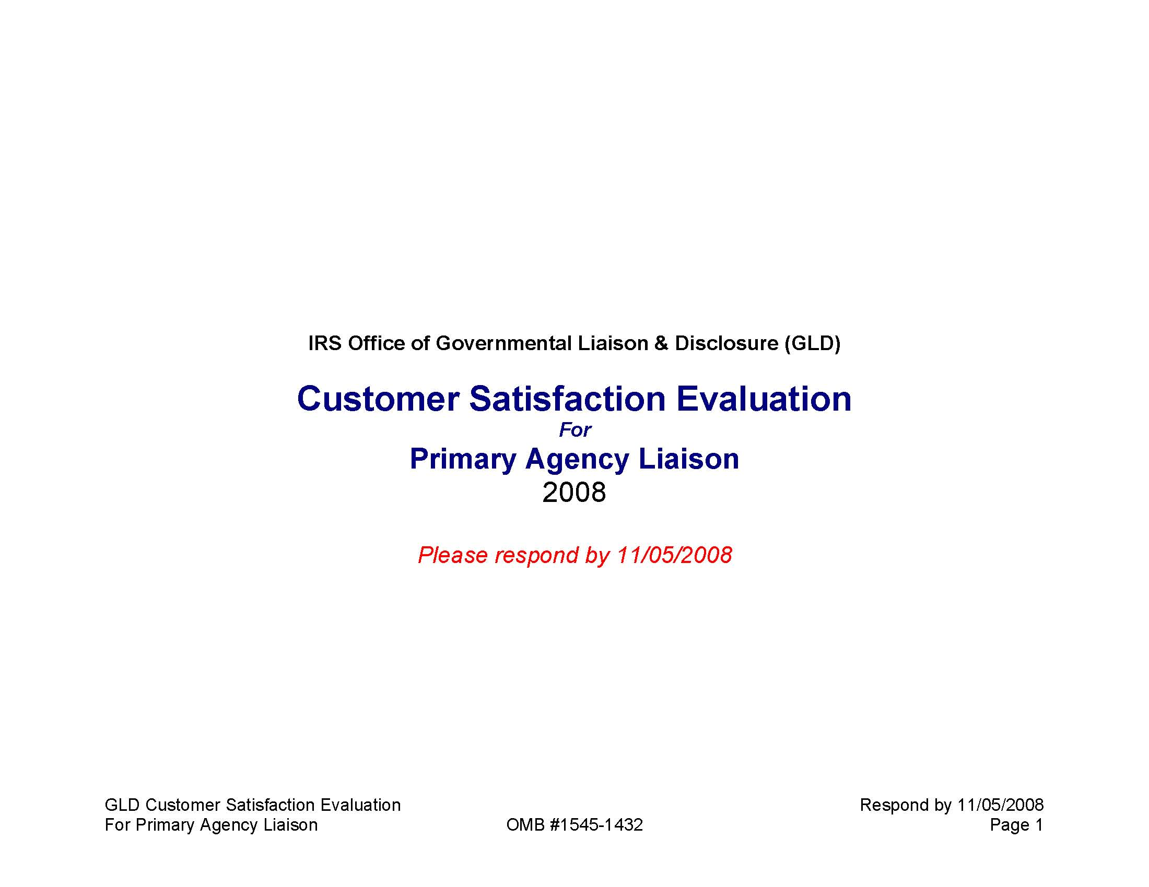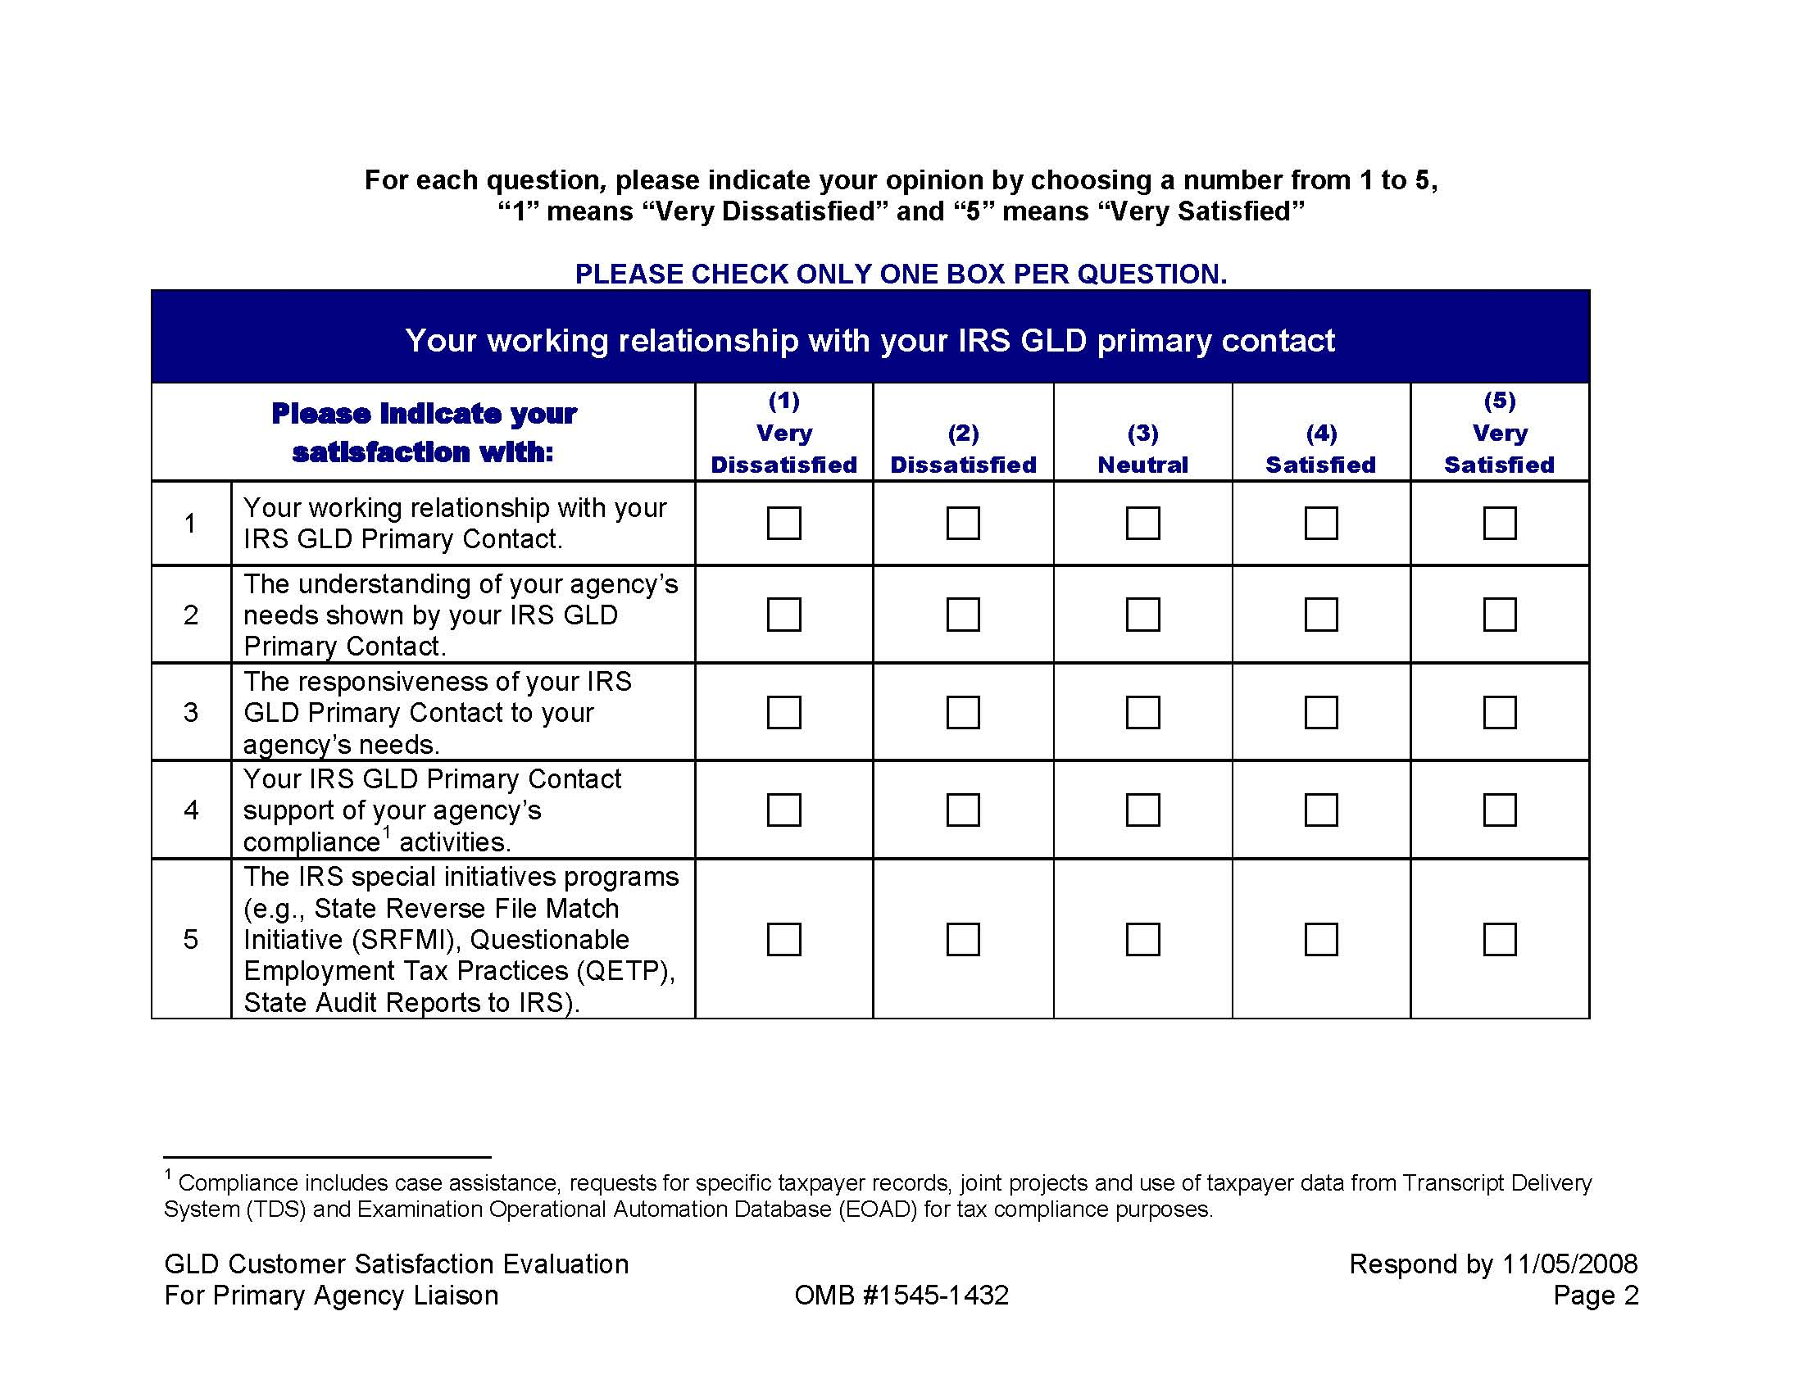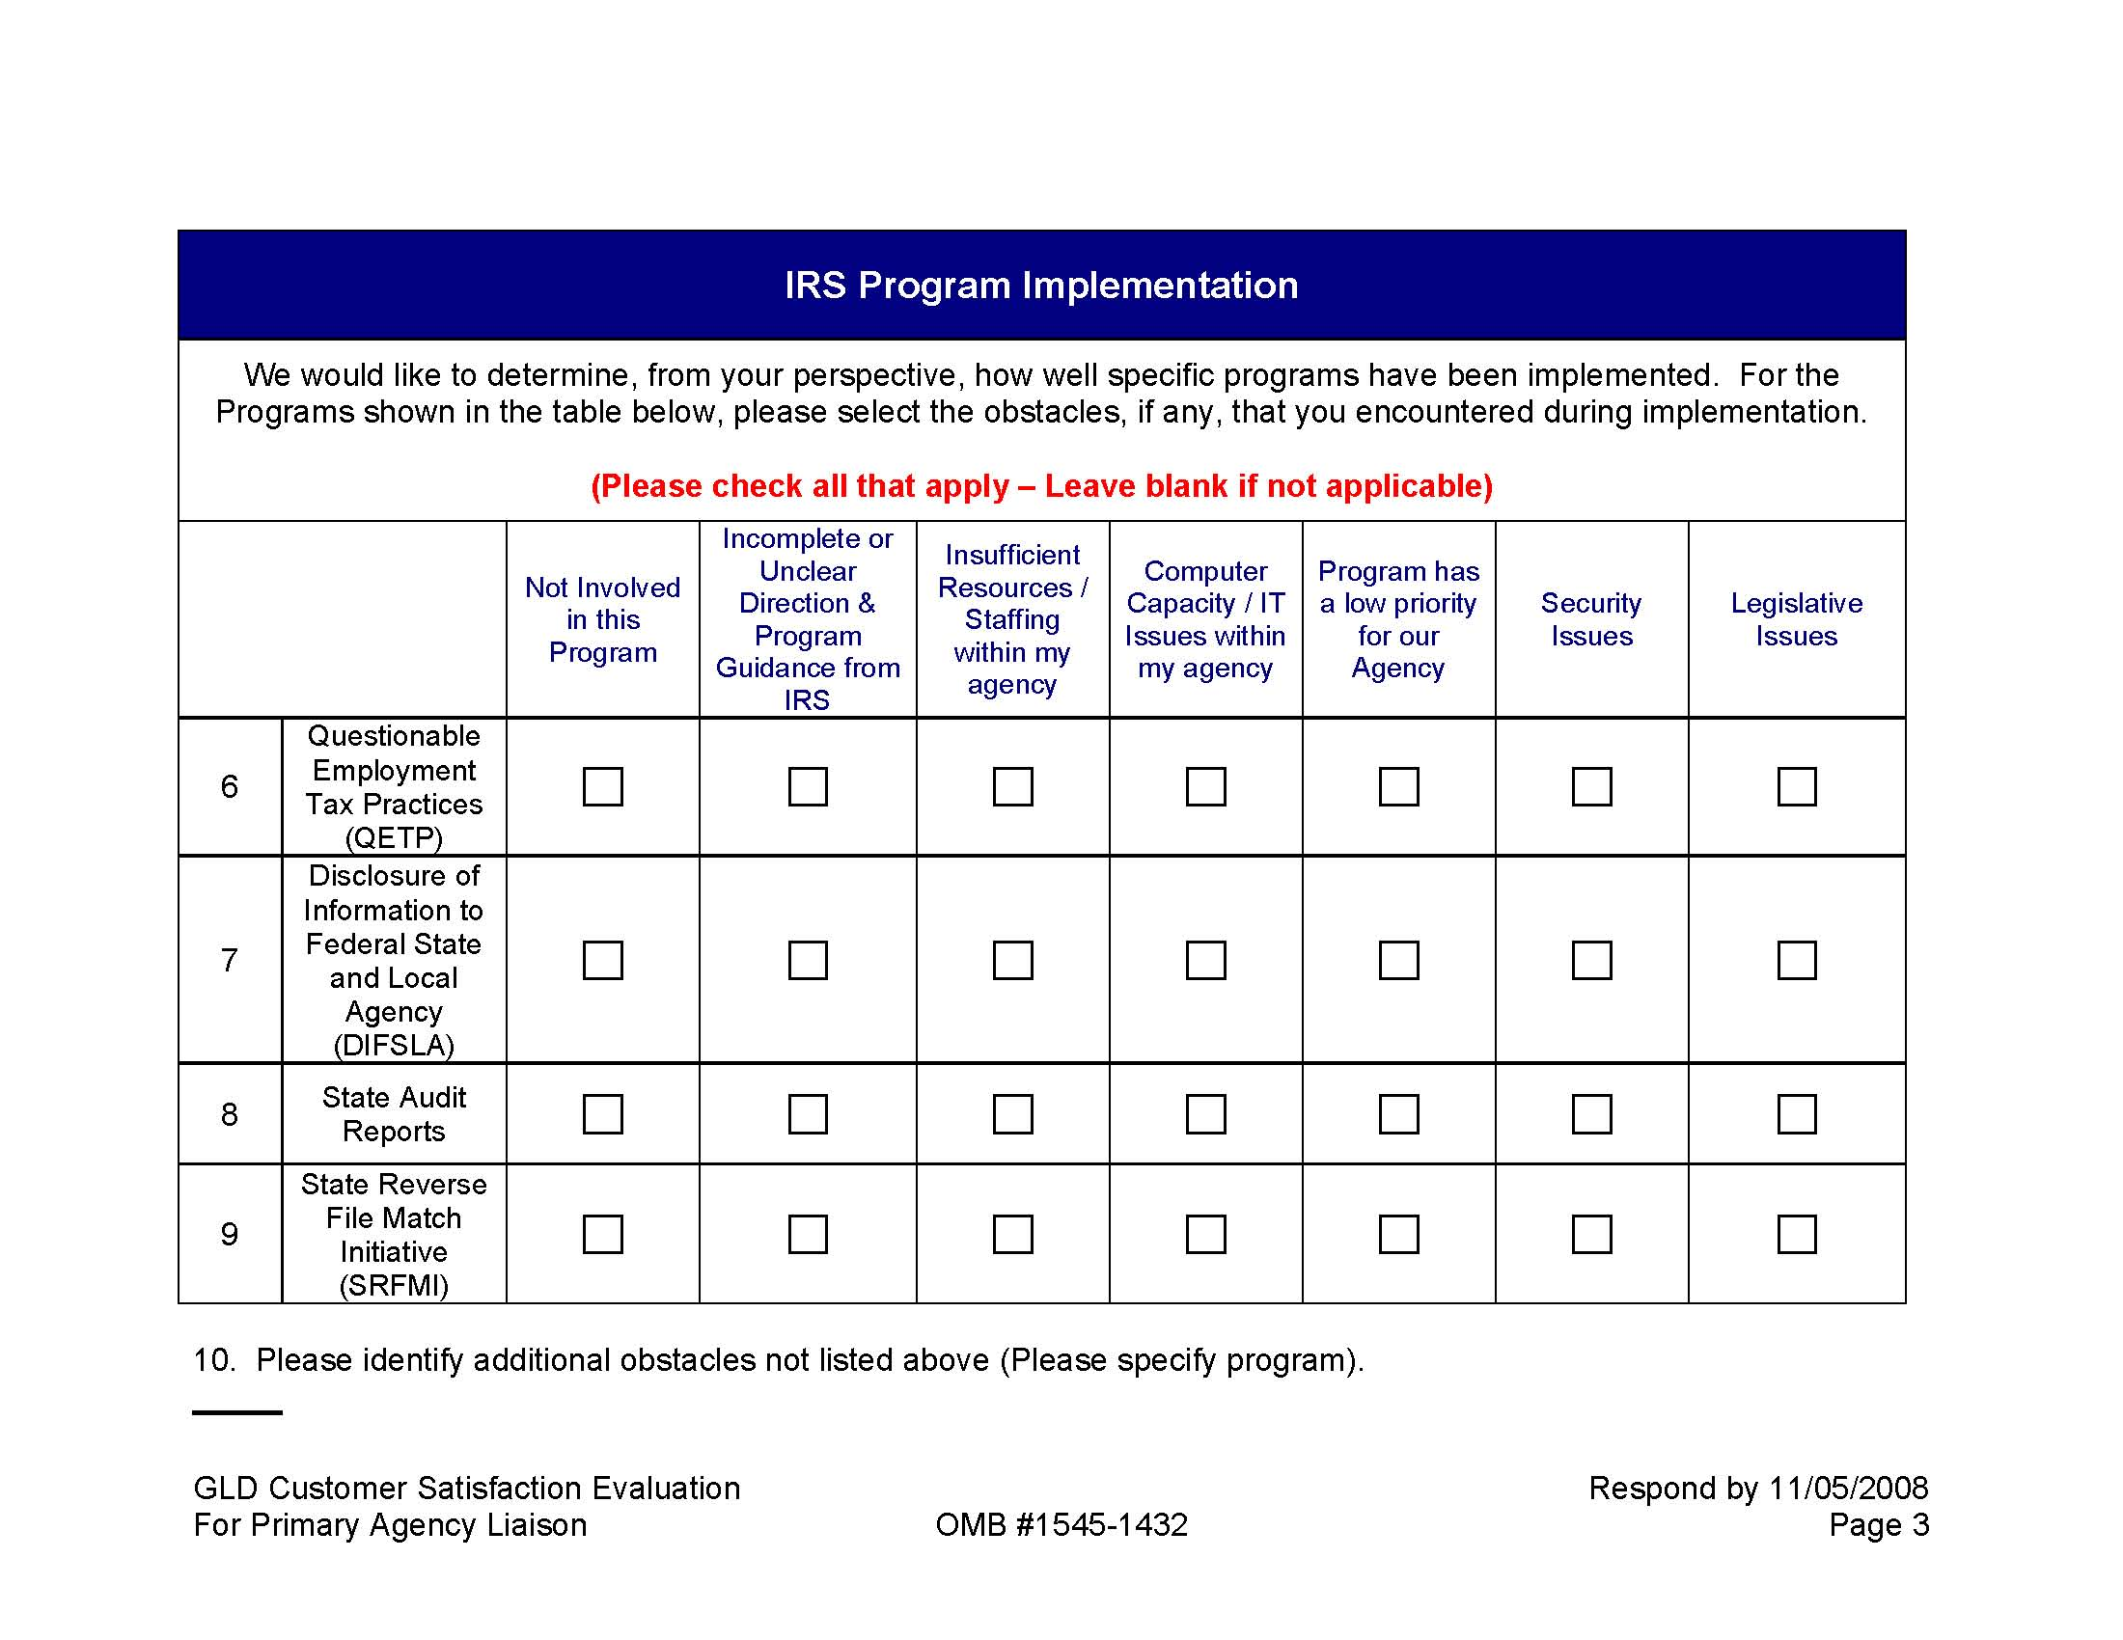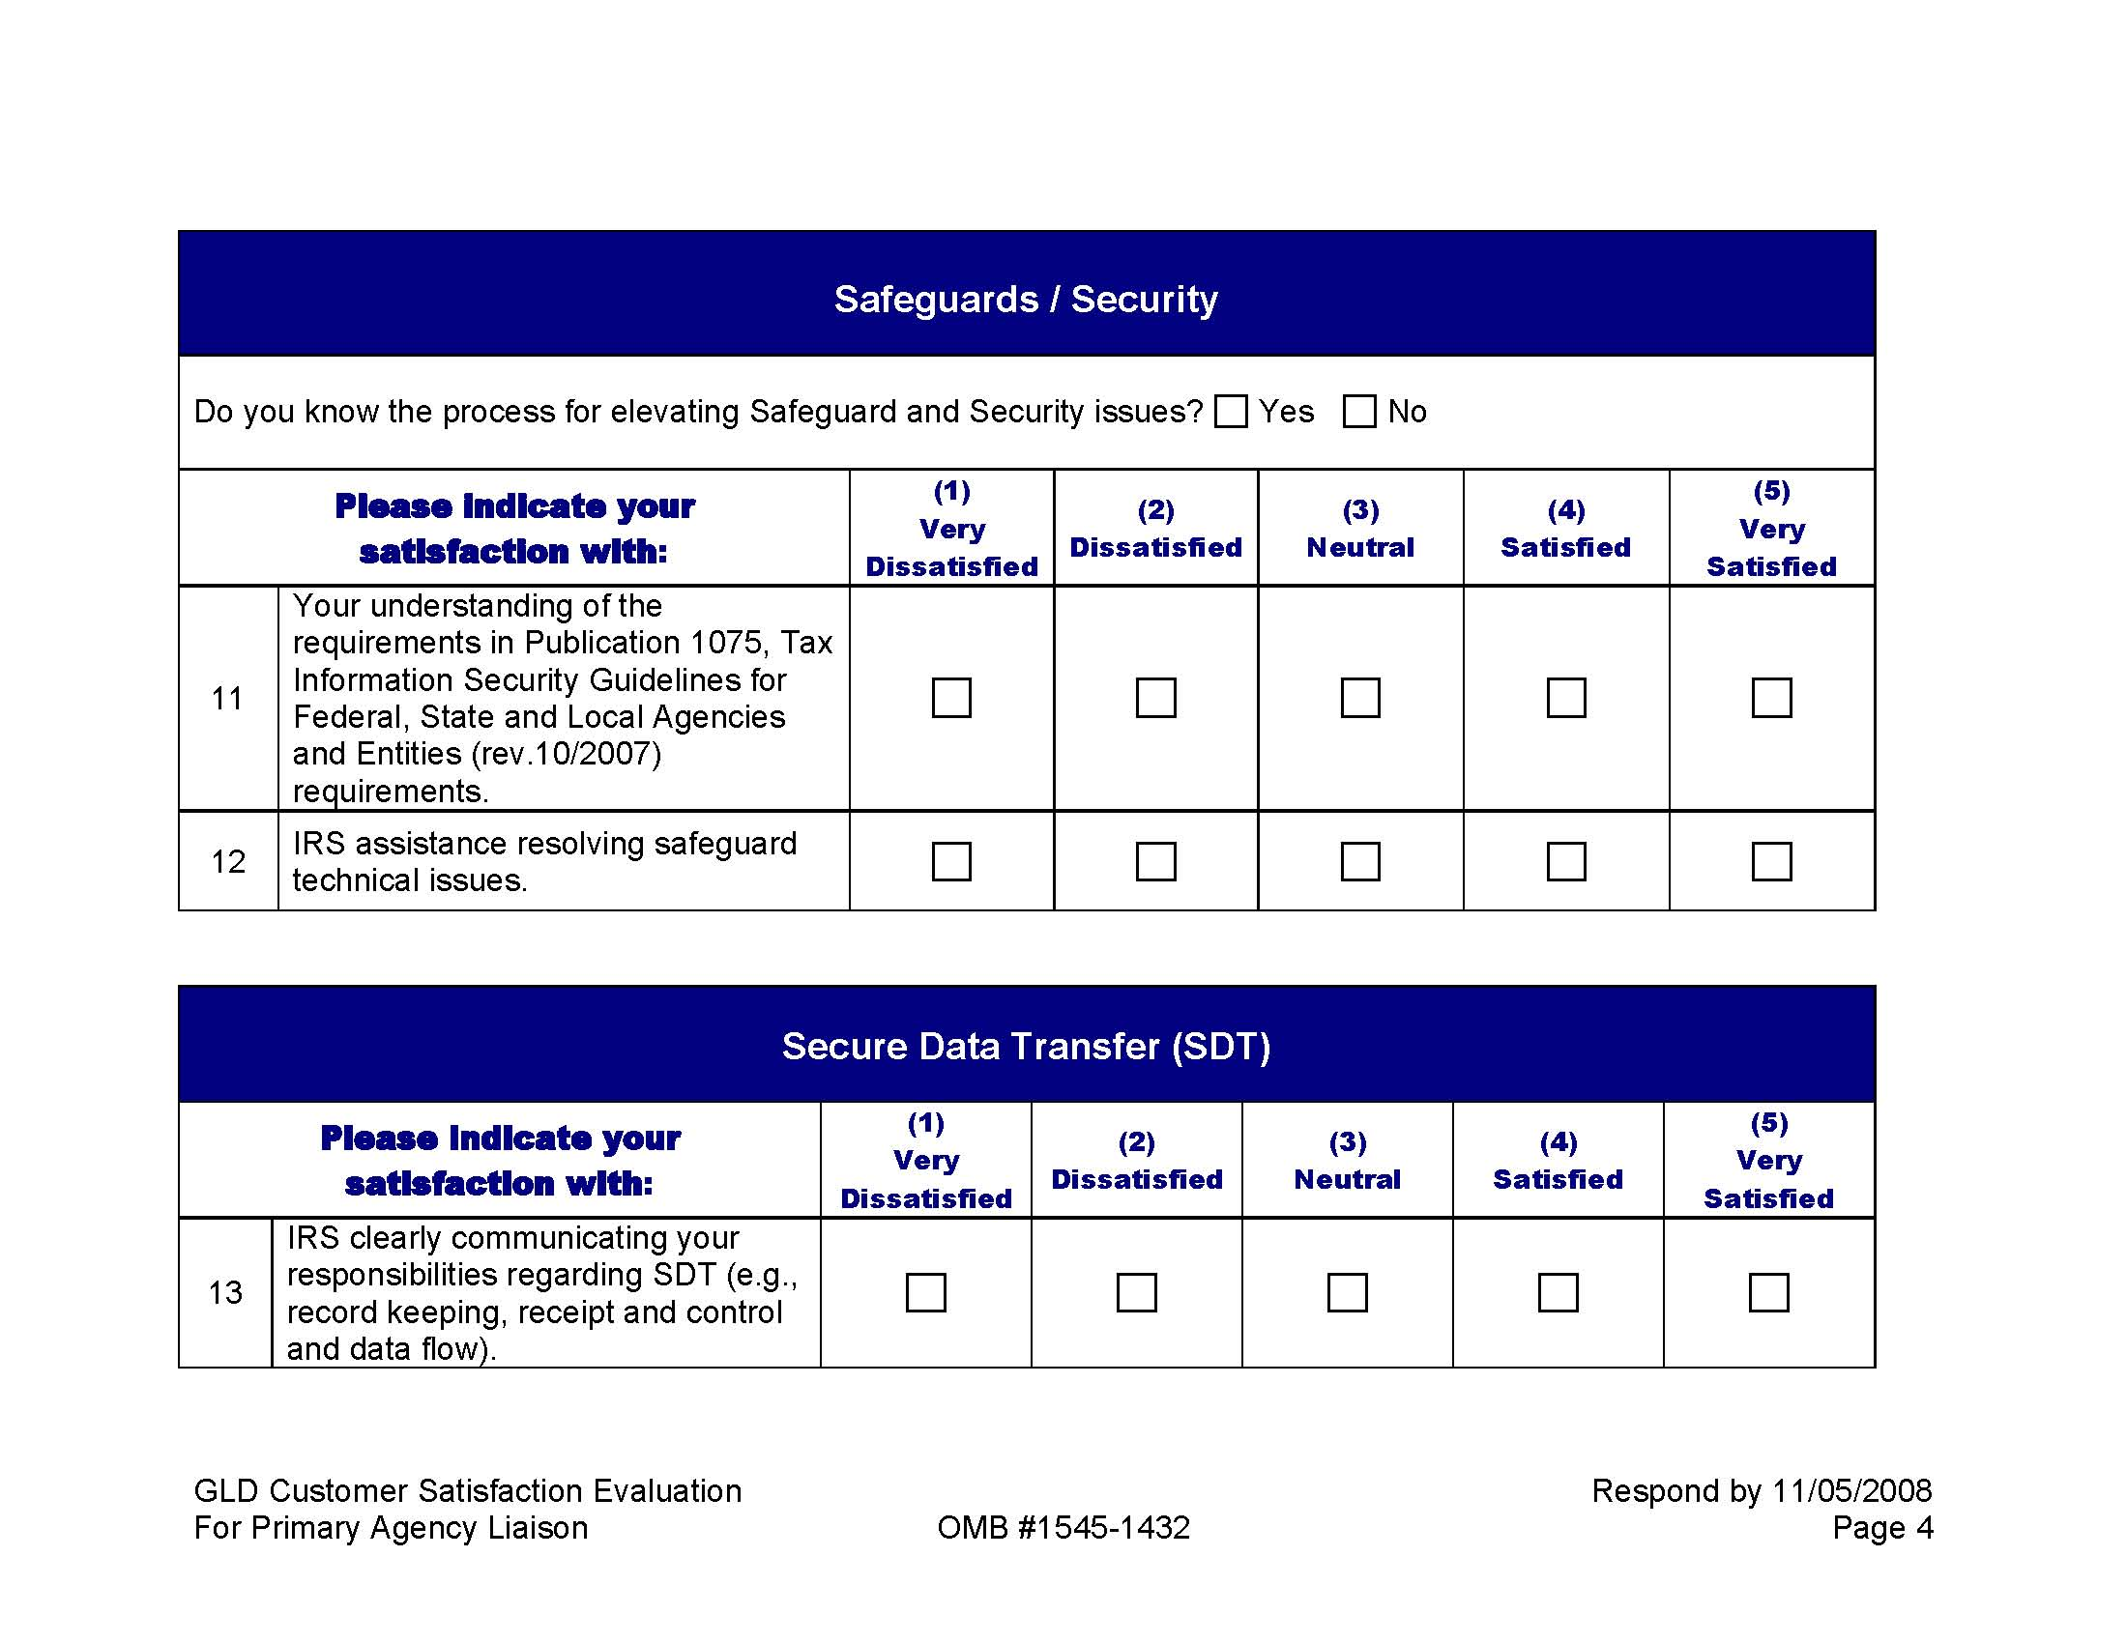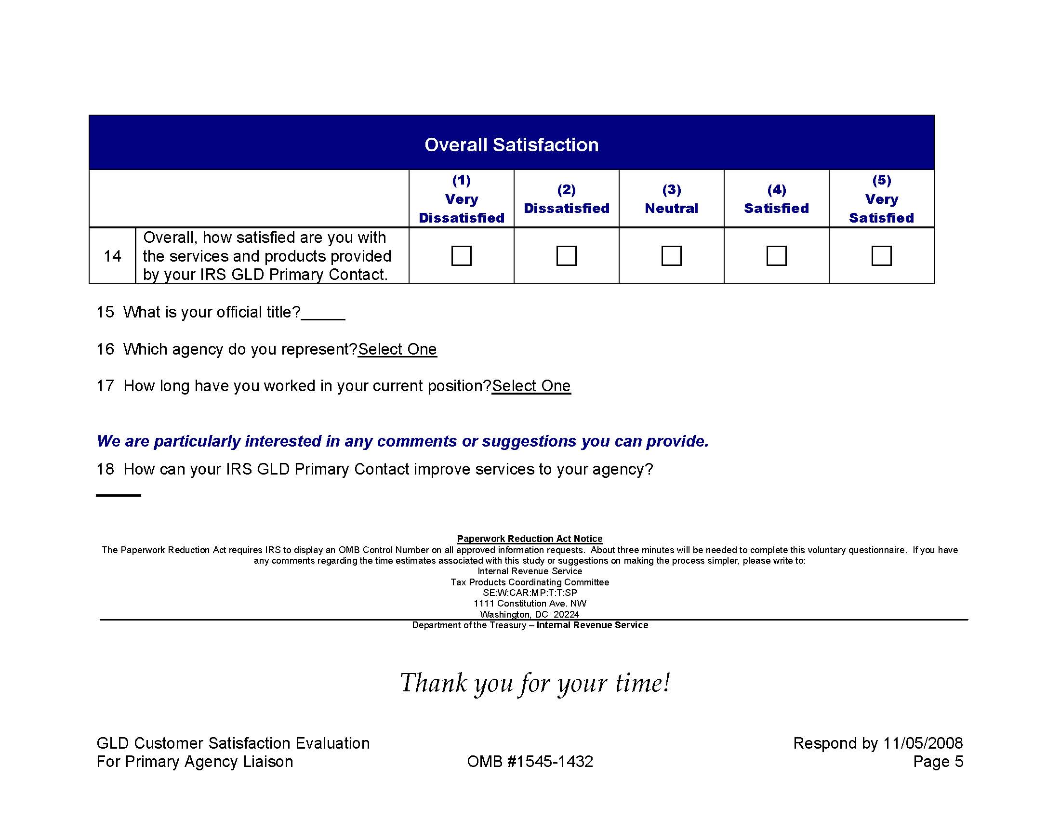

Attachment III: Users of Products and Services Evaluation

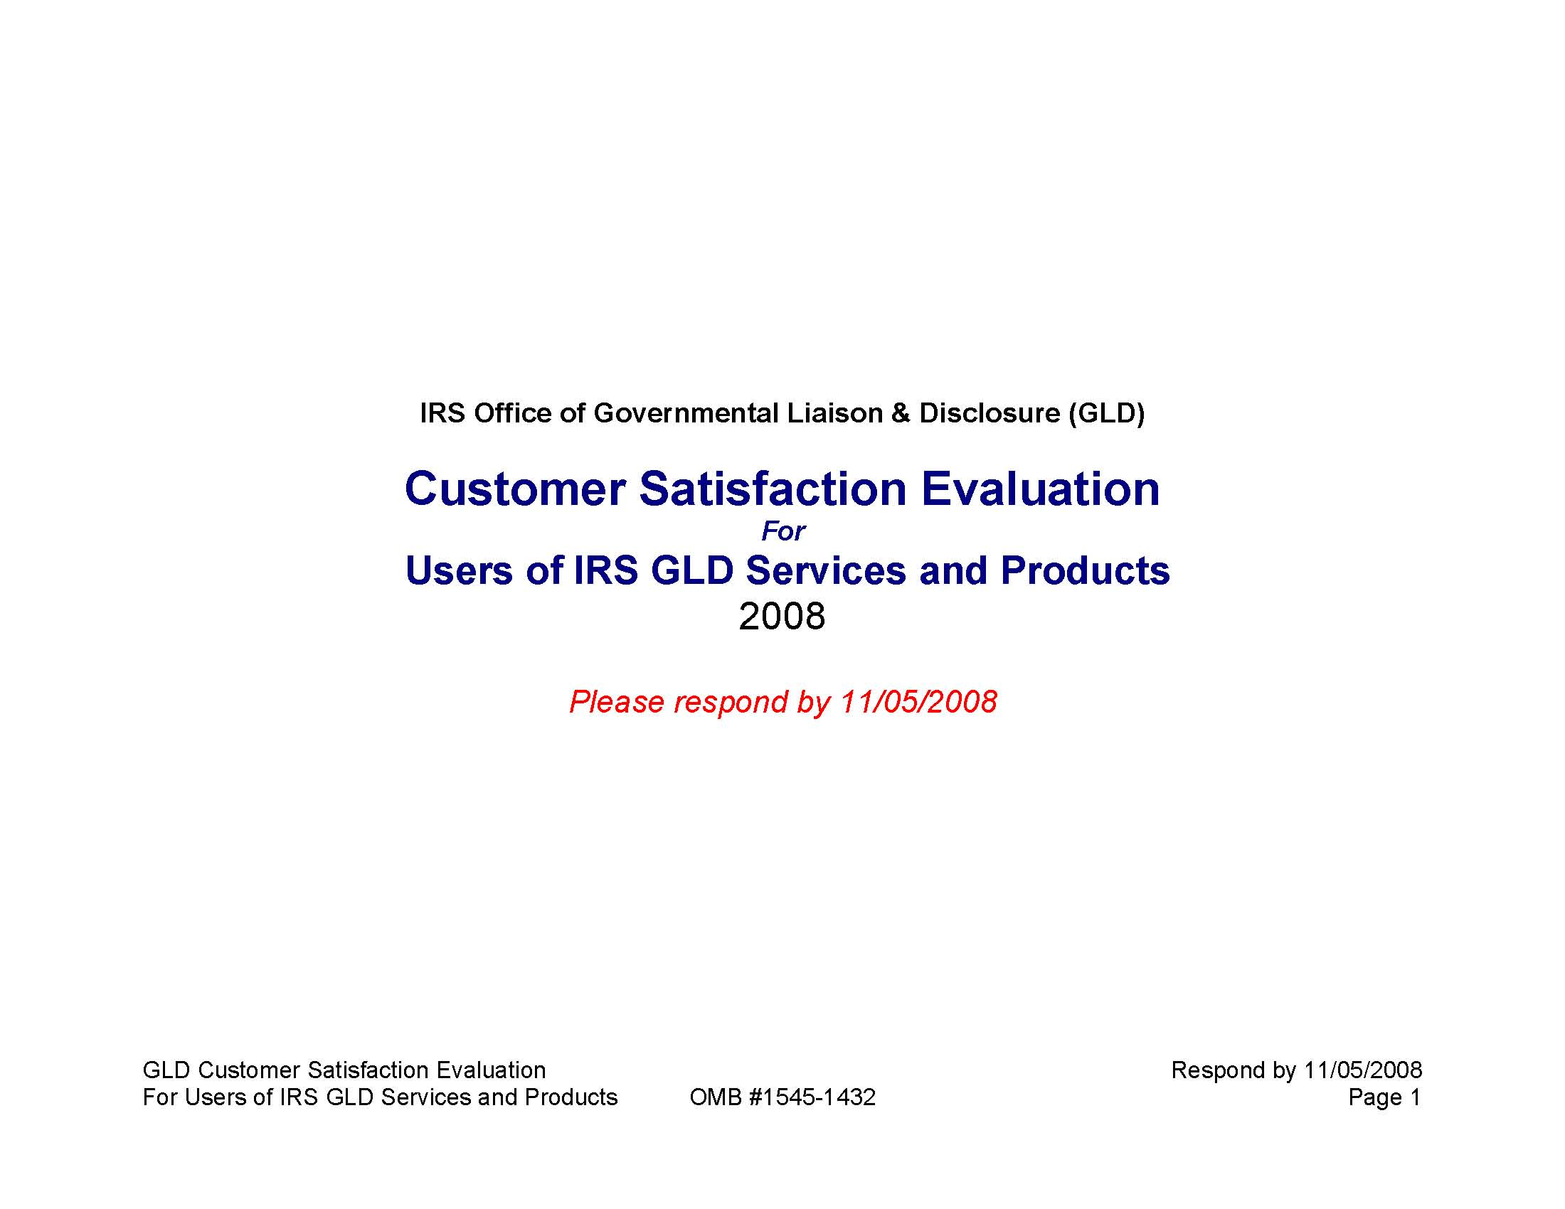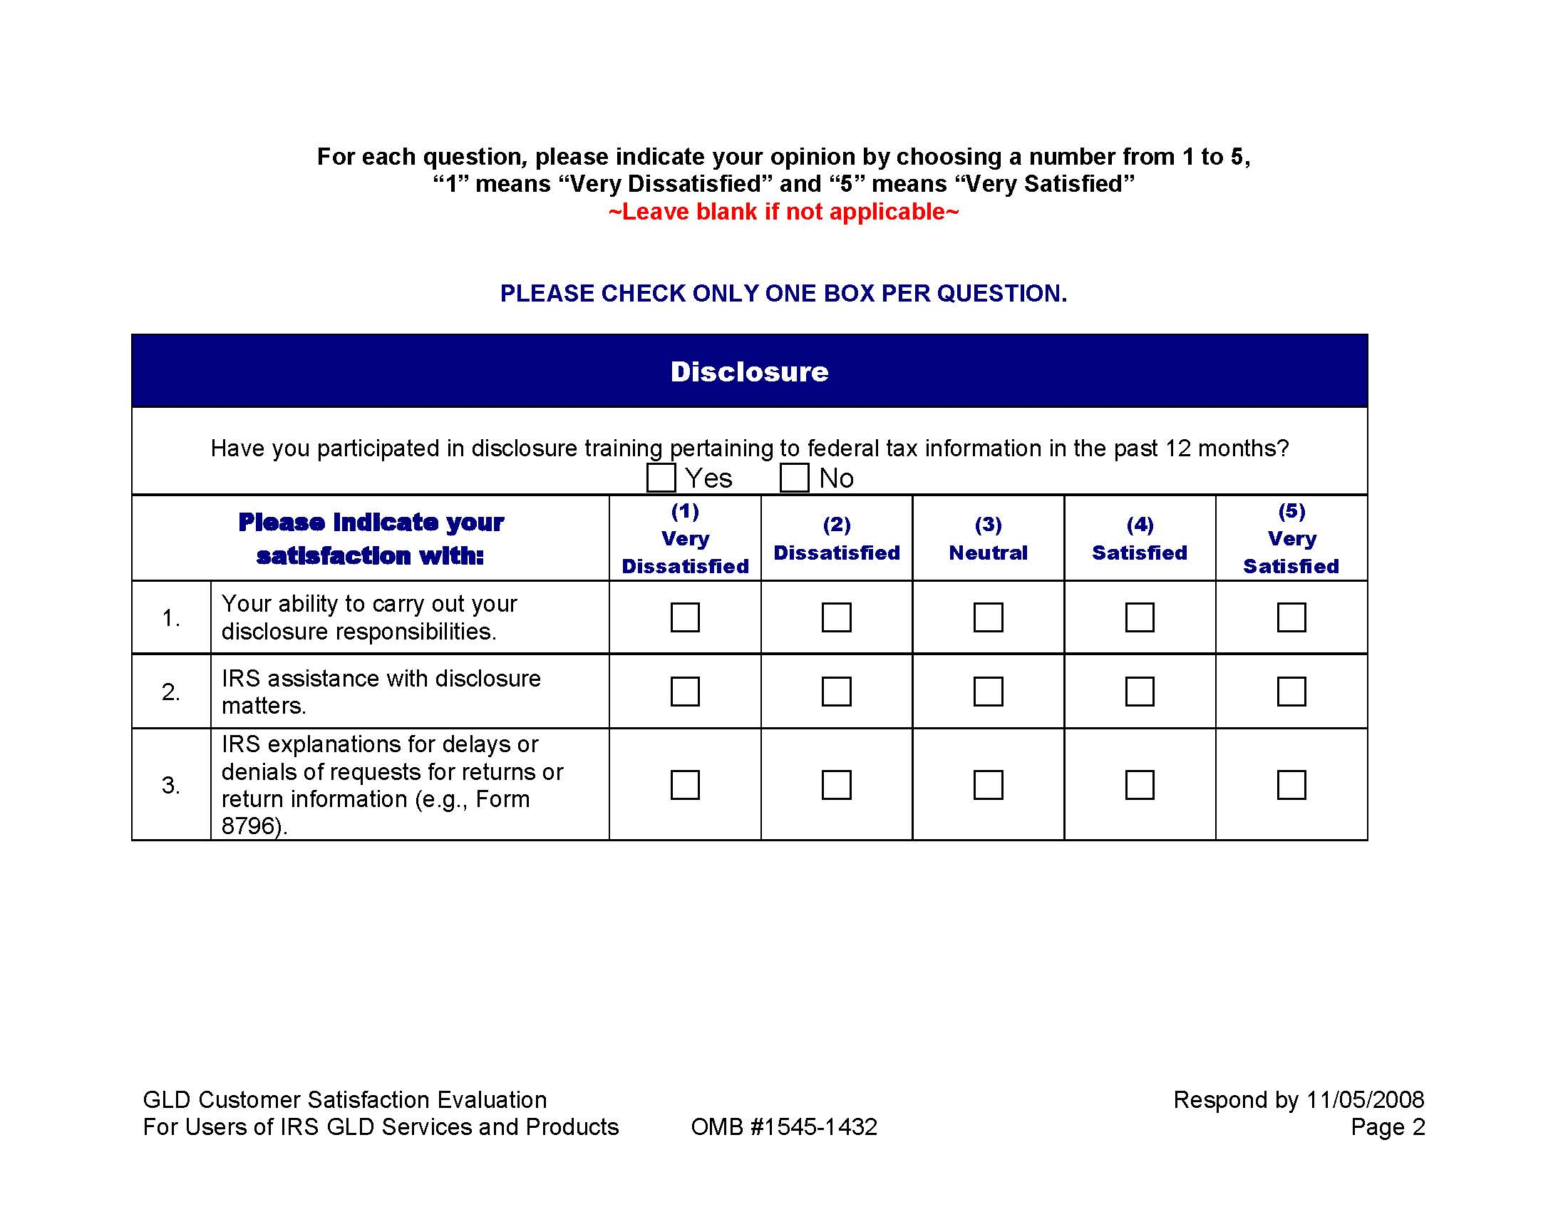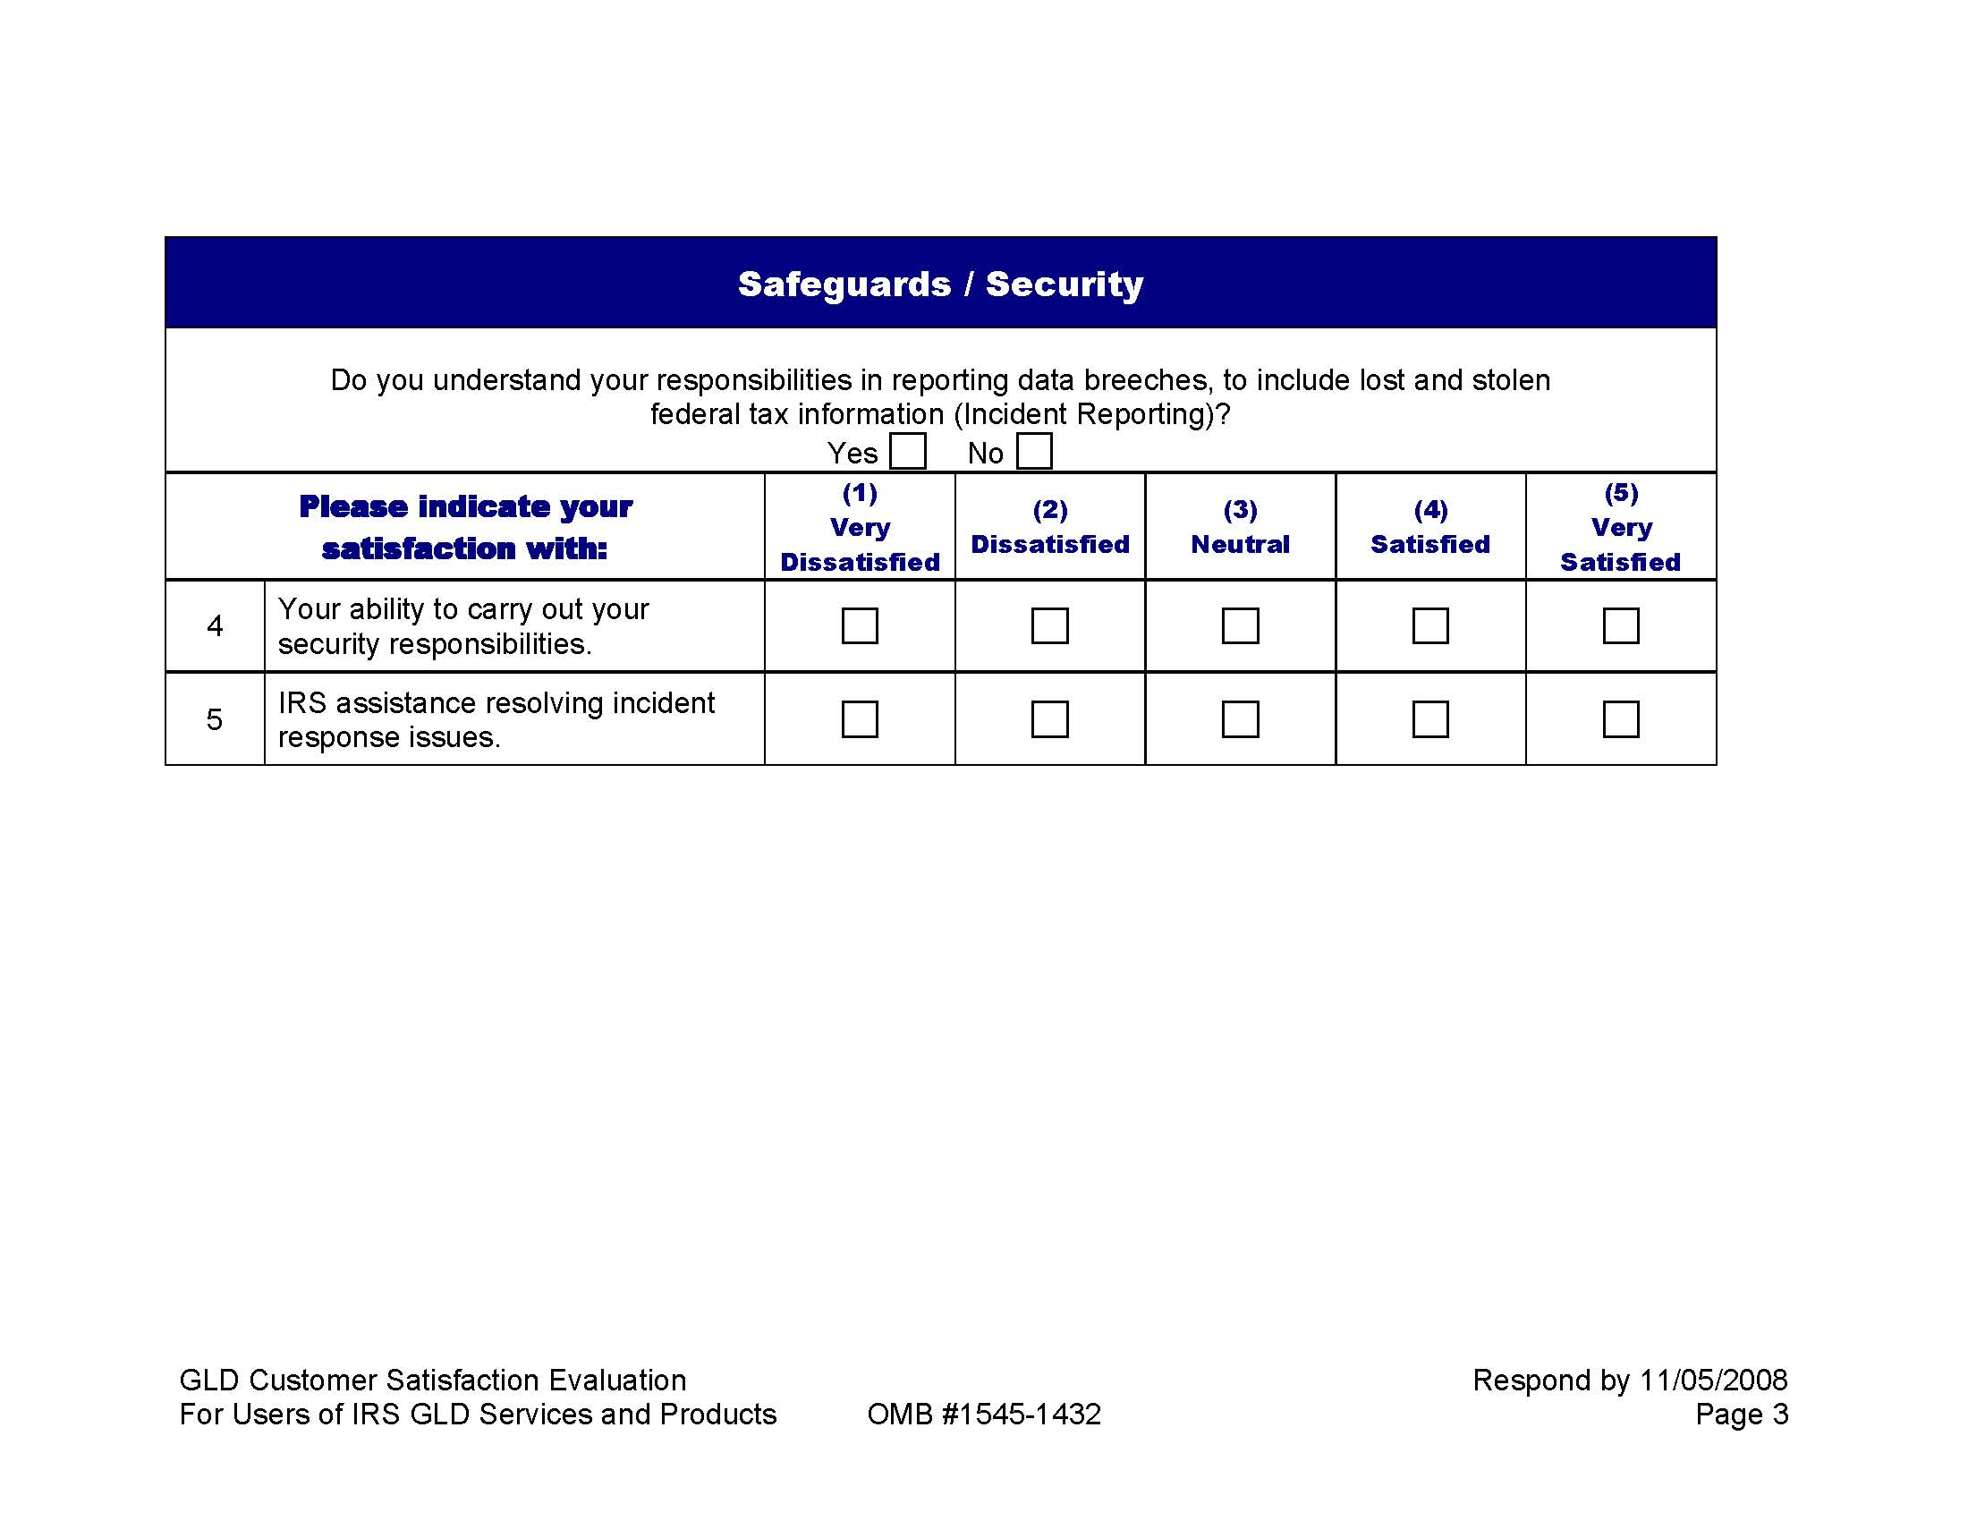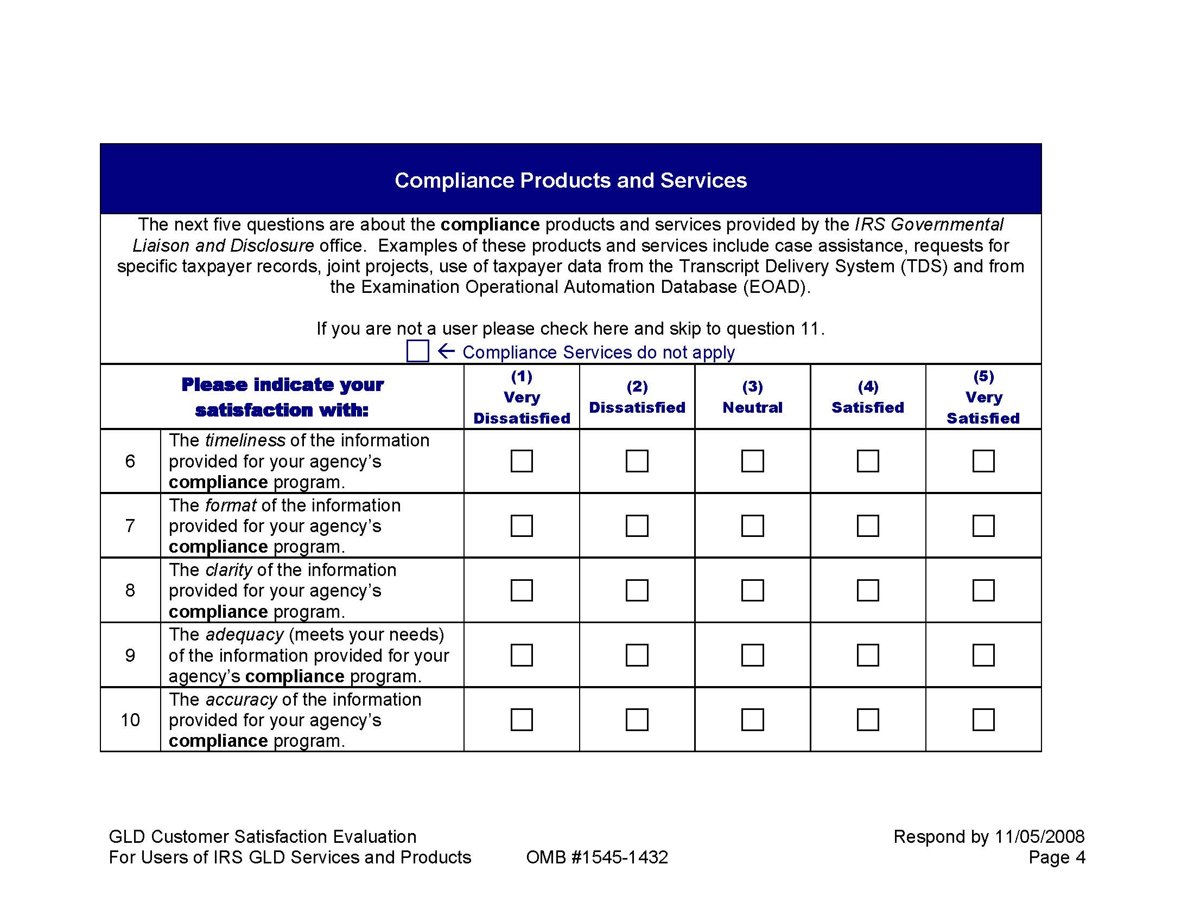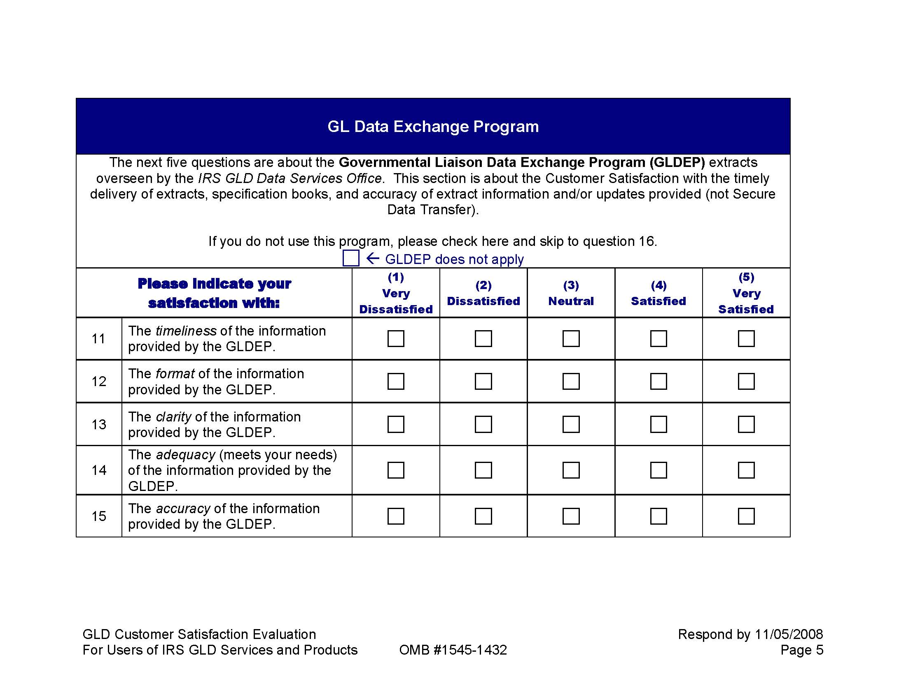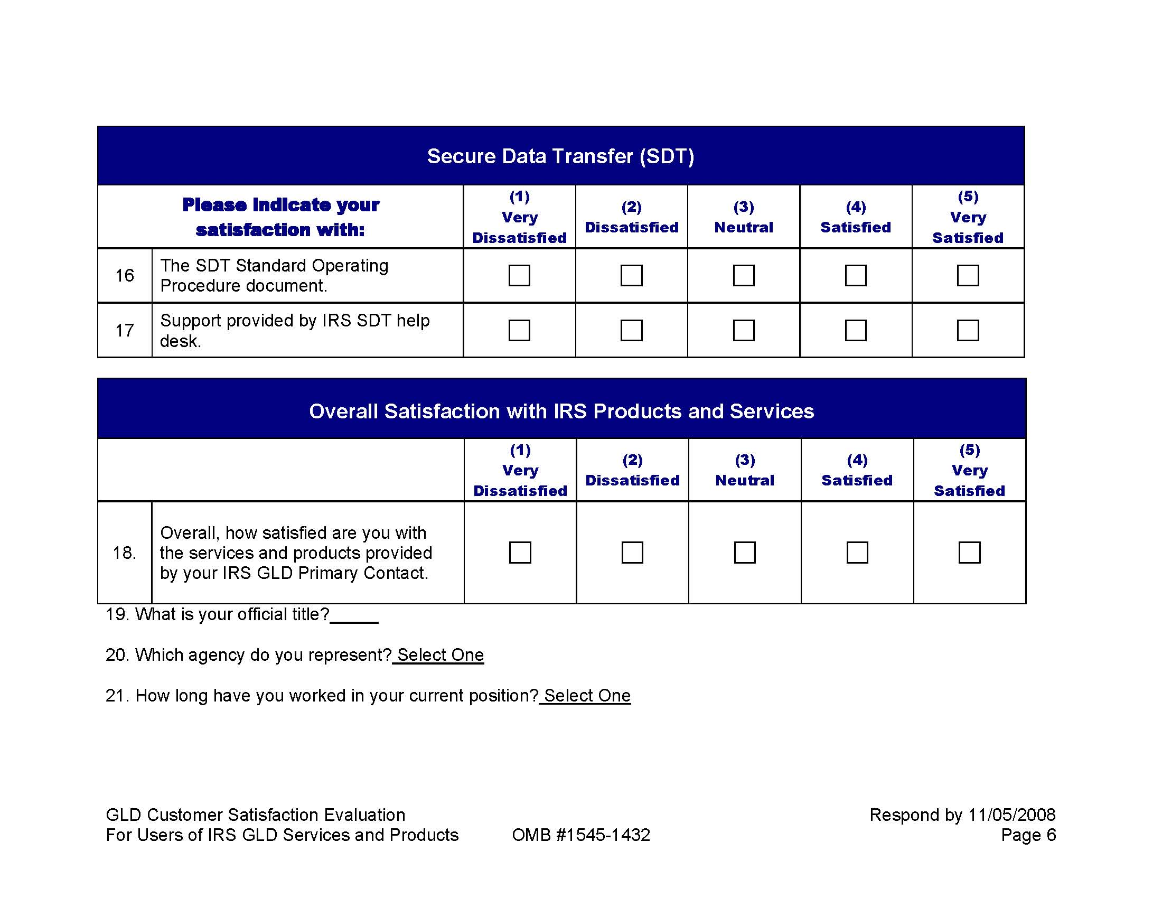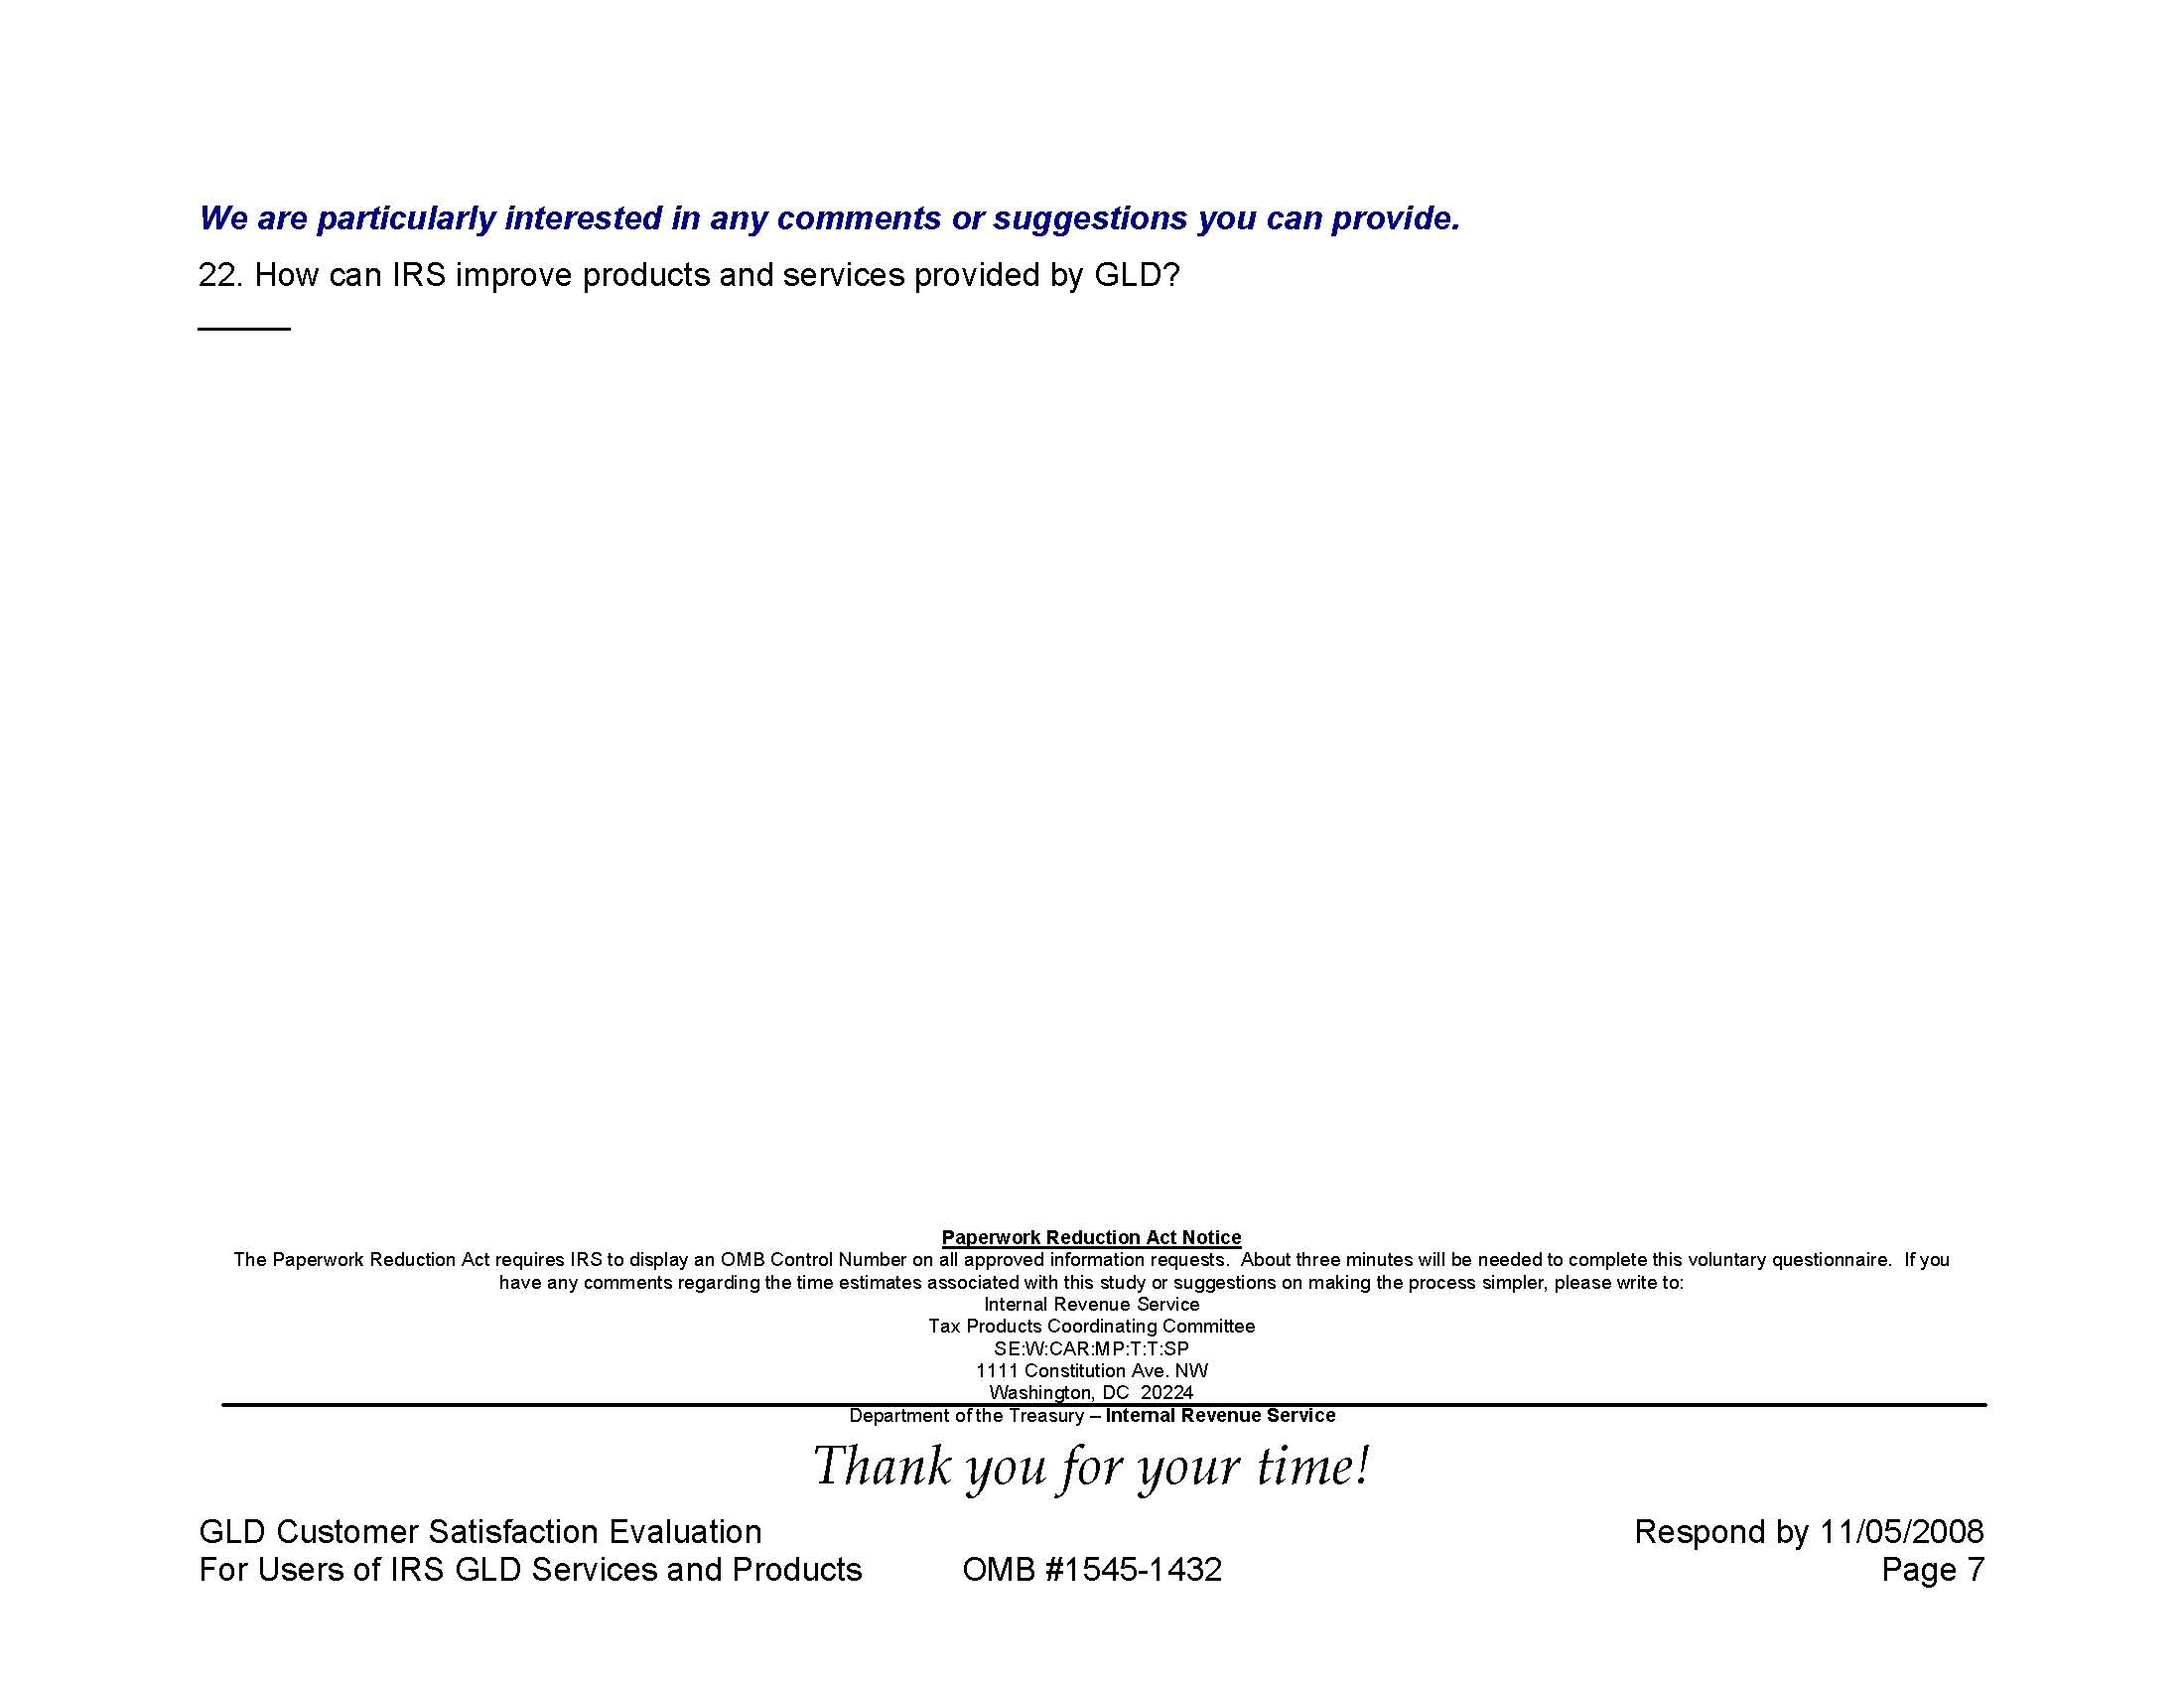

Attachment IV: Users of Products and Services Cover letter
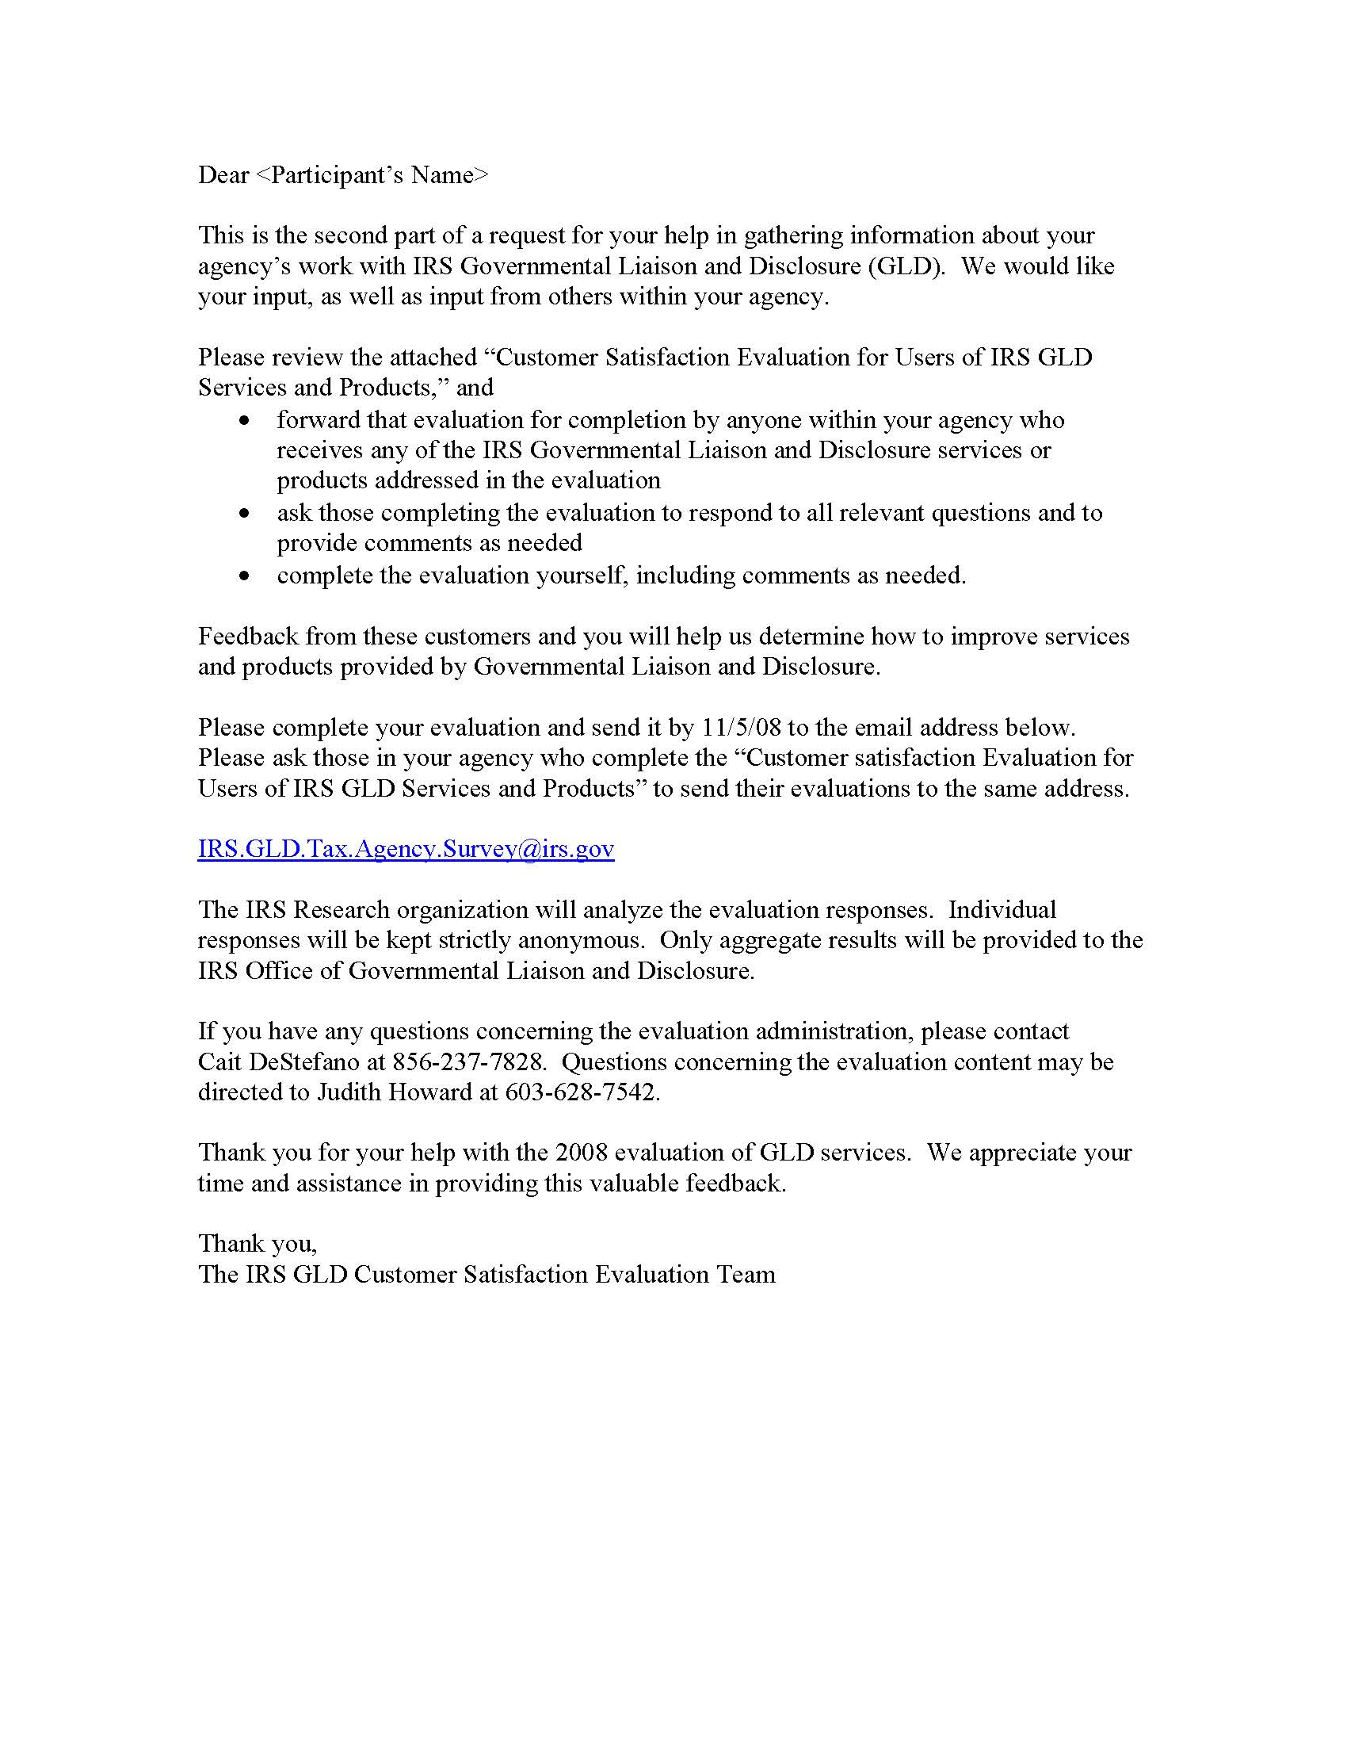

Attachment V: Follow-up / Reminder notice
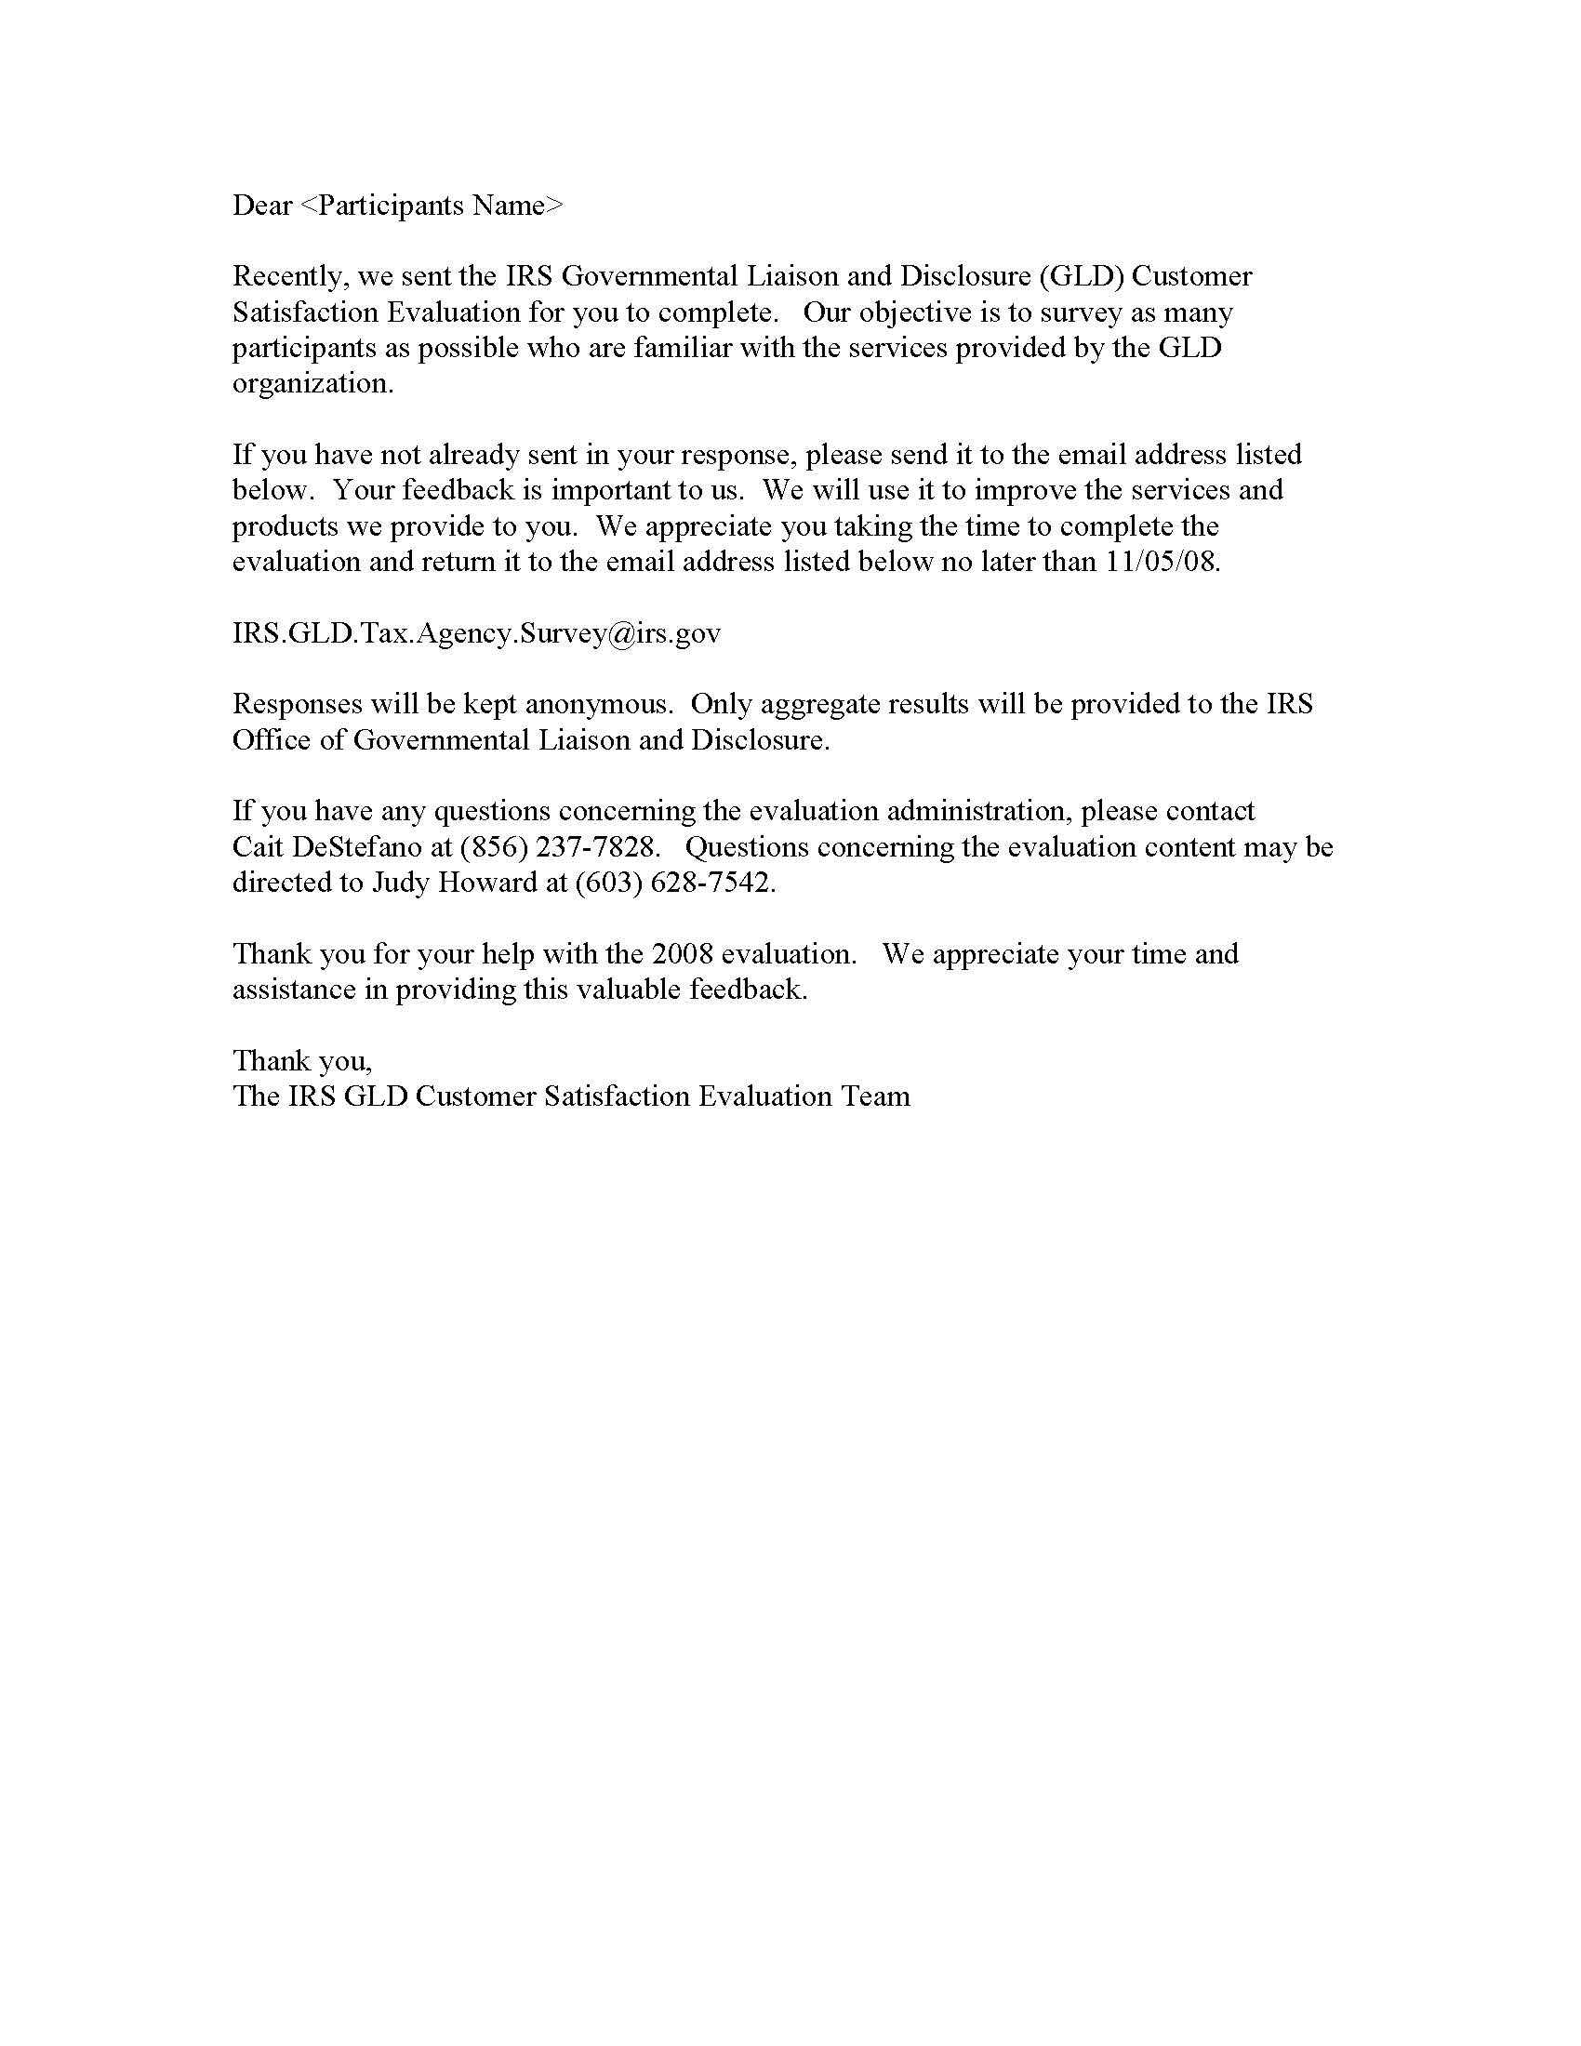
Attachment VI: GLD Agency Enrollment form
