Date

Dear OCS Grantee,

I am writing to request your participation in an evaluation questionnaire for the Office of Community Services, recently named the OCS Evaluation Initiative. The evaluation is being conducted by the Academy for Educational Development (AED) under the direction of Dr. Rose Ann M. Rentería.

Your perspectives as an OCS grantee are very valuable to us as we investigate how OCS can better support the Community Economic Development (CED) and Job Opportunities for Low -Income Individuals (JOLI) projects in the United States as well as the dissemination, translation and use of research findings for program impact, management and practice.

The evaluation questionnaire’s primary purpose is to document and systematically evaluate the program performance of the OCS discretionary grant programs—CED and JOLI—in qualitative and quantitative terms to capture key information about program and grantee-level performance in four general areas: (1) program purpose and design; (2) strategic planning; (3) program management; and (4) program results. The data collected with this questionnaire will provide guidance in program evaluation so that future CED and JOLI grantees continue to have effective plans. Only current information is needed for this data collection. Grantee staff is not required to collect new data for the performance measures or retain information beyond the performance measures as defined by OCS in the program announcement. Finally, with the results OCS hopes to be able to target evaluation training at specific levels of grantees and to make adjustments to the requirements based on the grantees capabilities.

The OCS questionnaire is web-based and can be accessed at the OCS Evaluation Initiative web site at: www.ocsevalinitive.com. To begin the questionnaire, please use the following user name and password:
Username:
Password:

Public reporting burden for this collection of information is estimated to average 1.5 hours including the time for reviewing instructions, gathering and maintaining the data needed, and completing and reviewing the collection of information. An agency may not conduct or sponsor, and a person is not required to respond to, a collection of information unless it displays a currently valid OMB control number. OCS grantees should not use more than 3 hours in total to complete the questionnaire. Should you encounter technical difficulties towards the completing of the questionnaire, please call 202-884-8608 for assistance.

Your participation is voluntary and you may refuse to answer any specific questions. While, all reports based on these data will combine your comments with those of other respondents so that they cannot be traced back to you, your grantee location name by region and by OCS program type may be used to present a general overview of the major findings. If during the course of the questionnaire, however, you share ideas for which you wish to receive credit, your contributions will be acknowledged. Thank you for considering your participation in this important evaluation. If you have any questions or concerns, please feel free to contact me.

Yours sincerely,

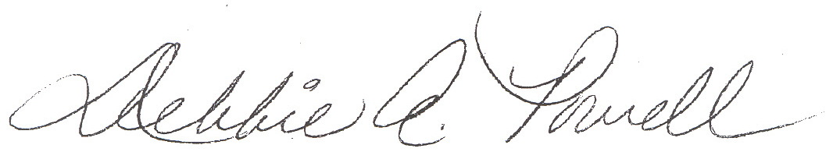

Debbie A. Powell
Acting Director
Division of Discretionary Programs
Office of Community Services
Administration for Children and Families
U.S. Department of Health and Human Services
370 L’Enfant Promenade, S.W – 5th Floor West
Washington, D.C. 20447
Phone (202) 401-6968
Fax (202) 401-5726
Email: dpowell@acf.hhs.gov

