 | NATIONAL AGRICULTURAL STATISTICS SERVICE |  |  | MONTHLY APPLE  STORAGE REPORT |  |  |  |  | Form Approved  O.M.B. Number 0535-0001  Approval Expires 03/31/07  Project Code 160  QID 20057042
USDA, NASS, Pennsylvania Field Office  2301 N. Cameron Street, Room G-19  Harrisburg, PA 17110-9405  1-800-498-1518  Fax: 1-800-498-1548  E-mail: nass-pa@nass.usda.gov |  |  |  |  |  |  | Pennsylvania Department of Agriculture  Dear Reporter:  Response to this survey is voluntary and not required by law. However, your reply to the questions on this form provide the basis for our reports on stocks of apples in refrigerated storage facilities at the end of the month.  Your individual report will be kept confidential. Please return your report in the envelope provided.  If you do not have apples or pears in cold storage, PLEASE CHECK ()  $ Season has not started ( )  $ Finished for the season ( )  $ No longer operate  cold storage facilities ( )  Thank you.  Sincerely,  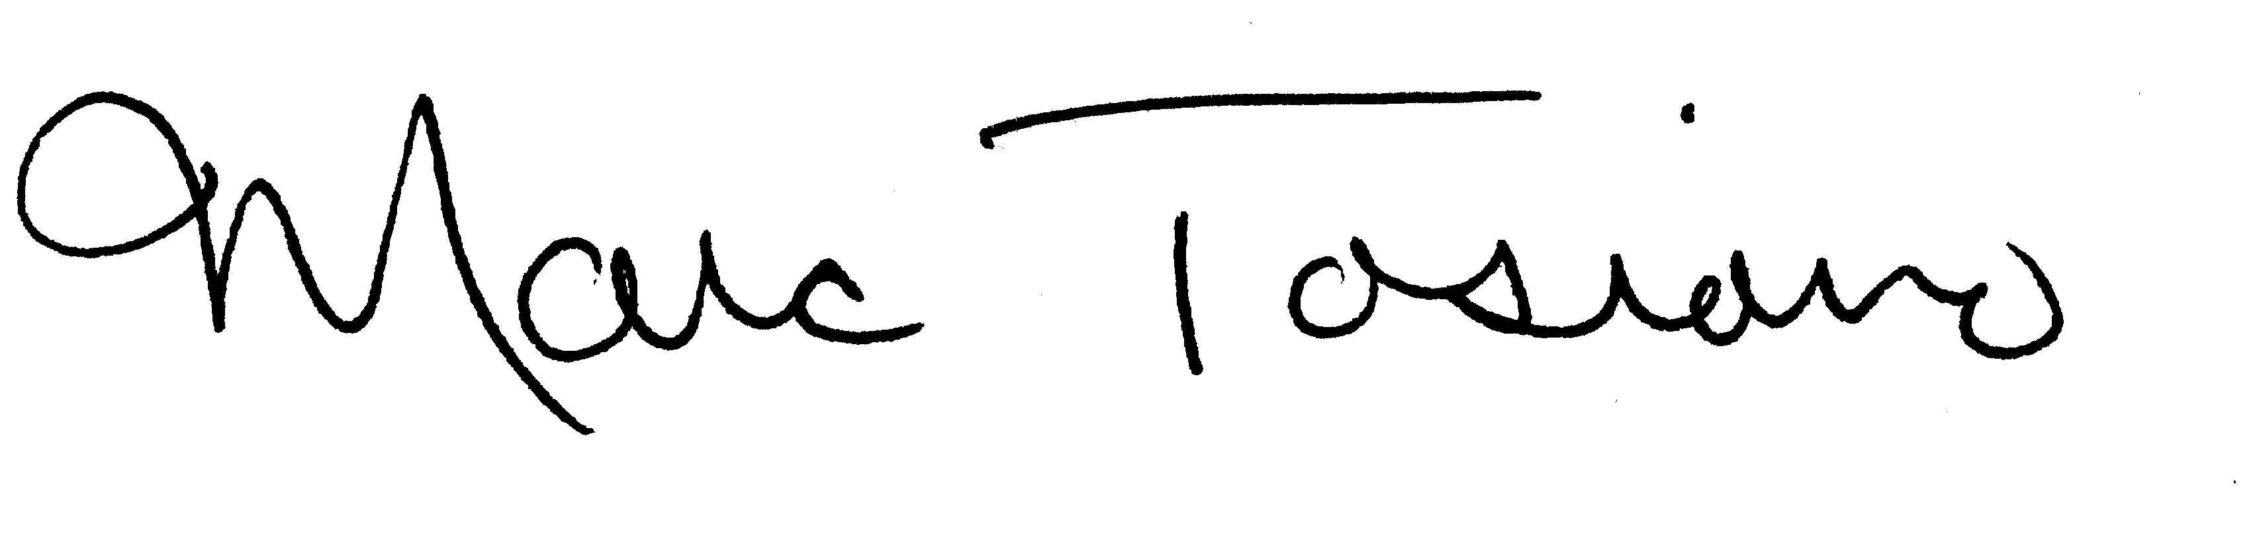  Marc Tosiano  Director
Please make corrections to name, address and Zip Code, if necessary
OFFICE USE
005 |  | 006

Instructions on the reverse side -
VARIETIES | STOCKS ON HAND February 28, 2007
VARIETIES | Fresh Market  (Bushels) |  | Processing or Stored for Processing (Bushels)
VARIETIES | Regular  Storage | C.A. Storage | Regular  Storage | C.A. Storage
Braeburn | 101 | 201 | 301 | 401
Cortland | 102 | 202 | 302 | 402
Empire | 103 | 203 | 303 | 403
Fuji | 104 | 204 | 304 | 404
Gala | 105 | 205 | 305 | 405
Golden Delicious | 106 | 206 | 306 | 406
Granny Smith | 107 | 207 | 307 | 407
Idared | 108 | 208 | 308 | 408
Jonagold | 109 | 209 | 309 | 409
Jonathan | 110 | 210 | 310 | 410
McIntosh | 111 | 211 | 311 | 411
Mutsu/Crispin | 112 | 212 | 312 | 412
Newtown Pippin | 113 | 213 | 313 | 413
Northern Spy | 114 | 214 | 314 | 414
Cripps Pink/Pink Lady | 115 | 215 | 315 | 415
Red Delicious | 116 | 216 | 316 | 416
Rome | 117 | 217 | 317 | 417
Rome Sport | 118 | 218 | 318 | 418
Spartan | 119 | 219 | 319 | 419
Stayman | 120 | 220 | 320 | 420
Winesap | 121 | 221 | 321 | 421
York | 122 | 222 | 322 | 422
All Other Varieties | 123 | 223 | 323 | 423
Not Segregated | 124 | 224 | 324 | 424
TOTAL - ALL VARIETIES | 125 | 225 | 325 | 425
Average weight per bushel | POUNDS
Average weight per bushel | 029

If you would like to receive a copy of the results of this survey in the mail,
please make a check () in the box.
(Results will also be available on the Internet at http://www.nass.usda.gov)

PLEASE CONTINUE ON BACK

INSTRUCTIONS:

 UNIT OF REPORT: Include ALL APPLES held for fresh market and processing use in regular cold storage and modified air (C.A.) storage. Please report in bushels all apples whether graded or ungraded, packed or loose, in boxes, bins, cartons, baskets and pallet-type boxes. Report separately for each variety according to the breakdown specified below.

 REFRIGERATED STORAGE: Reports are needed for all storages, public or private, which are artificially cooled to 50 degrees or lower, where food commodities are normally stored for 30 days or more.

 STOCKS ON HAND: Report total stocks held under refrigeration in this storage at the end of the month, regardless of ownership or length of time held. Do not include stocks held elsewhere. Include fruit held for all purposes, (fresh and processing) regardless of ownership.

COMMENTS: Any comments you wish to offer relative to the supply, demand, prices, movement, condition, etc. for your area would be appreciated.

Reported by: |  | Telephone: |  | Date:

According to the Paperwork Reduction Act of 1995, no persons are required to respond to a collection of information unless it displays a valid OMB control number. The time required to complete this information collection is estimated to average 10 minutes per response.

