Pregnancy Medical Care Log

The Pregnancy Medical Care Log will help keep track of all of your visits to doctors and other medical providers during your pregnancy. We will ask you about these visits during upcoming interviews. The log has two parts. The first part is for Routine/Well Visits and the other part is for Sick Visits. Please include visits to doctor’s offices, hospital emergency rooms and outpatient clinics, and any hospitalizations. Bring this Medical Care Log with you to each of your visits. If you forget to bring it with you to a visit, please complete the log as soon as possible afterwards.

Instructions for Completing Routine / Well Visits Log  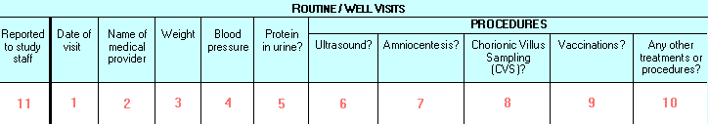  - Write in the visit date (month/day/year).  - Write in the name of the medical provider. For example, if you saw a Nurse Practitioner by the name of Jane Doe, write “Jane Doe” in the space provided.  - Ask the medical provider to fill in your blood pressure.  - Ask the medical provider to fill in your weight.  - If you had protein in your urine, put a √ in the space provided.  - If you had an ultrasound during the visit, put a √ in the space provided.  - If you had an amniocentesis during the visit, put a √ in the space provided.  - If you had chorionic villus sampling (CVS) during the visit, put a √ in the space provided.  - If you had any vaccinations during the visit, put a √ in the space provided and write in the name of the vaccination(s) you received.  - If you had any other treatments or procedures during the visit, put a √ in the space provided and write what the treatment or procedure was. For example, if you had your blood taken to test for anemia, please write “blood taken for anemia test.”  - After you have finished telling NCS Staff about the routine / well visit, put a √ in the space provided.  IF YOU NEED HELP OR HAVE QUESTIONS PLEASE CALL  XXX-XXX-XXXX | Instructions for Completing Sick Visits Log  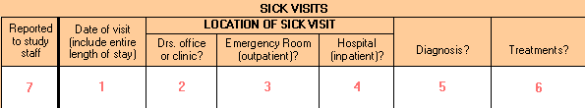  - Write in the visit date (month/day/year). If the visit lasts longer than a day, write in the entire length of the visit (i.e., 9/2/2008 – 9/3/2008).  - If you went to a doctor’s office or clinic, put a √ in the space provided.  - If you went to a hospital emergency room and were seen as an outpatient, put a √ in the space provided.  - If you went to the hospital and were seen as an in-patient, put a √ in the space provided. [You may put a √ in both the emergency room (outpatient) box and the hospital (in-patient) box if you were first seen in a hospital emergency room and you were later admitted to the hospital].  - If you received a diagnosis, put a √ in the space provided and fill in what the diagnosis was.  - If you received any treatments, put a √ in the space provided and write what the treatments were.  - After you have finished telling NCS Staff about the sick visit, put a √ in the space provided.  Affix label with VC info here

