Colorado River Basin Symposium Initial Contact E-mail

Dear 2008 Colorado River Basin Science and Management Symposium Attendee:

The Colorado River Basin Science and Management Symposium, held in Scottsdale, AZ in 2008, was designed to promote discussion and productive communication among participants, with a strong focus on enhancing communication between researchers and resource managers. I am writing to ask for your thoughts on how well the symposium met those objectives. I would like you to take a few minutes to fill out an online survey about your experiences and thoughts about the Symposium you attended in November 2008.

The goal of the survey is to learn what conference attendees feel are the strengths and weaknesses of the conference in order to improve future Colorado River Basin Science and Management conferences designed to bring researchers and managers together. Because the number of attendees is relatively small, your participation is needed for the success of this project. Your name will in no way be connected with your answers as all responses will be combined in the analysis. We will destroy the e-mail list once the survey is complete.

To complete the online survey, please click on the link below and enter the following access code on the first page of the survey:
Your access code:
http://www.surveymonkey.com/

The survey should take about 15 minutes to complete. Feel free to contact me at the phone number or e-mail address listed below with any questions.

Thank you very much for your participation.

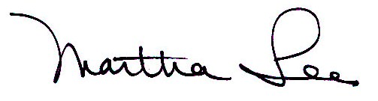
Martha Lee
Professor
School of Forestry
Box 15018
Northern Arizona University
Flagstaff, AZ 86011
(928) 523-6644
martha.lee@nau.edu

OMB control Number: 1040-0001
Expiration Date: March 31, 2012

