Colorado River Basin Symposium and Colorado Plateau Research Conference email to Non-respondents only.

Dear Colorado River Basin Science and Management Symposium [or Colorado Plateau Research Conference] Attendee:

I thought I would send you one final request concerning the survey I am conducting of those who attended the Colorado River Basin Science and Management Symposium [or Colorado Plateau Research Conference] held in Scottsdale, Arizona.

Your response to this survey is valuable regardless of your level of participation in the conference. This shortened version of the survey will only take about 5 minutes to complete. I hope you will take the time to participate.

Please click on the link below and enter the following access code on the first page of the survey.

Your access code:
http://www.surveymonkey.com/

Thank you so much for your help.

Best regards,
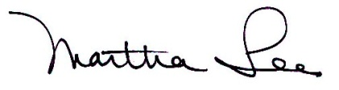
Martha Lee
Professor
School of Forestry
Box 15018
Northern Arizona University
Flagstaff, AZ 86011
(928) 523-6644
martha.lee@nau.edu

OMB control Number: 1040-0001
Expiration Date: March 31, 2012

