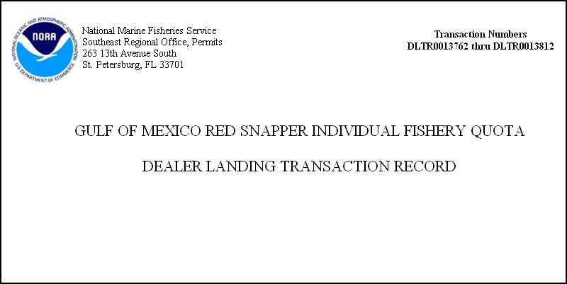
Under the provisions of the Paperwork Reduction Act of 1995 (PL 104-13) and the Privacy Act of 1974 (PL 93-579), you are advised that disclosure of the requested information is mandatory for the purpose of managing the Gulf of Mexico Reef Fish fishery. The requested information is used to ensure proper compliance with the red snapper IFQ program. Confidentiality of the information provided will be treated in accordance with NOAA Administrative Order 216-100. The public reporting burdens for this collection of information are estimated as follows 7 minutes for the dealer transaction report. The estimates of public reporting burdens for these collections of information include the time for reviewing instructions, searching existing data sources, gathering and maintaining the data needed, and completing and reviewing the collection of information. Written comments regarding the burden-hour estimates or other aspects of the collection-of-information requirements, or suggestions for reducing this burden, should be sent to Jason Rueter, NMFS, Southeast Regional Office, 263 13th Avenue South, St. Petersburg, FL 33701

OMB Control No. 0648-xxxx
Expiration date xx/xx/xxxx

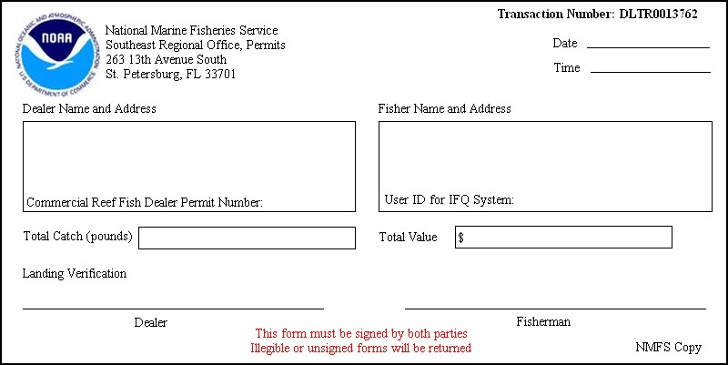
OMB Control No. 0648-xxxx
Expiration date xx/xx/xxxx
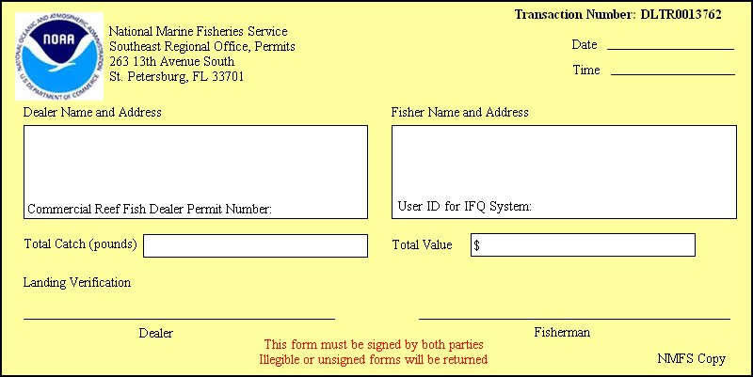
OMB Control No. 0648-xxxx
Expiration date xx/xx/xxxx

