Attachment A

New Reporting Pages for the
Oral Health Management Information System:

- Success Stories

- Environmental Assessment

SUCCESS STORIES

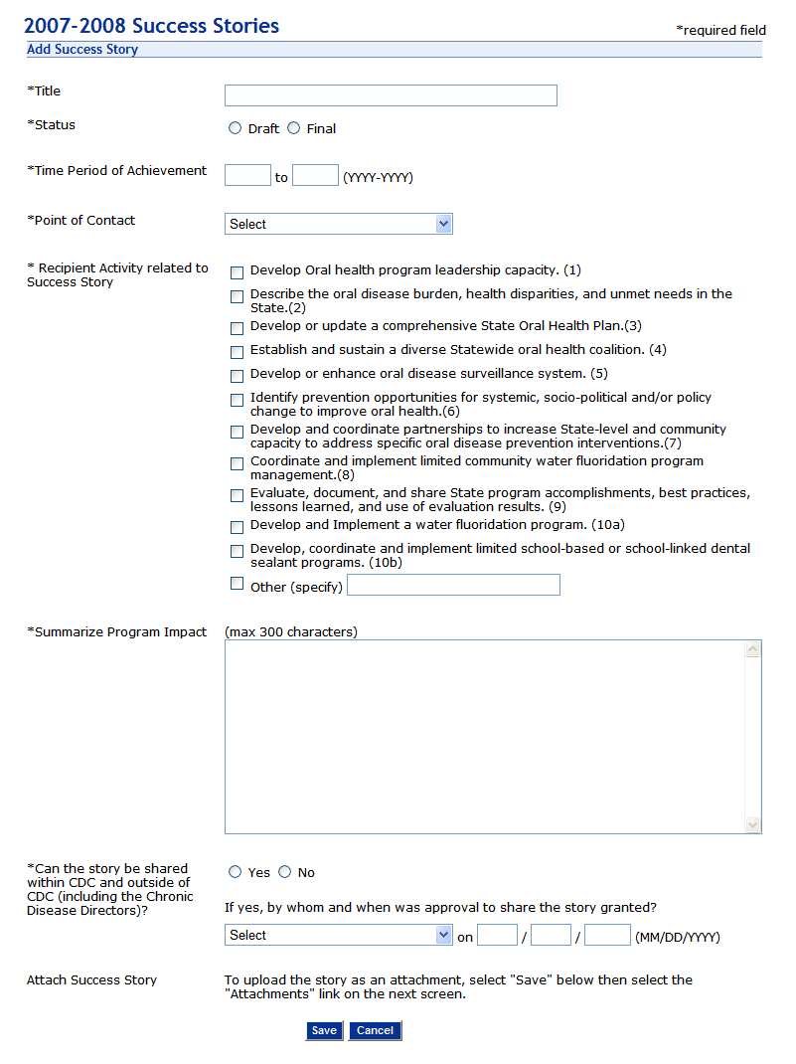

ENVIRONMENTAL ASSESSMENT

