Summary of ASAP Applicant Survey Questions:

Page 1 Questions
Is this the first time that you have applied for a vacancy announcement using the ASAP system?
I was able to navigate around the web site with no difficulty.
I was able to successfully complete and submit my application with no difficulty.

Page 2 Questions
I found it easier to enter my employment information on-line compared to completing a paper form.
I like being able to apply on-line.

Page 3 Questions
Overall, my experience using this automated staffing solution was positive.
Please add any additional comments you may have in the area below:

Applicants access the ASAP Applicant survey from the following location:
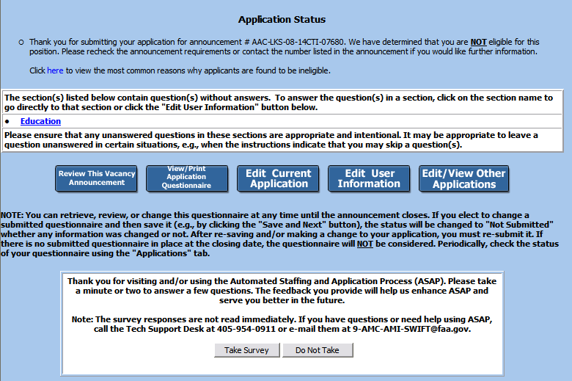

Page 1 of ASAP Applicant survey

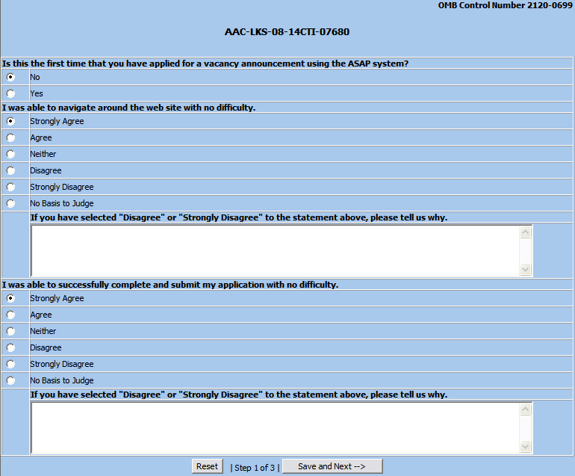

Page 2 of ASAP Applicant Survey

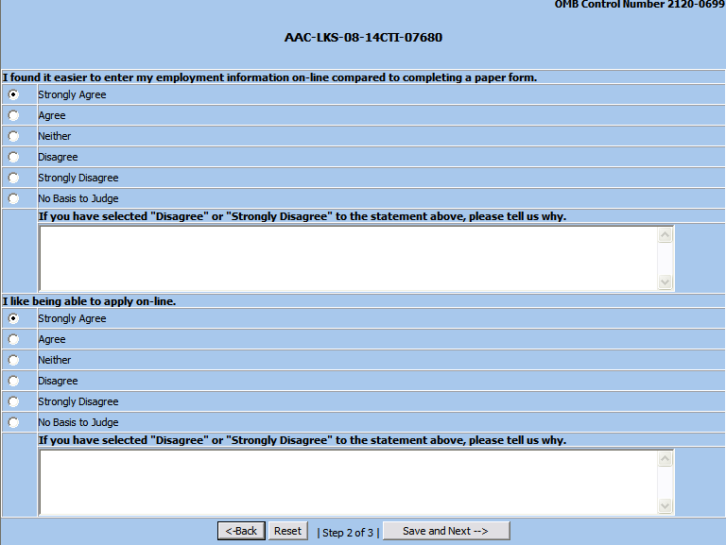

Page 3 of ASAP Applicant Survey

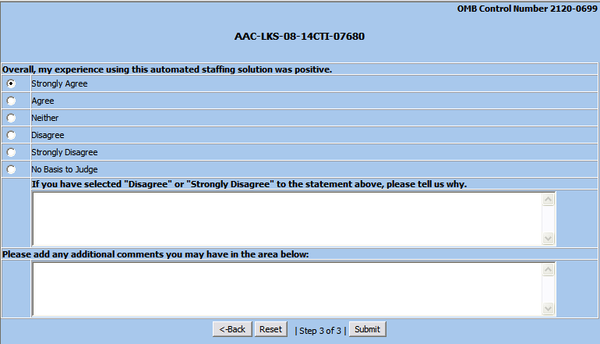

Confirmation of Survey Submittal

