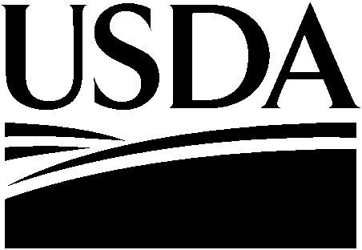

October 22, 2008

B. Sachau
15 Elm Street
Florham, NJ 07392

Dear B. Sachau

In response to your public comment regarding Federal Register Notice, Department of Agriculture, Food and Nutrition Service (FNS), Agency Information Collection Activities: Proposed Collection; Comment Request: Uniform Grant Application Package for Discretionary Grant Programs, Federal Register August 20, 2008, Volume 73, No. 162, pages 49159-49160, we offer the following information.

Enclosed is a copy of the FNS supporting statement which describes the types of information we will be collecting, the different grant programs we manage, the number of respondents who have submitted proposals in the past, and the number of hours spent preparing the proposals. Additionally, we encourage you to go to the FNS website (www.fns.usda.gov) for additional information regarding our grant opportunities. Thank you for your interest in our programs.

Sincerely,

LAEL J. LUBING
DIRECTOR
GRANTS MANAGEMENT DIVISION

