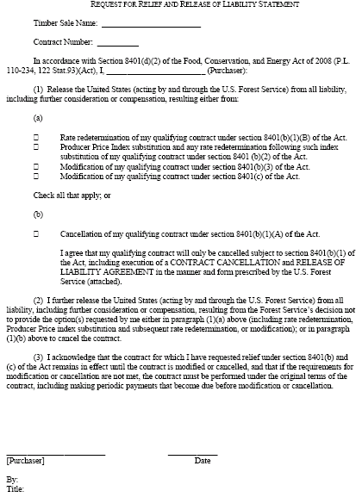

BURDEN AND NONDISCRIMINATION STATEMENTS

According to the Paperwork Reduction Act of 1995, an agency may not conduct or sponsor, and a person is not required to respond to a collection of information unless it displays a valid OMB control number. The valid OMB control number for this information collection is 0596-NEW. The time required to complete this information collection is estimated to average 10 minutes per response, including the time for reviewing instructions, searching existing data sources, gathering and maintaining the data needed, and completing and reviewing the collection of information.

The U.S. Department of Agriculture (USDA) prohibits discrimination in all its programs and activities on the basis of race, color, national origin, age, disability, and where applicable, sex, marital status, familial status, parental status, religion, sexual orientation, genetic information, political beliefs, reprisal, or because all or part of an individual’s income is derived from any public assistance. (Not all prohibited bases apply to all programs.) Persons with disabilities who require alternative means for communication of program information (Braille, large print, audiotape, etc.) should contact USDA’s TARGET Center at 202-720-2600 (voice and TDD).

To file a complaint of discrimination, write USDA, Director, Office of Civil Rights, 1400 Independence Avenue, SW, Washington, DC 20250-9410 or call toll free (866) 632-9992 (voice). TDD users can contact USDA through local relay or the Federal relay at (800) 877-8339 (TDD) or (866) 377-8642 (relay voice). USDA is an equal opportunity provider and employer.

