DATE: May 23, 2008
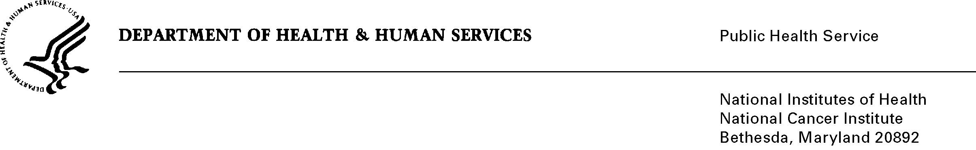

TO: Office of Management and Budget (OMB)

Through: Marilyn Tuttleman, Project Clearance Branch, NIH
Vivian Horovitch-Kelley, NCI OMB Project Clearance Liaison

FROM: Nina Goodman, Project Officer
National Cancer Institute, Office of Communications and Education (OCE)

SUBJ: Pretesting/Formative Research for NCI Communications Messages
Generic Sub-study “Web-Based Survey to Understand Public Perceptions of Genetic Testing”
(OMB No. 0925-0046-10; Expiration Date 1/31/10)

In accordance with the terms of the 3-year extension granted by OMB to the NCI Office of Communications and Education on January 26, 2007, requiring that we submit individual collections to OMB prior to being implemented, I am requesting approval for this sub-survey designed to help NCI and DHHS better understand the public’s perception of genetic testing.

Since the recent completion of the Human Genome Project, the advent of detailed, personalized genetic knowledge has been characterized by its rapidly-accelerating pace of discovery. A newly emerging marketplace, where genetic tests are marketed directly to the consumer is providing consumers with personal genome-based information outside of the traditional medical care delivery system. These services, where consumers provide samples at home and receive the results directly, are becoming increasingly common, with multiple organizations offering numerous and sophisticated tests. In the months since consumer genomic information services or “direct-to-consumer” genetic testing, has become widely available, there has been considerable reaction to them. These services have the potential to improve consumer engagement in medical decision-making, but consumers may not know or have access to the information necessary to evaluate the quality of the information that is provided.

It is beneficial for NCI to pretest their communications strategies, concepts, and messages while they are under development to fulfil NCI’s legislative mandate to educate and disseminate information about cancer prevention, detection, diagnosis, and treatment to a wide variety of audiences and organizations. Because little is known about this newly emerging area, HHS has teamed with NCI and proposes to conduct a web-based survey to help understand consumer knowledge and interest for genetic testing. The results of this survey will, in the short-term, be used to inform and stimulate discussion at the workshop and, in the longer-term, will inform future communications strategies, concepts, and messages of NCI and other HHS agencies. The results of this survey would provide basic understanding of the current state of the field and may be useful for evaluating future educational future initiatives.

The survey will be administered to 1000 participants, ages 18 and older, recruited from an existing panel of potential respondents obtained from commercial vendor. The total respondent burden for this effort, based on an average, pilot-tested administration time of 7 minutes and approximately 1000 respondents, is 116.67 hours. This effort will account for 5.8 percent of the total annual burden hours (2010) granted in our approval package.

Please feel free to contact me if you have any questions.

Nina Goodman, MHS

