Step One: Starts the process. The list is capable of being dynamic instead of manually having to edit the page each time.
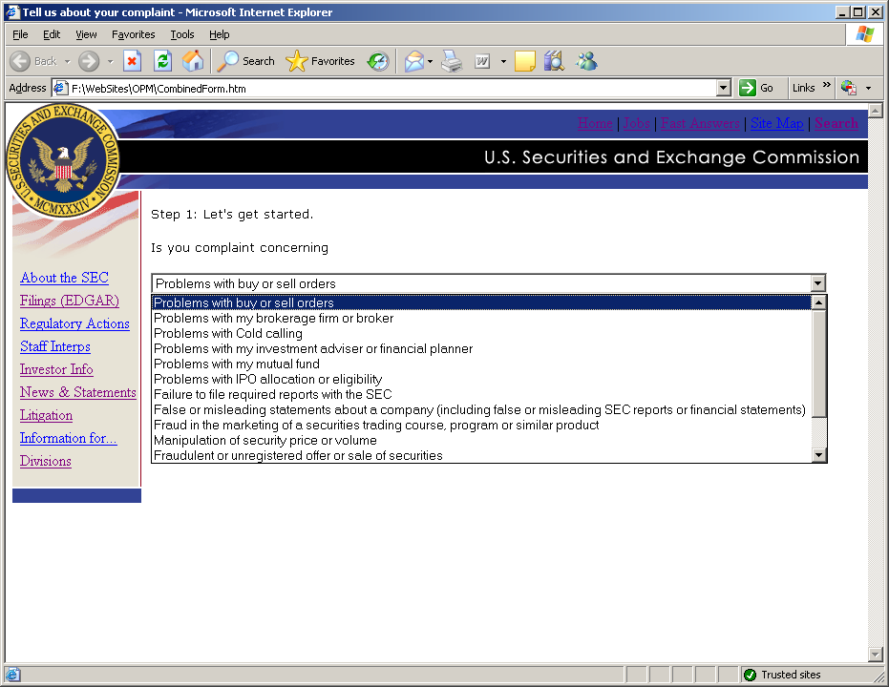
Step Two: Begins the collection process. Where appropriate drop-down lists are program driven versus manual edits.
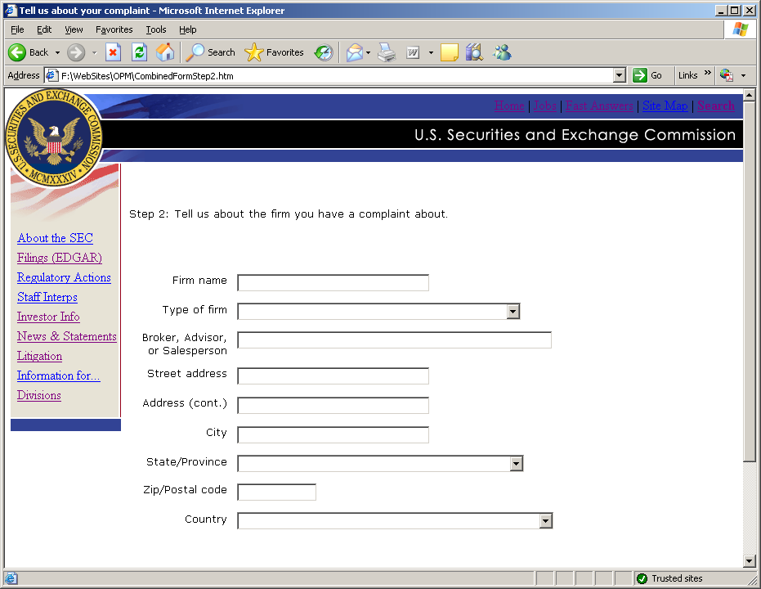

Sample of a drop down:
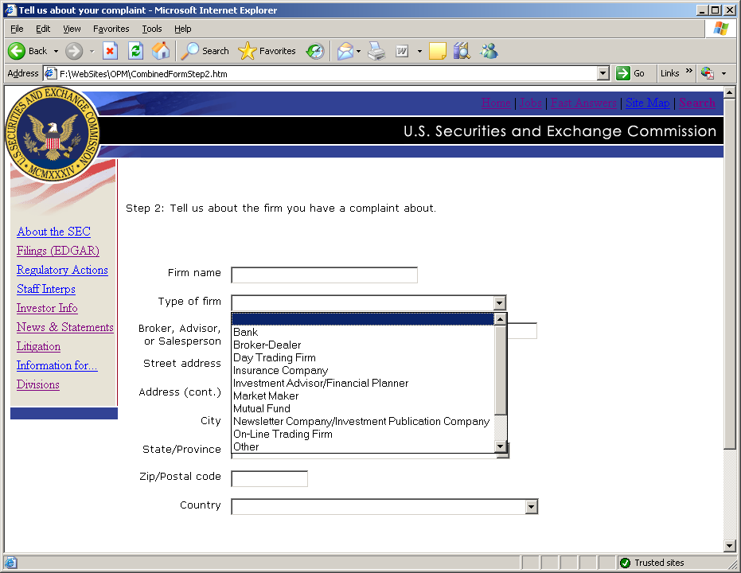
Step Three: Collects security information.
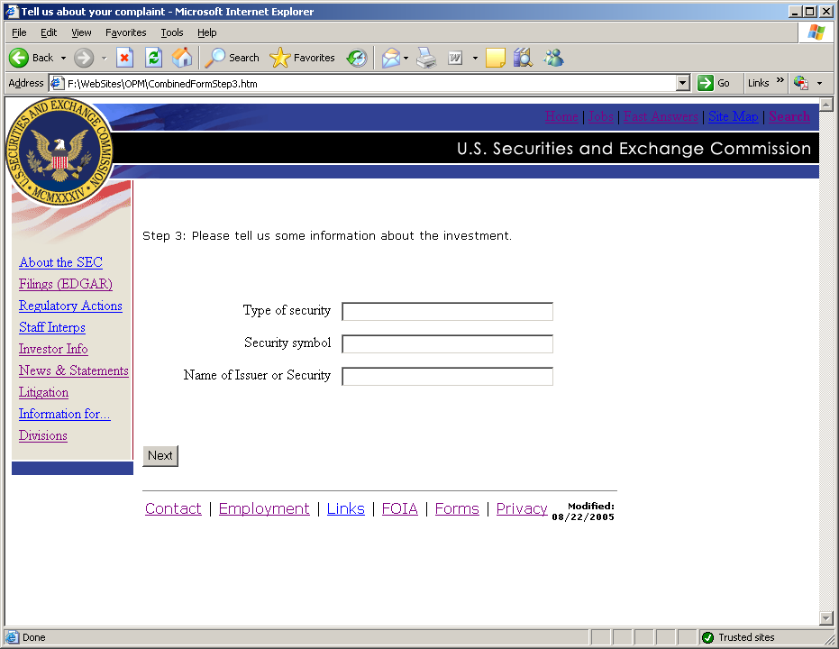

Step Four: Allows the investor to provide information about the complaint and actions he or she has taken.
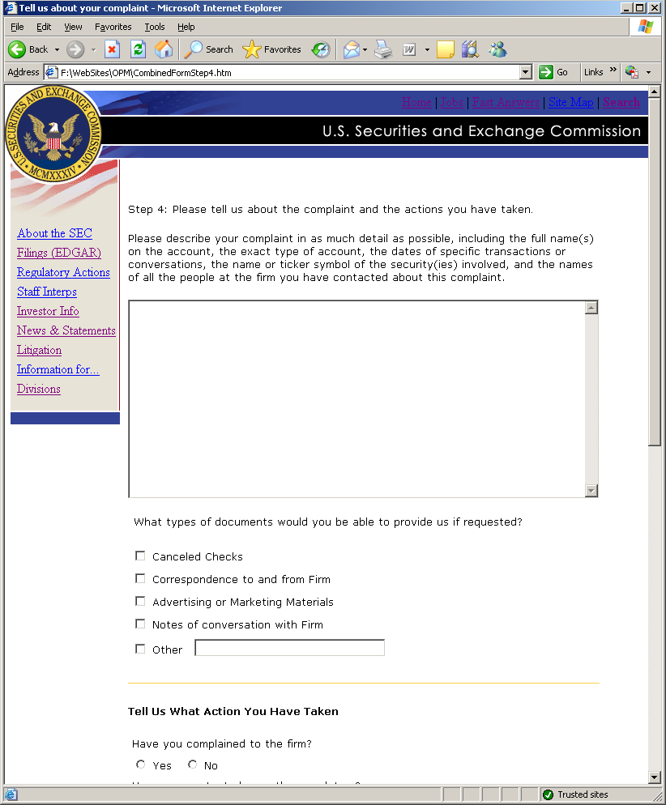
Additional information for step four:
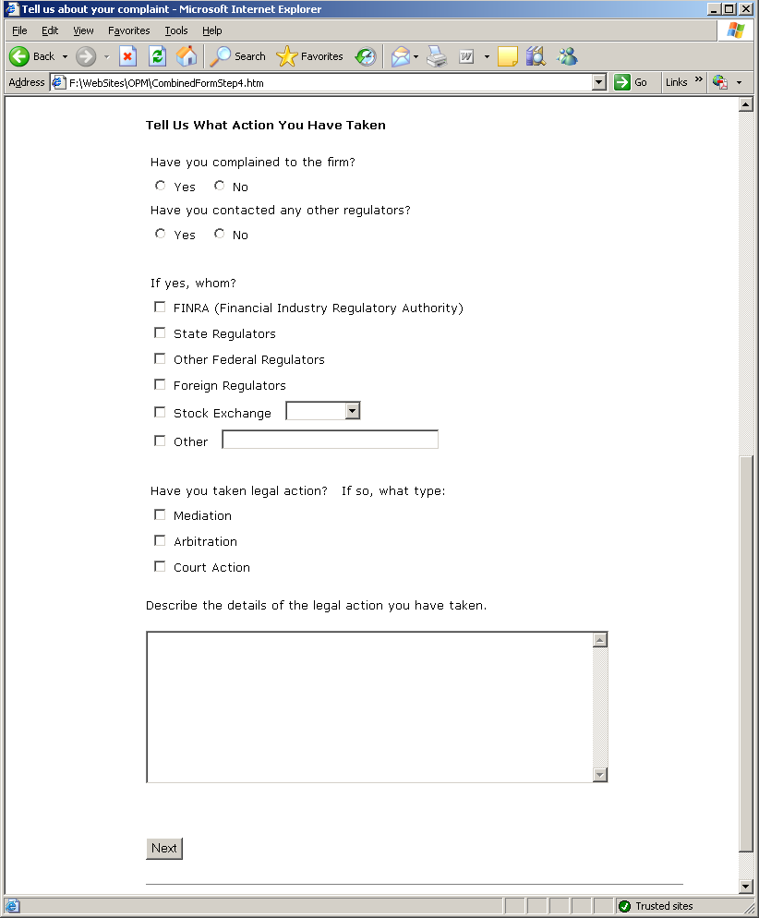
Step Five: Requests optional personal information:
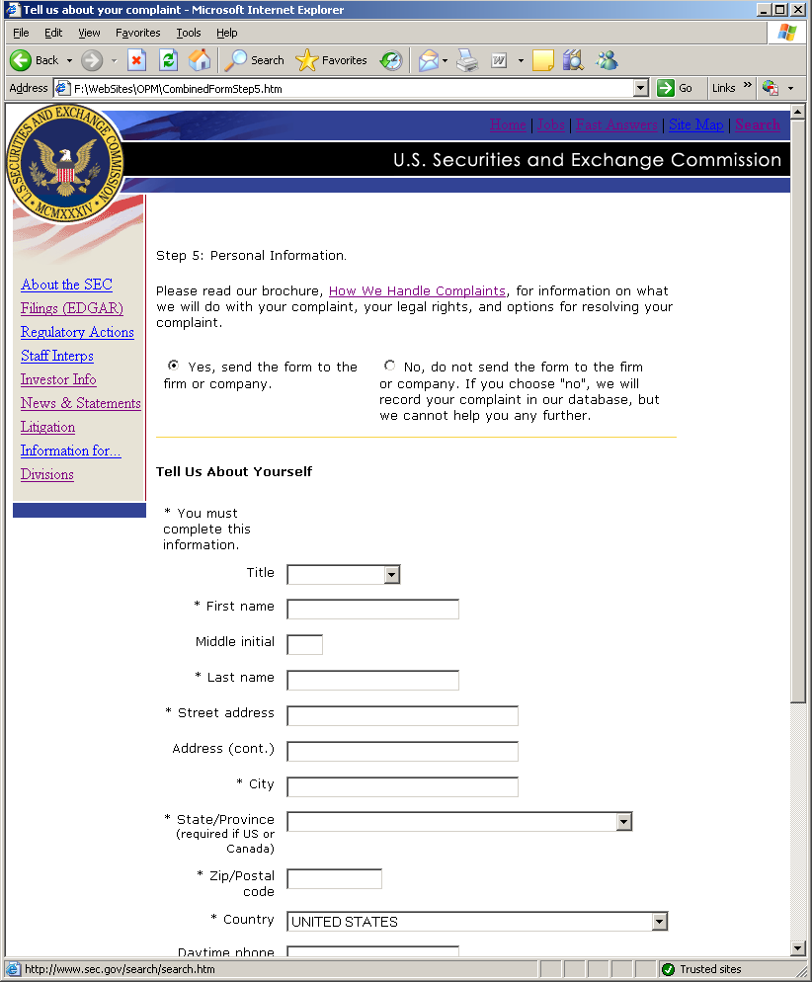
Additional fields for step five.
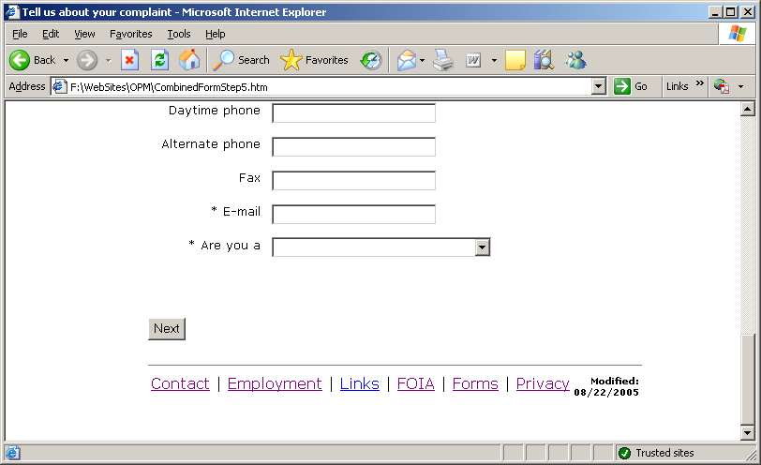

Step Six: For the investor’s convenience, we are offering the option for the investor to be alerted when we have rulemaking or an Enforcement action related to the issue(s) about which they contacted the SEC.
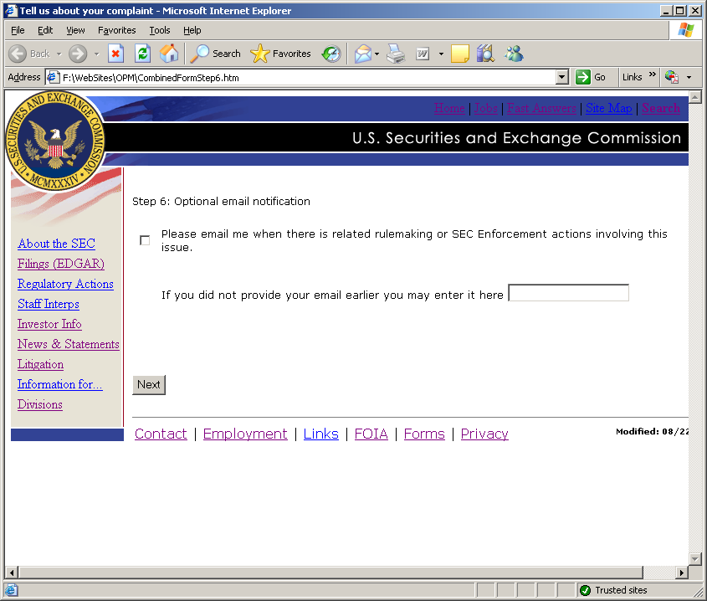

Review Step: Allows the investor to review their entries and correct inaccuracies or submit the complaint (1 of 3 screens):
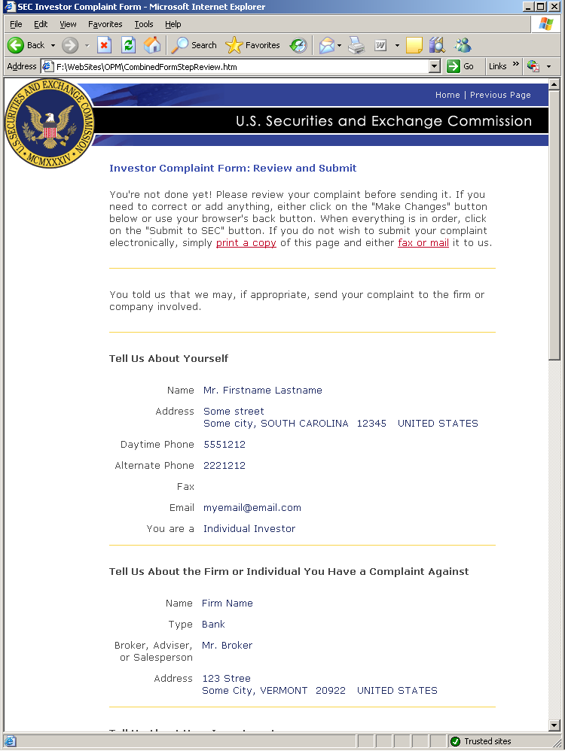
Additional information on the review screen (2 of 3):
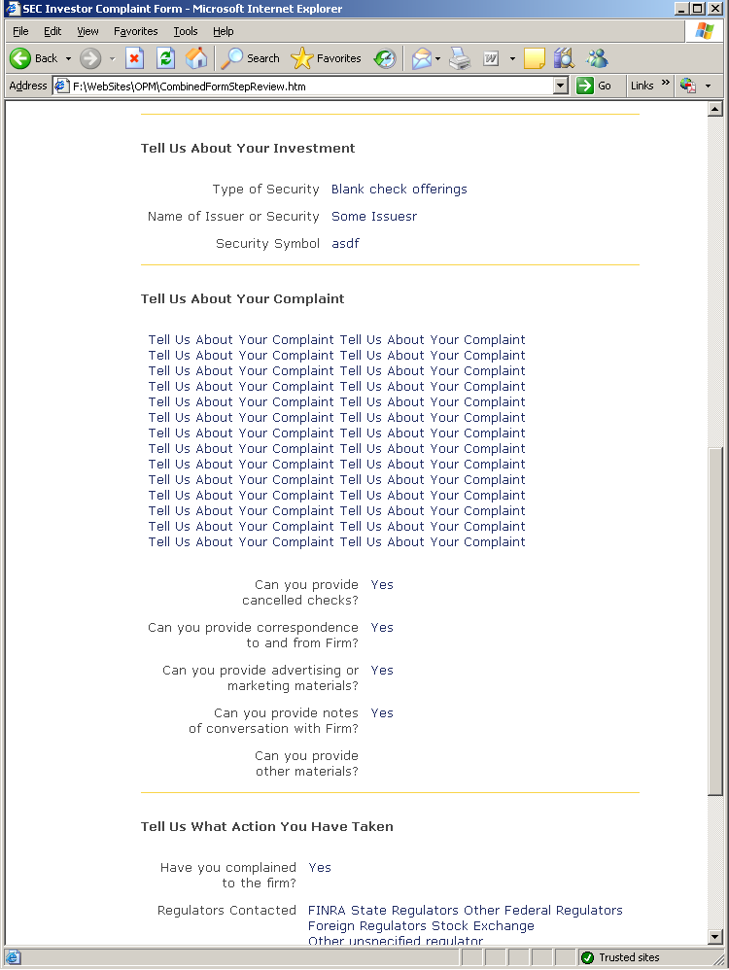

Additional information on the review screen (3 of 3):
