QD By Field Office QID 060001 |  |  | OMB No. 0535-0002 Approval Expires 3/31/2010

United States Department of Agriculture
National Agricultural Statistics Service
New England Field Office
53 Pleasant Street Room 2100 Concord, NH 03301
(603) 224-9639 (603) 225-1434 (Fax) www.nass.usda.gov
TOBACCO INQUIRY
March 2007
Please make corrections to name, address and Zip Code, if necessary. |  | Dear Tobacco Grower:  The first forecast of tobacco acreage to be harvested in 2007 will be published March 30. Your help in reporting the acreage you intend to plant this year is greatly appreciated. Updated information on sales and average price received for the 2006 crop is also requested. Response to this survey is voluntary and not required by law; however, to make our report as accurate as possible, it is important that we receive replies from as many individual growers as possible. Your cooperation in providing your best estimate for the questions below is appreciated. Individual reports will be kept confidential.  If necessary, interviewers will begin calling for information around March 5. Please help us save the cost of an interview by promptly returning this questionnaire in the enclosed envelope.  Sincerely,  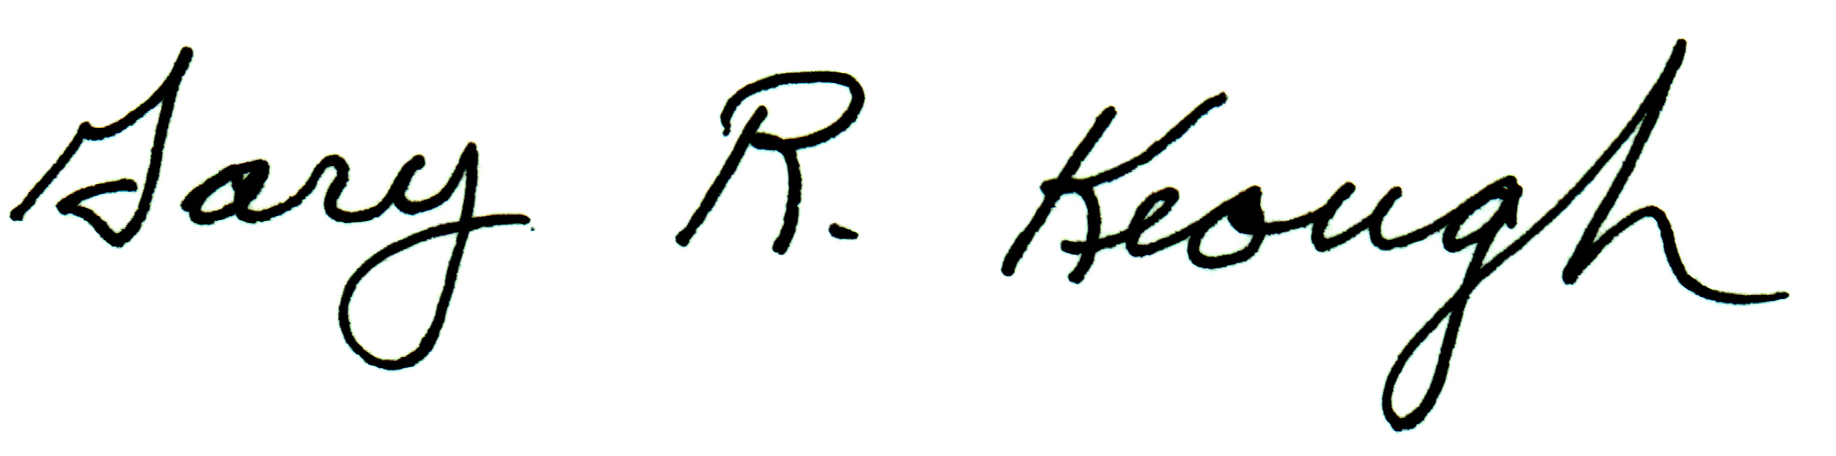  Gary R Keough  Director

Please Answer the Following Questions for Your Entire Operation
Information obtained from an earlier contact has been recorded for your verification; please correct as necessary.

2007 TOBACCO ACREAGE INTENTIONS
 | Connecticut | Massachusetts
BROADLEAF acres to be Planted 2007 (to tenths of acres) | acres | acres
SHADE acres to be Planted 2007 (to tenths of acres) | acres | acres

2006 BROADLEAF TOBACCO:
FINAL MARKETED PRODUCTION AND VALUE
 | Connecticut | Massachusetts
2006 Crop  BROADLEAF acres Planted 2006 (to tenths of acres) | acres | acres
BROADLEAF acres Harvested 2006 (to tenths of acres) | acres | acres
Pounds Marketed and To Be Marketed, 2006 crop | lbs | lbs
(Please exclude shrinkage, and exclude pounds destroyed and expected to be destroyed or not marketed for any reason)  2006 Crop Sold to Date (in pounds) | lbs | lbs
Dollars Received and to be Received for 2006 Crop Sold to Date. | dollars | dollars
(Exclude insurance payments)  2006 Crop Still on Hand and Expected to be Sold | lbs | lbs
Dollars Expected from 2006 Crop Yet to be Sold  (Exclude insurance payments) | dollars | dollars

— Shade Tobacco (Over) —

2006 SHADE TOBACCO:
PRELIMINARY MARKETED PRODUCTION
 | Connecticut | Massachusetts
2006 Crop  Shade Acres Planted 2006 (to tenths of acres) | acres | acres
Shade Acres Harvested 2006 (to tenths of acres) | acres | acres
Pounds Marketed and To Be Marketed, 2006 crop  (Please exclude expected shrinkage and pounds destroyed and expected to be destroyed or not marketed for any reason) | lbs | lbs

National 2007 crop tobacco survey results appear in the Prospective Plantings report from Washington, D.C. March 30, 2007. Revisions to the 2006 crop will be published May 11, 2007 in the Crop Production report. All reports are available via Internet at http://www.nass.usda.gov

If you would like to receive a free paper copy of the reports, please call 1-800-642-9571 to be put on the mailing list.

Please comment on any losses, or on the condition and marketing of the 2006 crop.

THANKS FOR YOUR HELP

Reported By: |  | Phone: |  | Date:

OFFICE USE
Response |  | Respondent |  | Mode |  | Enum. | Eval.
1-Comp  2-R  3-I | 9901 | 1-Op/Mgr  2-Sp  3-Acct/Bkpr  4-Partner  9-Oth | 9902 | 1-Mail  2-Tel  3-Face-to-Face  4-CATI | 9903 | 0098 | 0100
S/E Name

According to the Paperwork Reduction Act of 1995, no persons are required to respond to a collection of information unless it displays a valid OMB control number. The time to complete this information collection is estimated to average minutes per response.

