Living with Wildfires in
[CITY/COUNTY]
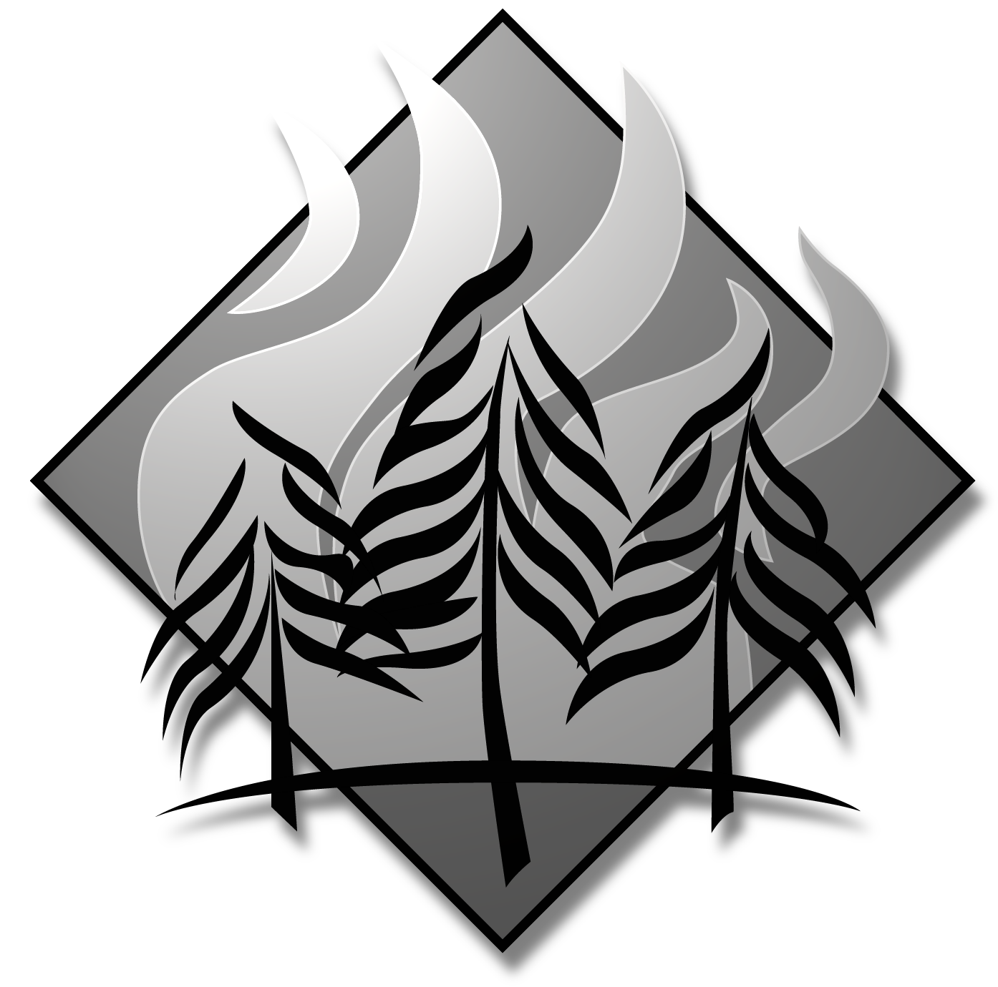
WHAT DO YOU THINK?

A community-wide survey about fire management in the [INSERT PLACE HERE]

This survey is part of a research project designed to help local officials understand the public’s views on wildfire fire management so they can develop better fire protection programs. This research is funded by the USDA Forest Service, Northern Research Station, and the Joint Fire Science Program. Please answer all of the questions and add any comments in the space provided on the last page of the survey.

Please return the survey in the postage paid envelope when you are finished.

Thanks for your help!

Department of Community, Agriculture, Recreation and Resource Studies

131 Natural Resources Building

Michigan State University

East Lansing, MI 48824-1222
BURDEN AND NONDISCRIMINATION STATEMENTS

According to the Paperwork Reduction Act of 1995, an agency may not conduct or sponsor, and a person is not required to respond to a collection of information unless it displays a valid OMB control number. The valid OMB control number for this information collection is 0596-NEW. The time required to complete this information collection is estimated to average 15 minutes per response, including the time for reviewing instructions, searching existing data sources, gathering and maintaining the data needed, and completing and reviewing the collection of information.

The U.S. Department of Agriculture (USDA) prohibits discrimination in all its programs and activities on the basis of race, color, national origin, age, disability, and where applicable, sex, marital status, familial status, parental status, religion, sexual orientation, genetic information, political beliefs, reprisal, or because all or part of an individual’s income is derived from any public assistance. (Not all prohibited bases apply to all programs.) Persons with disabilities who require alternative means for communication of program information (Braille, large print, audiotape, etc.) should contact USDA’s TARGET Center at 202-720-2600 (voice and TDD).

To file a complaint of discrimination, write USDA, Director, Office of Civil Rights, 1400 Independence Avenue, SW, Washington, DC 20250-9410 or call toll free (866) 632-9992 (voice). TDD users can contact USDA through local relay or the Federal relay at (800) 877-8339 (TDD) or (866) 377-8642 (relay voice). USDA is an equal opportunity provider and employer.

On a scale from 1 to 5, how concerned are you about each of the following issues in [CITY/COUNTY]: (please use the scale of 1=Not concerned, 5=Very concerned)
Not Concerned Very concerned
Local economy | 1 2 3 4 5
Quality of local public schools | 1 2 3 4 5
[CITY/COUNTY] budget | 1 2 3 4 5
Threat of wildfires in local area | 1 2 3 4 5
Crime in local area | 1 2 3 4 5
Access to health care | 1 2 3 4 5
Health of the local environment | 1 2 3 4 5

On a scale from 1 to 5, please rate the quality of following in [CITY/COUNTY]
(please use the scale of 1=No influence, 5=Much influence)
Poor Excellent
The [CITY/COUNTY]’s financial management | 1 2 3 4 5
Overall [CITY/COUNTY] government services | 1 2 3 4 5
The quality of services provided by local fire department | 1 2 3 4 5
Local services to prevent and protect the community from wildfires | 1 2 3 4 5
Local services to educate homeowners about wildfire protection and prevention | 1 2 3 4 5

How likely do you think it is that a wildfire will occur near your neighborhood in the next five years? (Please  one)
 Not likely at all  Slightly likely  Somewhat likely  Likely  Very likely

How likely do you think it is that a wildfire will damage your home in the next five years?
(please  one)
 Not likely at all  Slightly likely  Somewhat likely  Likely  Very likely

How concerned are you that a wildfire could change the quality of your life?
(please  one)
 Not concerned at all  Slightly concerned  Somewhat concerned  Concerned  Very concerned

Concerning [CITY/COUNTY], are the following required by local wildfire safety laws?
(please  one box for each item)
 | Yes | No | Not sure
Fire-resistant construction materials for all new homes |  |  | 
Fire-resistant landscaping and vegetation for new homes |  |  | 
Fire-resistant landscaping and vegetation for existing homes |  |  | 
Annual fire department inspection of landscaping for fire safety |  |  | 

Are the following vegetation management incentives offered to homeowners in [CITY/COUNTY]? (please  all that apply)
 | Yes | No | Not sure
Monthly or more frequent curbside pick-up of unlimited amount of yard waste (trimmings, branches, leaves, needles, etc.) |  |  | 
Monthly or more frequent curbside pick-up of limited amount of yard waste |  |  | 
Less frequent curbside pickup of yard waste |  |  | 
A free drop-off site where I can take my yard waste |  |  | 
A pay drop-off site where I can take my yard waste |  |  | 
Home visits by [CITY/COUNTY/] or fire department official to offer free advice about fire-resistant landscaping options |  |  | 
Financial assistance to property owners to help with costs of fire-resistant landscaping |  |  | 

Please indicate your level of agreement with each of the following statements about managing the vegetation on your property for wildfire protection.
(please use the scale of 1=Strongly disagree, and 5=Strongly agree)
Strongly disagree Strongly agree
It’s a good way to protect my home in case of a wildfire | 1 2 3 4 5
It improves the way my yard looks | 1 2 3 4 5
It interferes with other things I want from my yard | 1 2 3 4 5
It makes sense to do because insurance can’t replace everything | 1 2 3 4 5
It costs too much to do it right | 1 2 3 4 5
It’s hard to do the first time, but it’s easy every year after | 1 2 3 4 5
It makes my yard more attractive to wildlife | 1 2 3 4 5
I don’t really know how to go about managing my yard for fire safety | 1 2 3 4 5
I don’t know what to do with all the yard waste it creates | 1 2 3 4 5

To what extent has each of the following influenced your household’s actions to protect your home from wildfires using vegetation management techniques?
(please use the scale of 1=No influence, 5=Much influence)
No influence Much influence
Fire department | 1 2 3 4 5
City, town, or county government | 1 2 3 4 5
Fire or forestry department official visiting with me at my home | 1 2 3 4 5
Neighborhood or homeowner’s association | 1 2 3 4 5
Insurance company (educational materials) | 1 2 3 4 5
Insurance company (cost of coverage) | 1 2 3 4 5
Insurance company (discounts for fire-resistant landscaping/vegetation) | 1 2 3 4 5
Insurance company (possibility of losing home coverage) | 1 2 3 4 5
Newspaper ads/announcement | 1 2 3 4 5
A local ordinance that requires I take these actions | 1 2 3 4 5
Talking to an individual neighbor | 1 2 3 4 5
Observing neighbors’ actions | 1 2 3 4 5
University or cooperative extension | 1 2 3 4 5
A letter my household received telling us what to do | 1 2 3 4 5
A member of my family | 1 2 3 4 5
A realtor | 1 2 3 4 5
A home builder or developer | 1 2 3 4 5

The following list includes possible features of your home and actions that your household may have taken for the purpose of protecting your home from wildfires, or for some other reason (e.g. yard beauty or protection from other natural hazards). For each item, please check the ONE box that BEST explains if or why your household took that action. Please select only one box per row.

 | 1. Not a feature of my home or property | 2. Action not necessary, as already existed when purchased home | 3. My household took this action primarily for wildfire safety reasons | 4. My household took this action primarily for other reasons | 5. Have not done this to my home or property
Roof and rain gutters are kept free of leaves, needles, and twigs | □ | □ | □ | □ | □
Overhanging and dead branches are removed within 10 feet of roof | □ | □ | □ | □ | □
Firewood and lumber is stacked at least 30 feet from all buildings | □ | □ | □ | □ | □
A green area is maintained at least 30 feet around house | □ | □ | □ | □ | □
Trees and shrubs have been thinned out within 30-50 ft. of house | □ | □ | □ | □ | □
Removed shrubs and lower tree branches that could, carry flames from the ground into the crown of the trees | □ | □ | □ | □ | □
House has a fire-resistant roof (e.g. asphalt shingles or metal) | □ | □ | □ | □ | □
Dead vegetation, leaves, and needles are cleared at least 30 feet from home | □ | □ | □ | □ | □
House construction materials (e.g. siding, porches and decks) are fire-resistant | □ | □ | □ | □ | □
Underside of deck is enclosed to keep debris from collecting underneath | □ | □ | □ | □ | □
Landscaped yard with fire-resistant vegetation

For the actions mentioned above in Q10 that your household has taken PRIMARILY FOR WILDFIRE SAFETY reasons (column 3 of Q10), which of the following describe why you took these actions?
(please check all that apply)
 My household did not take any of the actions
 Voluntarily took one or more of these actions
 Took one or more actions because it was required by law
 My insurance company requires one or more of these actions
 None of the above
 I did not check any item in column 3 of Q10

For overall community wildfire protection in [CITY/COUNTY], how important is it that each of the following organizations or groups manage vegetation for wildfire safety on land that they own or manage? (please use the scale of 1=Not important, 5=Very important)
Not important Very important
My immediate neighbors | 1 2 3 4 5
Owners of vacant lots in my neighborhood | 1 2 3 4 5
Seasonal or vacation homeowners | 1 2 3 4 5
My own household | 1 2 3 4 5
[CITY/COUNTY] government | 1 2 3 4 5
Federal or state agencies | 1 2 3 4 5
Utility companies | 1 2 3 4 5
Local parks | 1 2 3 4 5
Businesses | 1 2 3 4 5

How well do the following groups maintain their vegetation for fire safety on the property they own or manage? (please use the scale of 1=not well at all, and 5=very well)
Not well at all Very well
My immediate neighbors | 1 2 3 4 5
Owners of vacant lots in my neighborhood | 1 2 3 4 5
Seasonal or vacation homeowners | 1 2 3 4 5
My own household | 1 2 3 4 5
[CITY/COUNTY] government | 1 2 3 4 5
Federal or state agencies | 1 2 3 4 5
Utility companies | 1 2 3 4 5
Local parks | 1 2 3 4 5
Businesses | 1 2 3 4 5

How would you rate your general attitude toward each of the following fire protection approaches?
(please use the scale of 1=extremely negative, and 5=extremely positive)
Extremely negative Extremely positive
Local government distributing educational materials to homeowners to encourage them to maintain their vegetation for fire safety | 1 2 3 4 5
A presentation by local government officials to my neighborhood or homeowners association about maintaining vegetation for fire safety | 1 2 3 4 5
A visit to my home by a local government official to show me how to manage the vegetation on my property for fire safety | 1 2 3 4 5
Local ordinances that require homeowners to manage their vegetation for fire safety | 1 2 3 4 5
A special taxing district in high wildfire risk areas to pay for enforcement of a local ordinance that requires homeowners to manage their vegetation for fire safety | 1 2 3 4 5
Curbside pickup of any yard waste that results from managing vegetation for fire safety | 1 2 3 4 5
Programs that will help homeowners with the cost of maintaining vegetation for fire safety if the homeowner will manage vegetation beyond the minimum standards | 1 2 3 4 5
Programs that will help lower-income households with the cost of maintaining vegetation for fire safety | 1 2 3 4 5
Homeowners insurance policies that require homeowners to maintain their vegetation for fire safety | 1 2 3 4 5

In your opinion, how effective are the following fire safety actions in reducing the risk of severe damage to your home if a wildfire occurred in your neighborhood?
(please use the scale of 1=not effective, and 5=very effective)
Not effective Very effective
Roof and rain gutters are kept free of leaves, needles, and twigs | 1 2 3 4 5
Overhanging and dead branches are removed within 10 feet of roof | 1 2 3 4 5
Firewood and lumber is stacked at least 30 feet from all buildings | 1 2 3 4 5
A green area is maintained at least 30 feet around house | 1 2 3 4 5
Trees and shrubs have been thinned out within 30-50 ft. of house | 1 2 3 4 5
House has a fire-resistant roof (e.g. asphalt shingles or metal) | 1 2 3 4 5
Removed shrubs and lower tree branches that could, carry flames from the ground into the crown of the trees | 1 2 3 4 5
Dead vegetation, leaves, and needles are cleared at least 30 feet from house | 1 2 3 4 5
House construction materials (e.g. siding, porches and decks) are fire-resistant | 1 2 3 4 5
Underside of deck is enclosed to keep debris from collecting underneath | 1 2 3 4 5
Landscaped yard with fire-resistant vegetation | 1 2 3 4 5

Please indicate your level of agreement with each of the following statements about the role of local government. (please use the scale of 1=strongly disagree, and 5=strongly agree)
Strongly disagree Strongly agree
Generally speaking, local government should promote community health and safety. | 1 2 3 4 5
Local government has the responsibility to require property owners to manage their property in a way that does not endanger their neighbors or the community. | 1 2 3 4 5
Local government may require property owners to manage their property in a certain way, but only if the risk to neighbors is very high. | 1 2 3 4 5
Local government does not have the right to tell property owners how to manage their property. | 1 2 3 4 5
Local government has the right to require property owners to manage their property in certain ways if the rules are enforced fairly and consistently. | 1 2 3 4 5

How long have you owned a home in [CITY/COUNTY]?
(please fill in a number, IF LESS THAN ONE YEAR, WRITE “<1”)

__________ YEARS

Which of the following best describes your residential status in [CITY/COUNTY]?
(please  one)
 I am a full time, year-round homeowner in [CITY/COUNTY].
 I am a full time, year-round renter in [CITY/COUNTY].
 I own a vacation home in [CITY/COUNTY]. My primary place of residence is in _______ zip code
 None of the above describes my residential status in [CITY/COUNTY].
Please explain: _____________________________________________________________

What is your present employment status? (Please  one)
 Employed, full-time  Retired  Unemployed  Student
 Employed, part-time  Self-employed  Homemaker  Other___________

Are you? (please  one)
 Male  Female

What is your age? (please fill in a number)

__________ YEARS OLD

Which of the following is closest to your total household income? (Please  one)
 Less than $20,000
 $20,000 - $39,999
 $40,000 - $59,999
 $60,000 - $79,999
 $80,000 - $99,999
 $100,000 or more

Which of the following best describes your home in [CITY/COUNTY]?
(please  one)

 Single-family house
 Condominium
 Other multi-family unit (e.g. duplex, triplex)
 Manufactured or mobile home
 Other type of house

If you would like to tell us anything else, please use the space below.

Thank you for your participation. Your answers are very helpful.
If you have any questions, please contact:

Dr. Christine Vogt, Department of Community, Agriculture, Recreation and Resource Studies, 131 Natural Resources Building, Michigan State University, East Lansing, MI 48824-1222;
Phone: (517) 432-0318 or Email: vogtc@msu.edu

