Transforming Urban Public Education:
Exploring the Potential of City-Based Strategies

May 12, 2011

Evaluation Form

Please take a few minutes to complete this survey. The purpose of the survey is to obtain information about how well the event met its objectives and your needs. Your feedback will assist us in planning high-quality events in the future and is voluntary.

Please indicate your level of agreement with the following statements: | Strongly Agree | Agree | Disagree | Strongly Disagree | Not Sure/ Does Not Apply
- The event was well organized.
- The information was presented in a clear and comprehensible manner.
- The event increased my knowledge about city-based school reform strategies.
- The speakers were knowledgeable about the topics discussed.
- The information, resources, and materials that were shared were useful to me.
- The information I learned will be of value to my work.
- There were opportunities for meaningful discussion.
- The event provided me with opportunities to connect with colleagues from other cities who are interested in city-based strategies.
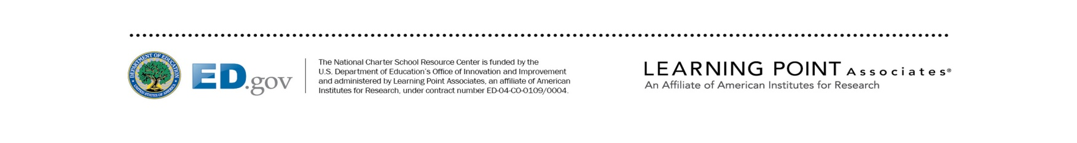
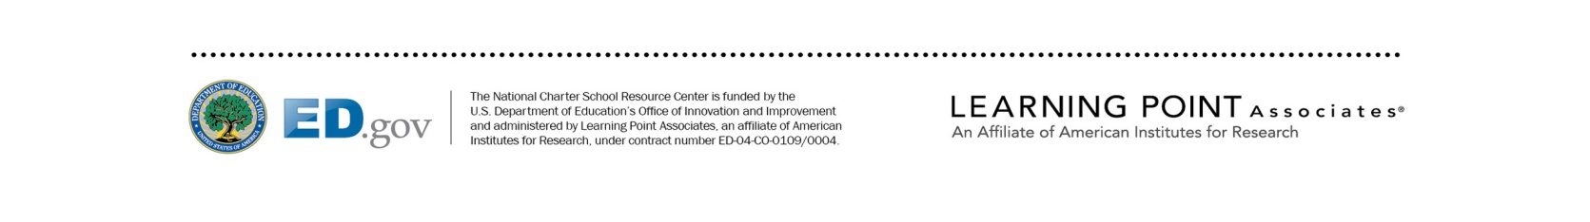
Please indicate how helpful the following sessions were to you: | Very Helpful | Helpful | Somewhat Helpful | Not Helpful | Not Sure/  Does Not Apply
- Opening keynote address: Independent Voices in Support of Quality
- Presentation on Alliance report about city-based strategies
- Panel focused on urban school reform in New York City
- Lunch keynote address: District-Charter Collaboration
- Panel focused on building a pipeline of quality
- Panel exploring out-of-the-box innovations

Please indicate how you would rate the event overall: | Excellent | Good | Fair | Poor
- Quality
- Relevance
- Usefulness

- What was most valuable about the event?

- How could the event have been improved?

Public Burden Statement:

According to the Paperwork Reduction Act of 1995, no persons are required to respond to a collection of information unless such collection displays a valid OMB control number. Public reporting burden for this collection of information is estimated to average 15 minutes per response, including time for reviewing instructions, searching existing data sources, gathering and maintaining the data needed, and completing and reviewing the collection of information. The obligation to respond to this collection is voluntary (Part B section 5201 Elementary and Secondary Education Act). Send comments regarding the burden estimate or any other aspect of this collection of information, including suggestions for reducing this burden, to the U.S. Department of Education, 400 Maryland Ave., SW, Washington, DC 20210-4537 or email ICDocketMgr@ed.gov and reference the OMB Control Number 1800-0011 version 148. Note: Please do not return the completed evaluation form to this address.

