Improving the Quality of Services for
Students with Disabilities in Charter Schools:
Exploring National Needs and Potential Policy Solutions

Monday, June 20, 2011

Evaluation Form

Please take a few minutes to complete this survey. The purpose of the survey is to obtain information about how well the event met its objectives and your needs. Your feedback will assist us in planning high-quality events in the future.

Your participation is completely voluntary. Your responses to this survey will be kept confidential, and results will be reported as a group only. No individual responses will be reported.

Please indicate your level of agreement with the following statements: | Strongly Agree | Agree | Disagree | Strongly Disagree | Not Sure/ Does Not Apply
- The meeting was well organized.
- The meeting was effectively facilitated.
- There were opportunities for meaningful discussion throughout the afternoon.
- The facilitators led a discussion of the most critical needs, issues, and challenges related to the quality of existing special education services in charter schools.
- The facilitators guided the collaborative development of a number of policy recommendations that are designed to improve the quality of special education services in charter schools.
- The conversations during the meeting will inform my future work related to the quality of services for students with disabilities.
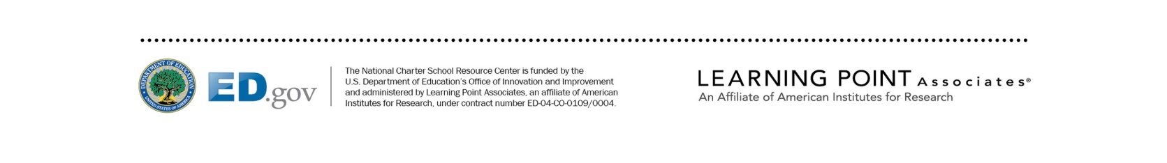

Please indicate how you would rate the meeting overall: | Excellent | Good | Fair | Poor
- Quality
- Relevance
- Usefulness

- What was most valuable about the meeting?

- How could the meeting have been improved?

Public Burden Statement

According to the Paperwork Reduction Act of 1995, no persons are required to respond to a collection of information unless such collection displays a valid OMB control number. Public reporting burden for this collection of information is estimated to average 15 minutes per response, including time for reviewing instructions, searching existing data sources, gathering and maintaining the data needed, and completing and reviewing the collection of information. The obligation to respond to this collection is voluntary. Send comments regarding the burden estimate or any other aspect of this collection of information, including suggestions for reducing this burden, to the U.S. Department of Education, 400 Maryland Ave., SW, Washington, DC 20202-4536 or email ICDocketMgr@ed.gov and reference the OMB Control Number 1800-0011 v162. Note: Please do not return the completed survey to this address.

