U.S. ENVIRONMENTAL PROTECTION AGENCY
2007 COALBED METHANE INDUSTRY SCREENER
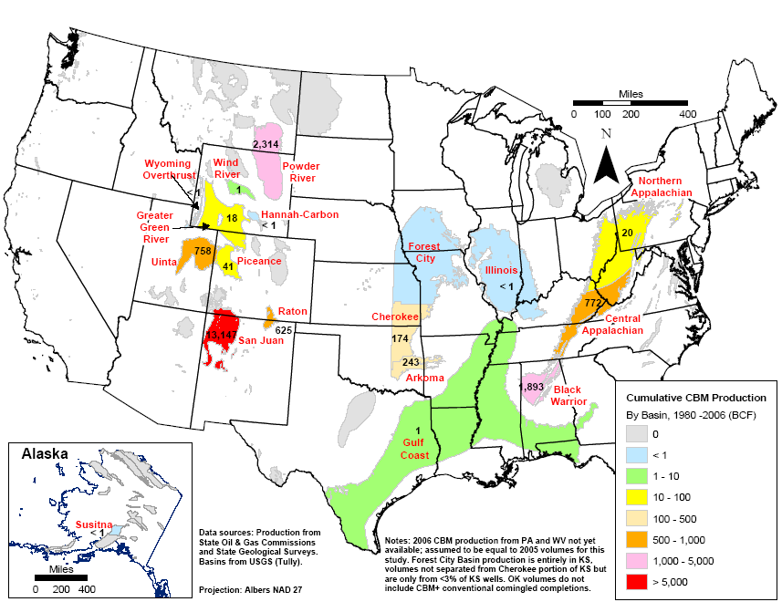
Source: EIA, November 2007

Form Approved
OMB Control No. 2040-NEW
Approval Expires: XXX

  OMB 2040-NEW  (approval expiration date):  DUE DATE:  YOUR RESPONSE IS REQUIRED BY LAW. Title 33, United States Code, requires businesses and other organizations that receive this questionnaire to answer the questions and return the report to the U.S. Environmental Protection Agency.  By the same law, you may claim confidentiality. See Instruction Guide. | 2007 COALBED METHANE INDUSTRY SCREENER
 | [ADDRESS LABEL]
INSTRUCTIONS:
- Please refer to the accompanying Instruction Guide for help in answering specific questions.
- More information is available from EPA’s contractor support at XXX@XXX.com or XXX-XXX-XXXX
Item A ESTABLISHMENT NAME

Is the establishment name shown above in the mailing address correct?

⁫ Yes

⁫ No – Enter establishment name →

Item B CONTACT INFORMATION

If we have any questions about your response, who may we contact?

Name: _____________________________________________________
Street Address: _______________________________________________
City, State, ZIP: _______________________________________________
Phone: __________________________
email: ___________________________
Item C OPERATING STATUS IN 2007 IN THIS BASIN

In 2007, did your establishment own or operate any wells that produce coalbed methane in [basin] in [state – if Powder River]? Please respond only for this location.

⁫ Yes → Go to Item D

⁫ No → Check the box, and return the survey to the address in the Instruction Guide.

Item D BUSINESS SIZE

In 2007, was your highest level of corporate ownership a small business? (See common size standards below)

⁫ Yes

⁫ No

NAICS | Name of Industry | SBA Size Standard
211xxx | Oil and Gas Extraction | ≤500 employees
21211x | Coal Mining | ≤500 employees
213111 | Drilling Oil and Gas Wells | ≤500 employees
213112 | Support Activities for Oil and Gas Operations | ≤$6.5 million annual revenues
213113 | Support Activities for Coal Mining | ≤$6.5 million annual revenues
22111x | Electric Power Generation | <4 million megawatt-hours/year
221112 | Fossil Fuels Electric Power Generation | <4 million megawatt-hours/year
22112x | Electric Power, Transmission, Control and Distribution | <4 million megawatt-hours/year
22121x | Natural Gas Distribution | ≤500 employees
32411x | Petroleum Refineries | ≤1,500 employees
486110 | Pipeline Transportation of Crude Oil | ≤1,500 employees
486210 | Pipeline Transportation of Natural Gas | ≤$6.5 million annual revenues

Item E NUMBER OF PROJECTS

A project in this survey is defined as a well, group of wells, lease, group of leases, or some other recognized unit that your establishment operates as an economic unit when making production decisions.

In 2007, how many projects did your establishment own or operate in [basin] in [state if Powder River]?
____ Projects

Item F PROJECT INFORMATION

For each project in [basin] in [state if Powder River], provide the following information.
- Additional copies of this page are available at www.epa.gov/xxxxxxx.
- If you have many projects, you may prefer to report this information in a tabular format. A spreadsheet version of this page is available at www.epa.gov/xxxxxxx and may be used instead of providing one page per project.

1. What is the name or identifier that you use for this project? →

2. How many wells were in this project in 2007?

3. What was the combined gas production from the wells in 2007?

4. In 2007, how did you manage your produced water? Check all that apply.
⁫ Thousands of Cubic Feet (Mcf)
⁫ Other – Enter other reporting units → ____________________
[This question will only be included on screeners for the Powder River Basin in WY & the Appalachian Basin.]

⁫ Subsurface injection
⁫ Hauled or trucked off-site
⁫ Land applied (for example, irrigation, dust suppression)
⁫ Disposed or discharged by some other method
⁫ No water produced by the project
5. In order to avoid asking you for detailed information about all of your projects, EPA intends to statistically select a limited number to receive a second questionnaire. If this project is selected, where should we send the second questionnaire?

⁫ To the same contact person identified in Item B.
⁫ To the same contact person identified in the previous project.
⁫ To the following contact person:
Name: _____________________________________________________
Street Address: _______________________________________________
City, State, ZIP: _______________________________________________
Phone: __________________________
email: ___________________________

REMARKS Please use this space to clarify your responses, if appropriate.

Please keep a copy and return the original to:

U.S. Environmental Protection Agency
CBM Industry Screener
c/o/ PG Environmental, LLC
447B Carlisle Drive
Herndon, VA 20170

THANK YOU.

The public reporting and recordkeeping burden for this collection of information is estimated to average 5 hours per response. Send comments on the Agency's need for this information, the accuracy of the provided burden estimates, and any suggested methods for minimizing respondent burden, including through the use of automated collection techniques to the Director, Collection Strategies Division, U.S. Environmental Protection Agency (2822T), 1200 Pennsylvania Ave., NW, Washington, D.C. 20460. Include the OMB control number in any correspondence. Do not send the completed survey to this address.

