Project 191 QID 030358 |  |  | OMB No. 0535-0002: Approval Expires 3/31/2010
 | DRY PEAS AND LENTILS  2007 CROP |  |  |  | 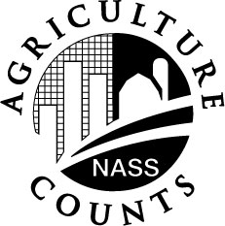 | NATIONAL  AGRICULTURAL STATISTICS  SERVICE
Idaho Field Office
P.O. Box 1699
2224 Old Penitentiary Road
Boise, Idaho 83701-1699
Phone 1-800-691-9987,Fax 208-334-1114
nass-id@nass.usda.gov
Dear Reporter:

The USDA National Agricultural Statistics Service, Idaho field office is collecting information for its yearly estimate of the acreage, production and average price received for 2007 Pea and Lentil Crops. Response to this survey is voluntary and not required by law; however, cooperation is very important. Your individual report will be held confidential and used only in combination with others to arrive at State totals. Please return this form in the enclosed envelope which does not require a stamp. Thank you.
Sincerely,
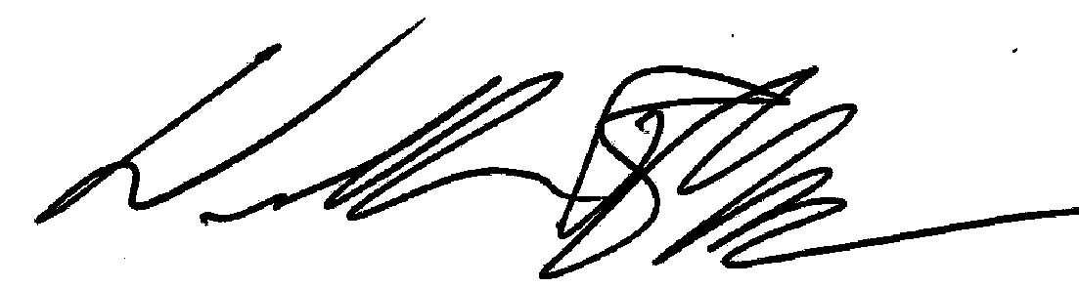
William R Myer
Director

REPORT FOR THE FARM(S) YOU OPERATE
CROP | ACREAGE HARVESTED |  | YIELD PER ACRE  2007 | AVERAGE PRICE  RECEIVED 2007
CROP | PREVIOUS YEAR  2006 | CURRENT YEAR  2007 | YIELD PER ACRE  2007 | AVERAGE PRICE  RECEIVED 2007
DRY EDIBLE PEAS
ALASKA and OTHER
FIRST & BEST, WHITE CANADA and OTHER SMOOTH YELLOW
or WHITE
OTHERS
WRINKLED SEED PEAS
AUSTRIAN WINTER PEAS
LENTILS

If you would like to receive a copy of the results of this survey, check box . . . . . . . . . . . . . . . . . . . .

COMMENTS:______________________________________________________________________________________

__________________________________________________________________________________________________

__________________________________________________________________________________________________

Reported by ___________________________________ Date ____________________ Phone ______________________

According to the Paperwork Reduction Act of 1995, no persons are required to respond to a collection of information unless it displays a valid OMB control number. The time required to complete this information collection is estimated to average 15 minutes per response.

