QID 060041 |  |  |  |  |  |  |  |  | OMB No. 0535-0002: Approval Expires 12/31/2007
 |  |  |  | NON-OIL SUNFLOWER  2007 CROP |  |  |  |  |  |  |  |  |  | 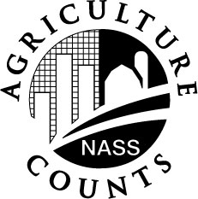 | NATIONAL  AGRICULTURAL STATISTICS  SERVICE
Minnesota Field Office
P.O. Box 7068
8 E. 4th St. Suite 500
St. Paul, MN 55107
Phone 1-800-453-7502, Fax 1-800-839-2186
nass-mn@nass.usda.gov
Dear Reporter:

Planting intentions for the 2007 non-oil sunflower crop will be released March 30. Please help us collect the information by reporting your contracting acreage.

Response to this survey is voluntary and not required by law. However, your cooperation is necessary to insure accurate estimates. Your report will be kept confidential. Thank you for your cooperation.

Sincerely,

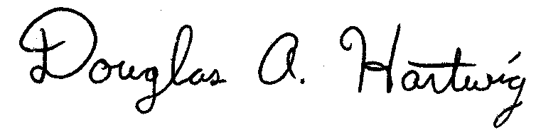
Douglas A. Hartwig
Director
 | PLEASE FAX TO 1-800-839-2186 OR RETURN BY MARCH 15, 2007
 |  |  | PLEASE REPORT FOR YOUR OPERATION
ACRES CONTRACTED AND TO BE CONTRACTED
(Include acres contracted through agents)
 |  |  | STATE |  |  |  |  | ACRES
 |  |  | North Dakota
 |  |  | Minnesota
 |  |  | South Dakota
 |  |  | Nebraska
 |  |  | Kansas
 |  |  | Colorado
 |  |  | Other
Reported by |  |  |  |  |  |  |  |  |  | Date
According to the Paperwork Reduction Act of 1995, no persons are required to respond to a collection of information unless it displays a valid OMB control number. The time required to complete this information collection is estimated to average 5 minutes per response.

