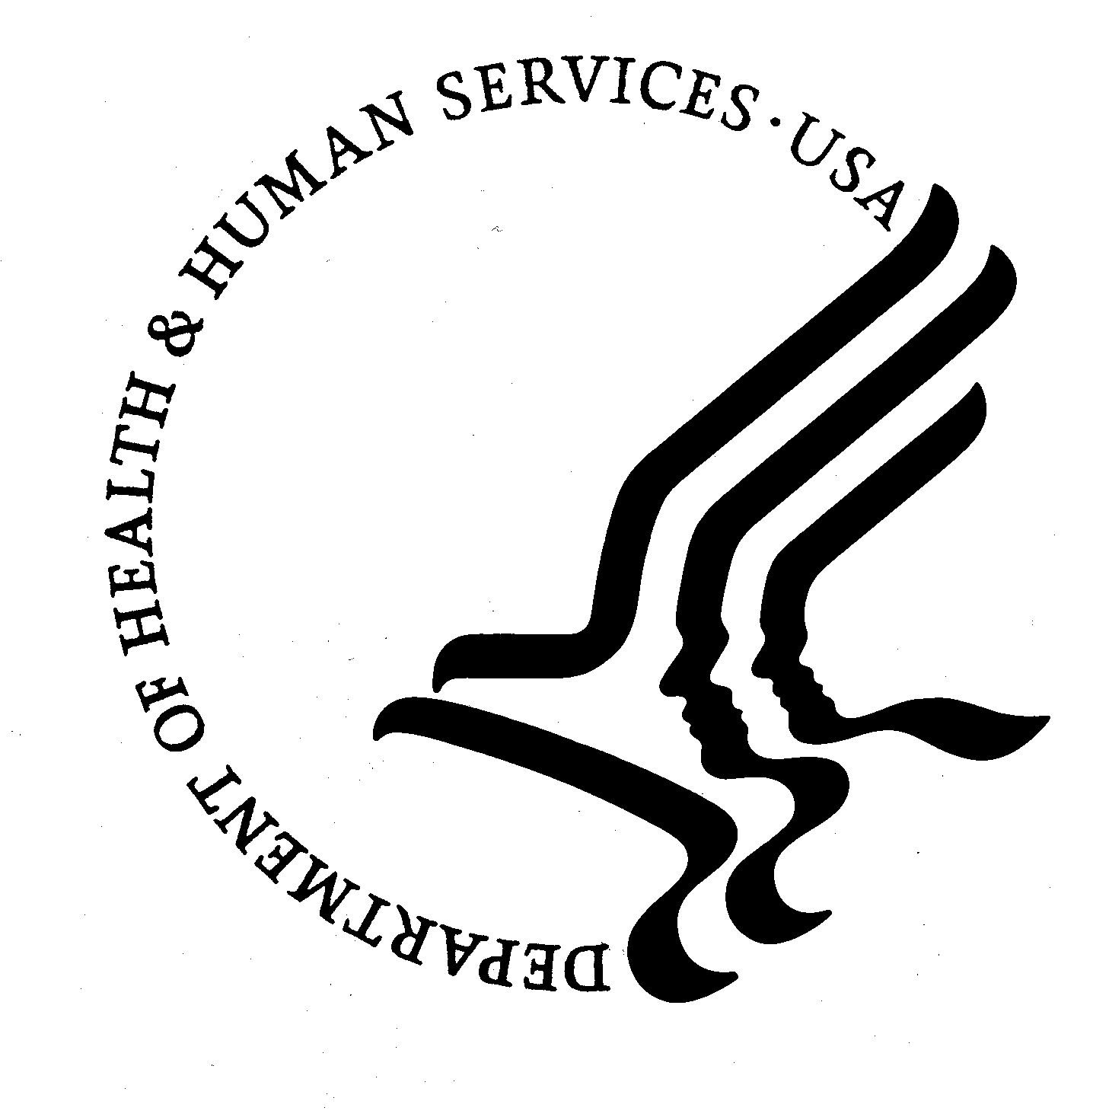

DEPARTMENT OF HEALTH & HUMAN SERVICES

Centers for Disease Control and Prevention

National Center for Health Statistics

3311 Toledo Road
Hyattsville, Maryland 20782

The Centers for Disease Control and Prevention’s National Center for Health Statistics (NCHS) has been conducting the National Hospital Ambulatory Medical Care Survey (NHAMCS), an annual study of hospital-based outpatient care, since 1992. The purpose of this study is to collect information about the large portion of ambulatory care provided by hospital outpatient and emergency departments throughout the United States. The information requested includes data about patient visit and hospital characteristics, including questions about emergency department crowding and ambulatory surgery.

Many organizations and leaders in the health care community, including those providing the enclosed letters of endorsement, have expressed their support and join me in urging your participation in this meaningful study. The following are some key points about the survey.
- Data collection for the NHAMCS is authorized by Section 306 of the Public Health Service Act (Title 42, U.S. Code, 242k).
- All information collected will be held confidential according to Section 308(d) of the Public Health Service Act (42, U.S. Code, 242m(d)) and the Confidential Information Protection and Statistical Efficiency Act (Title 5 of PL 107-347)* and will be used for statistical purposes only. No patient names, social security numbers, or addresses are collected.
- U.S. Census Bureau employees, who administer the study, have taken an oath to abide by Title 13, U.S. Code, Section 9, which requires them to keep all information about your hospital and patients confidential.
- The Privacy Rule as mandated by HIPAA allows your hospital to participate.
  - Disclosure of patient data is permitted for public health purposes.
  - NHAMCS has been approved by the NCHS Research Ethics Review Board.

A representative of the Census Bureau, acting as our agent, will be calling you to schedule an appointment regarding the details of your participation, which is voluntary. If you have any questions regarding your participation, please call a NHAMCS representative at (800) 223-3815.
Visit the NHAMCS participant website for more information about the survey (www.cdc.gov/nhamcs). We greatly appreciate your cooperation.

Sincerely,

Edward J. Sondik, Ph.D., Director
Enclosures

*Provisions of the Confidential Information Protection and Statistical Efficiency Act provide for a felony conviction and/or fine of up to $250,000 if this promise is violated.

