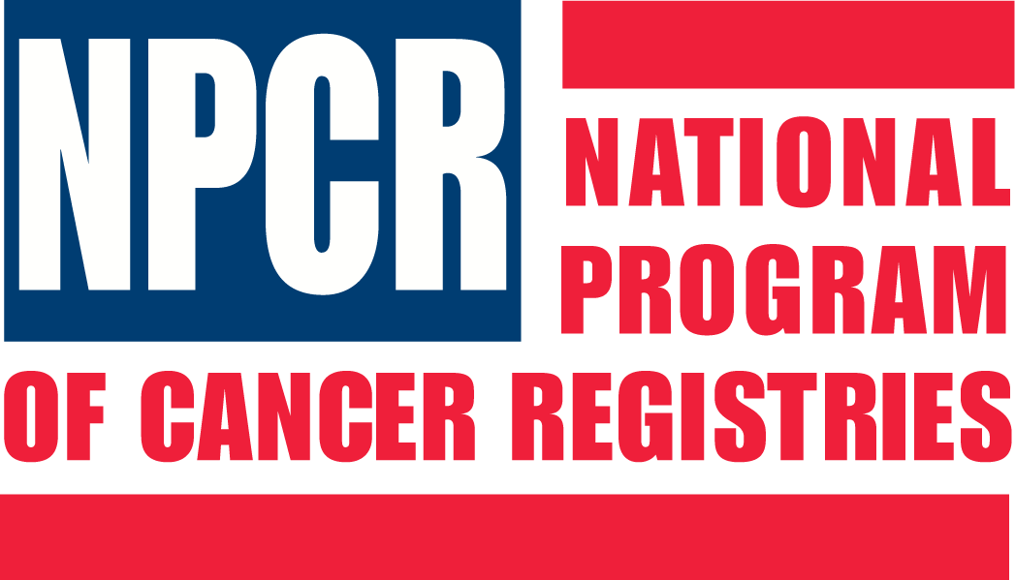

NATIONAL PROGRAM OF CANCER REGISTRIES
PROGRAM STANDARDS

Purpose: The purpose of these standards are to:
- Guide priorities and activities of funded programs over the next five years
- Provide objective measures of program progress
- Improve program processes that ultimately affect outcomes

The following are the National Program of Cancer Registries (NPCR) Program Standards as currently defined for the purposes of the Program Announcement. These standards are based on authority provided the CDC-NPCR under the Public Health Service Act and its subsequent amendments, and apply to all reportable cancers as defined in the Act and amendments. The NPCR Program Standards may change during the project period of the cooperative agreement.

All funded programs must meet the following standards for:

- Legislative Authority
- Administration
- Electronic Data Exchange
- Data Content and Format
- Completeness/Timeliness/Quality
- Quality Assurance
- Data Use and Data Monitoring
- Data Submission
- Collaborative Relationships

- Legislative Authority
  - The state/territory has a law authorizing a population-based central cancer registry.

  - The state/territory has legislation or regulations in support of the Public Law authorizing the National Program of Cancer Registries (NPCR).

- Administration:
  - The central cancer registry maintains an operational manual that describes registry operations, policies and procedures. At a minimum the manual contains the following:
    - Reporting laws/regulations
    - List of reportable diagnoses
    - List of required data items
    - Procedures for data processing operations including:
      - Procedures for monitoring timeliness of reporting
      - Procedures for receipt of data
      - Procedures for database management including a description of the Registry Operating System (software).
      - Procedures for conducting death certificate clearance
      - Procedures for implementing and maintaining the quality assurance/control program
        - Procedures for conducting follow-back to reporting facilities on quality issues. These procedures include rules for identifying when action or further investigation is needed
        - Procedures for conducting record consolidation
        - Procedures for maintaining detailed documentation of all quality assurance operations.
      - Procedures for conducting data exchange including a list of states with whom case-sharing agreements are in place
    - Procedures insuring confidentiality and data security including disaster planning
    - Procedures for data release including access to and disclosure of information
    - Procedures for maintaining and updating the operational manual

  - The central cancer registry has management reports that monitor the registry operations and database including processes and activities.

  - The central cancer registry has an abstracting and coding manual to be disseminated to and used by all reporting sources.

- Electronic Data Exchange

  - The central cancer registry uses and requires a standardized, NPCR-recommended data exchange record layout for the electronic exchange of cancer data. NPCR-recommended data exchange layouts include:
    - For abstract reports: The NAACCR record layout version specified in year-appropriate Standards for Cancer Registries Volume II: Data Standards and Data Dictionary.
    - For pathology reports: NAACCR Standards for Cancer Registries Volume V: Pathology Laboratory Electronic Reporting.

    - At a minimum, 95% of reports from hospitals are submitted to the central cancer registry in an electronic format (where the medical records are owned by the hospital).

  - At a minimum, 85% of reports from non-hospital reporting sources are submitted to the central cancer registry in an electronic format. (e.g. radiation therapy centers, ambulatory surgery centers, and in-state and out-of-state pathology laboratories where medical records are owned by the reporting source.)

  - At a minimum, 75% of reports from physician offices, identified as required to submit cancer cases to the central cancer registry, do so in an electronic format (where the medical records are owned by the physician). This includes responses from physicians to central cancer registry inquiries.

  - The central cancer registry primarily uses a secure Internet-based, FTP, or encrypted email mechanism to receive data from all reporting sources.

- Data Content and Format

  - For all NPCR required reportable cases, the central cancer registry collects or derives all required data items using standard codes as prescribed by NPCR. (see III. a)

  - The central cancer registry uses a standardized, NPCR-recommended data exchange format to transmit data to other central cancer registries and NPCR. (see III. a.)

- Data Completeness/Timeliness/Quality
  - Within 24 months of the close of the diagnosis year, at least 75% of physicians, surgeons, and all other health care practitioners diagnosing or providing treatment for cancer patients submit all reportable cases to the central cancer registry, except for cases directly referred to or previously admitted to a hospital or other facility providing screening, diagnostic or therapeutic services to patients in that State and reported by those facilities (based on PL 102-515).
  - Within 12 months of the close of the diagnosis year, the central cancer registry data meet the NPCR standards for the following two data quality criteria:
    - Data are 90% complete based on observed-to-expected cases as computed by NPCR.
    - 97% pass an NPCR-prescribed set of standard edits.

  - Within 24 months of the close of the diagnosis year, the central cancer registry data meet the NPCR standards for the following five data quality criteria:
    - Data are 95% complete based on observed-to-expected cases as computed by NPCR.
    - There are 3% or fewer death-certificate-only cases
    - There is a 1 per 1,000 or fewer unresolved duplicate rate
    - The percent missing for critical data elements are:
      - 2% or fewer age
      - 2% or fewer sex
      - 3% or fewer race
      - 2% or fewer county
    - 99% pass an NPCR-prescribed set of standard edits.

  - Within 12 months of the close of the diagnosis year, the central cancer registry exchanges data with other central cancer registries where a data-exchange agreement is in place. The data file must also include all cases not previously exchanged.
    - Regardless of residency, the central cancer registry collects data on all patients diagnosed and/or receiving first course of treatment in the registry’s state/territory.
    - The recommended frequency for data exchange is, at a minimum, two times a year.
    - Exchanged data must meet the following minimum criteria:
      - Exchange agreements are in place with all bordering central cancer registries.
      - Exchanged data include a dataset that consists of NPCR core data items.
      - 99% of data pass an NPCR-prescribed set of standard edits.
      - The dataset is transmitted via secure encrypted Internet-based, FTP, or encrypted email mechanism.
      - A standardized, NPCR-recommended data exchange format is used to transmit data. (see III. a.)

- Data Quality Assurance
  - The central cancer registry has an overall program of quality assurance that is defined in the registry operations policy and procedure manual. The quality assurance program consists of, but is not limited to:
    - A designated certified tumor registrar (CTR) is responsible for the quality assurance program.
    - Qualified, experienced CTR(s) conduct quality assurance activities.
    - At least once every 5 years, case-finding and/or re-abstracting audits from a sampling of source documents are conducted for each hospital-based reporting facility, and may include external audits (NPCR/SEER).
    - Data consolidation procedures are performed according to an accepted protocol.
    - Procedures are performed for follow-back to reporting facilities on quality issues.

  - The central cancer registry has a designated education/training coordinator who is a CTR to provide training to the central cancer registry staff and reporting sources to assure high quality data.
- Data Use

  - Within 12 months of the end of the diagnosis year with data that are 90% complete, the central cancer registry produces preliminary pre-calculated data tables in an electronic data file or report of incidence rates, counts, or proportions for the diagnosis year by Surveillance Epidemiology and End Results (SEER) site groups as a preliminary monitor of the top cancer sites within the state/territory.

  - Within 24 months of the end of the diagnosis year with data that are 95% complete, the central cancer registry produces pre-calculated data in tables in an electronic data file or report. The report includes, at a minimum, age-adjusted incidence rates and age-adjusted mortality rates for the diagnosis year by sex for SEER site groups, and, where applicable, by sex, race, and ethnicity.

  - The central cancer registry, state health department, or its designee annually uses registry data for planning and evaluation of cancer control objectives in at least three of the following ways:
    - Comprehensive cancer control.
    - Detailed incidence/mortality estimates.
    - Linkage with a statewide cancer screening program to improve follow-up of screened patients.
    - Health event investigation(s).
    - Needs assessment/program planning.
    - Program evaluation.
    - Epidemiologic studies.

- Data Submission

  - The central cancer registry annually submits a data file to the NPCR-Cancer Surveillance System (CSS) that meets the reporting requirements outlined in the NPCR-CSS Submission Specifications document and meets criteria for publication in United States Cancer Statistics

- Collaborative Relationships

  - The central cancer registry actively collaborates in the state’s comprehensive cancer control planning efforts.

  - The central cancer registry establishes a working relationship with all components of the National Cancer Prevention and Control program to ensure the use of registry data to assess and implement cancer control activities.

  - The central cancer registry establishes and regularly convenes an advisory committee to assist in building consensus, cooperation, and planning for the registry. Representation should include key organizations and individuals both within (such as representatives from all cancer prevention and control components) and outside the program (such as hospital cancer registrars, the American Cancer Society, clinical-laboratory personnel, pathologists, and clinicians). Advisory committees may be structured to meet the needs of the state/territory such as the Comprehensive Cancer Control Program committee structure, an advocacy group, or a focus group

