
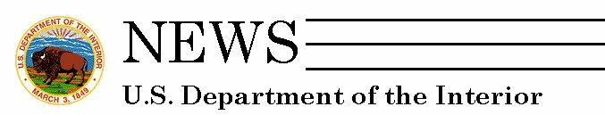

[Date]

Dear Moderate-Resolution Imagery User,

Last summer you agreed to participate in a nationwide survey conducted by the U.S. Geological Survey. Today is the day to tell us what you think!

As you may know, the Federal Government is in the process of designing the next generation of moderate-resolution imagery satellites. A clear understanding of the current uses, applications, and societal benefits of moderate-resolution imagery, including Landsat, is essential as policy and decision makers go forward with this effort.

That is why your participation in this survey is so important. We need users like you to tell us the role this type of satellite data plays in your work and research, and your insights regarding its value to society.

Your voluntary participation in this survey has been approved through the requirements of the Office of Management and Budget (OMB Control # XXX). After we receive your completed on-line survey, your email address will be deleted from our database. All responses will be released only as summaries and not linked in any way to individuals.

If you have any questions or comments, contact us at fort_survey_tech@usgs.gov . Thank you very much for helping with this important study!

Begin the Moderate-Resolution Imagery Survey by clicking here!*

Sincerely,
Lynne Koontz and Natalie Sexton
Study Researchers
Policy Analysis and Science Assistance Branch
U.S. Geological Survey
http://www.fort.usgs.gov/PASA/

*This is a unique link. Please do not forward.

