INSTRUCTIONS FOR COMPLETING THE
NOAA HEALTH SERVICES QUESTIONNAIRE
(NHSQ, REVISED 10/08)

Please print clearly if you are not submitting this form electronically. Make sure your name appears at the top of each page. Fill out ALL questions completely to avoid a delay in processing.

Any questions answered “yes” on this form will require further explanation in the space provided. If additional space is needed, please use page 4 of the form. If you answered “yes” to hypertension or diabetes in the “Cardiac Screening” section, you must provide the most recent blood pressure or HbA1c reading.

In the Immunization Screening section, everyone who sails on a NOAA vessel must have a test for tuberculosis (TB) within the last 12 months. If you have a PPD test done for TB, the results must be recorded in millimeters only. PPD tests are not read as positive or negative.

The Functional Abilities Screening section makes reference to a survival suit and a rope ladder. More detailed information can be found on these items by typing “survival suit” and “rope ladder” in to any internet search engine.

An adult survival suit is often a large bulky one-size-fits-all design meant to fit a wide range of sizes. It is made of neoprene and typically has large oversize booties and gloves built into the suit. This allows the user to quickly don it on while fully clothed and without having to remove shoes. It typically has a waterproof zipper up the front, and a face flap to seal water out around the neck and protect the wearer from ocean spray. In the event of an emergency, it should be possible to put on a survival suit and abandon ship in about one minute.

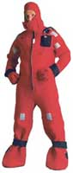

Survival Suit

A rope ladder is a flexible ladder made by attaching rope to both ends of wooden rungs. It hangs down over the side of the ship and is used to enter a small boat or to get back on the ship’s deck from a small boat. The rope ladder is anchored to the ship at one end but the other end hangs freely and is not attached. A free hanging rope ladder is more difficult to climb than one that is firmly moored at the bottom.

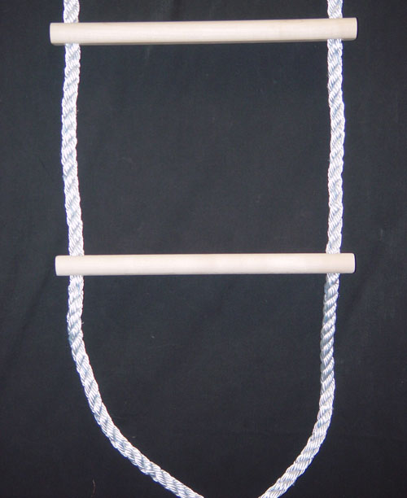

Rope Ladder

Sign and date this form near the bottom of page 3. Do not write in the NOAA Health Services Use Only section. Use page 4 to provide any additional information.

