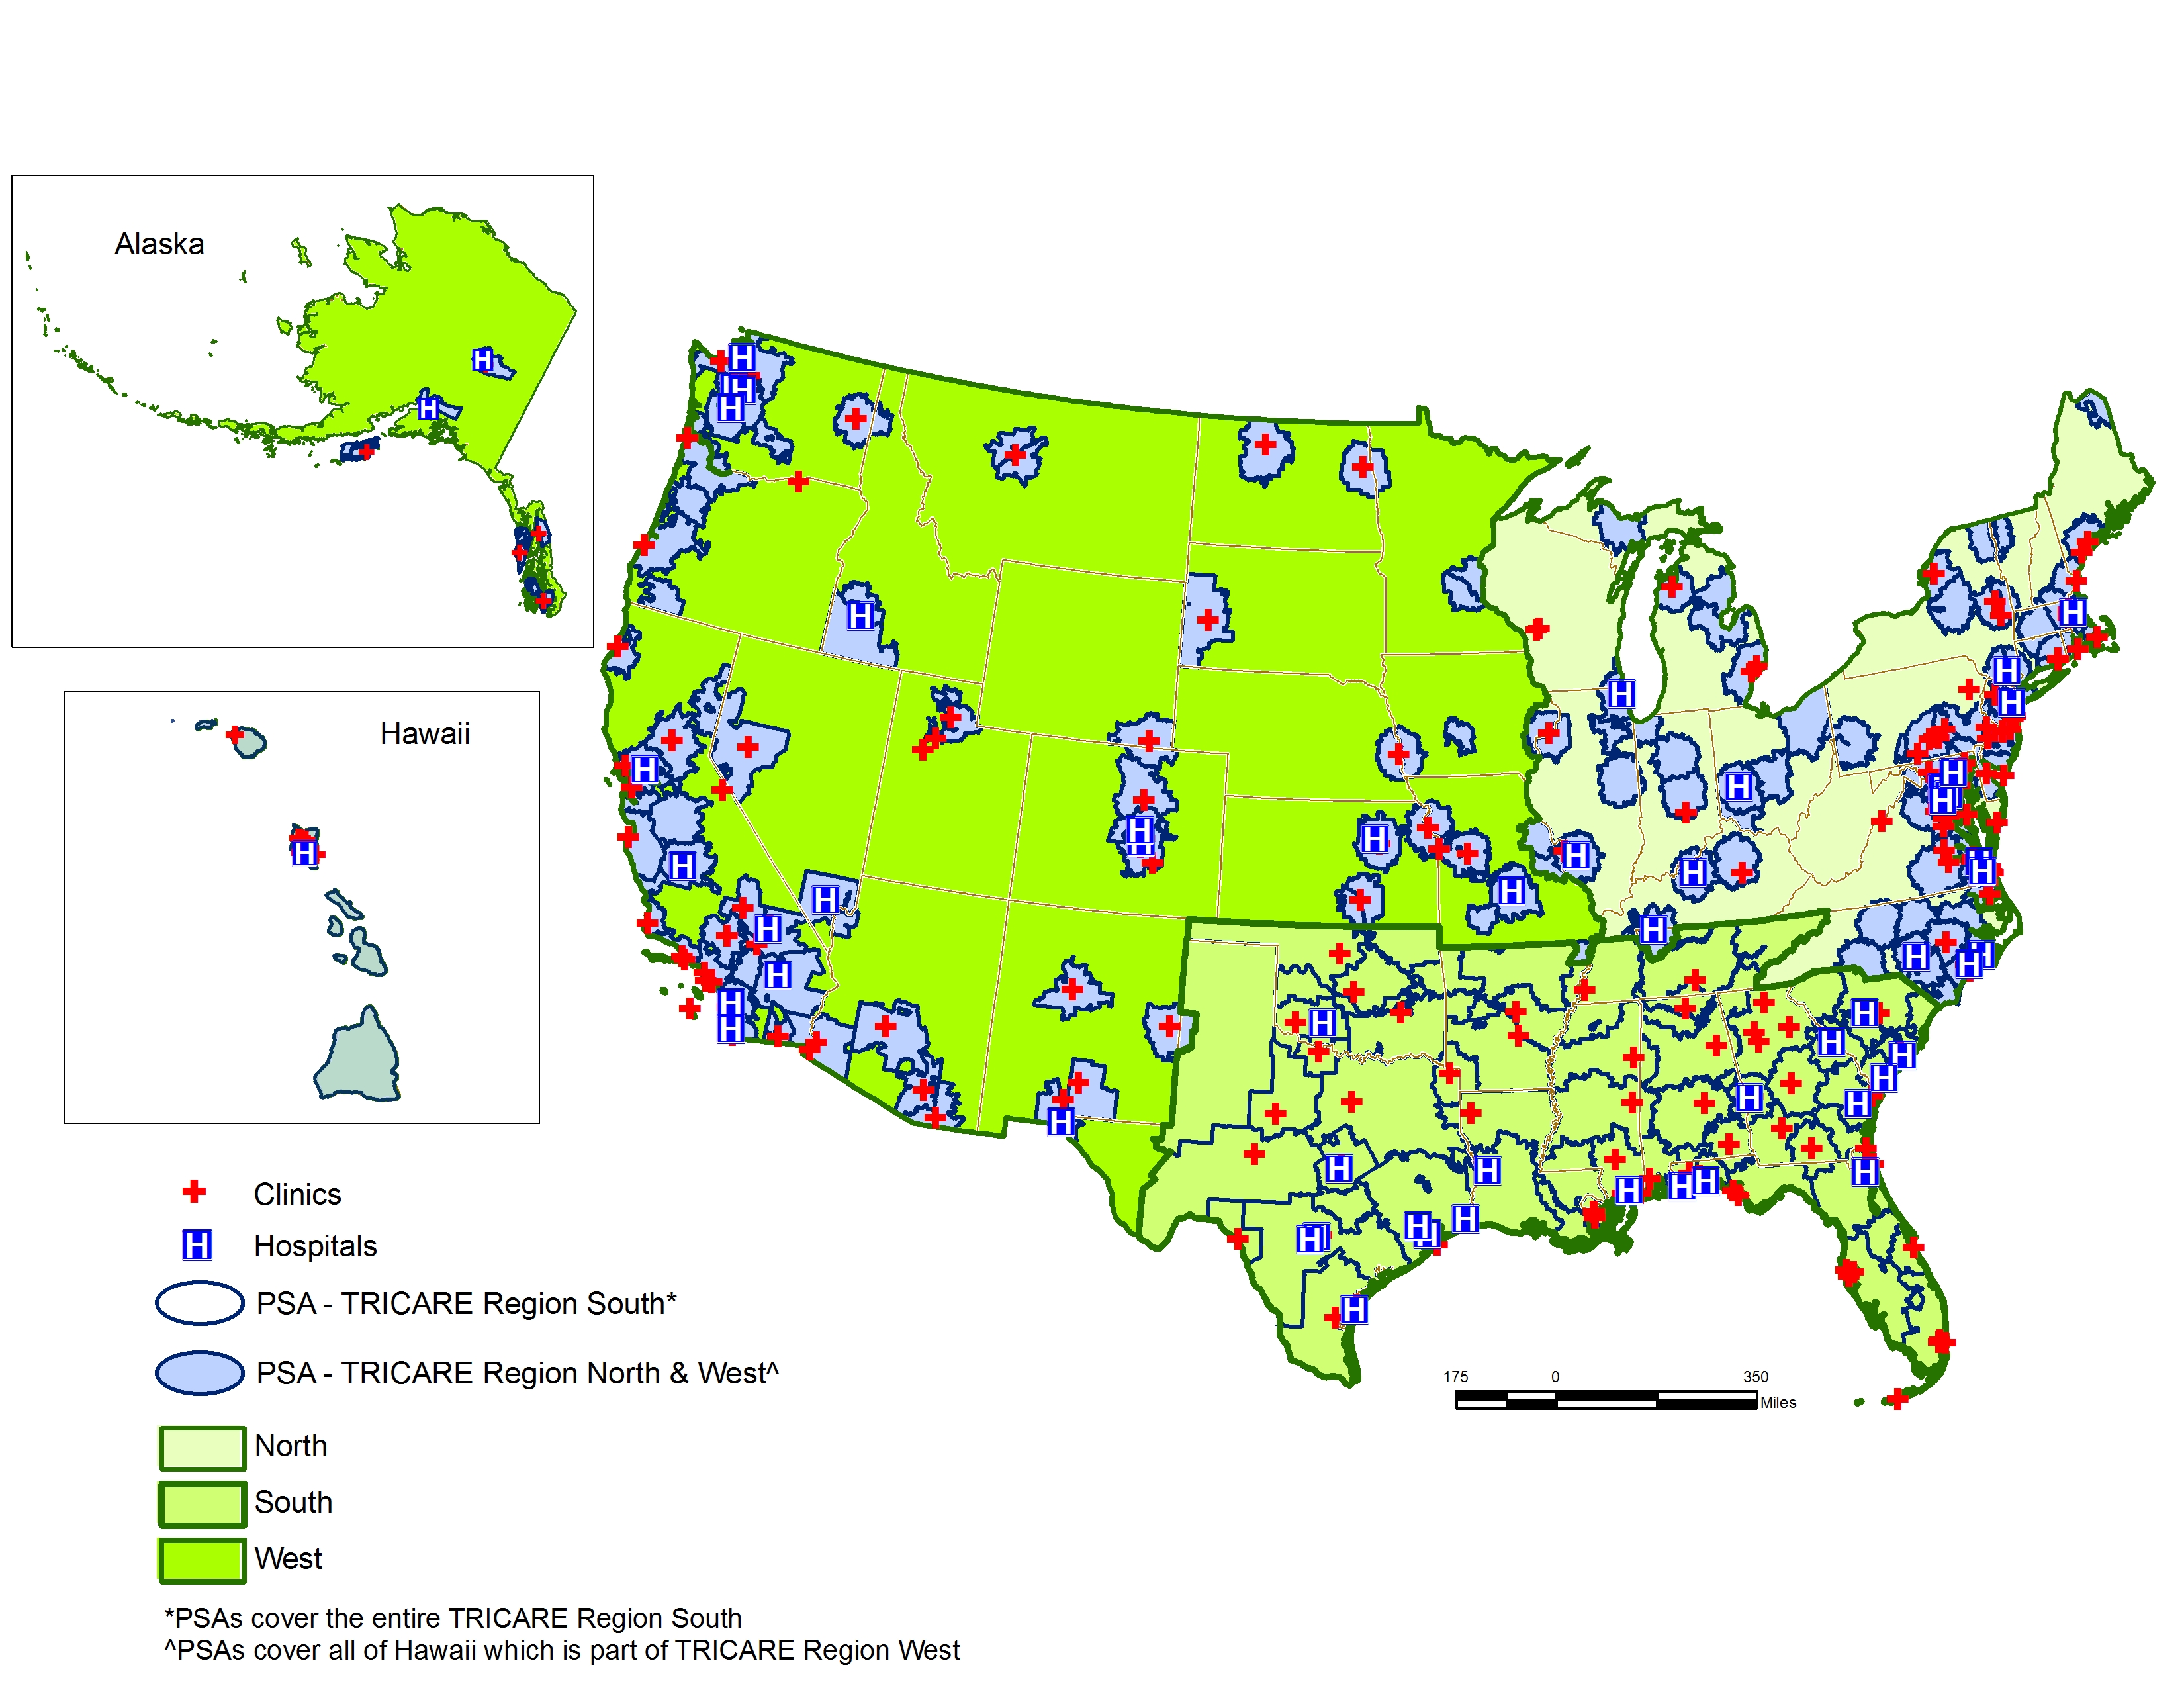
Attachment 6
Map of TRICARE Prime Service Areas

