July 30, 2026
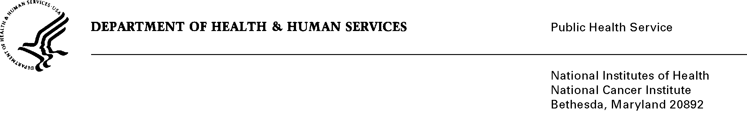

Name
Address
Address
City State Zip

Dear Mr./Ms./Dr. :

The National Cancer Institute (NCI) at the National Institutes of Health (NIH), along with the National Institute of Child Health and Human Development, the National Institute of Diabetes and Digestive and Kidney Diseases, the Office of Behavioral and Social Sciences Review, and the Centers for Disease Control and Prevention request your participation in a survey of practice administrators and physicians. Research indicates that there are links between poor diet, low levels of physical activity, being overweight, and the risk of chronic disease. Our Administrator Survey collects information about practice and office systems that support or hinder clinicians’ activities related to diet, physical activity and weight control. We are sending this survey to 1,000 administrators working with 2,000 randomly selected physicians.

A physician in your office, _________, MD has recently completed the Physician portion of our survey. We understand that you are the best person in your office to answer the questions about the practice itself. We are hoping you will be willing to help us out with this important Administrator Survey.

We will combine your responses with those of other surveyed administrators, and use these data to publish publicly-available reports and journal articles with the goal of informing health care policy and improving health care.

Completing the enclosed questionnaire should take no longer than 20 minutes, and space is left at the end for comments. The information you provide is confidential. Your participation is voluntary; there are no penalties for not responding. Your answers will be stored separately from your identity, and only aggregated findings will be reported. A $30 check is enclosed as a token of our appreciation for your participation.

Please complete this one-time survey and return it in the enclosed envelope. If you would prefer to complete your survey by telephone with a researcher, please call 800-937-8281 ext 2828, weekdays between 9 a.m. and 5 p.m. EDT, or e-mail MiriamAikent@westat.com. If you have questions about the study, please call Dr. Caroline McLeod, Westat, (800-937-8281 ext. 2786 or carolinemcleod@westat.com) or Dr. Ashley Wilder-Smith at NCI (301) 451-1843 or smithas@mail.nih.gov).

Your participation is both critical and much appreciated. Thank you in advance for your valuable contribution to this important study.

Sincerely,

Rachel Ballard-Barbash, M.D.
Associate Director
Division of Cancer Control and Population Sciences
National Cancer Institute

