OMB No. 2900-0381
Respondent Burden: 10 Minutes

Privacy Act Notice: VA will not disclose information collected on this form to any source other than what has been authorized under the Privacy Act of 1974 or Title 38, Code of Federal Regulations 1.576 for routine uses (e.g., to a member of Congress inquiring on behalf of a veteran) as identified in the VA system of records, 55VA26, Loan Guaranty Home, Condominium and Manufactured Home Loan Applicant Records, Specially Adapted Housing Applicant Records, and Vendee Loan Applicant Records – VA, and published in the Federal Register. Your obligation to respond is required to exercise your right to convey property under 38 CFR 36.4320.

Respondent Burden: We need this information to process your election to convey a property under 38 CFR 36.4320. We estimate that you will need an average of 10 minutes to review the instructions, find the information, and complete this form. VA cannot conduct or sponsor a collection of information unless a valid OMB control number is displayed. You are not required to respond to a collection of information if this number is not displayed. Valid OMB control numbers can be located on the OMB Internet Page at www.whitehouse.gov/omb/library/OMBINV.VA.EPA.html#VA. If desired, you can call
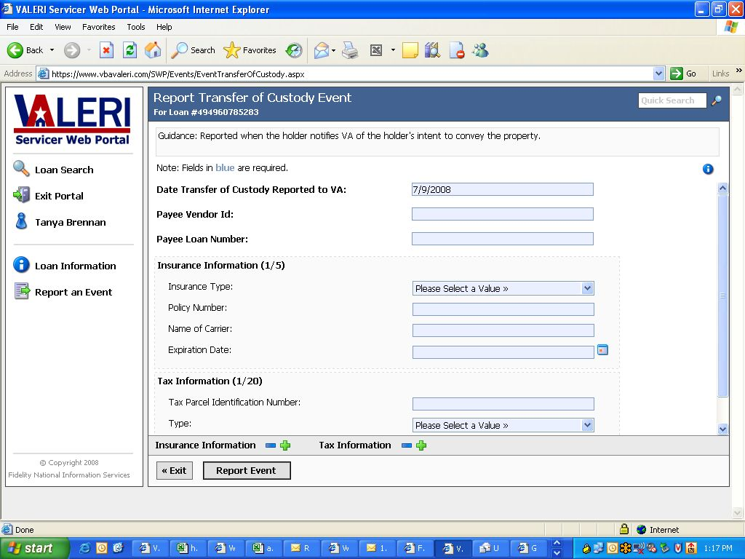
1-800-827-1000 to get information on where to send comments or suggestions about this form.

VA Form 26-8903
September 2008

