Date: January 26, 2009
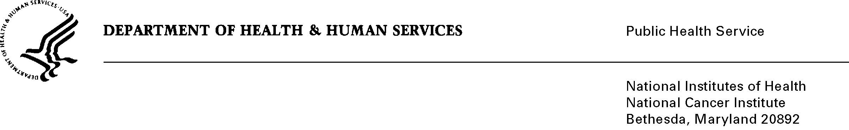

To: Office of Management and Budget (OMB)

Through: Marilyn Tuttleman, NIH Project Clearance Officer, OPERA
Vivian Horovitch-Kelley, NCI OMB Project Clearance Liaison Office

From: Nina Goodman, Project Officer
Office of Communications and Education (OCE)
National Cancer Institute/NIH

Subject: Amendment to the Generic Sub-Study, “Amended Survey to Assess Public Understanding of Risk Estimates through Visual Displays” (OMB No. 0925-0046-14)

OMB approved the original generic sub-study 0925-0046-12 on 11/25/2008. The National Cancer Institute proposed conducting a web-based survey of visual methods for communicating the uncertainty of individualized cancer risk estimates. The objective of this study was to collect formative data to inform development of a new cancer risk prediction model, the Colorectal Cancer Risk Assessment Tool (CCRAT), developed by Dr. Andrew Freedman and colleagues in the Applied Research Program and the Division of Cancer Epidemiology and Genetics.

Since our original proposal, a prototype of the CCRAT has been made available on a publicly-accessible website and the developers of the CCRAT have identified the need to better educate potential users of the model about its proper use and limitations. Accomplishing this goal requires developing effective educational text to explain the model, and to test people’s understanding of and responses to this text.

We therefore propose an amendment to our previous proposal, which provides an opportunity to use our existing methods and infrastructure to examine the public’s responses to additional educational information about the model. The current amendment adds 100 respondents to our original request of 250 (50 respondents per group). This will provide the capacity to examine educational text as an additional condition to be tested.

We request prompt evaluation of this proposal in order to take advantage of the resources from the existing study; the contract for this study requires completion of data collection by the end of February.

The amended sample size of 100 will be added to 0925-0046-12, which was originally approved for 250 respondents. A total of 350 represents the minimum number of participants required for reliable inferences to be drawn to guide NCI’s development of the CCRAT for public use regarding both visual method and effect of educational text.

Estimates of Hour Burden

Types of Respondents | Number of Respondents | Frequency of Response | Average Response Time | Annual Hour Burden
General Public | 100 | 1 | 10/60 | 16.67

The full generic study, approved on January 26, 2007, requested a total of 2010 burden hours. There have been ten previous sub-studies approved by OMB under this umbrella submission, totaling 965 burden hours requested to date.

Approval by OMB of this amended sub-study would bring the total burden hour requested to date for 0925-0046 to 1023; well below the original request of 2010 hours per year.

Thank you for your consideration of this proposed amendment to sub-study #14.

Attachments: Web-based survey

