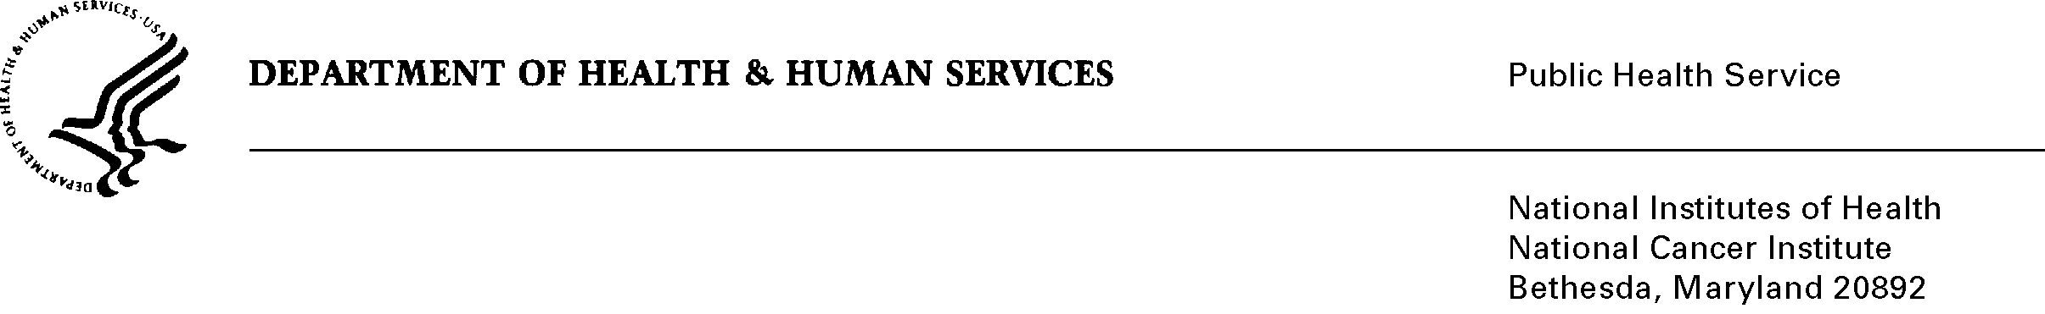
Date: October 1, 2008 (anticipated date to HHS)

To: Office of Management and Budget (OMB)

Through: Seleda Perryman, DHHS Report Clearance Officer
Marilyn Tuttleman, NIH Project Clearance Officer, OPERA
Vivian Horovitch-Kelley, NCI OMB Project Clearance Liaison Office

From: Paul Han, M.D.
National Cancer Institute/NIH

Subject: The National Survey of Physician Attitudes Regarding the Care of Cancer
Survivors (SPARCCS) (NCI)

This is a request for OMB to approve The National Survey of Physician Attitudes Regarding the Care of Cancer Survivors (SPARCCS) for 2 years. The Federal Register Notices, supporting statements, and various attachments accompany this memorandum.

The overall purpose of the Survey of Physician Attitudes Regarding the Care of Cancer Survivors (SPARCCS) is to obtain national data on the perceptions, knowledge, and practices of primary care and oncology specialist physicians regarding post-treatment follow-up care of adult cancer survivors. The survey will investigate the reasons for the fragmentation in health care delivered to cancer survivors by exploring limitations in knowledge, confusion about roles, and the key barriers to perceived “best practices” from the unique perspective of the practicing physicians.

To achieve this purpose, two distinct survey instruments will be administered: one to 1,100 oncologists and another to 1,100 primary care physicians (PCPs) - Family Practice, Obstetrics/Gynecology and General Internal Medicine physicians. The rationale for the dual survey is to permit comparisons of the perceived roles, knowledge and practices of these two key provider groups with regard to follow-up care for cancer survivors. Coordination of care across these two groups is repeatedly articulated as a key facet of care for survivors of adult cancer. The surveys focus on the treatment of patients surviving two common cancers -- breast cancer and colon cancer.

