Media Bureau Auction

Following the Permit Selection (Table) / Engineering Proposals (Non-Table) section:

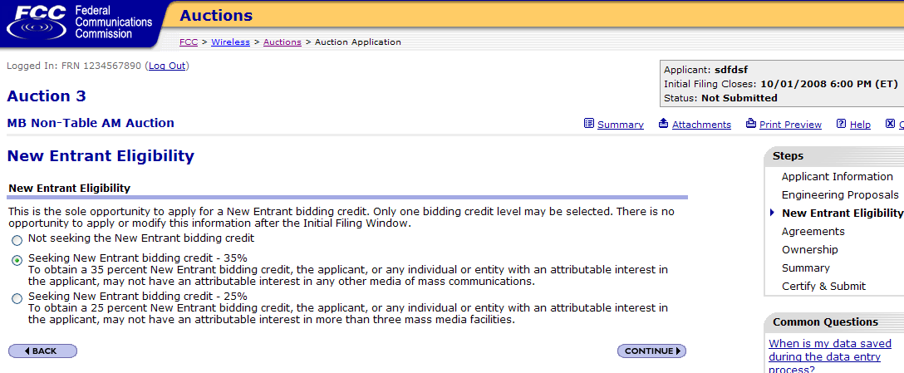

-- If not seeking the New Entrant bidding credit, then proceed to the Agreements section.

-- If seeking the New Entrant bidding credit (25% or 35%), then proceed to the “Eligible Entity” Election page, as shown below.

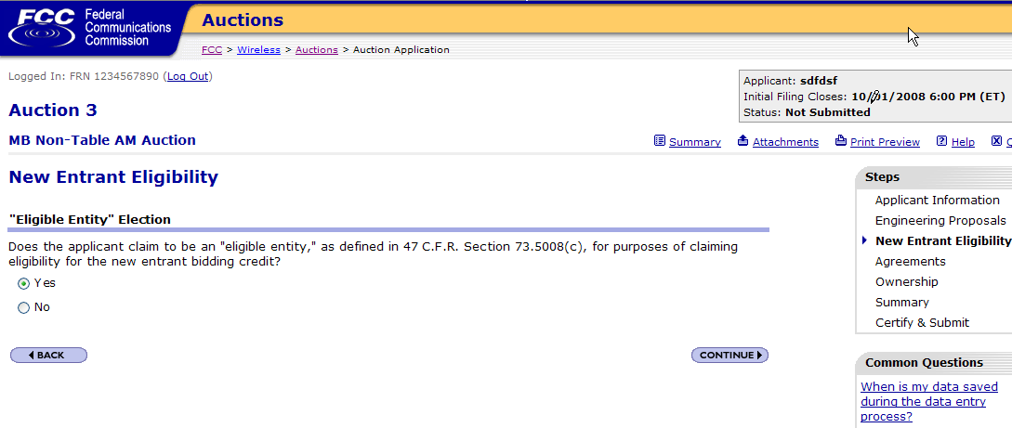

-- If applicant claims Yes, to be an eligible entity, and is applying for 35% bidding credit, then proceed to the Agreements section.

-- If applicant claims Yes, to be an eligible entity, and is applying for 25% bidding credit, then proceed to the Add Facility or View/Edit Facilities page.

-- If applicant claims No, to not be an eligible entity, then proceed to the Agreements section.

-- If applicant does not select Yes or No, then display the following error page:

