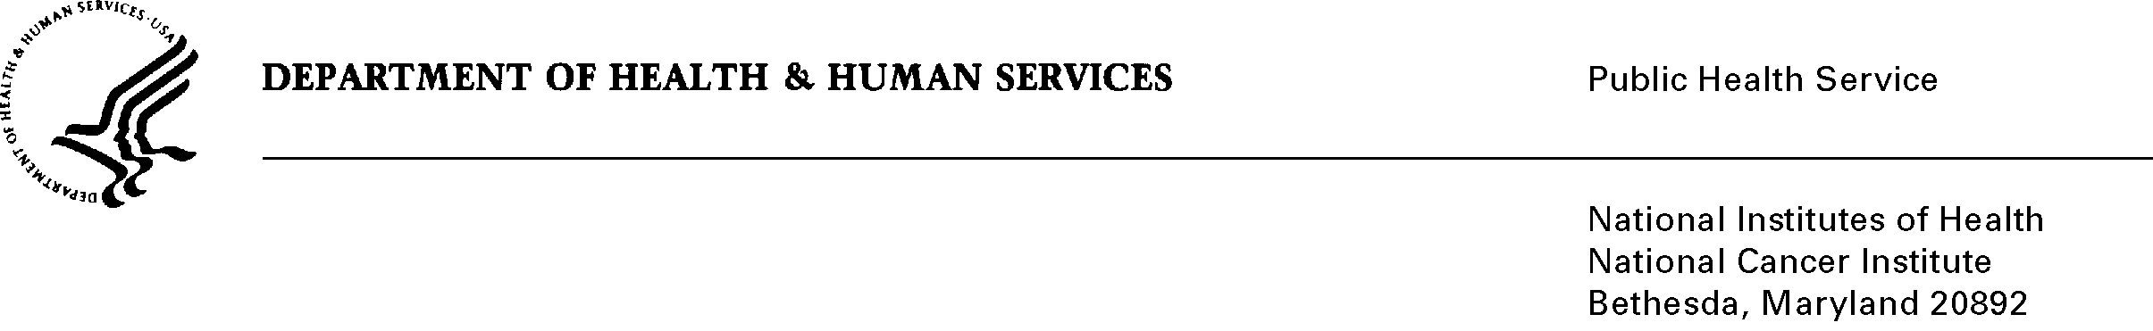
Date: October 31, 2008

To: Office of Management and Budget (OMB)

Through: Seleda Perryman, Report Clearance Officer, DHHS
Marilyn Tuttleman, Project Clearance Branch, NIH
Vivian Horovitch-Kelley, NCI PRA Clearance Office, NCI

From: Nancy Breen, Ph.D.
National Cancer Institute/NIH

Subject: California Health Interview Survey Cancer Control Module (CHIS-CCM) 2009

This is a request for OMB to approve the California Health Interview Survey Cancer Control Module (CHIS-CCM) 2009. The Federal Register Notices, supporting statements, and various attachments accompany this memorandum.

The NCI has sponsored four Cancer Control Modules in the California Health Interview Survey (CHIS), and will be sponsoring a fifth to be administered in 2009. CHIS is a telephone survey that collects population-based, standardized health-related data to assess California’s progress in meeting Healthy People 2010 objectives for the nation and the state. The CHIS sample is designed to provide statistically reliable estimates statewide, for California counties, and for California’s ethnically and racially diverse population.

The purpose of CHIS-CCM is to collect data to allow NCI to examine patterns and trends in cancer screening and follow-up, as well as to study other cancer-related topics such as tobacco control, diet, physical activity, and obesity by collecting data on health- and disease-related topics such as patterns and trends in cancer screening, disease risk factors, disease outcomes, family history of disease, and social factors such as discrimination.. Additionally, CHIS is designed to be comparable to the National Health Interview Survey (NHIS) data in order to conduct comparative analyses. CHIS provides enhanced estimates for cancer risk factors and screening among racial/ethnic minority populations.

A total of 55,000 adult and adolescent (persons 12 years of age and older) California residents will be asked to complete CHIS 2009. The annualized burden for the completion of the survey by all respondents is 3,437 hours.

A mission of the Division of Cancer Control and Population Sciences at the NCI is to establish and support programs for the prevention and treatment of cancer. The California Health Interview Survey Cancer Control Module 2009 is an important instrument that supports our ability to further examine patterns and trends in cancer screening and follow-up.

