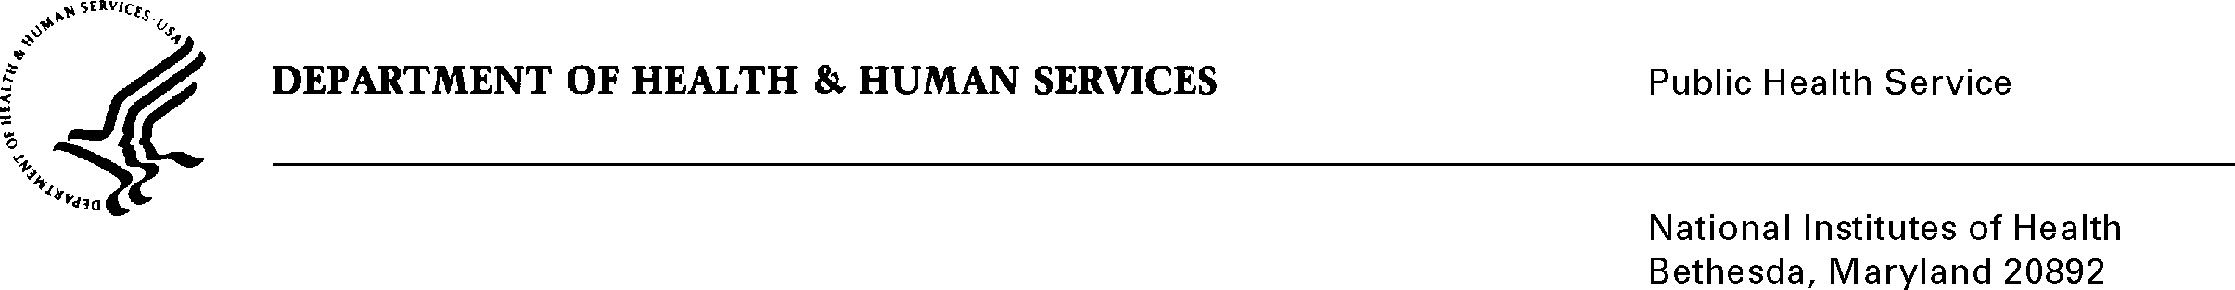

DATE: November 5, 2008

TO: Nancy Breen, Project Officer
Applied Research Program
Division of Cancer Control & Population Sciences, NCI

FROM: NIH Privacy Act Officer

SUBJECT: Applicability of the Privacy Act: CHIS-CCM Health Survey

I have reviewed the NCI/DCCPS submission to OMB requesting approval for the statewide population-based research study entitled California Health Interview Survey Cancer Control Module (CHIS-CCM) 2009. I have determined that the Privacy Act will apply to this data collection which involves the collection and storage of personally identifiable records that are designed to be retrieved by a personal identifier.

The data collection is covered by NIH Privacy Act Systems of Record 09-25-0200, “Clinical, Basic and Population-based Research Studies of the National Institutes of Health (NIH), HHS/NIH/OD”.

If you have any questions, please contact my office at (301) 496-2832.

Karen M. Plá

Attachment

